ANPH 202 Worksheet – Circulation – ANSWER KEY

- Please label the vessels in image 1. Be sure to label the anatomical side:

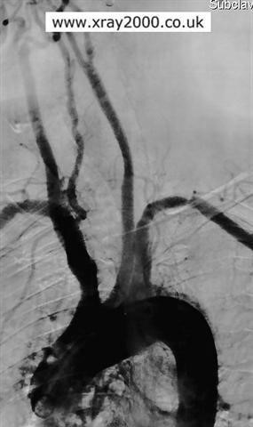

2
. Right common carotid

1.

Left common carotid

3
. Right vertebral

4.

Left subclavian

6.

A
ortic arch

5.

Brachiocephalic trunk

7.

Ascending aorta

8.

Descending thoracic aorta

Image 1

- List the following sections of the aorta in order, from the most proximal to the most distal:

descending thoracic aorta | 3
aortic arch | 2
abdominal aorta | 4
ascending aorta | 1

- List two exterior landmarks of the body that correspond to the bifurcation of the aorta. Umbilicus (belly button), iliac crests, and lumbar spinal body 4

- Study the branches of the abdominal aorta and see if you can draw them from memory in the space below. Be sure to include the location of the celiac trunk, renal arteries, left gastric artery, common hepatic artery, superior mesenteric artery, inferior mesenteric artery, and common iliac arteries

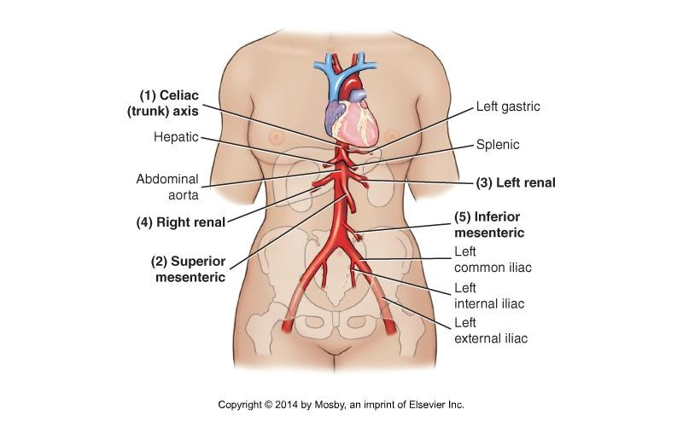

- You need to pick up your friend who lives at “47 Right Renal Way S.W.” and you live at “96 Left Subclavian Way N.E.”. As you head towards the center of town will you need to turn right or left when you come to the “Aortic freeway”? Left As you head south past the “Diaphragmatic bridge” will you need to take the first, second, or third right, after the bridge? First left after the diaphragmatic bridge. The celiac trunk is not a right or a left as it comes off the anterior side of the aorta, and then branches into the left gastric, common hepatic, and splenic arteries.

- A radiologist wants to introduce a catheter into the left internal carotid artery. List the arteries that the catheter will pass through enroute to the final destination, given that the catheter is inserted into the left common femoral artery. Left common femoral artery, Left external iliac artery, left common iliac artery, abdominal aorta, thoracic aorta, left common carotid artery, left internal carotid artery.

- The smooth muscle layer of arterial walls is known as the tunica media

- Which terms best describe the external carotid artery’s relationship to the internal carotid artery?

- Anterior and lateral
- Anterior and medial
- Posterior and lateral
- Superior and medial

- The right vertebral artery branches off the

  - Aortic arch
  - Brachiocephalic artery
  - Right subclavian artery
  - Right common carotid

- If your friend lived at “100 right posterior communicating artery drive” and you lived at “26 right subclavian way”, what is the shortest route that you could take to your friend’s house? Turn left at right common carotid drive, continue onto right internal carotid drive, turn left on posterior communicating artery drive.

Note: This image is from Net Anatomy
Image 2
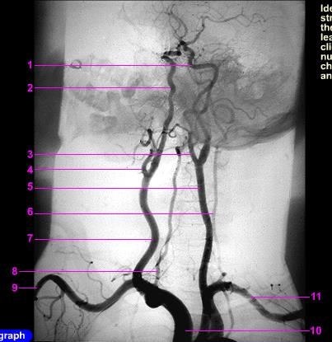
- Label the arteries in image 2.

    - Left internal carotid
    - Right internal carotid
    - Left external carotid
    - Right external carotid
    - Left common carotid
    - Left vertebral artery
    - Right common carotid
    - Right vertebral artery
    - Right subclavian
    - Brachiocephalic trunk
    - Left subclavian

Label the arteries in the “artist’s rendition” of the circle of willis below:

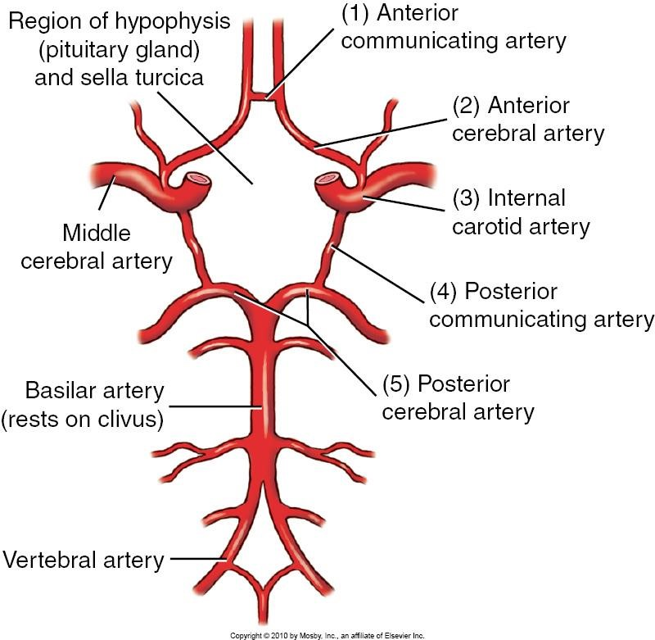
Right and left posterior cerebral arteries

Anterior cerebral artery

Left internal

carotid artery

Left Posterior communicating artery

ng artery
Anterior communicati

Right middle
cerebral artery

Basilar artery

Which gland lies
here?
Pituitary
gland

13) Label the arteries in image 3.

- Right anterior cerebral artery
- Anterior communicating artery
- Left posterior communicating artery
- Left internal carotid artery (cervical part)
- Left internal carotid artery (petrous part)
- Left middle cerebral artery
- Left anterior cerebral artery

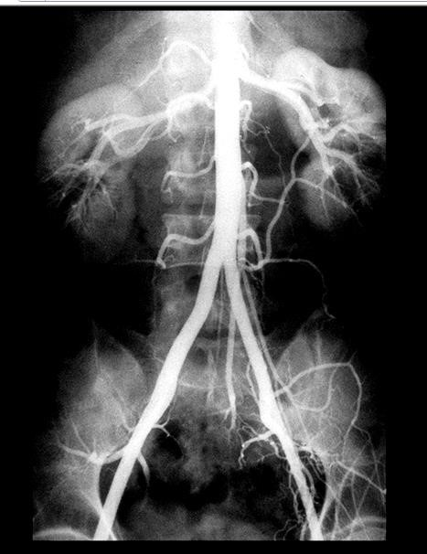
14
)

Label the anatomy in image 4

Note:
This image is from Net Anatomy

. Organ
1

within yellow circle
? Right kidney

2
. Artery? Right renal

4
. Artery? Right external iliac

3
. Artery? Right common iliac

Image 4

Note: This image is from Net Anatomy
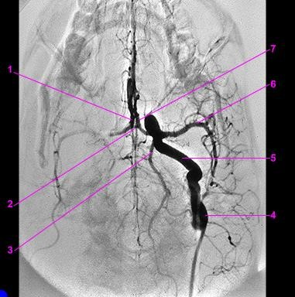
Note this vessel is
perpendicular to the
circle of

willis

Image 3

- Artery? Right internal iliacVenous Circulation, Dural Sinuses, and Portal System

- Artery? Right common femoral artery
To complete the following questions, please refer to pages 660,662,663,664, in Bontrager

15) Label the veins on image 5.
A

B

C

D
(
superficial
)

E

G

F
(
superficial
)

H

Image 5

    - Left Internal Jugular
    - Left external jugular
    - Left subclavian D Cephalic
    - Median Cubital
    - Basilic
    - Superior Vena Cava
    - Inferior Vena Cava

16) Which of the veins in the image above are useful for venipuncture?

Cephalic, Basilic, and Median cubital

- Which of the veins in the image above may be used to insert a central line for the administration of drugs? Left subclavian, and internal jugular

- Which of the following is true regarding the IVC?

a) The portal vein dumps into the IVC

b) Blood pressure in the IVC is very low
- It lies a little to the left of the spine
- It branches into the right and left external and internal iliac veins at the level of L4

19) Which of the following is true regarding the SVC?

a) It only receives blood from the head and neck

b) Its proximal end is at the confluence of the right and left brachiocephalic veins
- It dumps deoxygenated blood into the left atrium of the heart
- It anastomoses with the IVC

- The portal vein carries nutrient rich deoxygenated blood from the digestive organs to the liver, where solute and nutrient levels are regulated, and foreign matter is removed. T F

- Which of the following will provide a palpable pulse?

  - IVC
  - Internal Jugular vein
  - Brachial vein
  - None of the above (veins do not provide a pulse)

- Which of the following is true regarding the dural sinuses?

a) They are contained within the folds of the dura mater
- They drain into the carotid veins
- They lie in the subarachnoid space
- They drain into the external jugular veins

- On image 6, label the superior sagittal sinus, and the transverse sinus. “2” is the superior sagittal sinus, and “3” is the transverse sinus

Image 6
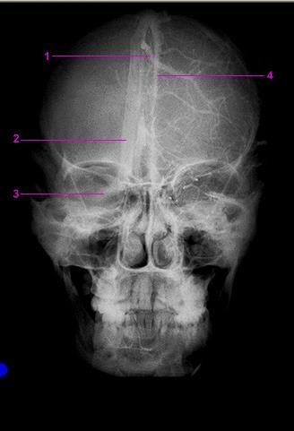
Note: This image is from Net Anatomy

- Which is more anterior, the SVC, or the thoracic aorta? SVC

- Which lies more to the right, the IVC or the aorta? IVC

- Describe how the cerebral sinuses are similar to veins.

They both collect deoxygenated blood and return it to the heart

- Arteries have three layers to their walls but veins have only two. T F

- The blood pressure in the portal vein is higher than the blood pressure in the IVC. T F

- There are ______ pulmonary veins:

  - One
  - Two
  - Three

Four

