RADP 215 – Radiation Protection

Activity: Biological Aspects of Exposure

Questions 1 - 29

Purpose:

To apply your knowledge about the biological aspects of exposure.

Instructions:

- Answer the following questions.
- Upload a completed copy into EDENBROOK.
- Your instructor will review the answers with the class.

- Define the term LET.

- Explain the significance of Low LET and High LET.

- Define the term RBE.

- Define the term OER.

- Define the terms protraction and fractionation.

- What is the difference between somatic and genetic cells and what are the potential effects of irradiating these cells?

- What does it mean when macromolecules are irradiated in vitro and why is this important to know?

- What are the three major effects of the irradiation of macromolecules?

- Describe the process of radiolysis of water.

- What are the products of radiolysis of water?

- What is the difference between direct and indirect action?

- Explain the concept of Target Theory and describe what we believe the master molecule is.

- According to the Law of Bergonié and Tribondeau, what determines a cell’s radiosensitivity?

- What is the purpose of radiation dose response curves?

- What is the difference between threshold and non-threshold?

- Label the following dose response curves.

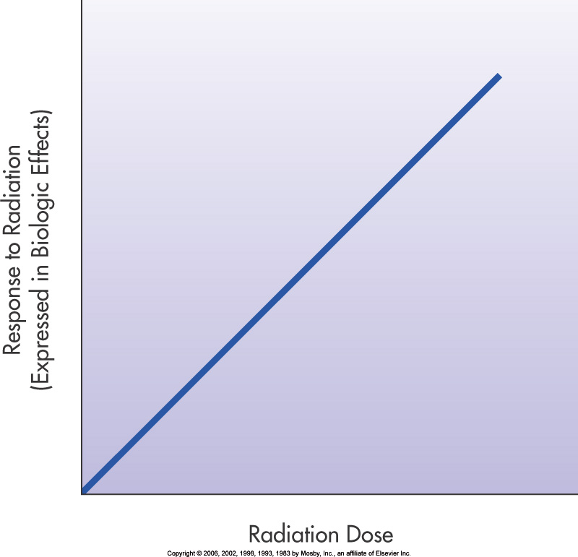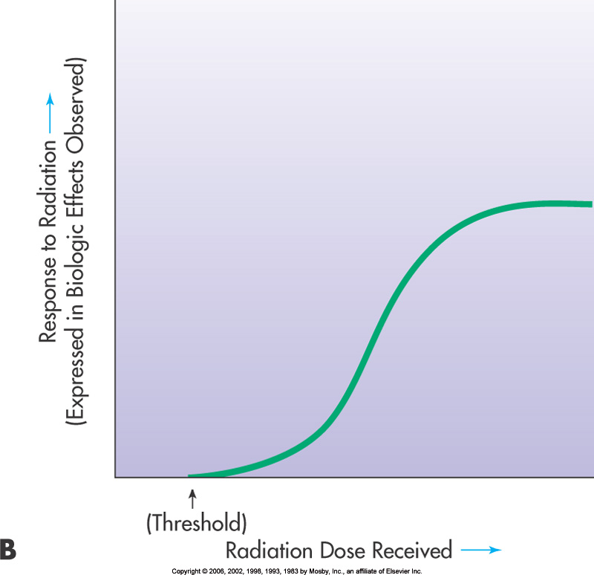

- Explain the concept of somatic effects. How are these effects classified?

- What is the difference between stochastic and deterministic reations?

- Are stochastic effects threshold or non-threshold? Explain why.

- List examples of stochastic effects.

- List examples of early deterministic effects.

- List examples of late deterministic effects.

- Describe ARS and include the major stages.

- Describe the three forms of ARS.

- Define the term Lethal Dose.

- What is the purpose of risk estimates?

- List and describe the three types of risk estimates.

- What is radiation hormesis?

- What is the difference between quality factor and radiation weighting factor?

