ANPH 252 – Worksheet- GI Anatomy – ANSWER KEY
- Technically speaking, the GI tract is shorter than the alimentary canal. T F
- Starting with the most inferior, list the four layers that make up the walls of the GI tract and describe their basic functions:
  - Mucosal layer – allows for protection, absorption and secretion.
  - Submucosa – connective tissue that has blood vessels and nerves
  - Muscularis – maintains peristalsis
  - Serosa – double walled loops of mesentery formed from the visceral peritoneum, that secure the intestines to the posterior wall of the abdominal cavity. (see page 507 Patton and Thibodeau 7th ed.)
- Mechanical digestion is completed by the teeth and the stomach
- Food that has been mechanically digested can be directly absorbed into adjacent tissues”
  - True
  - False. It must be mechanically and chemically digested, and nutrients are absorbed into the blood stream, not directly into the tissues.
- Food that has been chemically digested can be directly absorbed into adjacent tissues
  - True
  - False (see explanation in question 4 above)
- List the accessory organs that aid in digestion. Teeth, tongue, salivary glands, liver, gallbladder, pancreas
- In the human body the three pairs of salivary glands include:
  - parotid b) submandibular c) sublingual
- The largest salivary gland is the parotid. The medical term “otic” is used with reference to the ear
- The portion of the throat posterior to the soft palate is known as the nasopharynx
- The portion of the throat posterior to the buccal cavity is known as the oropharynx
- The portion of the throat posterior to the laryngeal prominence (and larynx)is known as the laryngopharynx

- The structure that prevents food from slipping into the trachea (windpipe) duringswallowing is the epiglottis. It is attached to a “free floating bone” inferior to the tongue, known as the hyoid bone
- Which of the following structures is most immediately anterior to the spine?
    - Nasopharynx
    - Trachea
    - Esophagus
    - Palatine tonsil
- Which of the following is most superior?
    - Hepatic flexure
    - Tail of the pancreas
    - Splenic flexure
    - Spleen
- The stomach lies more transversely in patients with a hypersthenic body habitus.
- A specific pathology of the digestive system that causes projectile vomiting in youngneonates is known as hypertrophic pyloric stenosis. Describe what each of these medical terms means, and based on the definitions, make an educated guess regarding the location and physiology associated with this pathology:
Hypertrophic means “an increase in cell size” (page 61) - the pyloric region is at the distal end of the stomach where chyme leaves the stomach and enters the small intestine; stenosis refers to a narrowing – so……. in this disease there is a narrowing of the pyloric region due to a thickening of tissues, which makes it difficult for chyme to leave the stomach at the normal rate.
- The gastric folds that allow the stomach to expand with food are called rugae
- From the most superior to the most inferior, the three sections of the small bowel include:
  - duodenum
  - jejunum
  - illeum
- If a patient developed a tumor on the head of the pancreas what part of the digestivesystem would be “displaced”? C – loop of the duodenum
- The pancreatic duct opens into the duodenum at the major duodenal papilla which is located in the descending portion of the duodenum.
- The organ that occupies most of the right upper quadrant is the liver
- What is the English translation of “porta hepatis”, and what structures pass through it?
“Gateway to the liver”; hepatic artery, common hepatic duct, portal vein
- Bile produced in the liver is stored in a concentrated form in the gallbladder
- What is the main purpose of bile? It emulsifies or breaks down fat
- Fats in chyme, stimulate the release of cholecystokinin (CCK) into the duodenum. CCK is a hormone that triggers the gallbladder to contract, which releases bile into the duodenum
- The right and left hepatic ducts join to form the common hepatic duct
- The common bile duct is formed by the cystic duct and the common hepatic duct
- The only “two directional” duct in the biliary tree is the cystic duct
- Refer to the digestive system power point on D2L to match the following:
A) Lower esophageal sphincter | C | Controls chyme leaving the stomach
B) Sphincter of oddi | A | Allows a food bolus to enter the stomach
C) Pyloric sphincter | B | Controls flow of pancreatic digestive enzymes and bile
D) Illeocecal valve | D | Controls food entering the large bowel
- Which part of the stomach is most posterior? The fundus
- The blind pouch at the proximal end of the large intestine is known as the cecum
- Another name for the right colic flexure is the hepatic flexure
- Another name for the left colic flexure is the splenic flexure
- The most distal section of the colon is the anal canal
- The descending colon is on the right side of the body T F
- Wavelike muscular contractions of the digestive system are known as peristalsis
- Which part of the GI tract is the main site of nutrient absorption?
Small intestine, especially the duodenum

Label the anatomy on the radiograph below:
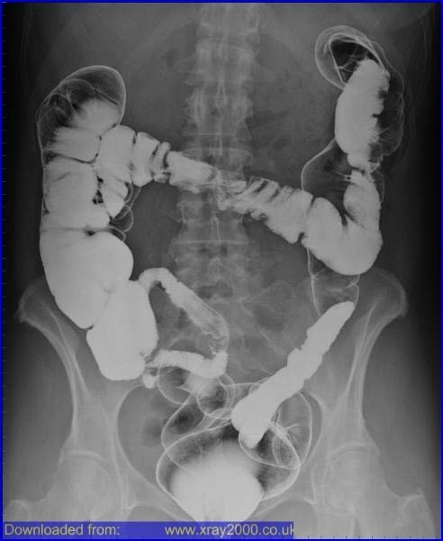
A

B

C

D

E

F

G

A) hepatic flexure; B) splenic flexure; C) ascending colon; D) descending colon;
E) terminal ileum/ illeocecal valve; F) Sigmoid colon; G) small intestine/illeum
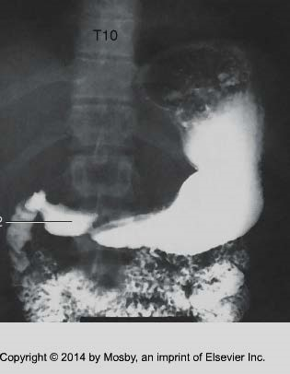
41
:
.Label the anatomy on the radiograph below
\
1
.
fundus

of
(
the
stomach)

2
.
greater curvature

(
of the stomach
)

5
.
Location of which

o
rgan?
Pancreas (head
of the pancreas)
3.
lesser

curvature

)
of the stomach
(
4.
small intestine
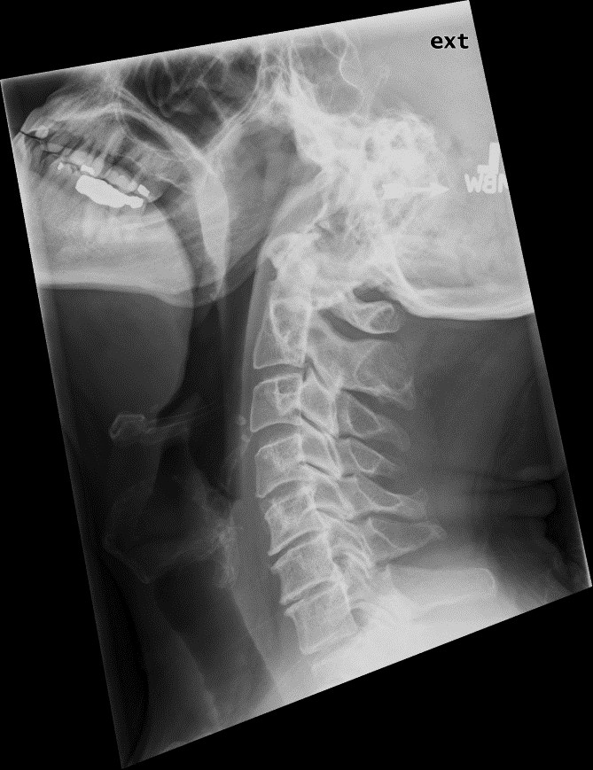
42
:
.Label the structures in the radiograph below
A)Cavity?

nasal
B)Cavity?

oral or buccal
C)
naso
p
harynx
D
)
oropharynx
F)
laryngopharynx
E)
epiglottis
G)
esophagus

