MRAD 358 – Clinical Integration 1
Pathology Review – ANSWER KEY

- Name the pathology in the image. Is this pathology malignant or benign?
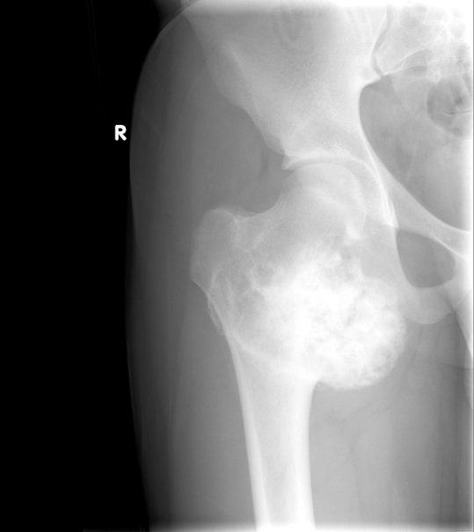

Osteosarcoma - malignant

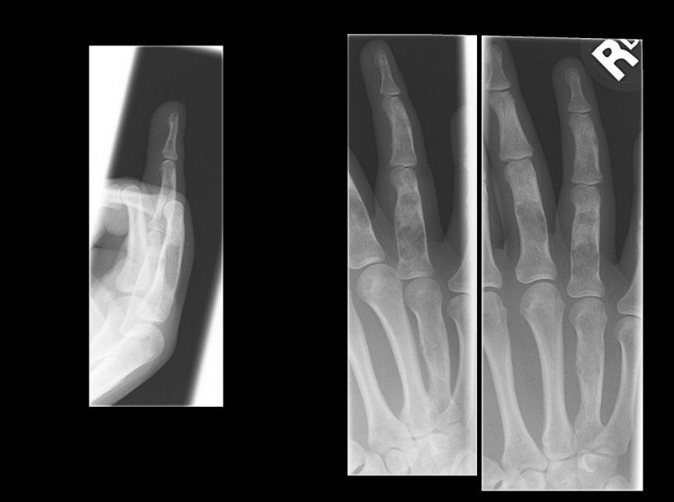
- Name the pathology in the images. Is this pathology malignant or benign?

Enchondroma – benign

- Define atelectasis and describe its etiology.
Absence of air in all or part of the lung; pulmonary collapse. May be caused by neoplasm, foreign body or mucous plug.

- Why do inhaled foreign bodies tend to occur more frequently in the right lower lung?
The right main stem bronchus is larger and more vertical so foreign bodies pass through it easier.

- List some congenital respiratory pathologies.
Cystic fibrosis
Hyaline membrane disease
Adult respiratory distress syndrome

- What are some disease processes that contribute to COPD?
Chronic bronchitis
Emphysema
Asthma
Bronchiectasis

- What pathology is shown in the image?
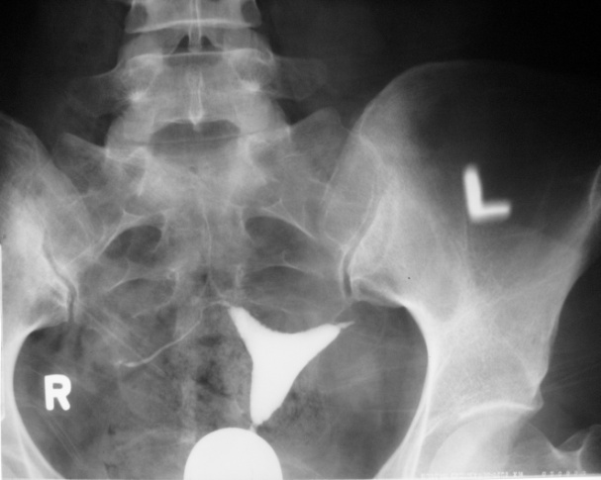

The left fallopian tube is blocked - little passage of contrast.

- Describe the radiographic projection used to demonstrate an imperforate anus.
An inverted lateral abdomen (with metallic markers on skin where anus should be).

- How would you adjust your radiographic technique for the following pathologies?
  - Ascites – Increase
  - Bowel obstruction – Decrease (more air present)
  - Cirrhosis – Increase

- Describe the radiographic signs of Crohn’s disease?
Narrowing of the lumen (string sign), dilation of the bowel proximal to the lesion; cobblestone appearance and skip lesions.

- Name the pathology in the image.
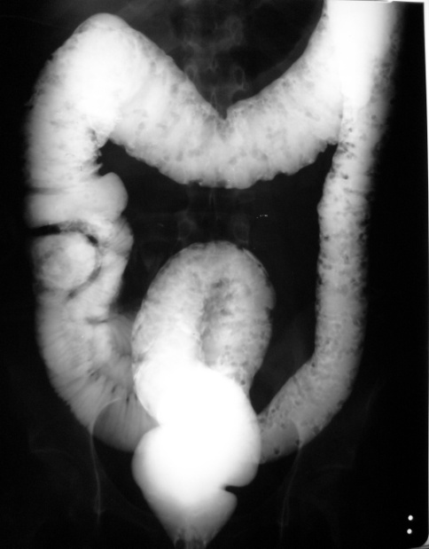

Ulcerative colitis

- What four anatomical abnormalities characterize the Tetralogy of Fallot?
1. High ventricular septal defect
2. Pulmonary stenosis
3. Overriding of the aortic orifice above the ventricular defect
4. Right ventricular hypertrophy
- Why is a chest x-ray taken on a patient who has had an MI?
To determine if the lungs are becoming congested as a result of left- sided heart failure.

- Describe the difference between thrombus and embolus.
Thrombus – a mass of coagulated blood or clot that usually adheres to the wall of a vessel. It may break free and enter the blood stream to form an embolus.
Embolus – a foreign object, air, bit of tumour, thrombus etc. that enters the bloodstream with the potential of becoming lodged in a vessel, which results
in occlusion.

- What are some predisposing factors for a CVA?
- TIAs
- Atherosclerosis
- Hypertension
- Cigarette smoking
- Family history of CVA
- Rheumatic heart disease
- Diabetes mellitus
- Cardiac or myocardial enlargement
- Use of oral contraceptives
- What is a “goiter”?
Enlargement of the thyroid gland – not caused by inflammatory or neoplastic process – where thyroid hormone in the blood is low and the anterior pituitary continues to secrete TSH, thereby causing the thyroid gland to enlarge.

- What are the signs and symptoms of Cushing’s syndrome?
Obesity of the trunk, moon-shaped face, buffalo hump (fat pad between shoulders), hypertension

- What would the following hematomas look like on a CT image?
Intracerebral hematoma – Well circumscribed, homogenous increased density lesion, surrounded by decreased density edema.
Subdural hematoma – Increased density in a crescent shape.
Epidural hematoma – Increased density in a lens shape.
Subarachnoid hemorrhage – Increased density within the basilar cisterns, cerebral fissures and sulci.
- For the images below, state whether the hematoma is intracerebral, subdural or epidural. (Note: images are from the Evolve website and can also be found at the following link: https://evolve.elsevier.com/staticPages/s_index.html )
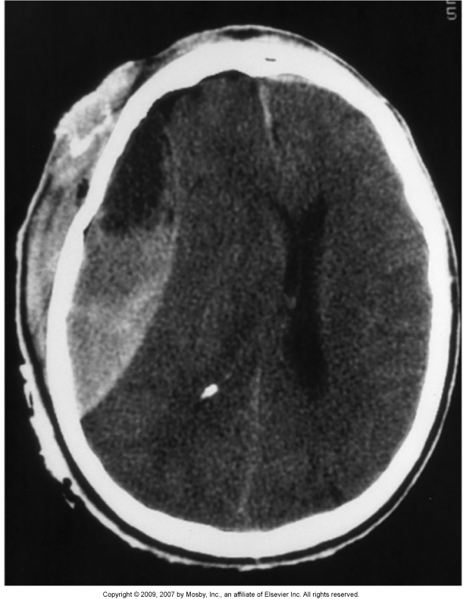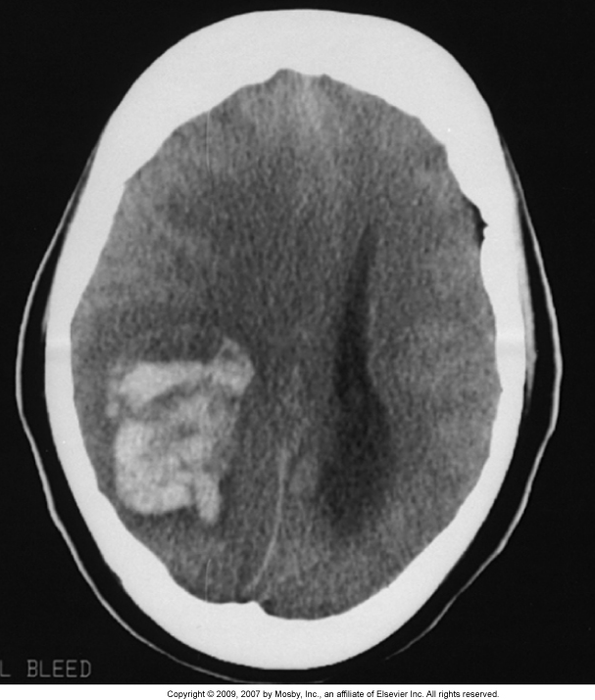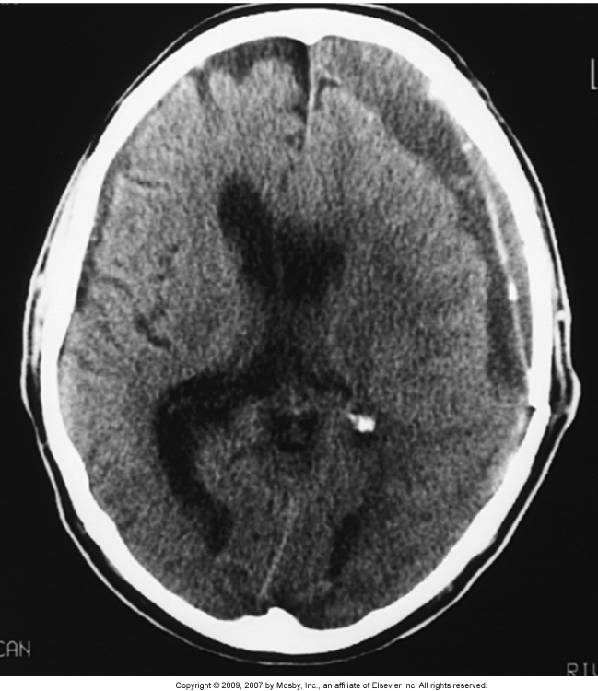
Image 1 Image 2 Image 3
Answer : Epidural Intracerebral Subdural

