

Professionalism

Guiding Principles for Success in Clinical Placement

Objectives:
Professionalism in the Workplace – Clinical Placement:

- Professional conduct: What does it mean?
- Bringing the right attitude to clinical
- Using effective communication
- Understanding the significance of feedback
- Initiative and learning
- Responsibility awareness
- Attendance and punctuality

Professional Conduct
Professionalism has a profound impact on workplace performance and is now being looked at by employers as an asset to any team, department or organization.

From Job Boom
“Professionalism is the underlying foundation that increases productivity and quality, reinforces trust, improves teamwork and inspires excellence. Studies suggest that approximately 85 percent of dismissed employees lose jobs because they lack appropriate work habits. Behaviors which most often lead to job loss are tardiness, absenteeism, inability to follow instructions, and lack of cooperation”.

Your clinical experience is your major professional responsibility. You are expected to conduct yourself in a professional way at all times including your dress, attendance, punctuality, behavior, communication, and general attitude.

To conduct yourself unprofessionally will damage your experience and your chance of a good recommendation from your clinical site. It is true when we say that clinical is a long interview.

As part of your professionalism, be open to your preceptors and site liaisons. Although you may not have seen a new approach or method, listen and observe respectfully and keep in mind they are experienced, seasoned professionals. They want to help you as much as they can; show how you respect that effort by how you respond.

What we learn from every new experience will enhance our technical skills, give us additional tools to work with in new situations and grow our confidence in our own abilities.

Embrace new ideas and when faced with a challenging study, communicate with your preceptor so that you can step into those uncomfortable situations and attempt them knowing that you are learning and now is the time to try.

No two clinical experiences will be the same – they will be unique and varied depending on the clinic or hospital site. Be receptive of the variances and embrace new methods and approaches.

In all of your relationships with peers, preceptors and site liaisons, remember to always respect the person.

Communication
Make it a priority to have reflective and responsible communication daily with your preceptors and site liaisons. I can’t stress this enough:

- Discuss goals with preceptor / site liaison
- Identify roadblocks – fear of trying, past problems or mistakes
- Ask questions for clarification when necessary – to avoid misunderstanding
- Be an engaged listener - * not only hearing but gaining & understanding information
- Refrain from making excuses / can be perceived as arguing – accept feedback

Sounds simple, but can be challenging. Remember to always keep your exchanges professional:

- New and intimidating atmosphere
- Feeling stress to perform
- Teamwork - in ICU, working with radiologists, surgeons in OR
  - Appropriate time, appropriate manner
- Test your ability to find confidence
- Communicating with patients
- Language, cultural, non-verbal, simplifying instructions, listen to concerns, relaying pertinent pt. information, etc.
- Avoid gossip

Be sure to check email regularly for vital communication and EDENBROOK updates or changes in upcoming events, deadlines or scheduling. Be timely, polite and use professional language in your correspondence.

Significance of Feedback
You will receive feedback from preceptors, site liaisons, instructors on a daily basis.

Reflect on the feedback you receive and perfect your ability to process, understand and implement suggestions in a positive way. Try not to take feedback personally…don’t look at it as criticism. It is an opportunity to learn!

The feedback you receive will vary, not only on your performance, communication skills and workflow, but also from site to site where protocols and environment vary.

Take responsibility for your work (this includes errors). Some of the best learning opportunities can be taken from mistakes.

You will receive plenty of positive feedback – try not to focus and fixate on the negative. Learn from mistakes, but own your progress as well.

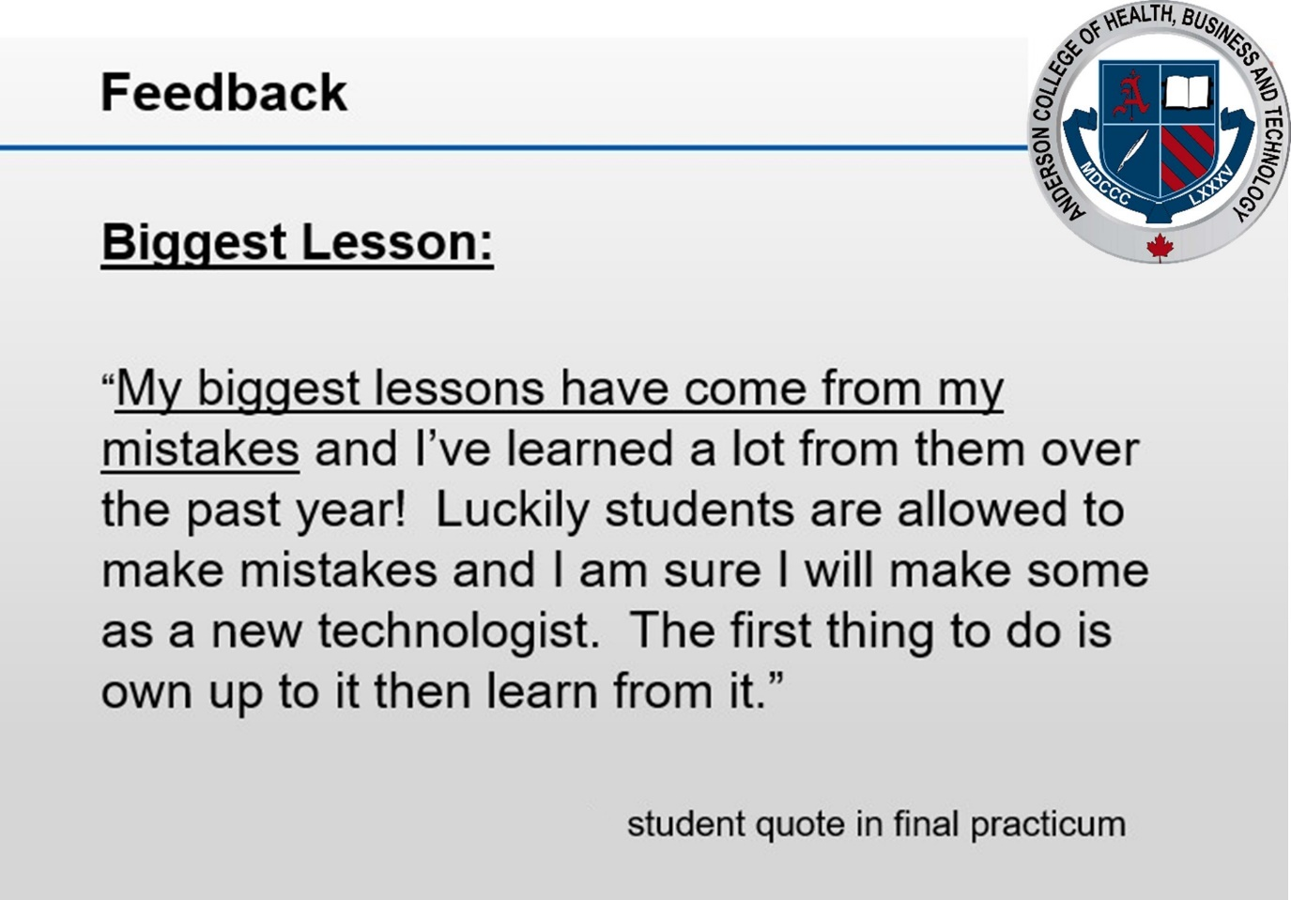

Initiative and Learning
Take initiative in clinical. Once you understand the workflow, tasks, etc., don’t wait to be asked to do something by your preceptor – speak up and request to do an exam.
Ask what you can do if you are unsure.

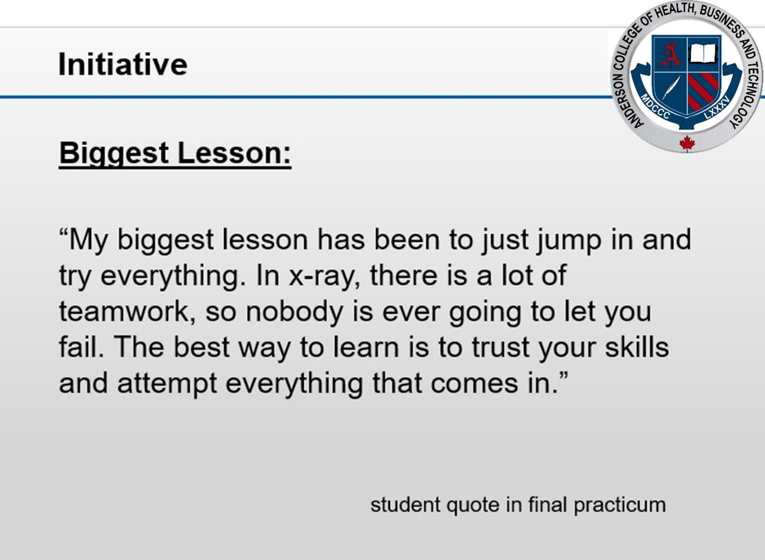
Be ready to jump in on exams, and understand that the more experience you gain, the more confident you will become.

Offer assistance to others when needed and look for chances to help others, as these situations may also give you learning experience in handling challenging, difficult or adaptive exams.

These opportunities will also assist you in building trust with your preceptors, which is a big step in establishing a comfort level in trying to do imaging cases.
Preceptors are always ready to assist when they know you are showing initiative and desire to learn. Preceptors may differ in their approach to working with students, each may have their own style. Some will be more involved and direct whereas others will use more gentle guidance or instruction.

Remember to be prepared for your rotation by studying and trying to understand what is expected in each situation.

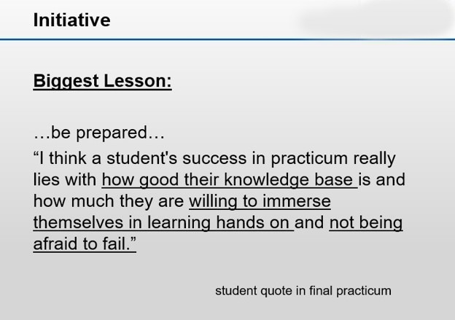

Responsibility
As part of your professional responsibility, you will take advantage of learning opportunities provided, participate in all tasks performed by MRTs including positioning, paperwork, cleaning and stocking rooms, responding to patient care needs, etc.

You will be prepared for your clinical by studying and reviewing all procedures, radiographic anatomy, pathology, etc. and continuing this practice throughout your clinical experience.
It is important for you to practice safely at all times, and to be especially sure to have your preceptor watching or assisting you when you are performing the exam and taking exposures. Ask for help when needed.

You must ensure that all images are approved by a certified Technologist prior to dismissing patients. You are not allowed to repeat exposures or delete images unless approved by your preceptor. Your imaging is done under the name of a registered MRT, so always respect their decision making when performing exams.

Attendance and Punctuality

Attendance is a high priority in the clinical setting.
Professionalism requires you to be on time. Make a habit of arriving early to demonstrate a strong desire to work and show interest in your job.
Minutes late is too late.
You will need to check with your site for the correct time expected to be on the floor and ready to work. Make it a practice to always be on time, appropriately dressed and ready for the workday ahead.
Please refer to the MRT Clinical Placement Attendance policy, and this course outline for more information about our attendance policy and the course hours requirement, and the consequences of not meeting the course hours.

Review and be aware of the protocol for absence notification. The submission of your Daily Performance Forms (DPF) to the preceptor you are working with is a valuable tool to outline your goals, identify learning points and receive feedback that will help you to improve. Be sure to communicate your intent to send your DPF to the preceptor you are working with that day. The DPF is also a way to track your attendance in clinical.

Summary
Be interested and show initiative
- Look for ways to improve
- Don’t be afraid to try…even if you fail
- Accept feedback in positive manner – Be adaptable and open to suggestion
- Listen and respect the feedback given to you
- Communicate with preceptors, site liaisons, etc.
- Be a valued team member
**Be your own best advertisement for your future as a Medical Radiation Technologist.
Exhibit positive energy. This means to have an optimistic frame-of-mind, interact with others in a cheerful, respectful and polite manner.
Demonstrate how much you enjoy your profession as your behavior will be noticed not only by your immediate preceptor, but also by your patients and other health care staff.

Additional References
Please refer to both of the Clinical Placement Orientation and Keys to Success PowerPoint presentations, available in EDENBROOK under PRCT 353 Orientation, as well as the following links for further information.
- CAMRT Member Code of Ethics and Professional Conduct
- CAMRT Best Practice Guidelines
- CAMRT Competency Profile: Medical Radiation Technologists

