Worksheet - Central Nervous System – ANSWER KEY
- “Neuroglia (glial) cells are specialized neurons.” T F
- “Sensory neurons transmit information to the brain and spinal cord, and motor neurons transmit information away from the brain and spinal cord” T F
- “Motor neurons transmit information to muscle and glandular epithelium only” T F
- A life threatening brain tumor that arises from glial cells is known as a/an glioma
- “Axons coated in myelin can transmit sensory and motor information more quickly than thosewithout” T F
- Match the following:
A) cerebrum | E | Enlarged upward extension of the spinal cord formed by the midbrain, pons, and medulla oblongata
B) cerebellum | A | The large superior portion of the brain.
C) diencephalon | C | Egg shaped section between the cerebrum and brainstem that houses the thalmus, hypothalamus and pineal gland.
D) cerebral cortex | F | Masses of grey matter found deep within the cerebrum; responsible for automatic movements and postures such as developing good x-ray habits☺
E) brain stem | D | A thin layer of grey matter on the surface of cerebrum that is responsible for  “consciousness, thinking, memory, sensations, emotions, and willed movements”
F) basal nuclei | B | The smaller posteroinferior part of the brain that is responsible for muscle coordination, balance and posture
©
- Label the gyri, sulci, third ventricle, pineal gland, and falx cerebri on the diagram below.
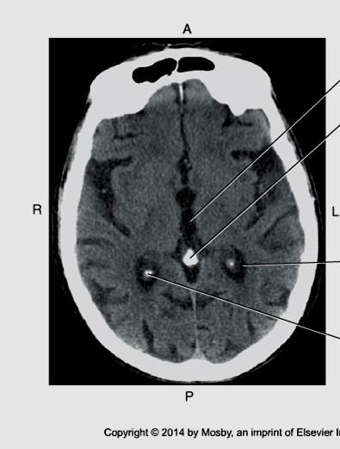
A
Sulci

B
Gyri

D

Pineal gland

E

Falx cerebri

C
T
hird ventricle

- Is the image above taken at the level of the diencephalon, midbrain, pons, or medulla oblongata? (The pineal gland is posterior to the thalmus which is part of the diencephalon)
- Label the lobes of the brain on the diagram below:
Bontrager 9th ed. 18-6
Parietal
Occipital
Temporal
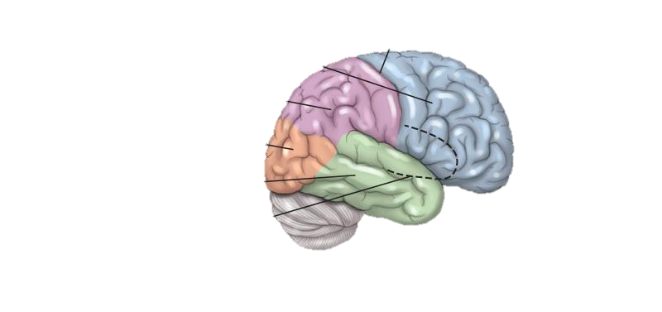Frontal
- Ridges of tissue on the cerebral cortex are known as gyri
- Depressions in the cerebral cortex are known as sulci
- Deep grooves in the cerebral cortex are called fissures
- The diencephalon is part of the brain stem. T F
- The diencephalon is superior to the brain stem, and is completely surrounded by the cerebral hemispheres. T F
- The thalmus sorts and relays sensory/emotional information to the cerebral cortex.
- The hypothalamus regulates emotions, sleep cycles, hormone production, and homeostatic functions such as body temperature and heart rate T F
- Match the following:
A) Pons | B | Superior section of the brain stem
B) Midbrain | C | Most inferior section of the brain stem that regulates heart rate, respiration, and blood pressure (through vasomotor responses i.e. changes in vessel diameter )
C) Medulla Oblongata | A | Middle section of the brain stem that relays information to the cerebellum
- Coordination and communication between the left brain and the right brain is controlledby a fibrous tract of white matter known as the corpus callosum.
- Explain the term “hemispheric lateralization”.
Refers to the fact that each cerebral hemisphere is responsible for different tasks; the left for logical thinking, reading, writing, math etc, and the right for creativity. Also the left brain controls the right distal extremities and vice versa.
- Three membranes cover the brain and spinal cord. They are collectively known as the meninges. List them in order from the most superficial to the most deep:
  - Dura mater
  - Arachnoid mater
  - Pia mater
- What are “dural sinuses” and what do they do?
Dural sinuses are reservoir-like spaces between the inner and outermost layers of the brain’s dura mater, where venous blood from the brain collects, before returning to the heart via the veins in the neck.
- The double walled fold in the dura mater that is found midline between the cerebral hemispheres is known as the falx cerebri. It forms the walls of the superior sagittal sinus which lies in the superior sagittal fissure. The falx cerebri, superior sagittal sinus and superior sagittal fissure can all be seen on a CT scan.
- The double walled fold in the dura mater that separates the hemispheres of the cerebellum is known as the falx cerebelli.
- Where is the subarachnoid space, and what kind of fluid does it contain? It is a narrow space between the arachnoid mater and pia mater and it contains cerebrospinal fluid.
- What does CSF stand for and what two functions does it have?
Cerebrospinal fluid – it protects the brain from impact and provides nutrients
- What structures form CSF and where are these structures located?
The choroid plexus which are specialized structures in the roofs of the cerebral ventricles
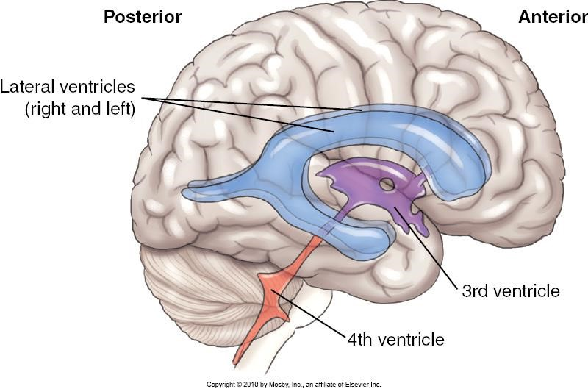
Fo
u
rth ventricle

Third
ventricle

Lateral ventricles (bodies of)

Cerebral aquaduct

Bontrager

9
^{th}

ed.

18
-
8

- Label the following on the diagram above:
lateral ventricles cerebral aquaduct fourth ventricle third ventricle location of the pineal gland (mark it with a star)
- Which space do we draw CSF from during a lumbar puncture or spinal tap?
  - epidural space
  - arachnoid space
  - subarachnoid space
  - subdural space
- How is CSF returned to the blood? It is reabsorbed into the dural sinuses, which return venous blood to the heart.
- The spinal cord extends from:
  - foramen magnum to the hips
  - foramen magnum to diaphragm
  - foramen magnum to the first lumbar vertebra
  - foramen magnum to the fourth lumbar vertebra
- Where is the “epidural space”? It lies between the inside lumen of the bony vertebral canal and the dura mater of the spinal cord.
- Explain why it is safe to insert a needle into the subarachnoid space near the inferior end of the spinal cord.
The dura mater and the arachnoid mater extend inferiorly to the second sacral segment whereas the spinal cord typically ends around L1 of the lumbar spine (just superior to the lower edge of the rib cage) This leaves a fairly large meningeal sac to place a needle into without impacting the spinal cord.
- Which of the following is located most superiorly in the body?
  - medulla oblongata
  - pineal gland
  - diencephalon
  - corpus collosum
- Which of the following is located most inferiorly in the body?
  - lateral ventricle
  - third ventricle
  - thalmus
  - pons
- Which of the following is located most anteriorly in the body?
  - anterior horns of the lateral ventricles
  - midbrain
  - pons
  - medulla oblongata
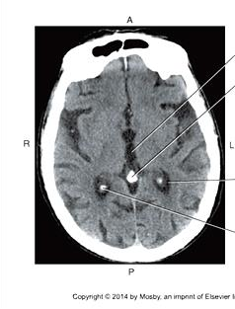
- Given what you know about the location of the ventricles of the brain, what ventricle is arrow “A” likely pointing to? The third ventricle, because the pineal gland is visualized, and the third ventricle is long in an anterior to posterior direction, and narrow side to side.
A

Bontrager
9
^{th}

ed.
18
-
3
6

