MRAD 202 – Patient Care 2
What Equipment or Supplies May be Found on a “Crash Cart?”

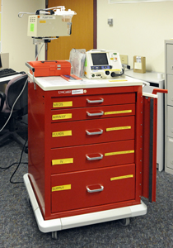
Things the technologist needs to remember:
- Based on the location of the code, the code/crash team bring their own cart or the will be the technologist’s responsible for bring the cart that’s within the D.I dept. This is determined by whether the patient is from ER, ICU, in-pt or if they are an out-pt.
- Make sure you unplug cart and release the brakes prior to moving it.
- There will be an inventory list of everything that is kept in the cart and in which drawer it belongs. Example- the medication and IV set up in kept in the top drawer.
- If the crash cart used during the code was the one from the D.I department, it is the technologists and D.I nurses responsibility to re-stock the cart after the code.
- Never borrow any supplies from the crash cart. The carts will have a seal on them.

