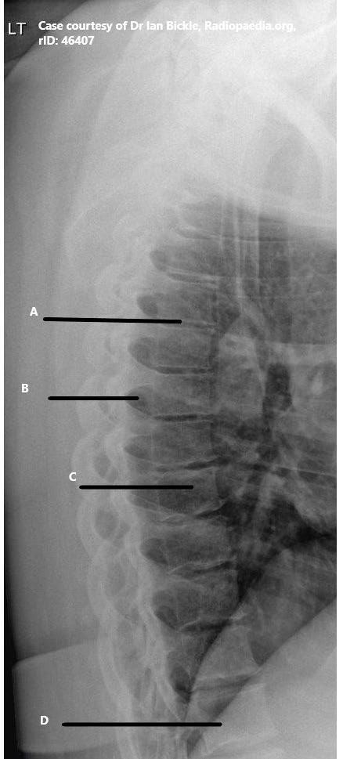
MRAD 256 – Worksheet - T-Spine Radiographic Anatomy Labelling – ANSWER KEY

1

MRT Program
©
Anderson College
intervertebral joint space T5-6
intervertebral foramina T 7
Body of T9
L1
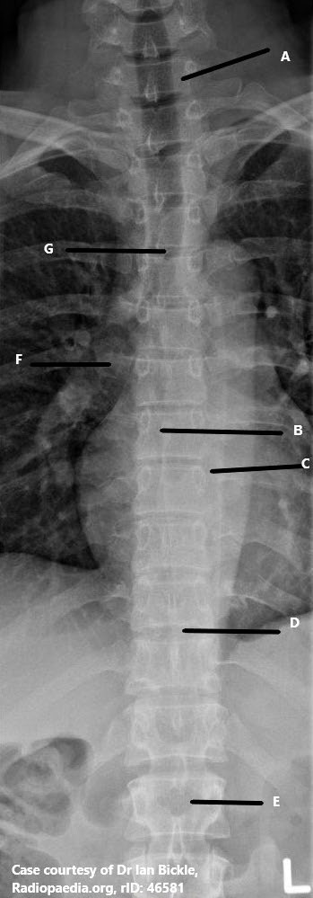
T
HORACIC SPINE RADIOGRAPHIC ANATOMY LABELING

2

MRT Program
©
Anderson College
C7
Spinous process of T7
L costovertebral joint T8
Intervertebral joint T 10-11
L1

