ANPH 202 – Anatomy and Pathology 1
Worksheet - Central Nervous System
- “Neuroglia (glial) cells are specialized neurons.” T F
- “Sensory neurons transmit information to the brain and spinal cord, and motor neurons transmit information away from the brain and spinal cord” T F
- “Motor neurons transmit information to muscle and glandular epithelium only” T F
- A life threatening brain tumor that arises from glial cells is known as a/an __________
- “Axons coated in myelin can transmit sensory and motor information more quickly than those without” T F

- Match the following:
A) cerebrum |  | Enlarged upward extension of the spinal cord formed by the midbrain, pons, and medulla oblongata
B) cerebellum |  | The large superior portion of the brain.
C) diencephalon |  | Egg shaped section between the cerebrum and brainstem that houses the thalmus, hypothalamus and pineal gland.
D) cerebral cortex |  | Masses of grey matter found deep within the cerebrum; responsible for automatic movements and postures such as developing good x-ray habits☺
E) brain stem |  | A thin layer of grey matter on the surface of cerebrum that is responsible for  “consciousness, thinking, memory, sensations, emotions, and willed movements”
F) basal nuclei |  | The smaller posteroinferior part of the brain that is responsible for muscle coordination, balance and posture

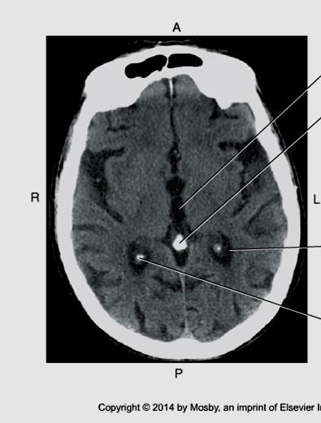
- Label the gyri, sulci, third ventricle, pineal gland, and falx cerebri on the diagram below.
A
B
D

E

C

Bontrager 9th ed. 18.36
- Is the image above taken at the level of the diencephalon, midbrain, pons, or medulla oblongata?

- Label the lobes of the brain on the diagram below:
Bontrager 9th ed. 18-65
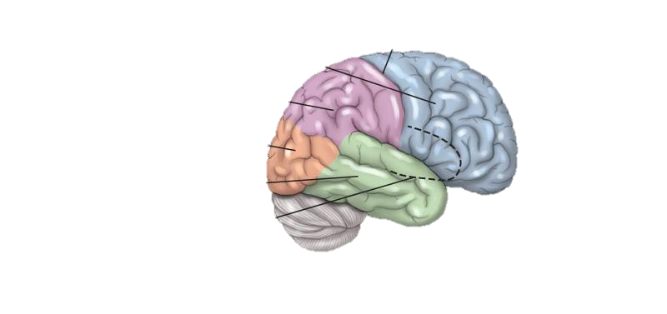

- Ridges of tissue on the cerebral cortex are known as _____________
- Depressions in the cerebral cortex are known as ____________
- Deep grooves in the cerebral cortex are called _______________
- The diencephalon is part of the brain stem. T F
- The diencephalon is superior to the brain stem, and is completely surrounded by the cerebral hemispheres. T F
- The thalmus sorts and relays sensory/emotional information to the _______________
- The hypothalamus regulates emotions, sleep cycles, hormone production, and homeostatic functions such as body temperature and heart rate T F

- Match the following:
A) Pons |  | Superior section of the brain stem
B) Midbrain |  | Most inferior section of the brain stem that regulates heart rate, respiration, and blood pressure (through vasomotor responses i.e. changes in vessel diameter )
C) Medulla Oblongata |  | Middle section of the brain stem that relays information to the cerebellum

- Coordination and communication between the left brain and the right brain is controlled by a fibrous tract of white matter known as the ____________________
- Explain the term “hemispheric lateralization”.
- Three membranes cover the brain and spinal cord. They are collectively known as the ______________. List them in order from the most superficial to the most deep:
1. 2.
3.
- What are “dural sinuses” and what do they do?
- The double walled fold in the dura mater that is found midline between the cerebral hemispheres is known as the _______________. It forms the walls of the superior sagittal sinus which lies in the superior sagittal fissure. The falx cerebri, superior sagittal sinus and superior sagittal fissure can all be seen on a CT scan.
- The double walled fold in the dura mater that separates the hemispheres of the cerebellum is known as the ______________.
- Where is the subarachnoid space, and what kind of fluid does it contain?
- What does CSF stand for and what two functions does it have?
- What structures form CSF and where are these structures located?
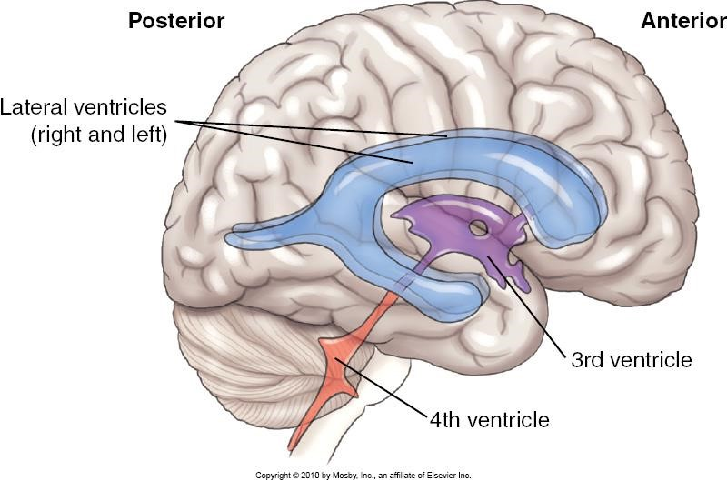

Bon
trager

9
^{th}

ed.

18
-
8

- Label the following on the diagram above:
lateral ventricles cerebral aquaduct fourth ventricle third ventricle
location of the pineal gland (mark it with a star)
- Which space do we draw CSF from during a lumbar puncture or spinal tap?
  - epidural space
  - arachnoid space
  - subarachnoid space
  - subdural space
- How is CSF returned to the blood?
- The spinal cord extends from:
  - foramen magnum to the hips
  - foramen magnum to diaphragm
  - foramen magnum to the first lumbar vertebra
  - foramen magnum to the fourth lumbar vertebra
- Where is the “epidural space”?
- Explain why it is safe to insert a needle into the subarachnoid space near the inferior end of the spinal cord.
- Which of the following is located most superiorly in the body?
  - medulla oblongata
  - pineal gland
  - diencephalon
  - corpus collosum

- Which of the following is located most inferiorly in the body?
  - lateral ventricle
  - third ventricle
  - thalmus
  - pons
- Which of the following is located most anteriorly in the body?
  - anterior horns of the lateral ventricles
  - midbrain
  - pons
  - medulla oblongata
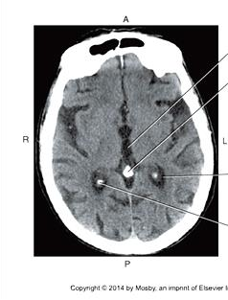
- Given what you know about the location of the ventricles of the brain, what ventricle is arrow “A” likely pointing to?
A

Bontrager
9
^{th}

ed.
18
-
3
6

