MRAD 358 – Clinical Integration 1
Fluoroscopy Review – Questions 1 - 29

- What structures must be demonstrated on an AP/ PA projection for a single contrast barium enema?

- Describe the Valsalva maneuver.

- What is the patient prep for an upper GI?

- How much, in what direction, and at what level, do we angle our tube for a routine image of the sigmoid colon on a prone patient?

- What are some reasons (indications) for the ordering of an esophogram?

- What instructions should be given to a patient following a barium exam?

- Why is it important for the patient to follow the preparation instructions prior to a barium enema?

- The purpose of double contrast exams of the stomach or colon is to better visualize __________.

- What is the patient prep for an esophagus /Barium Swallow?

- What position was the patient in for the image to the right? | 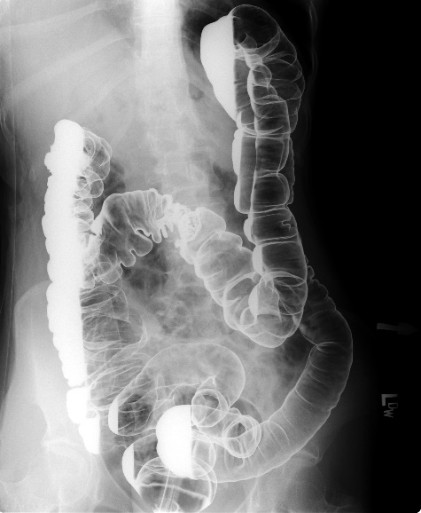

- Identify the anatomy on the image to the right: | 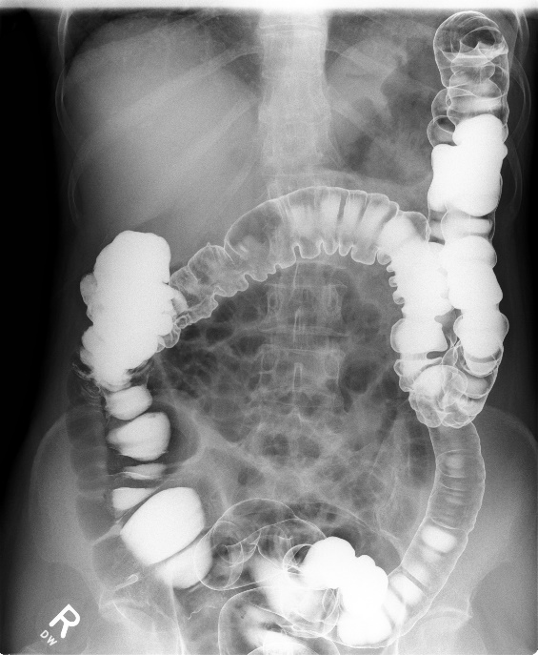  A  B  C  D  E  F  G  H  I

- What are the advantages to laparoscopic cholecystectomy?

- What position is the patient placed for a T-tube cholangiography?

- Identify the anatomy on the image to the right: | 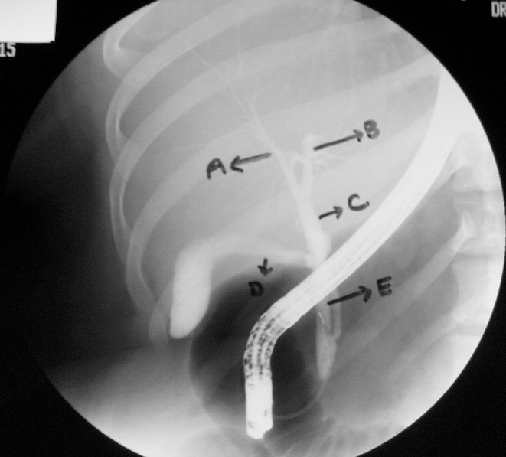

- List the reasons for performing a KUB ?

- List the major contraindications to injecting contrast?

- During an IVU, what are some things a technologist can do to move the contrast out of the kidneys and into the ureters?

- Identify the exams demonstrated by the following images:

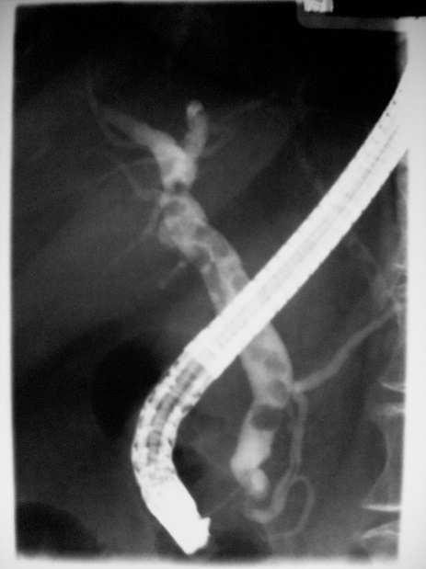  Image A |  | Image B  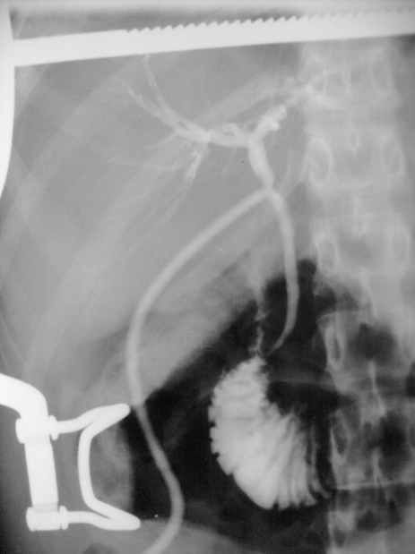 | Image D  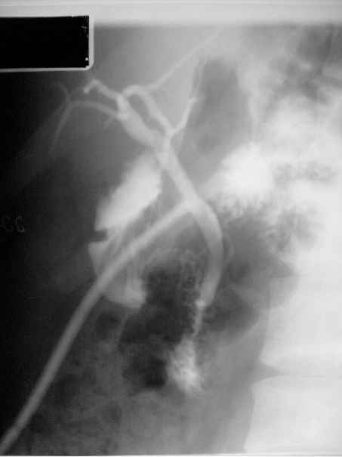

Image C  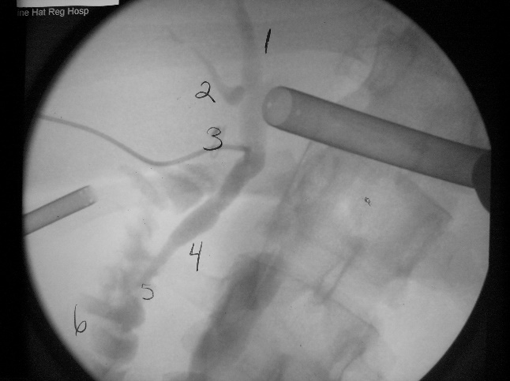 |  | Image E  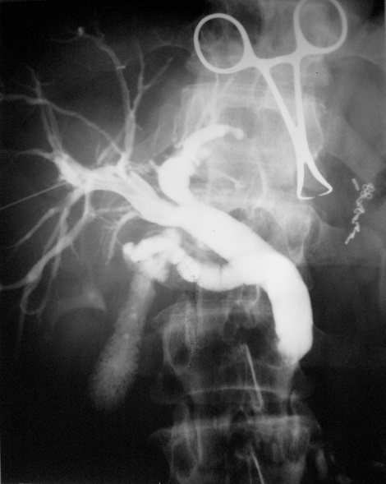

- What are some methods of stone removal?

- How is the CR directed for an AP projection of the bladder?

- Radiographically, what are we looking for during a hysterosalpingography?

- Identify the anatomy on the picture below:

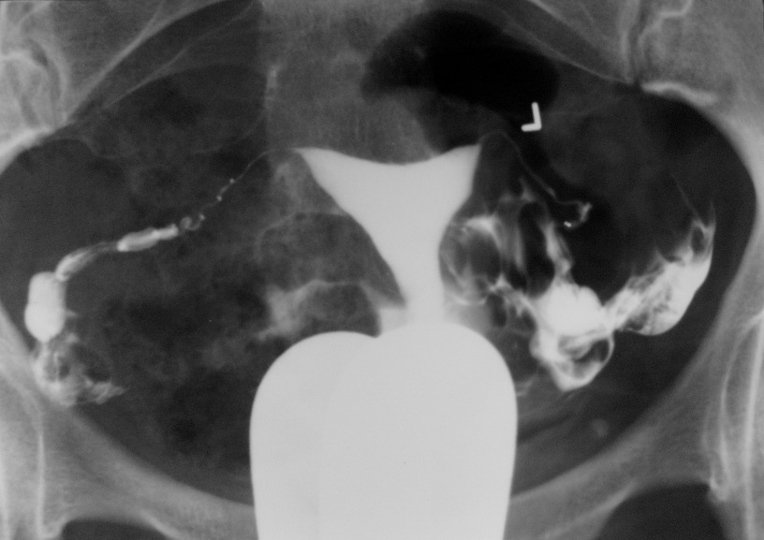
A
B
C
D
E

- Identify the anatomy:

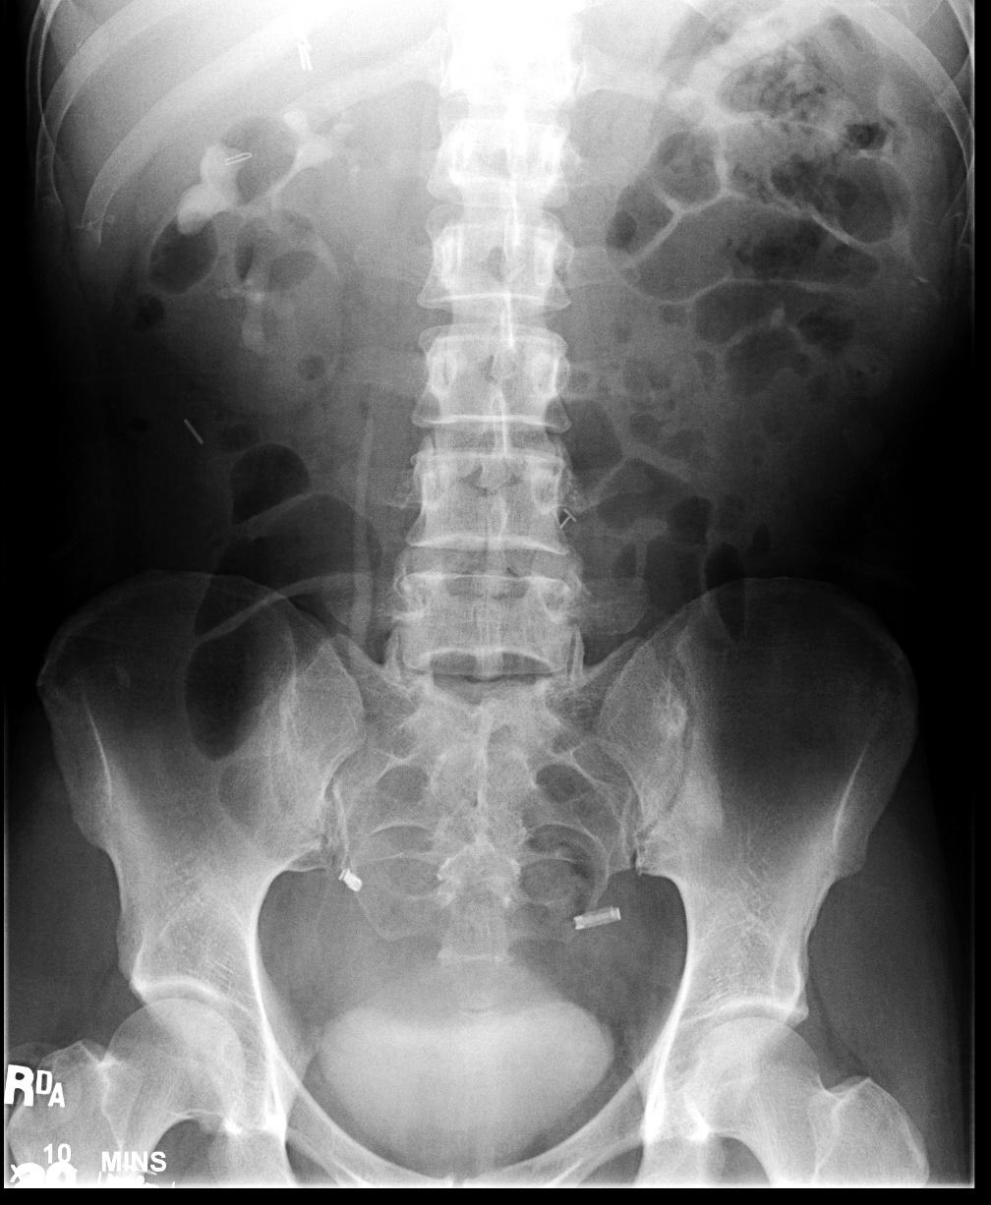
F A
A A
D A
C A
B A
E A

- What are the advantages of digital fluoroscopy over conventional fluoroscopy?

- Why does the dose to the patient increase when operating the image intensifier on magnification mode?

- What is the minification gain of a 10/5 dual field I.I. in regular and magnification mode?

- How would quantum mottle be corrected in a fluoro system that uses a set kVp and a variable mA ABC?

- If we were to decrease the size of the input screen on the I.I. from 23 cm to 15 cm what would result?

- If you increased the magnification, would the resolution be increased?

