Activity: Test 21 High-Contrast (Spatial) Resolution Procedure

Purpose
This activity will help you identify the procedure steps for this test.

Instructions
- Review the images below of the equipment and materials used at Edenbrook for this test.
- Review the procedure steps from the Edenbrook MRT lab.
- Compare the textbook readings and your practicum site QA manual for similarities and differences between a C-arm and dedicated fluoro unit.

Equipment
- High contrast resolution test tool

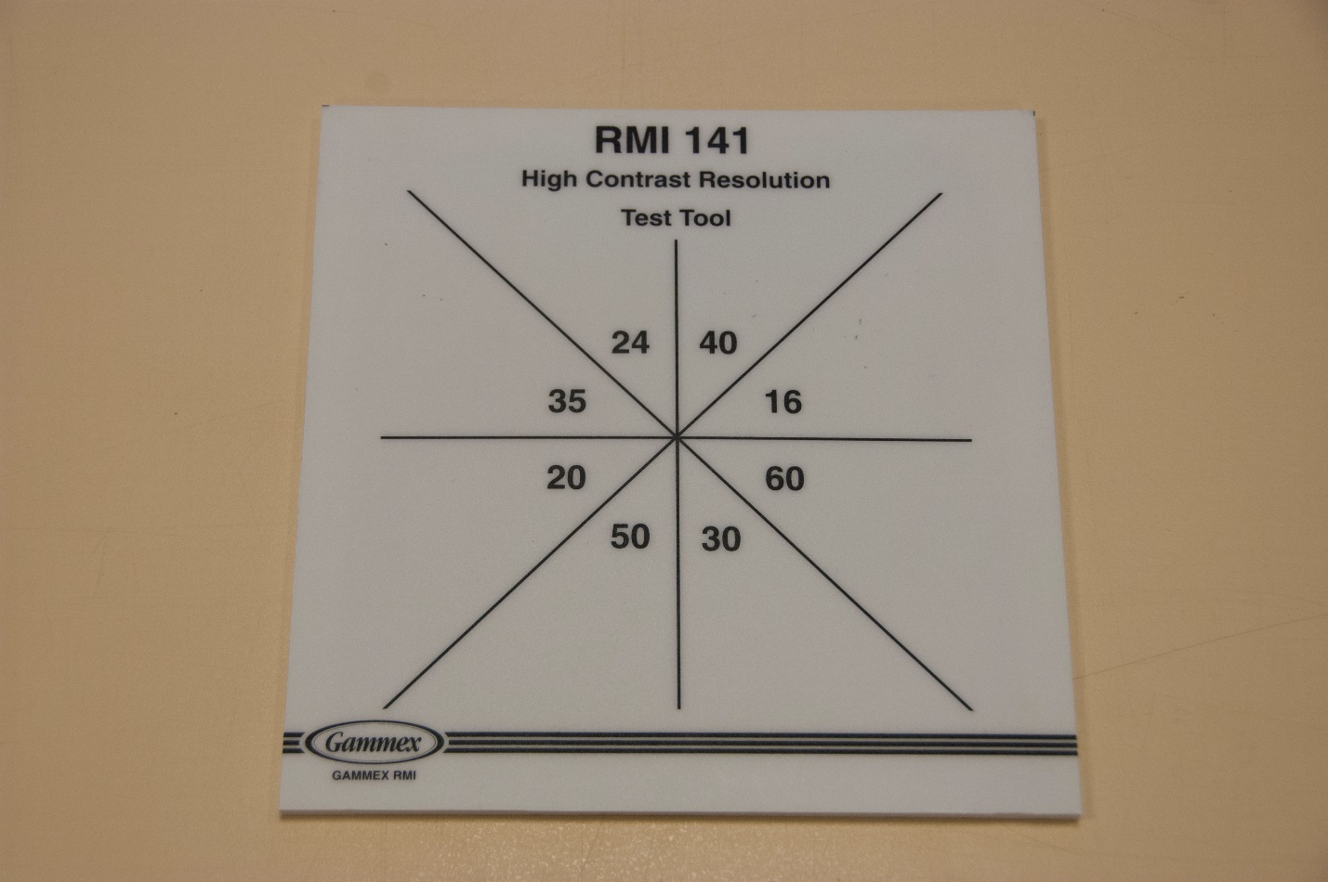

Edenbrook MRT Procedure Steps (Note: using C-arm at Edenbrook is limited by equipment)
- Position the C-arm with the image intensifier on the bottom.

- Centre the high-contrast test tool on the image intensifier and collimate appropriately to include the entire test tool.

- Using 100 kVp on the continuous fluoro setting, expose for 2 seconds and determine the highest numbered section that the lines that can be visualized. Record the results.

The image will look like this:
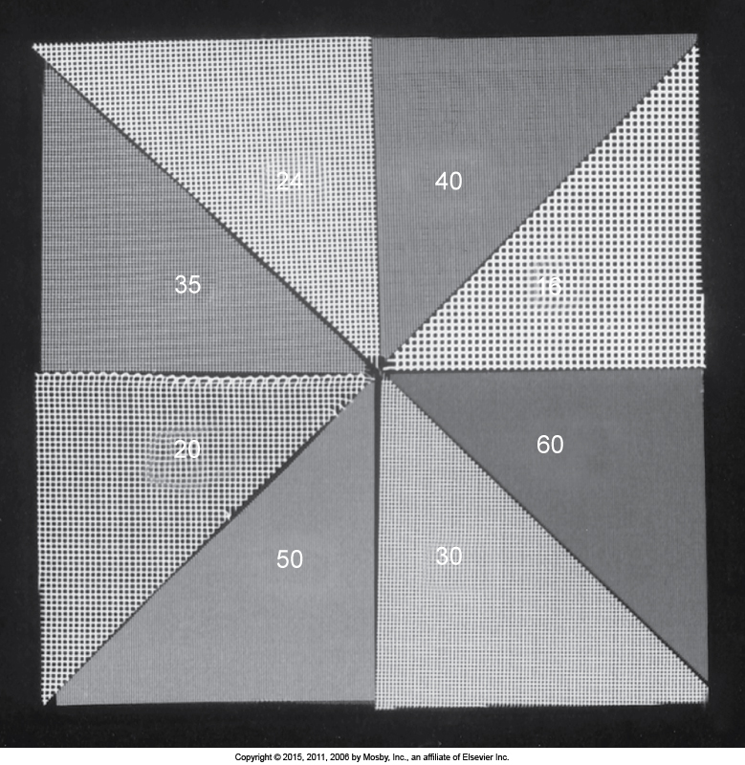

- Add one aluminum block onto the test tool and repeat the exposure. Record the results.

- Add the second block on top of the first and expose. Record the results.

- Repeat steps 3–5 on both magnification settings and record the results.

- Change the fluoro setting to low dose, repeat steps 3–5 and record the results.

