- a) Label the buttons seen on this detector control, using all of the terms provided.
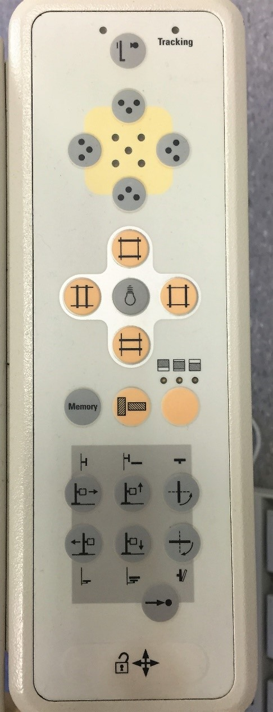
horizontally
1.
Tracking
2.
A
EC Indicator
3.
L
ight Field
4.
Collimators
5.
Moves detector position
6.
Moves the detector position
7.
S
econdary function
8.
A
ll locks release
9.
Adjusts the centering to
the detector
vertically
  - Circle which button(s) would need to be depressed if the detector was below the table and needed to be returned to the upright position quickly.
Must press the secondary function first, then the upright button (top left button that moves the detector horizontally)
  - If the detector crashed into the table, identify which button(s) would correct the error.
Pressing and holding the All Locks button down while physically pushing the detector down (away from the table). The detector will then automatically reset.
- Label the buttons seen on the following two control panels, using all of the terms provided.
- On button  - Off button  - APR button  - Focal spot selector | - AEC button  - kVp Readout  - Exposure/Rotor button  - Exposure/System ready | - mAs Readout  - AEC cell selector  - Detector selector
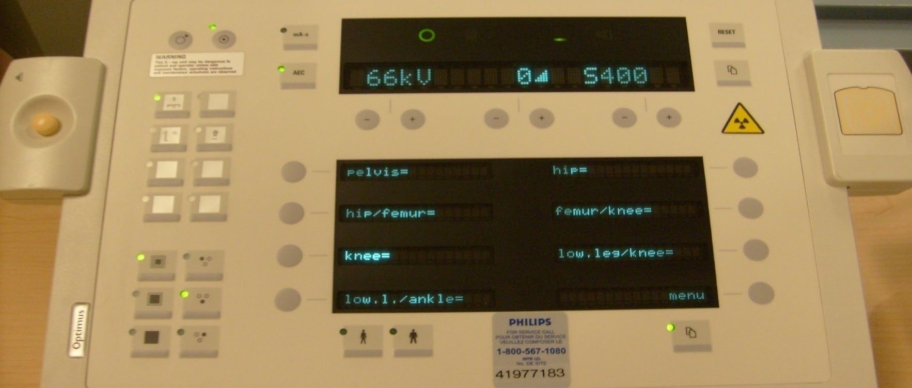
1.
On
2.
O
ff
3.
APR
4
.Fss
5.
AEC
6
.kVp
9
.mAs
.Exposure
7
.System Ready
8
10
.AEC
cell selector
.Detector selector
11
*Note: The “on” (1) and “off” (2) buttons, and the exposure/rotor button (7) are not displayed in this image.
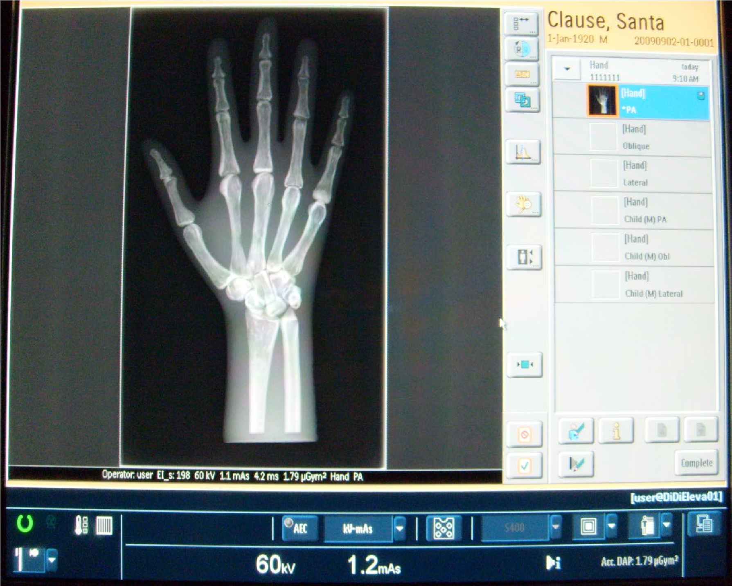
3.
APR
. Fss
4

5.
AEC
.kVp
6
9
.mAs
8
.System Ready
10
.AEC cell selector
11
.Detector selector
- a) Label the buttons displayed on the tube, using all of the terms provided.
- Collimation controls  - Light field only  - Light field/laser light  - Detector selector | - All locks release  - Transverse lock  - Vertical lock  - Angulation lock | - Rotational lock  - Longitudinal lock  - SID Readout  - Angulation Scale
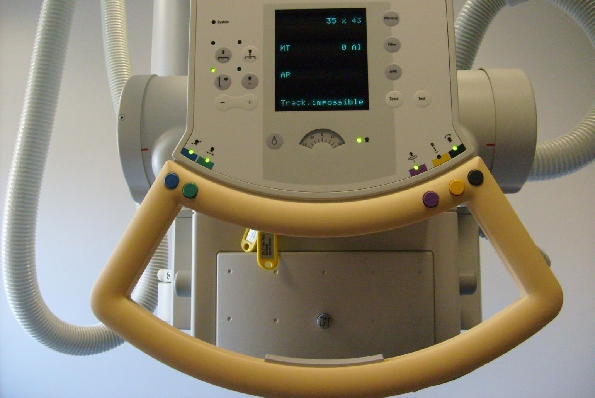
1.
Collimation Controls
2.
Light Field
3.
Light Field/Laser
4.
Detector
Selection
5.
All Locks Release
.Transverse lock
6
.Vertical lock
7

8
.Angulation lock
.Rotational lock
9
10.
Lo
ngitudinal lock

.SID Readout
11
12.
A
ngulation scale
  - Identify where the measuring tape could be found (if it where visible).
Behind and below the collimation controls, as shown in red.
  - Which end is the anode, and which is the cathode?
Left side of the image (Detector selection side) = Anode (+)
Right side of the image (Measuring tape side) = Cathode (-)
  - How many degrees of angulation does each increment (line) on the angulation
scale indicate?
15 degrees
- Label all the components seen in the image below.
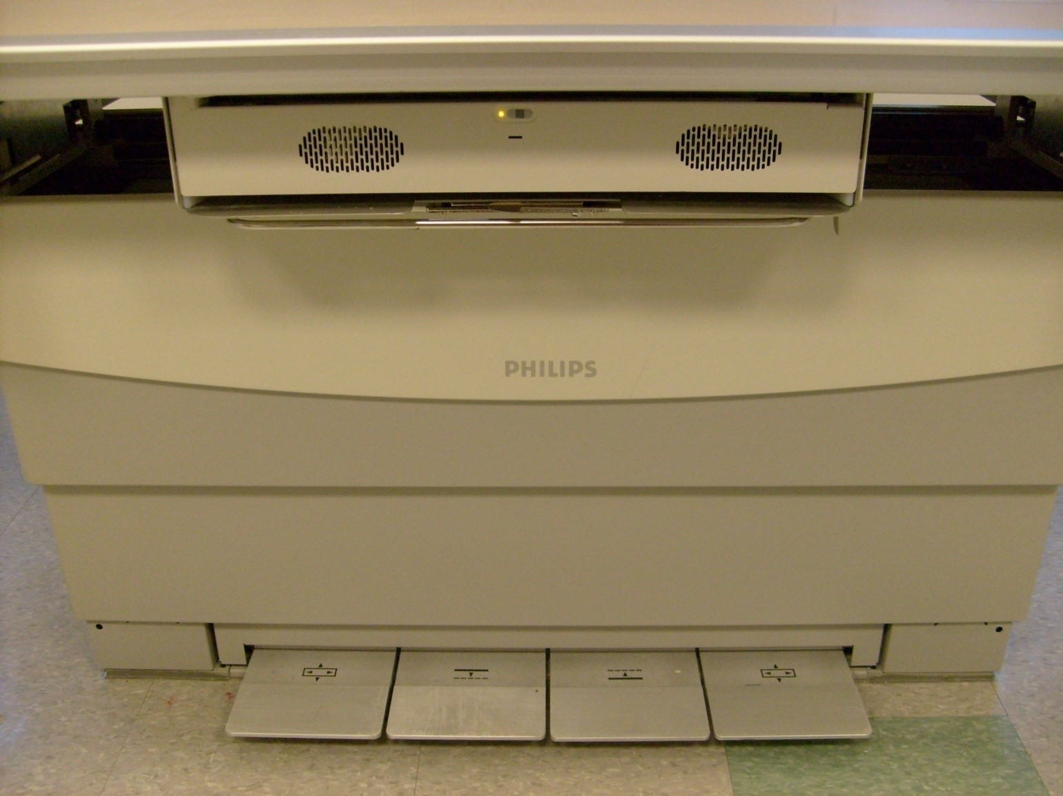
Detector Lock
Table Release/Float
Table Down
Detector Alignment Tool
Center of Detector Indicator

