INFC 215 – Infection Prevention and Control

Module Two: Interaction between Microbe and Host

Topic 2.6: Antibiotic Testing and Antibiotic Resistant Bacteria

Antibiotics
An antibiotic is defined as a substance, produced by a microorganism (often a fungus), which in small amounts inhibits the growth of, or kills, another microorganism (bacteria). The ideal antibiotic destroys the harmful microorganism without damaging the cells or tissues of the host.
The first antibiotic discovered was penicillin. It was first noted in 1928 by Alexander Flemming who discovered that mold (penicillium), growing on one of his culture plates, inhibited the growth of bacteria. It was not used clinically until 1940.
Different antibiotics act in different ways. For example, some inhibit cell wall synthesis, others inhibit protein synthesis or injure the plasma membrane of the bacterial cell.
Some antibiotics have a narrow spectrum of activity, meaning they are effective against a small group of bacteria. For example, some are effective only against gram positive bacteria; while others are effective only against gram negative bacteria.
Other antibiotics may be effective against a large group of microbes, usually gram positive and gram negative. These are called broad spectrum antibiotics.
A few bacteria have a predictable sensitivity pattern. For example, Pseudomonas is always resistant to the antibiotic ampicillin. Streptococcus pyogenes, the causative agent of strept throat, is always (so far) sensitive to penicillin.
However, for most bacteria, an antibiotic susceptibility test is required to determine if the microbe is sensitive or resistant to various antibiotics.

See a image of Penicillium Mold on a culture plate of Staphylococcus aureus:
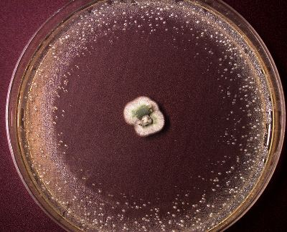
 | Description: This picture was taken from a tour bus in Oxford, England. The simple brick building behind the trees was where penicillin was used for the very first time on a patient in 1943. A momentous occasion that changed the treatment of infectious diseases.
Image 2.6.1: Hospital where penicillin was first used
Used with Permission: (© Courtesy SAIT, 2007)

Antibiotic Susceptibility (Sensitivity) Testing
Antibiotic Susceptibility (Sensitivity) testing is carried out in the laboratory to aid the physician in choosing an antibiotic for treatment.
The organism is first isolated and identified, then a susceptibility test is performed buy spreading the organism evenly over the surface of an agar plate. Paper discs soaked in various antibiotics (indicated by abbreviations on the disc) are then placed on the plate, which is incubated over night.
The plate is examined, results recorded, interpreted and reported to the physician who determines which to use in treatment.
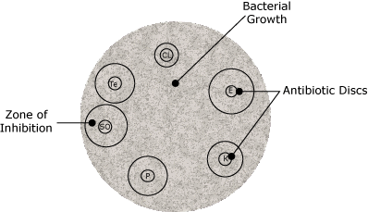
Figure 2.6.1
A clear area around a disc indicates that the organism is susceptible (sensitive) to it. If the bacteria grow right up to the disc, it is resistant (insensitive) to that antibiotic and it should not be used.
Results of Sensitivity Testing:
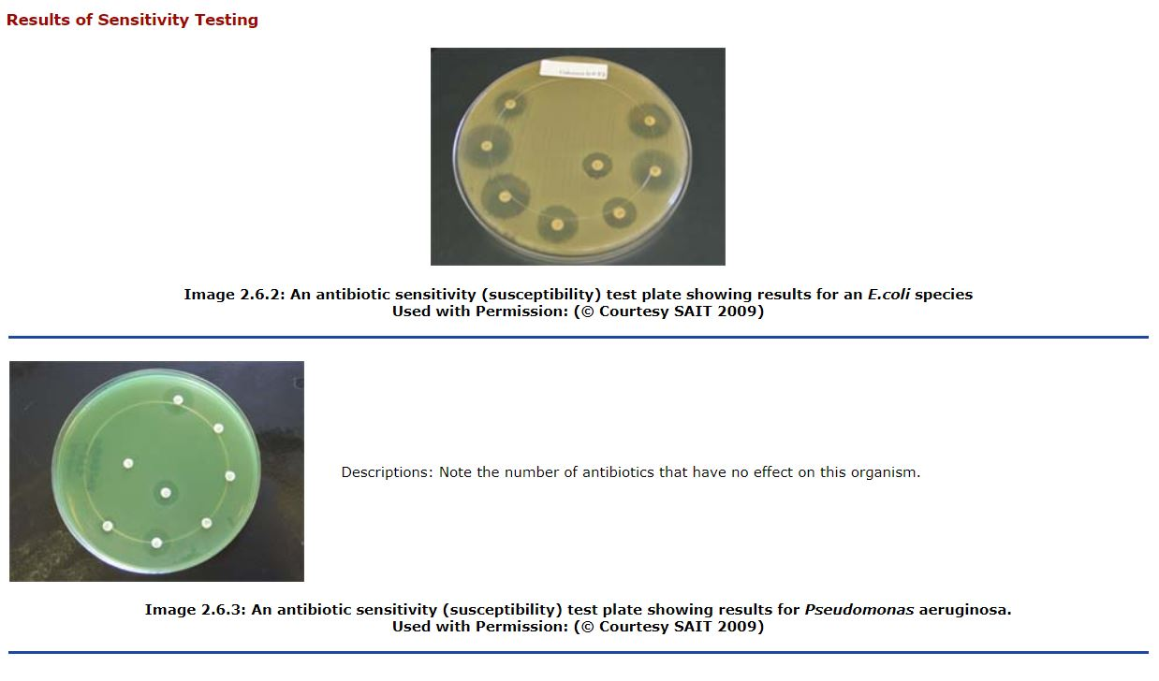

Antibiotic (Drug) Resistant Bacteria (ARO’s)
- Also called Antibiotic Resistant Organisms (AROs)
- Also called Multidrug Resistant Organisms (MDROs)
All of the above terms are used to describe organisms that have drug resistance patterns that severely limit the choice of effective antibiotics.
Drug-resistant bacteria are bacteria that were previously treatable by the best antibiotic available (e.g., penicillin), but have now become resistant to that drug. Treatment is now required with alternate (second-choice) antibiotics. This often presents problems because these drugs are not always as effective and may be more toxic and more costly. Patients with infections caused by these bacteria must be isolated in the health care facility and precautions must be taken so the organisms do not establish a foothold in the institution.
Among the drug-resistant bacteria causing the most alarm in health care facilities are methicillin-resistant Staphylococcus aureus (MRSA) and vancomycin-resistant Enterococcus (VRE). These strains of bacteria have been dubbed “super bugs” by the media, but they are no more virulent than regular Staphylococcus aureus or Enterococcus. However, infections with these bacteria are more difficult and expensive to treat. Clostridium difficile has also recently been termed a super bug.
box 1
Other examples of drug-resistant bacteria, some of which require special isolation precautions:
- Streptococcus pneumoniae: This organism is a common causative agent of bacterial pneumonia. In the past, infections could be successfully treated with almost any antibiotic, although penicillin was the drug of choice unless the patient was allergic. By the 1990s, strains of the organism emerged that have outwitted not only penicillin and penicillin-type drugs, but several other antibiotics as well.
- Neisseria gonorrhoeae: Gonorrhea is increasingly difficult to treat, having acquired wide-spread penicillin resistance during the 1970s. In the 1980s several strains developed tetracycline resistance as well. In the 1990s it was recommended that a combination of two antibiotics be used to treat gonorrhea, one of which was considerably more expensive, available only in injectable form, and a sulfa drug to which many people are allergic.
- Mycobacterium tuberculosis: One of the usual drugs for treating tuberculosis is INH (isoniazid), however, INH-resistant strains are becoming increasingly common. In 2007 an American patient was found to have Extremely Drug Resistant Tuberculosis (XDR) tuberculosis.
- VRSA: Vancomycin Resistant Staphylococcus aureus.
- GISA: Glycopeptide (Vancomycin) intermediate resistant Staphylococcus aureus.
- Extended Spectrum β lactamase (ESBL): Gram negative organisms that have a specific type of resistance to third generation cephalosporins.
- Pseudomonas: Most Pseudomonas strains are normally resistant to many antibiotics but the emergence of even more resistant strains is creating a problem in health care settings.
- MBL Pseudomonas – (metallo-β-lactamase producing strain).
- Highly Resistant Pseudomonas.
- AMP C: Organisms that are more resistant to the usual antibiotics due to the presence of a plasmid transferred Beta lactamase enzyme. There have been recent increase in these strains of E. coli causing urinary tract infections in older women.
Bioterrorism organisms are also a concern since 9/11. E.g., anthrax, smallpox.

Modes of Resistance
Some organisms are naturally resistant to certain antibiotics, while being susceptible to others.
Factors that contributed to the development of drug-resistant bacteria include:
- Over-prescription of antibiotics: More than 26 million prescriptions are written for antibiotics in Canada every year. Many of them are given for any hint of infection, whether it is proved to be bacterial in nature or not. Patients often demand antibiotics for colds, flu and sore throats that are caused by viruses against which antibiotics have no effect. When bacteria are continually faced with antibiotics, they become genetically tougher and resistant strains develop. Enzymes may evolve that can inactivate an antibiotic. For example, Penicillinase can break bonds in the penicillin molecule, rendering it useless.
- People often stop taking antibiotics when their symptoms fade but before all the bacteria are killed. This has led to survival of the strongest bacteria which have the best defenses.
- Mutation: When a colony of bacteria is treated with an antibiotic, most of the microbes are killed. Sometimes, however, there is a microbe with a mutation that makes it resistant to the drug. Antibiotics attack harmless microbes as well as harmful ones. Some resistant mutations occur spontaneously.
The diagram below illustrates how a resistant mutant can develop in to a colony of antibiotic resistant organisms.

Figure 2.6.2
- Conjugation: Drug resistance from harmless bacteria may be transferred to harmful microbes. One microbe attaches itself to another and a tube is opened between them in a process called conjugation. A copy of the genes that make the microbe resistant can then be passed from one to the other. An illustration of conjugation is shown in the figure below.
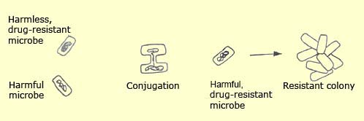
Figure 2.6.3

How do you know which antibiotic is effective?
Laboratory testing will indicate the antibiotics which may be effective for a particular patient.
Development of Antibiotic Resistance for Some Types of Staphyloccus aureus.

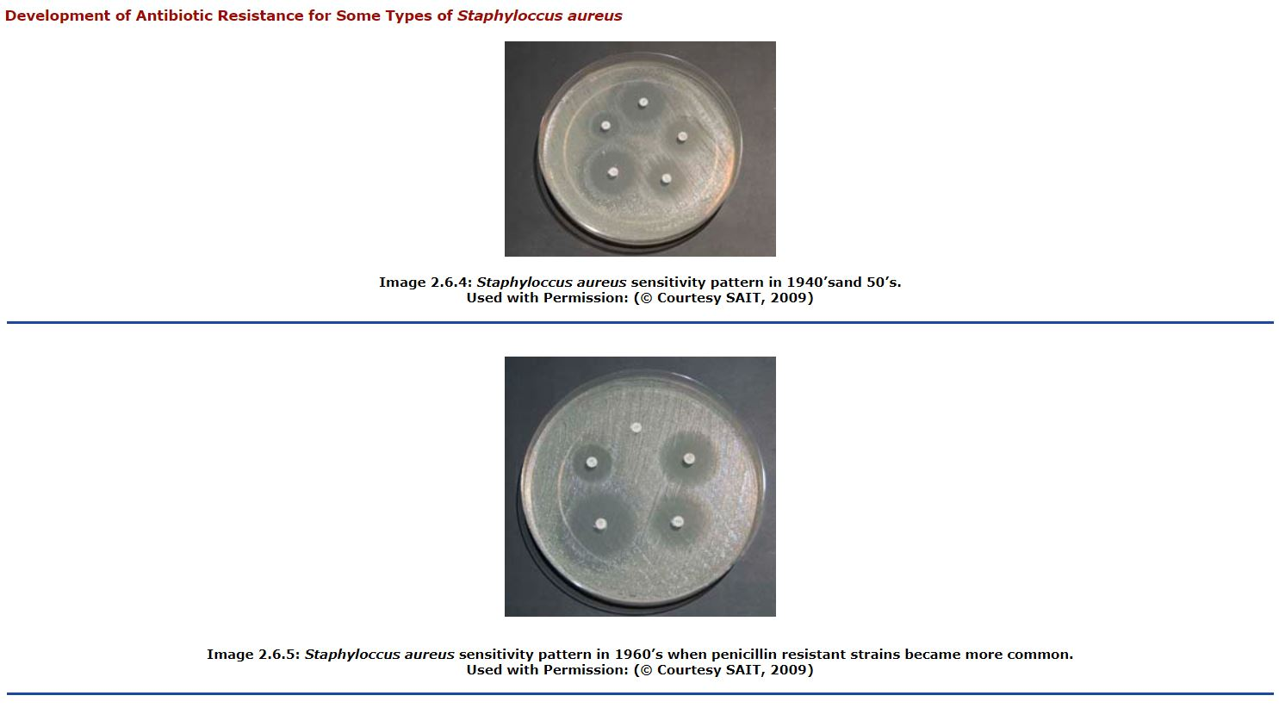

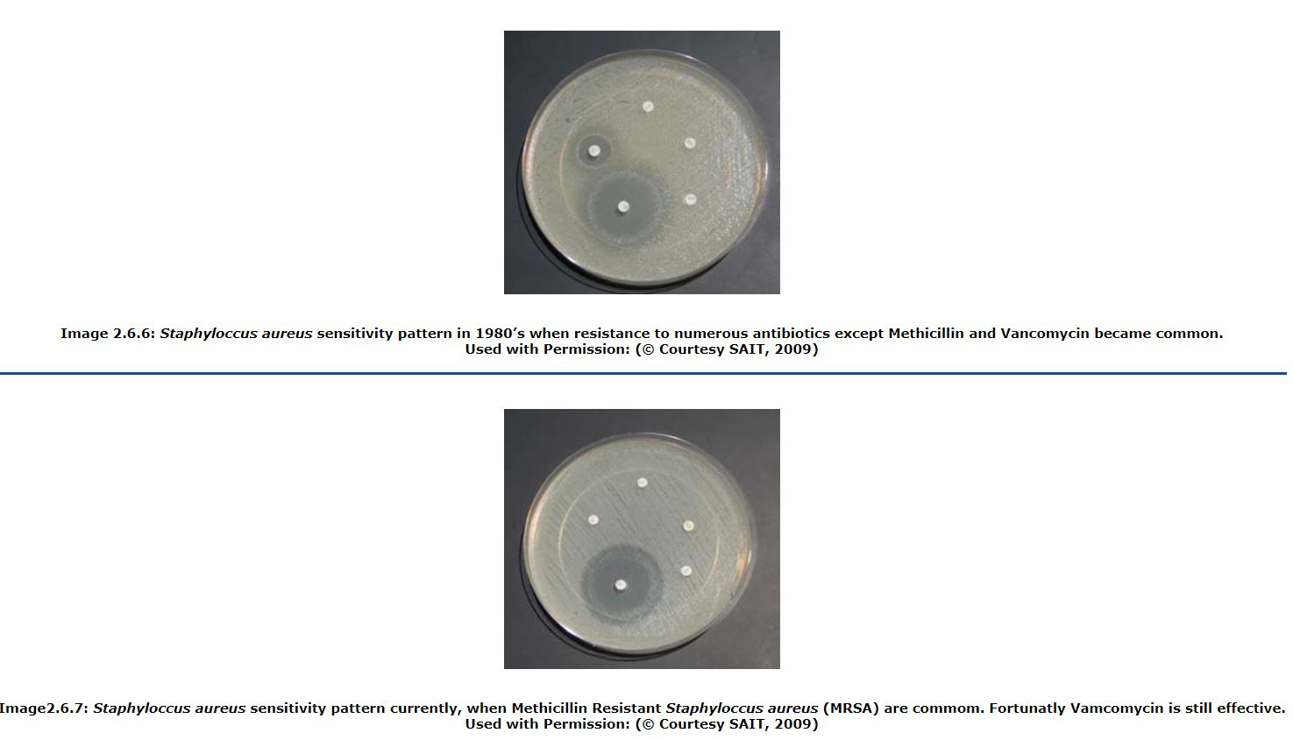

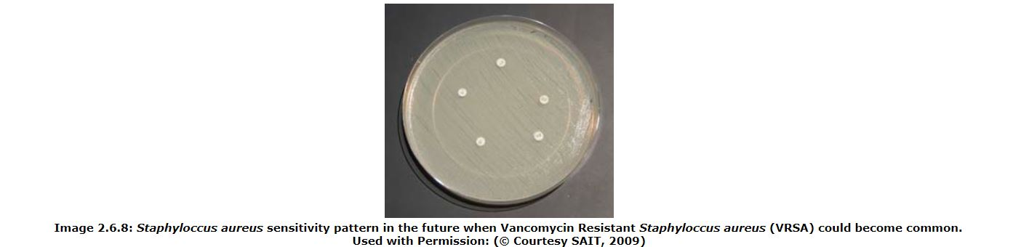

Examples of antibiotic resistant organisms (Super Bugs MRSA, VRE and C difficile)
Examples of bacteria commonly called “super bugs”, because they have a limited number of treatment options, include MRSA (methicillin Resistant Staphylococcus aureus and VRE (Vancomycin Resistant Enterococcus ) and C difficile.
Staphylococcus aureus is a common cause of a variety of infections such as cellulitis, skin abscesses and post-operative incision infections. It can also be harbored without causing disease in the nasal passages. MRSA is a strain of Staphylococcus aureus that is resistant to a number of antibiotics including methicillin.
Currently, most MRSA is spread in hospital or health care settings (called HA MRSA), though some spread in community settings does occur and is on the increase (called CA MRSA). Transmission is almost entirely by direct contact.

Why should we try to prevent the spread of MRSA in a health care facility?
Experiences in United States hospitals, where MRSA is widespread, have shown that once established, MRSA is difficult to eradicate from an institution. This results in increased patient mortality (death), morbidity (illness), length of stay and cost of care.

How can we prevent MRSA from being introduced and spread in a health care facility?
- Identify cases - screen all patients who enter a health care facility, by collecting nasal and rectal swabs.
- Isolate cases - a single room is preferable, but if not feasible, an individual who is infected/colonized with MRSA can be cohorted (placed in the same room as other individuals with MRSA). Special isolation precautions apply.
- Identify carriers amongst patients and staff - test patients and staff who have been in contact with a case prior to appropriate isolation. This is easily done by obtaining and culturing a nasal swab.
- Eradicate MRSA from carriers - this is usually accomplished by a course of intranasal mupirocin (Bactroban), use of disinfectant soaps and special home laundering precautions. Special ‘decolonization’ clinics have been set up for non hospitalized patients.

Will I be asked to leave my job if I am found to be an MRSA carrier?
Decisions regarding work status are made on a case-by-case basis. A health care worker, who is thought to have spread MRSA, may be asked to abstain from direct patient contact until eradication is achieved.¹
One of the most disturbing prospects for physicians world-wide was the emergence around 1988 of vancomycin-resistant Enterococcus. There was, and still is, great concern that these resistant enterococci could share their resistance genes with other microbes, including MRSA. If this happens, there would be few options left for treating staph infections. Transfer of vancomycin-resistance from Enterococcus to Staphylococcus has been done experimentally, so scientists know the microbial species are capable of such a feat. In July 2002, the first case of vancomycin-resistant Staphylococcus aureus was isolated from a patient in Michigan. Fortunately, in this case, there were other antibiotics that destroyed her particular strain of the organism. There have not been any documented cases since that time.

The worry is that a bacterial strain will develop that is resistant to all known antibiotics.
box 1
Using genetic finger-printing techniques, a team of researchers from the New York City Health Department discovered that all MRSA bacteria descended from a strain that first emerged in Cairo, Egypt, in 1961. By the end of that decade, the strain’s descendants could be found in New York, New Jersey, Dublin, Geneva, Copenhagen, London, Kampala, Nairobi, Ontario, Halifax, Winnipeg and Saskatoon. A decade later, they were seen planet-wide.
Garrett, L. (1994). The coming plague: Newly emerging diseases in a world out of balance. New York: Penguin Books.

What is Vancomycin Resistant Enterococcus (VRE)?
Enterococcus is a bacterium found as normal flora in the bowel. If it causes an infection, it is likely to be a nosocomial urinary tract infection or septicaemia, particularly in the elderly or patients whose immune systems are compromised. It is a low-grade pathogen and does not pose a threat to healthy individuals. Vancomycin-resistant strains of Enterococcus are often resistant to almost all available drugs, so if a patient has an infection with one of these strains, it may be untreatable and potentially fatal.
box 1
Amplification of VRE in a Health Care Facility
When antibiotics known as third generation cephalosporins are used to treat an infection in a patient, they will effectively wipe out gram negative bacteria - both pathogens and normal flora - which allows gram positive Enterococci to flourish. The patient is now heavily colonized with an overabundance of Enterococci - some of which are potentially resistant to vancomycin.
Like MRSA, most VRE is spread in hospital or health care settings. Transmission is by direct contact or indirect contact through contaminated equipment such as thermometers, stethoscopes, blood pressure cuffs, call buttons, telephones and computer keyboards. (Enterococcus can withstand variable degrees of heat and drying and can survive up to 7 days on surfaces.)
To control the spread of VRE in an institution, it is vital to restrict antibiotic use (vancomycin and certain other antibiotics that allow enterococci to proliferate) and employ rigorous hygienic measures including hand washing and decontamination of everything in the environment of the patient who is colonized with VRE. Patients with VRE are placed in isolation with special precautions.
Patients are screened for MRSA and VRE by collecting and culturing a nose and rectal swab. Open wounds and draining sites are also cultured. Patients and visitors are taught proper hand hygiene. If the culture(s) are positive, then the patient is placed in an appropriate room and isolation precautions are instituted. If the patient is known to be positive, precautions are instituted immediately. Always check in IPC (Infection Prevention and Control) manual for your institution.

What is Clostridium difficile (CDAD)?
It is a spore forming organism that can be found in the normal intestine, where it does not generally cause a problem. However, in some cases, particularly following antibiotic therapy with Vancomycin, the normal flora of the intestine is disrupted, which allows the spores to vegetate. These vegetative organisms produce a toxin which affects the intestinal wall with a range of responses from mild (toxic megacolon) to severe (ileus) and even death, particularly in the elderly. The primary symptom is watery unformed stools. This is sometimes called Clostridium difficile associated diarrhea (CDAD). Alcohol hand rubs may not be effective against the spores. Hand washing with disinfectant soap and water is recommended- especially during outbreaks.
¹Wiens, R. & Taylor, G. (1997, June). Infection Prevention and Control Newsletter, Foothills Medical Center/UAH. Vol.3, no.6

