INFC 215 – Infection Prevention and Control
Module One: Characteristics of Microorganisms

Topic 1.3: Viruses

Viral Characteristics
Viruses are very different from bacteria. Two of the most distinguishing characteristics are:
- They are obligate intracellular parasites and only multiply when inside a living host cell. They have no ability to reproduce when outside the host cell. Viruses cannot multiply in the non-cellular environment and do not grow in foods, water, bacterial culture media or medications.
- They contain a single type of nucleic acid, either deoxyribonucleic acid (DNA) or ribonucleic acid (RNA). All other forms of life contain both types of nucleic acid.
Viruses possess a protein coat that surrounds the nucleic acid. Some viruses also have an envelope composed mainly of lipids that surrounds the coat while others have spikes protruding from the lipid envelope. Lipid viruses are generally easier to inactivate with disinfectants. Hepatitis B is an exception, as it is an enveloped virus that is quite resistant to destruction. It may still be infective in dried body fluids for seven days.
Figure 1.3.1 shows the general structure of a naked (unenveloped) virus and an enveloped virus with spikes.
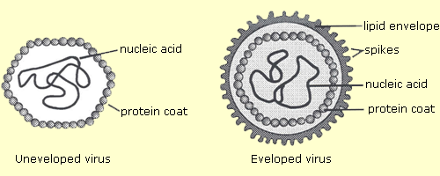
Figure 1.3.1

Multiplication of Animal Viruses
In order for a virus to multiply in a host, it must attach to complementary receptor sites on the surface of the host’s cells. For the adenoviruses that cause colds, the complementary sites are located on epithelial cells of the respiratory tract, while the virus that causes AIDS attaches to receptor sites of specific white blood cells called lymphocytes.
Once attachment has taken place, the virus is taken into the host cell by endocytosis during which the cell’s membrane folds inward forming a vesicle containing the virus. As the host cell attempts to destroy the contents of the vesicle, the outer protein coat is digested and the nucleic acid released inside the host cell.
The stage is now set for replication of new viral material using the enzymes and metabolic pathways of the host cell. The viral nucleic acid carries the genetic coding for new viral material and directs the synthesis of viral parts. Most DNA viruses replicate DNA in the nucleus of the cell and replicate proteins in the cytoplasm. The proteins move to the nucleus and are joined with the DNA, ready for movement out of the host cell. Lipids and other viral components may be added as the virus particle is released from the host cell.
Influenzae A viruses are responsible for pandemic flu outbreaks, which often rapidly spread world-wide and cause a great number of deaths. They are dangerous because they mutate quickly and often. Individuals do not have immunity to them and it is difficult to produce appropriate vaccines in time to protect large numbers of people. Examples of influenza A (H1N1) virus outbreaks include the 1918 Spanish flu epidemic, the Asian flu (H2N2) outbreak in 1957-58 and the Hong Kong flu (H3N2) of 1968-69. The spring of 2009 saw an outbreak of H1N1 swine flu. The is also concern about a possible Avian flu.
You can keep up to date by checking the Health Canada website for information.
Influenza B and C Viruses cause local outbreaks. They are generally less severe with a lower mortality rate than influenza A virus outbreaks.
Colds are not caused by flu viruses. The majority are caused by rhinoviruses. Symptoms of the common cold include sneezing, runny nose, nasal congestion, scratchy or sore throat, coughing, headache and fatigue.
Influenza symptoms are more severe with a rapidly rising fever, chills, body and muscle aches.
Figure 1.3.2 shows the multiplication of an adenovirus (the type of virus that causes respiratory infections). Many other types of viruses replicate in a similar manner.
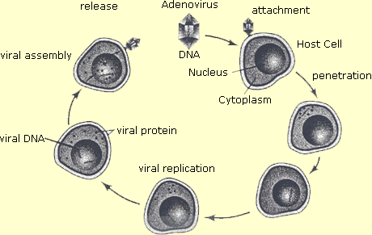
Figure 1.3.2

Effects of Viruses on Host Cells
- Infection of a host cell with virus usually kills the host cell due to:
- Lysis of the cell when it fills with virus particles
- Diversion of the cell’s metabolic pathways to the manufacture of viral particles
- Destruction of the virus-infected cell by the lymphocytes of the cellular immune system. This may be destructive to the host if the cells are vital for survival, as sometimes happens with liver cells infected with hepatitis B virus.
- A few viruses are able to alter the nucleic acid of the host cell in such a way that the cell is transformed to a tumour cell. These viruses are called oncogenic viruses. Hepatitis B is considered an oncogenic virus because it is associated with liver cancer.
Infection with Viruses:
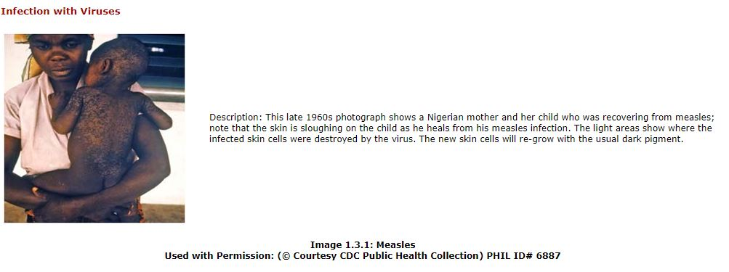

Control of Viruses
Antibiotics have no effect on viral replication. This is because antibiotics are directed against metabolic pathways of bacteria. Since viruses have no metabolic activities of their own, antibiotics provide no antiviral activity.
Many drugs that would inhibit replication of viruses cannot be used because they would destroy the host cells. However, there are a few useful antiviral drugs. Acyclovir is well-known as a control measure for genital herpes and Zidovudine (ZDV) is useful in controlling the rate of replication of the AIDS virus. Research into antiviral agents is especially active today in the search for a drug to treat AIDS patients.
Immunization is also effective for many viral diseases.

