Activity: Test 9 Radiation Leakage Procedure

Purpose
This activity will help you identify the procedure steps for this test.

Instructions
- Review the images below of the equipment and materials used at Edenbrook for this test.
- Review the procedure steps from the Edenbrook MRT lab.
- Compare your practicum site QA manual for similarities and differences.

Equipment
- Dosimeter and wand
- Lead sheets and lead apron
- Tape measure
- Calculator

View of set-up from above (i.e., from ceiling)

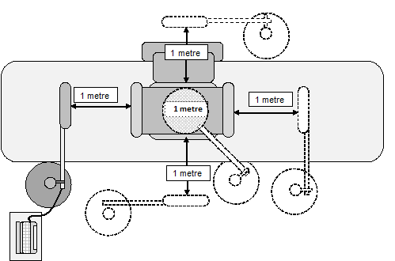

Edenbrook MRT Procedure Steps
- Move the detector away from the tube.

- Place a lead apron on the table. Close the collimator shutters and bring the tube down directly onto the lead apron.

- Secure the dosimeter wand/paddle on a stand at the anode end of the tube at a distance of 1 metre.

- Set 100 kVp and 200 mA and take exposure.

- Repeat step 4, each time moving the probe to the areas specified by the diagram.

- Take a total of 5 exposures, one each with the probe on all 4 sides of the tube and one from 1 metre above. Record any readings you get.

- Finally, raise the tube just high enough to fit the dosimeter wand underneath. Take an exposure and record the result as the primary mR.

