CT Theory
Introduction to
CT Scanning

MRT Program Anderson College
©© 2201016,6, SSAAITIT PPololyytectechnhniicc

Course Objectives
- Apply your knowledge of anatomy to cross-sectional images.
- Build your knowledge of relational anatomy.
- Identify anatomical structures on CT images.
- Learn about CT imaging techniques and prepare to perform CT procedures in clinical practice.

Course Objectives
- Outcome-based learning
  - In clinical practice, time spent in CT
  - Perform exams, achieve clinical competence for basic, entry-level procedures
  - Use textbooks as a guideline, but clinical practice always varies based on
Radiologists’ preferences

- Course Structure
  - In D2L you’ll find:
    - Textbook readings
    - Power Points and accompanying presentations
    - Separate Anatomy & Procedure presentations (for most modules)
    - Additional web-based anatomy learning activities
    - Anatomy worksheets
    - CT Procedures case studies
    - Additional Review worksheets before assessments
    - All answer keys will be posted!

- Check D2L newsfeed often
- Check email often
- Check the course schedule and make note of:
  - Review Class dates (via Blackboard) – bring a second device like a smartphone or tablet
  - Exams
- The following app is strongly recommended…

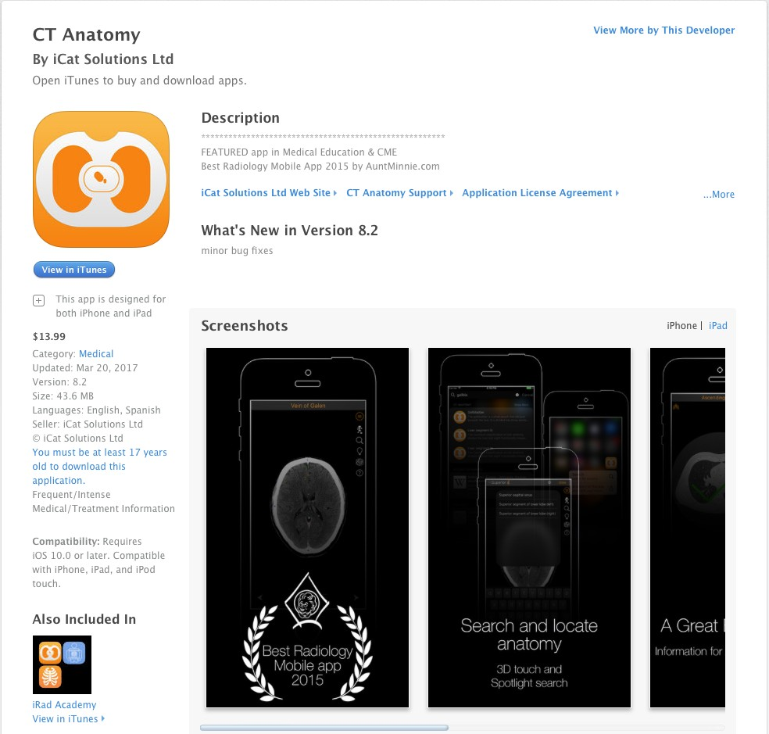

Module Objectives
- Review planes of the body and CT terminology
- Viewing CT images
- A CT procedure: start – finish
- Review important elements of a CT protocol
- Patient communication & preparation
- Post-Processing CT images

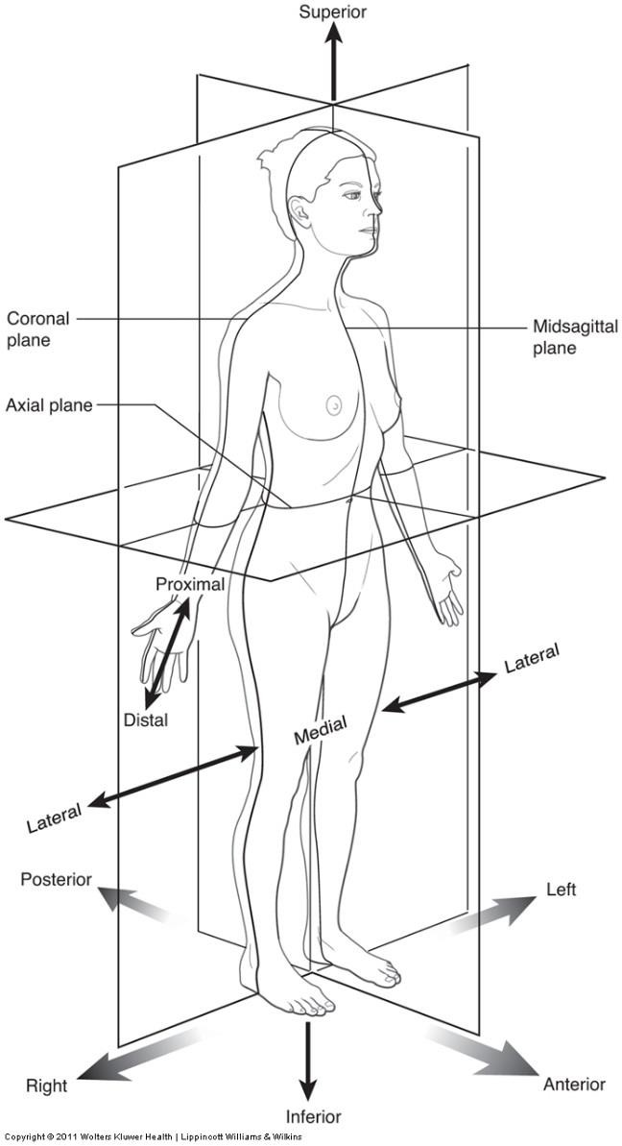
  - Superior / Cephalad
  - Inferior / Caudad
  - Medial
  - Lateral
  - Anterior
  - Posterior

© MRT Program

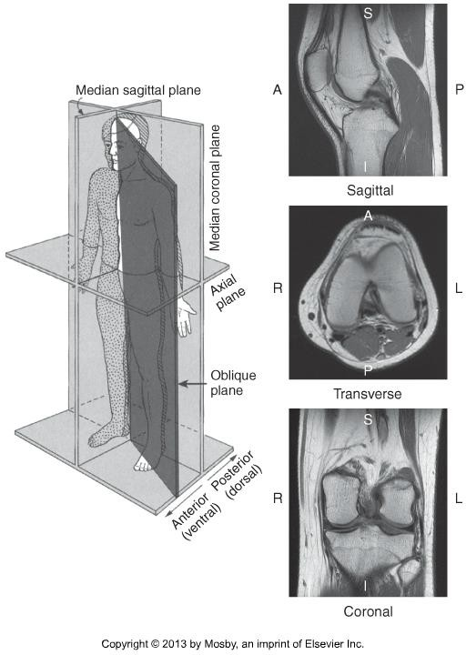

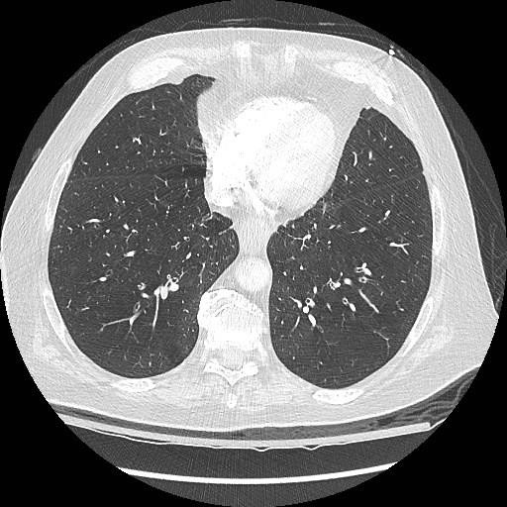
•

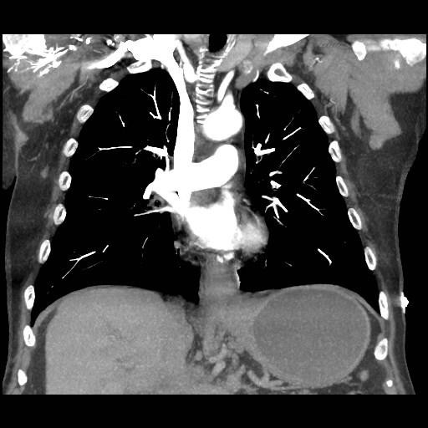
•

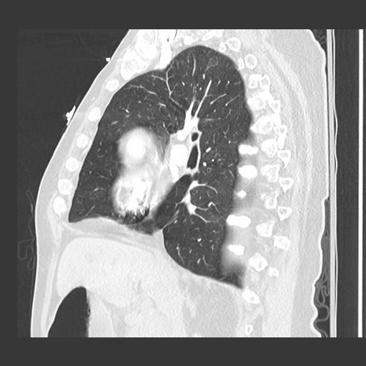
•

Right
Left

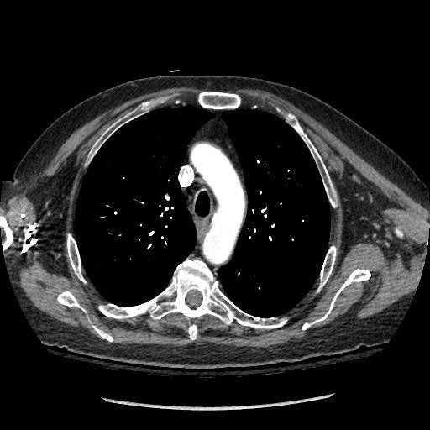
Posterior

A CT Procedure start – finish
- Patient and/or requisition arrives. Assess clinical information and
“protocol” is assigned
- Patient is prepared for appropriate protocol
  - Lab work, suitability for contrast protocol
  - Previous exams, any artifacts?
  - Communication & consent
  - Prepare for IV contrast administration (if applicable)

A CT Procedure start – finish
3. Position patient in CT scanner and select correct CT procedure

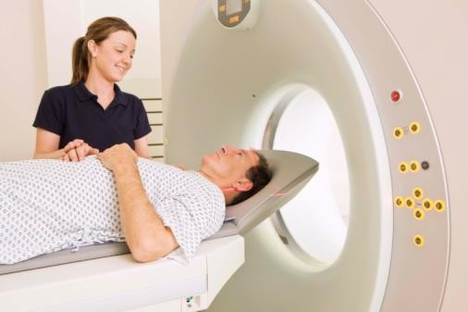
Image Source: https://www.phillymag.com/be-well-philly/05/08/new-heart-disease-screenings/

A CT Procedure start – finish
- Position patient in CT scanner and select correct CT procedure
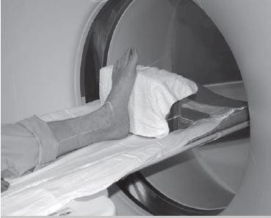
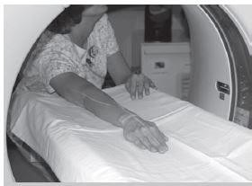
Image Source: http://www.radtechonduty.com/

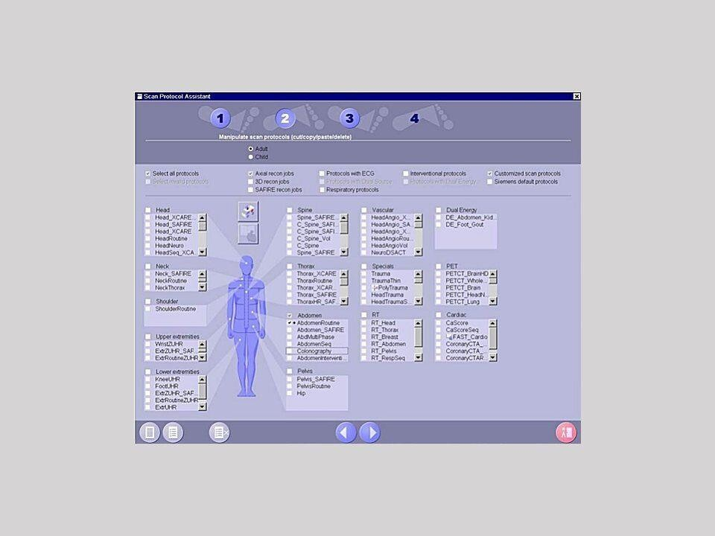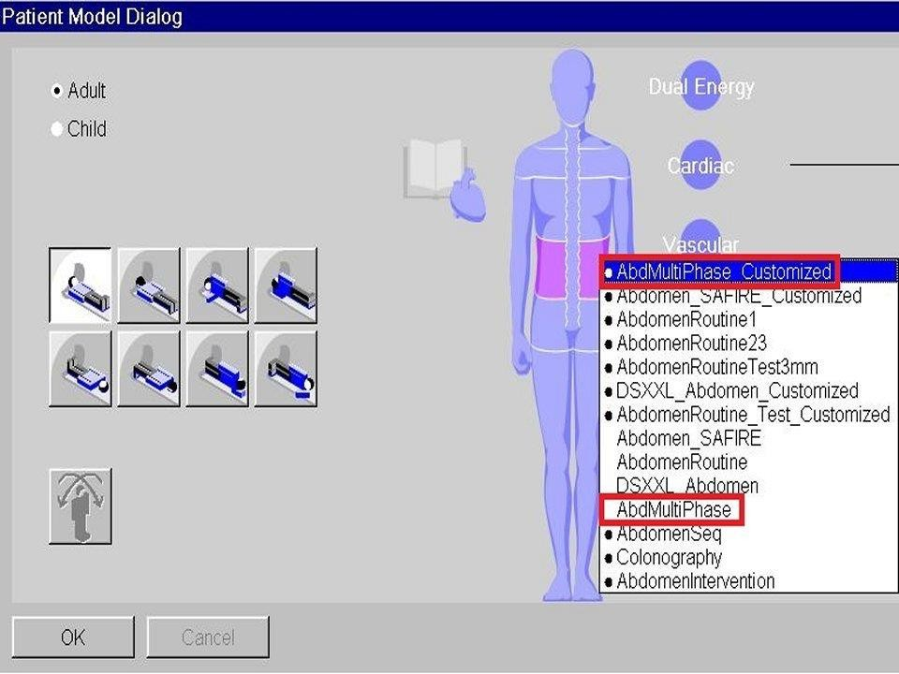

Image Source: https://www.healthcare.siemens.com/computed-tomography/

- Acquire the Scout Image
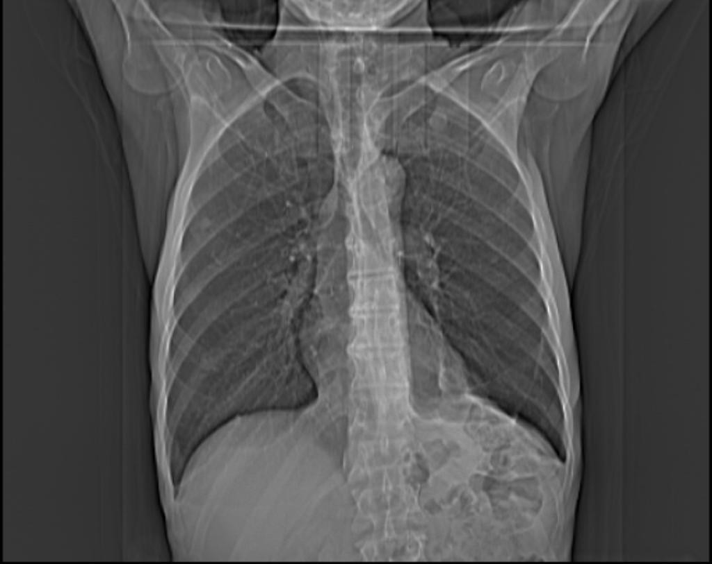
Image Source: https://radiopaedia.org/cases/16292/studies/15969

- Use the scout image(s) to set up scan parameters.

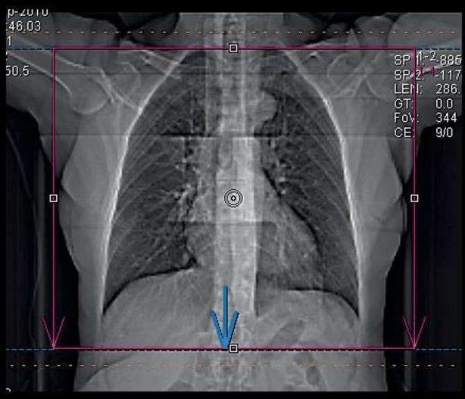

- Perform the scan, including contrast administration, if required.
- View images, and ensure scan is complete.

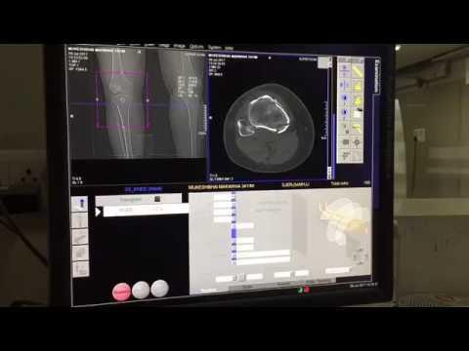

- Dismiss & counsel patient
- Post-processing & storage of images
  - MPR & 3D image reconstruction
  - Retrospective recons
  - Adjust window settings

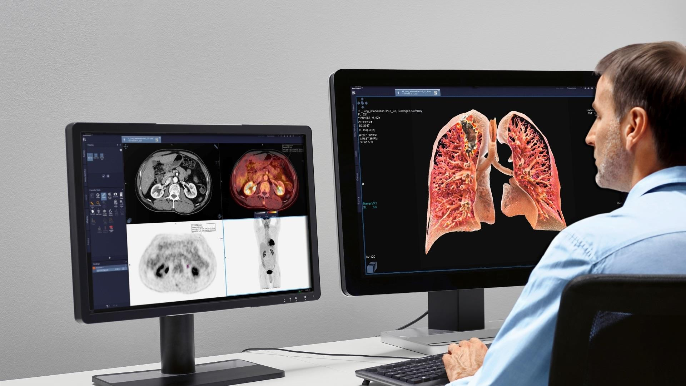
Image Source: https://static.healthcare.siemens.com/

CT Protocols – Important Elements
- Clinical Indications
- Scout Position
- Anatomy included
- Contrast
- DFOV & SFOV
- Window Setting
- Reconstructions – MPR, Algorithms, Thickness, etc.

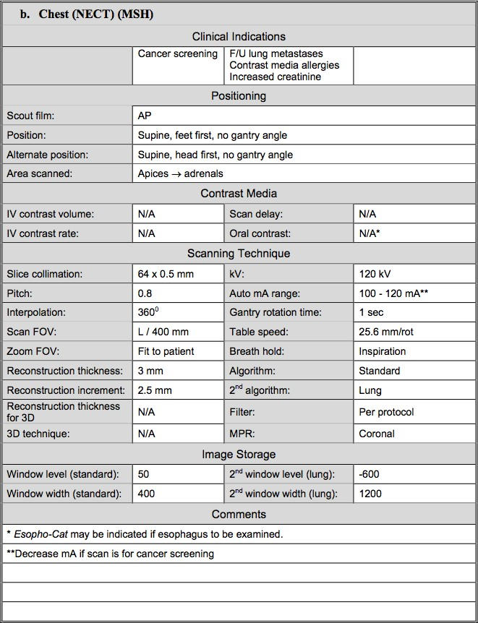

Activity – Review Worksheet

Pause here and complete the Review Worksheet posted in the Introduction to CT Scanning module.

Patient Preparation

- Lab Work - what tests?
- BUN (blood urea nitrogen)
- GFR (glomerular filtration rate)
- Creatinine

- Why are these tests important in CT?

Patient Preparation
- Medical History & Consent
- Renal Function
- Allergies
- Surgeries
- Thyroid Conditions
- Diabetes
- Hypertension / Heart Condition
- Pregnancy & Breastfeeding

Patient Preparation
- Explanation of the procedure
- You will find efficient and effective phrases to explain to your patient.
- Explain what you’re going to do, and how it’s going to feel.
Example: I am going to inject contrast into your IV, and it is going to give you a warm, flush
sensation. That is normal.
- Give the patient an approximate time frame.
Example: That warm feeling will be intense for about 15 seconds, and you should feel normal again in a few minutes.

Patient Preparation
- Explanation of the procedure
- Speak clearly and concisely
- Ask questions to ensure your patient understands
- Be a good listener, nod and make eye contact
- Use language your patient can understand
- Answer questions, and seek clarification when needed
- Be aware of fears and claustrophobia
- Explain as you go

NECT – Non-Enhanced CT CECT – Contrast-Enhanced CT
- Scan Delay is important!
- Arterial Phase
- Venous Phase
- Delayed Venous Phase
- Multi-phase scans
- How do you decide if a scan is done in arterial or venous phase?

- Refer to Table 13-1 in Romans Textbook (page 156) for general rules regarding scan delay:
  - Early arterial
  - Late arterial
  - Portal Venous
  - Excretory
- How does a technologist determine how to time a scan?

Scan Timing Methods
- Bolus Triggering
- Aka Bolus Tracking or Smart Prep
- Select target location from the scout image (example – at the level of the carina)
- Acquire Reference image
  - Set ROI on the vascular structure of interest
- Inject entire contrast bolus
- Acquire low-dose scans at selected level (usually 2 s apart).
- Monitor attenuation within the ROI
- Scan is triggered when HU threshold is reached.

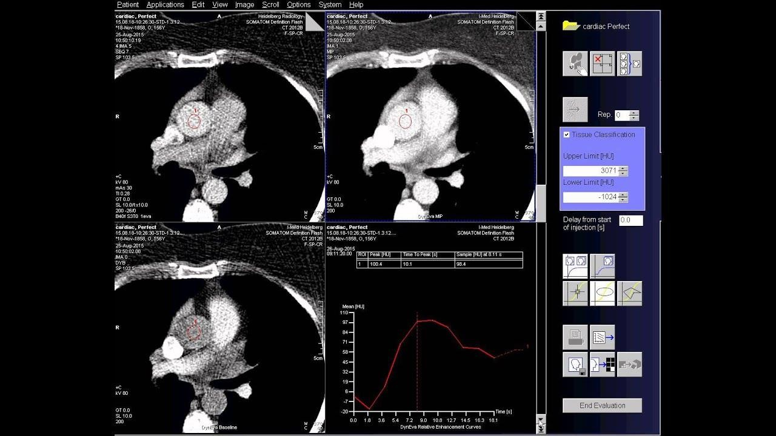

- Scan Timing Methods
  - Test Bolus
  - Aka Timing Bolus, Tracking Bolus, Sample Bolus
- Select target location from the scout image (example – at the level of the carina)
- Acquire reference image
  - Set ROI over vascular structure of interest
- Administer a small amount (10-20 ml) of contrast while acquiring several low-dose
scans.
- Determine the time required for peak enhancement within the ROI.
- Perform the scan, injecting entire contrast bolus using the calculated scan delay
required for peak enhancement.

- Bolus-Triggering
- Advantages
  - Efficient - One injection of contrast
  - Lower radiation dose (less images acquired)
- Drawbacks
  - Patient monitoring for extravasation
  - Lag time (3-9 seconds for table to move into start position)

- Test Bolus
- Advantages
  - Tailored to individuals’ cardiac output
  - Peak contrast enhancement (best image quality)
  - Patient monitoring for extravasation
- Drawbacks
  - Higher radiation dose (more images acquired)
  - 2 injections required
  - Less efficient
    - Potential for patient motion

Post-Processing
- According to department protocols, the technologist must ensure the correct images are sent to PACS to aid in diagnosis.
- MPR – create series in new imaging planes
- Adjust technical parameters
  - WW and WL
  - Slice thickness & increment
  - Reconstruction Algorithms
  - Retrospective reconstructions (alter DFOV/target)
  - 3D imaging

Introduction to CT Scanning

- MPR - Create Coronal, Sagittal, Oblique series from the axial raw data acquired.
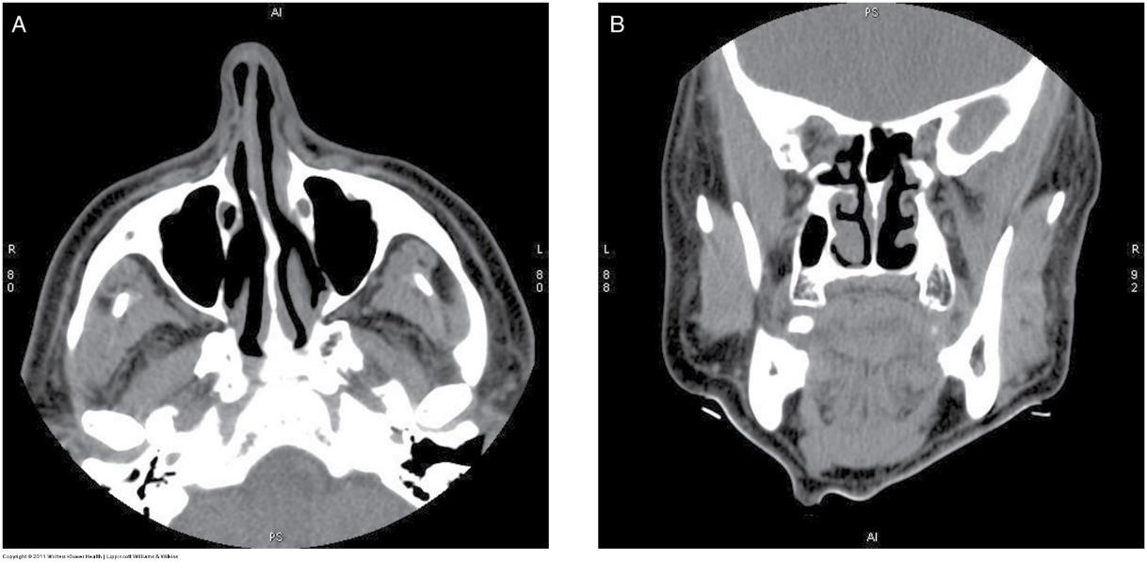

© 2016, Southern Alberta Institute of Technology

- Adjust WW and WL
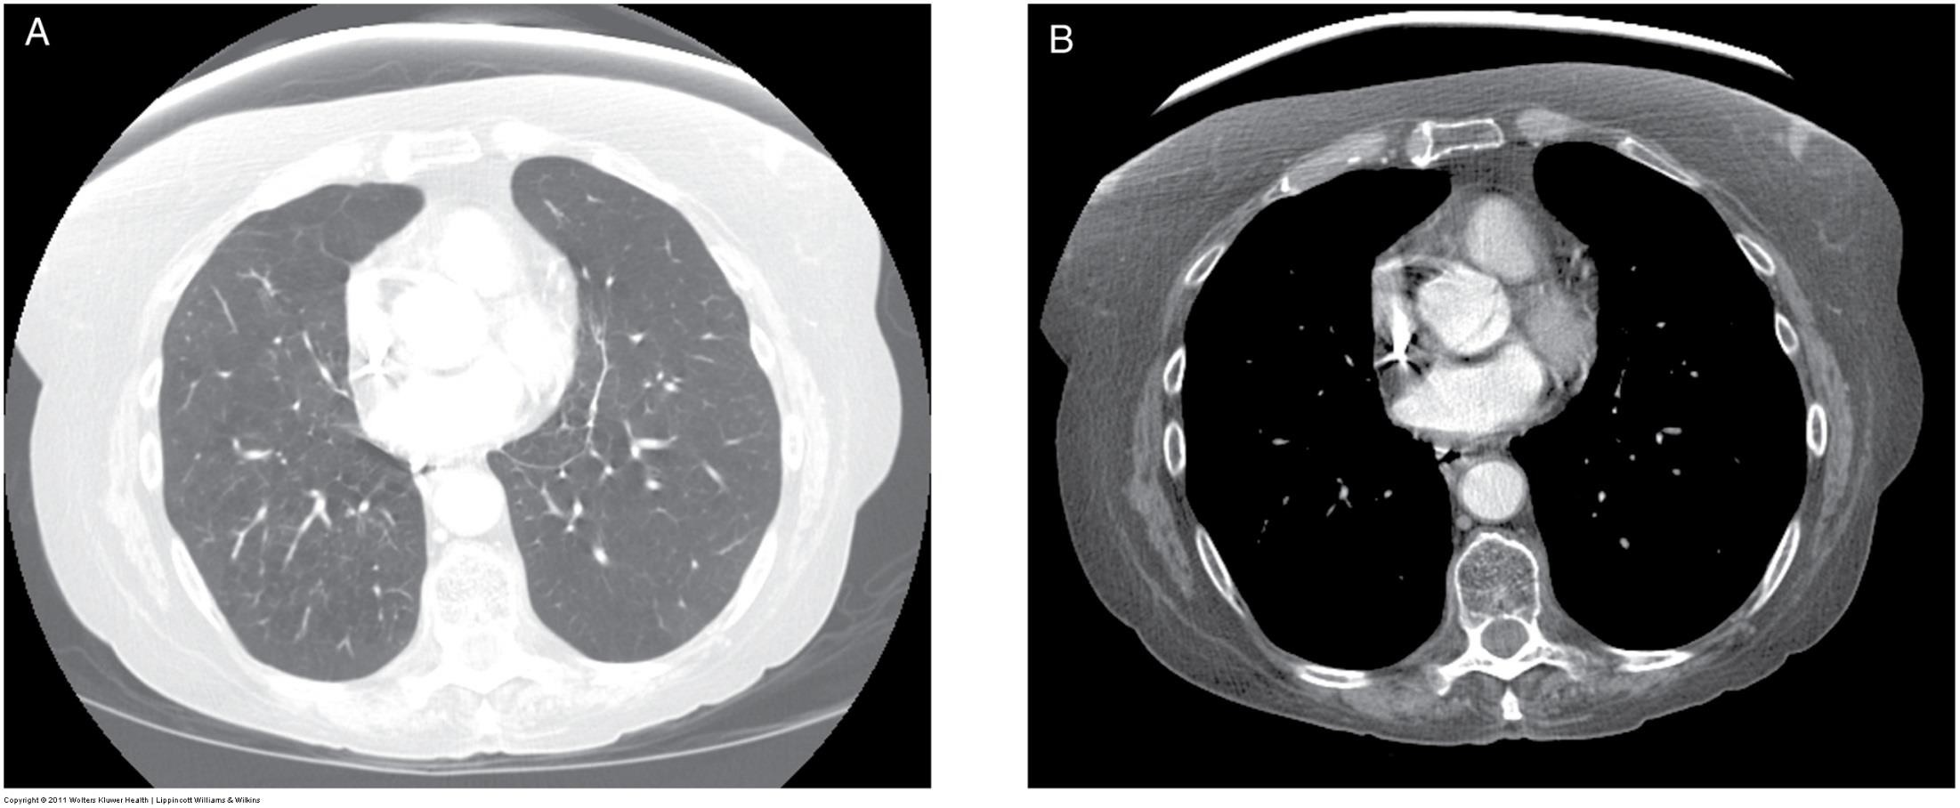
- What’s the difference below?

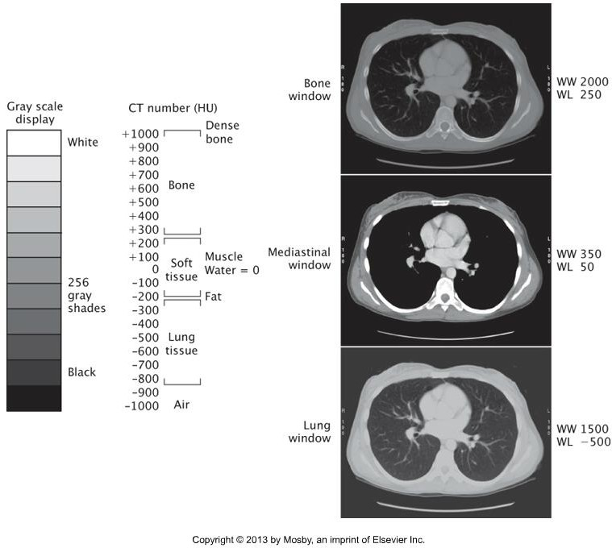

- Adjust slice thickness and/or apply reconstruction algorithm
  - Done by computer software – often built into the program / protocol selected
- Some examples:
  - Smooth data – reduce the difference between adjacent pixels (reduce artifacts) which improves contrast resolution
  - Sharpen data – accentuate the difference between adjacent pixels which
optimizes spatial resolution

- Internal Auditory Canal
- Bone filter applied to Image B to optimize spatial resolution
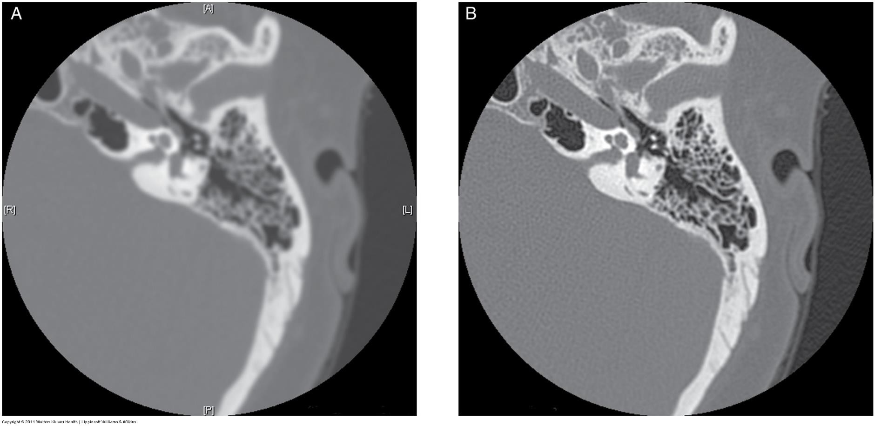

- Retrospective Reconstructions
  - Change DFOV and/or target to produce image series from within raw data acquired.
- Some examples:
  - SFOV is large, to include all of abdomen
  - Post-processing, change isocenter and DFOV to produce image series of the L-spine.

- Summary
- Apply knowledge of CT physics and instrumentation to elements of a CT protocol.
- Technologist is responsible for obtaining a thorough medical history, informed consent, and patient communication to ensure a safe outcome and high quality images.
- Apply knowledge of CT physics and post-processing tools to optimize image quality to aid in diagnosis.

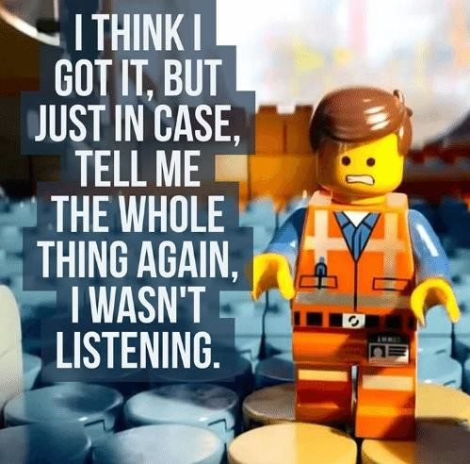
- Additional Learning Activities
- Online Activities for Introduction module
- Module Self-Test

- This learning material is property of College.
- Any sharing, reproduction or use of this information or material other than educational purposes at College is prohibited.

