Activity: Test 4 Timer Accuracy Procedure

Purpose
This activity will help you identify the procedure steps for this test.

Instructions
- Review the images below of the equipment and materials used at Edenbrook for this test.
- Review the procedure steps from the Edenbrook MRT lab.
- Compare the textbook readings and your practicum site QA manual for similarities and differences.

Equipment
- Wisconsin timer test tool (synchronous spinning top test tool)
- Dosimeter (digital timer)
- Lead sheet or lead ½ apron
- Calculator

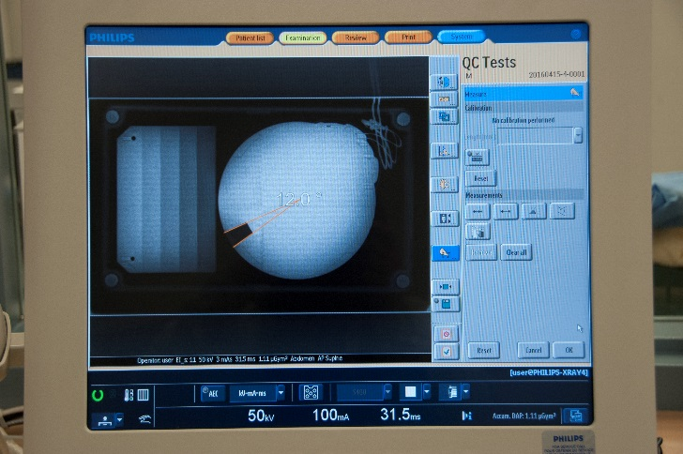 | 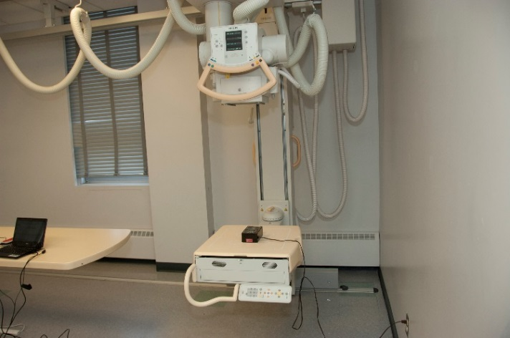

MRT Procedure Steps

Method A – Wisconsin Timing Test Tool
(3 phase unit)
- Plug the Wisconsin timing test tool into a convenient 110V 60Hz outlet.

- Place the test tool on the detector, centre and collimate to include the entire test tool, using 110 SID.

- Set exposure factors to 100 mA and 50 kVp.

- Start at a set time of 33 ms. Expose the test tool.

- View the resulting image. Use the protractor tool on the console, measure the arc and divide by 360 to determine the exposure time. Record the result.

- Repeat step 4–5 for a set time of 50, 100 and 200 ms. Record the results and compare with the acceptable range.

Method B – Digital X-ray Timer Test Tool

- Place the digital timer test tool/dosimeter on the X-ray table with the lead sheet/lead apron underneath to reduce the effects of backscatter.

- Using a 110 cm SID, centre to the digital timer test tool/dosimeter and collimate to include the entire chamber.

- Set the exposure factors to 100 mA and 60 kVp.

- At a set time of 40 ms, expose on the small focal spot and record the result. Expose on the large focal spot and record the result.

- Repeat step 4 for set times of 50 and 100 ms. Record the results.

