ANPH 252

Additional Notes on Stomach Pathologies

Peptic gastric ulcer: benign versus malignant
2016, SAIT Polytechnic

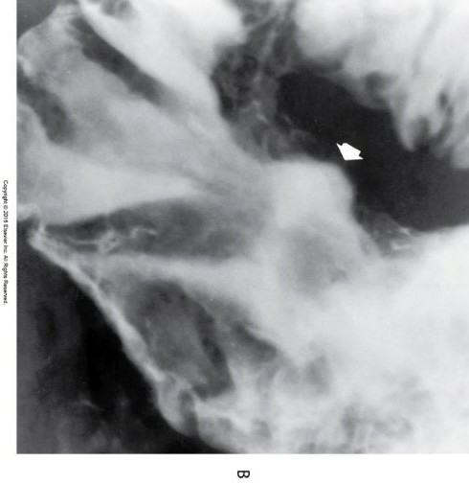
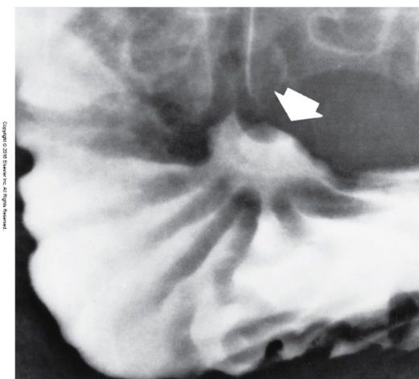
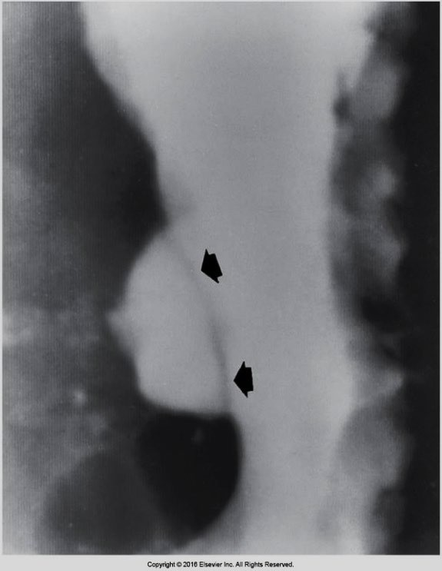
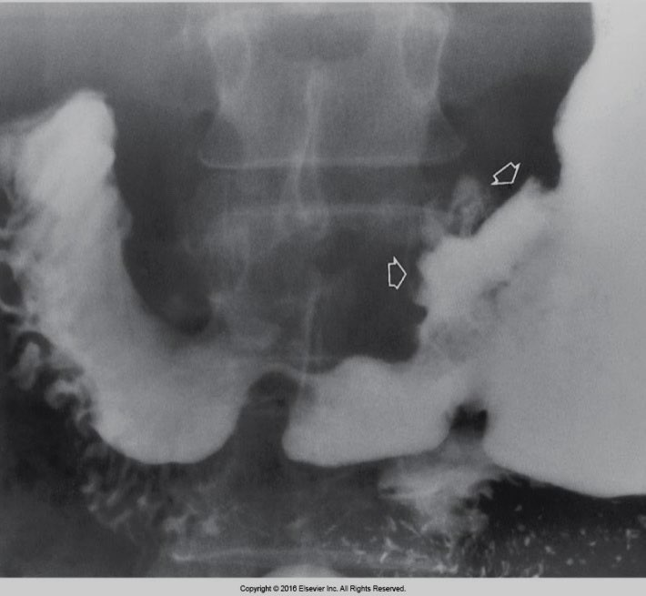

Benign
Malignant

©
Eisenberg 5-34, 5-35, 5-36 B, and 5-37

Benign Gastric Ulcers:

- More likely to occur along the lesser curvature of the stomach

- Present with smooth, rounded, deep ulcer crater

- Smooth ulcer mound

- Smooth gastric folds that reach the margin of the ulcer

Malignant Gastric Ulcers:

- More likely to occur on the greater curvature of the stomach

- Does not protrude past the gastric contour (endoluminal)

- Irregular and shallow ulcer crater

- Nodular and angular ulcer mound

- Nodular gastric folds that do not reach the ulcer margin

Gastric adenocarcinoma

- arises from the gastric epithelium

- Most common gastric malignancy

- Can have different radiographic appearances

- Tumour infiltration of the stomach wall causes fibrosis, thickening, narrowing and fixation (linitis plastic pattern seen on imaging) 1/3
  - Stomach becomes enlongated and contracted

- Polypoid mass is a large, irregular mass on the gastric wall 1/3
  - Presence of ulcerations within the mass indicate malignancy

- Ulceration can develop in any gastric carcinoma 1/3
  - Can appear as shallow ulcerations to deep excavations

Gastric adenocarcinoma
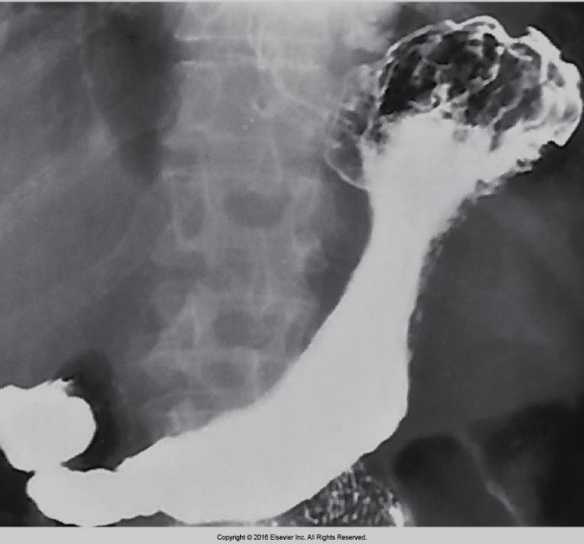
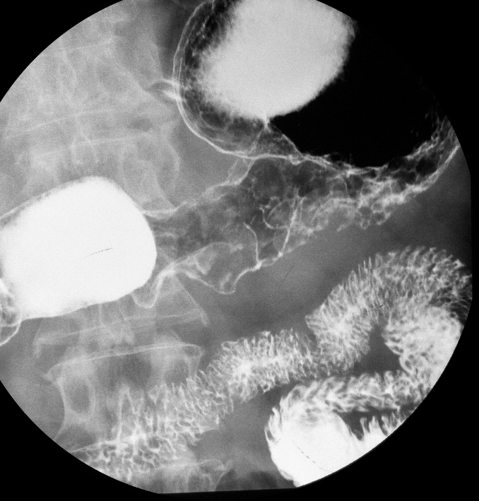
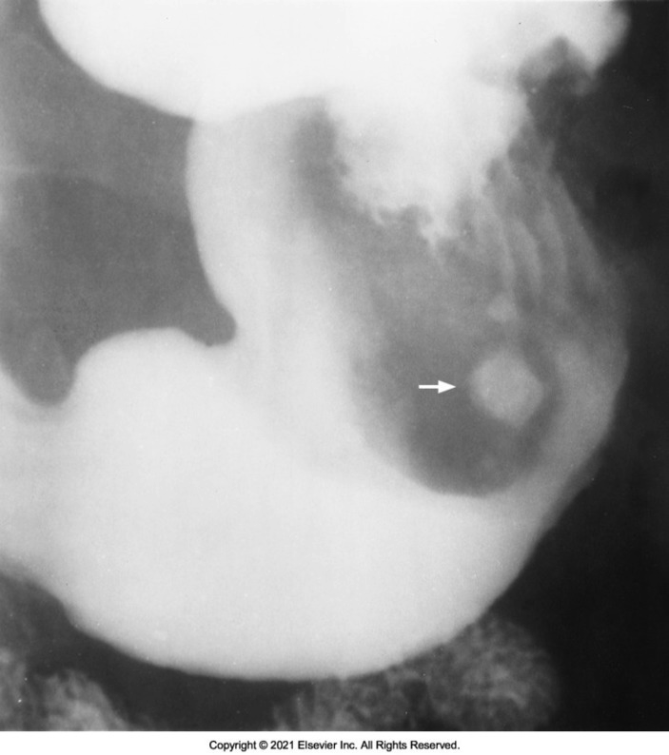
Case courtesy of Dr Ian Bickle, Radiopaedia.org, rID: 21214

