MRAD 358 – Clinical Integration 1
Computed Tomography (CT) Review – Questions 1-23

- What should you communicate to all patients prior to an enhanced scan?

- How long should you monitor a high-risk patient post-scan? Identify the type of reaction that warrants this type of monitoring.

- Why is patient hydration an important consideration?

- How would your image be affected if you had to use Optiray 350 instead of Optiray 300?

- Can you utilize a PICC line to administer IV contrast media? Why or why not?

- The warming device brings the contrast media to body temperature. True or False?

- Which substance should be loaded into the syringe that has a green display on the control panel and which goes into the syringe with the blue display?

- What can the technologist do to prevent causing an air embolus in the patient?

- A vertical plane that passes through the body, dividing it into anterior and posterior portions, is the _____ plane.
  - sagittal
  - coronal
  - axial
  - oblique

- The plane that passes diagonally between the axes of two other planes is the _____ plane.
  - Sagittal
  - Coronal
  - Axial
  - Oblique

- The dorsal cavity can be further subdivided into which of the following cavities?
- Cranial and spinal
- Thoracic and abdominopelvic
- Two lateral pleural
- Abdominal and pelvic

- Which of the following is a parameter that allows for the adjustment of the gray scale?
- CT number
- Hounsfield unit
- Window width
- Window level

- Water is used as a reference tissue and is given the CT number of:
- –1000
- –500
- 0
- +1000

- Slice Thickness in CT is determined by:
  - Technologist setting
  - Focal spot size
  - Collimator width
  - Radiologist preference

- How does noise appear on a CT image?
  - Decreased contrast
  - Increased brightness
  - Graininess
  - Streak artifact

- Increasing the pitch will result in a scan covering more anatomy lengthwise for a given total acquisition time. True or false?

- Patients with asthma must be identified prior to injection of contrast media because:
  - Their renal function may be impaired
  - The contrast media may cause hypertension in an asthmatic patient
  - The risk of allergic reaction is higher
  - The radiologist will cancel the exam

- What is the Scan Field of View?
  - The area within the gantry from which raw data is acquired
  - The size of the computer matrix
  - The collimation applied to the images
  - The region of interest selected by the operator

- Which of the following statements is true?
  - The DFOV cannot be larger than the SFOV
  - The DFOV is a subset of all the scan data available
  - Changing the DFOV changes the pixel size
  - Changing the DFOV does not affect image quality

- What is another name for a bone algorithm?
  - Standard
  - Soft-tissue
  - High resolution
  - High contrast

- The image below is an example of which of the following?

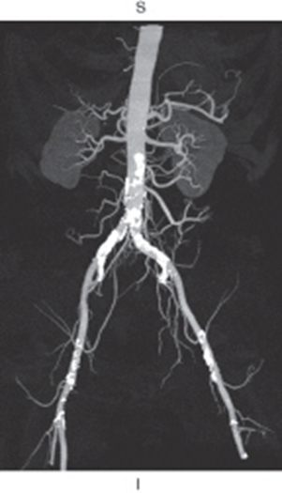

  - Multiplanar reformation
  - Shaded surface display
  - Maximum intensity projection
  - Volume rendering

- When would it be beneficial to apply the edge enhancement feature?

- When would it be beneficial to apply the image smoothing feature?

