Activity: Test 11 Automatic Collimation Procedure

Purpose
To confirm that the automatic collimation system (PBL or positive beam limitation) quickly and accurately adjusts to the appropriate field size of the image receptor/cassette placed in the cassette holder or bucky. This test can only be performed on equipment that has a cassette holder (bucky) where image receptors can be inserted.

Instructions
- Review the images below of the equipment and materials used at Edenbrook for this test.
- Review the procedure steps from the Edenbrook MRT lab.
- Compare the textbook readings and your practicum site QA manual for similarities and differences.
Equipment
- Tape measure/ruler
- Calculator
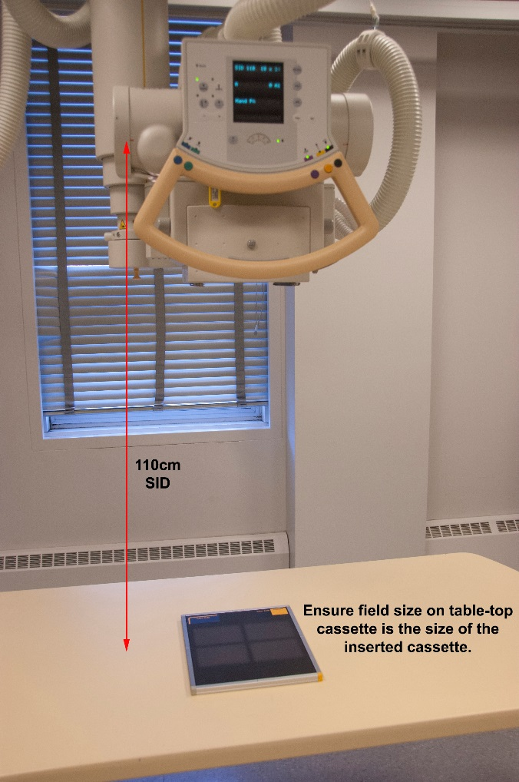

Part A:
- Using a 110 cm SID, centre the tube and cassette holder on the table. Open the light field as large as possible.
- Set the timer and time how long it takes for the light field to adjust after a cassette is inserted. Visually confirm that the light field changed to the corresponding appropriate field size of the image receptor/cassette.
- Repeat step 2 for all sizes of cassettes used in the department.
- Record the results.

Part B:
- Using a 110 cm SID, centre the tube and cassette holder on the table.
- Place an 18 $×$ 24 cm cassette into the cassette holder. Visually confirm the PBL.
- On the table top, centre a 24 $×$ 30 cm cassette in the light field.
- Take an exposure at 70 kVp and 2 mAs.
- Process the 24 $×$ 30 cm (table top) cassette and determine that the radiation field size did not exceed the image receptor by more than 3% of the SID/SDD.
- Erase the 18 $×$ 24 cm cassette.

