Activity Answers: Test 13 Half Value Layer Calculations

Evaluation of Data:

mm Al | mR
0 | 386.2
0.5 | 337.4
1 | 299.7
1.5 | 268.2
2 | 247.2
2.5 | 223.7
3 | 204.1
3.5 | 180.8
4 | 171.8

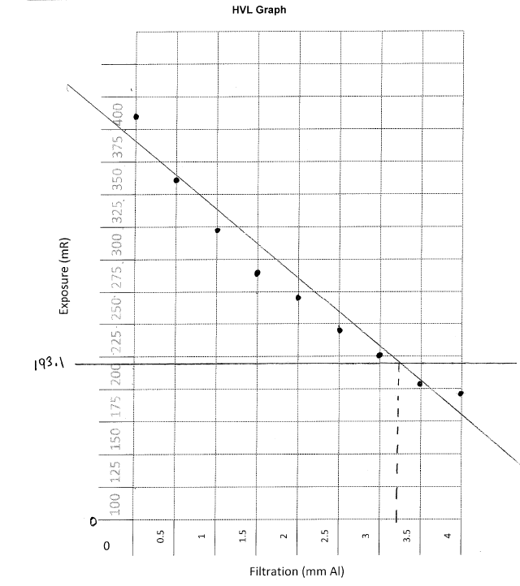

- Plot the exposure results onto the graph and draw a “best fit” line for the data points
See graph above

- Calculate 50% of the exposure at 0 mm Al.

_386.2_______mR 0mm Al x 0.5 = ___193.1______ mR (a)

- Draw a line across the graph at the level of the result (a) above.
See graph above
- Determine the point where that line intersects with the best fit line, and draw a line directly down from it.

- From the graph: HVL = ___3.25___ mm AL

- Compare the actual HVL to SC 35 acceptance criterion.

- According to Table 8, the SC 35 states there must be a minimum HVL of __2.9____ mm at 80 kVp.
Conclusion: Pass _____X_________ Fail ________________

Critical Thinking Questions

- What is the definition of half value layer?
The amount of filtration that reduces the exposure rate to one half its original value (Papp pg. 98)
- What does the HVL measure?

Beam quality (Papp pg. 98)
- What test needs to be done first in order for the HVL test to be accurate?
“kVp accuracy test should be done before the HVL test. The X-ray tube voltage (kVp) has a significant effect on contrast, optical density and patient dose. The kVp stated on the control panel should produce an X-ray beam with a comparable and consistent amount of energy.” (Papp, p. 98)

- Regarding inherent filtration, what is the difference between a general radiography X-ray tube and a mammographic X-ray tube?
X-ray tube has a glass window to filter out lower energy photons, mammography tube has a beryllium window, which allows lower energy photons through, since mammography uses low 25-32 kVp (Papp, pp. 98 -195)

Name the two circumstances from which the HVL should NOT vary.
The HVL should not vary from its original value (which is established at acceptance) or its value at the beginning of the quality control program (Papp, p. 98, Safety Code 35 p. 53)

