MRAD 256 – Worksheet - Cranium Image Critique
- Positioning: Tilt or rotation, is the head positioned properly, are appropriate lines “lined up” properly: OML, IOML, AML etc
- Central ray angulation: what is the angle that should be used for the image/position/projection
- Collimation: is the collimation appropriate for the projection? Comment how it should be corrected
- Required anatomy: is all required anatomy imaged/. If not, what is missing? Is the anatomy demonstrated properly ie petrous ridges in lower 1/3 of orbit etc
- Acceptable?: Would you consider this image appropriate for a student logbook?
☺
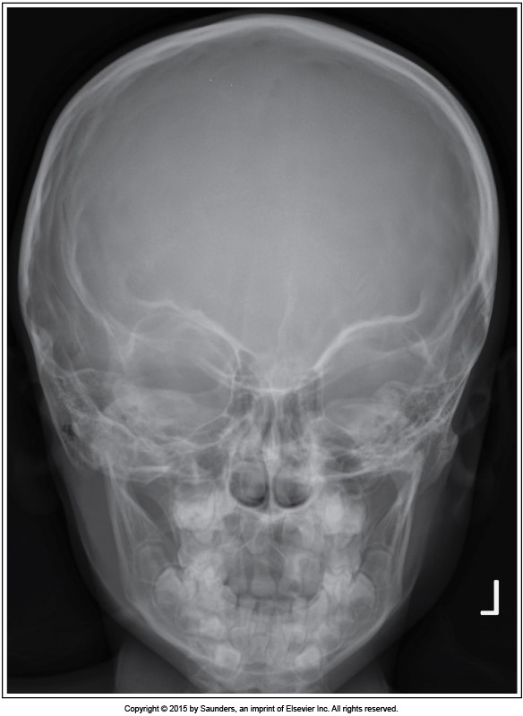
Positioning:
Central ray angulation:
Collimation:
Required anatomy:
Acceptable?:
Caldwell for skull
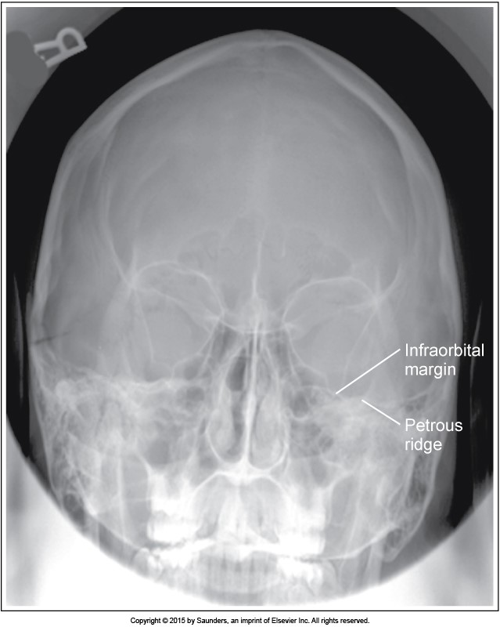
Positioning:
Central ray angulation:
Collimation:
Required anatomy:
Acceptable?:
Caldwell for skull

Positioning:
Central ray angulation:
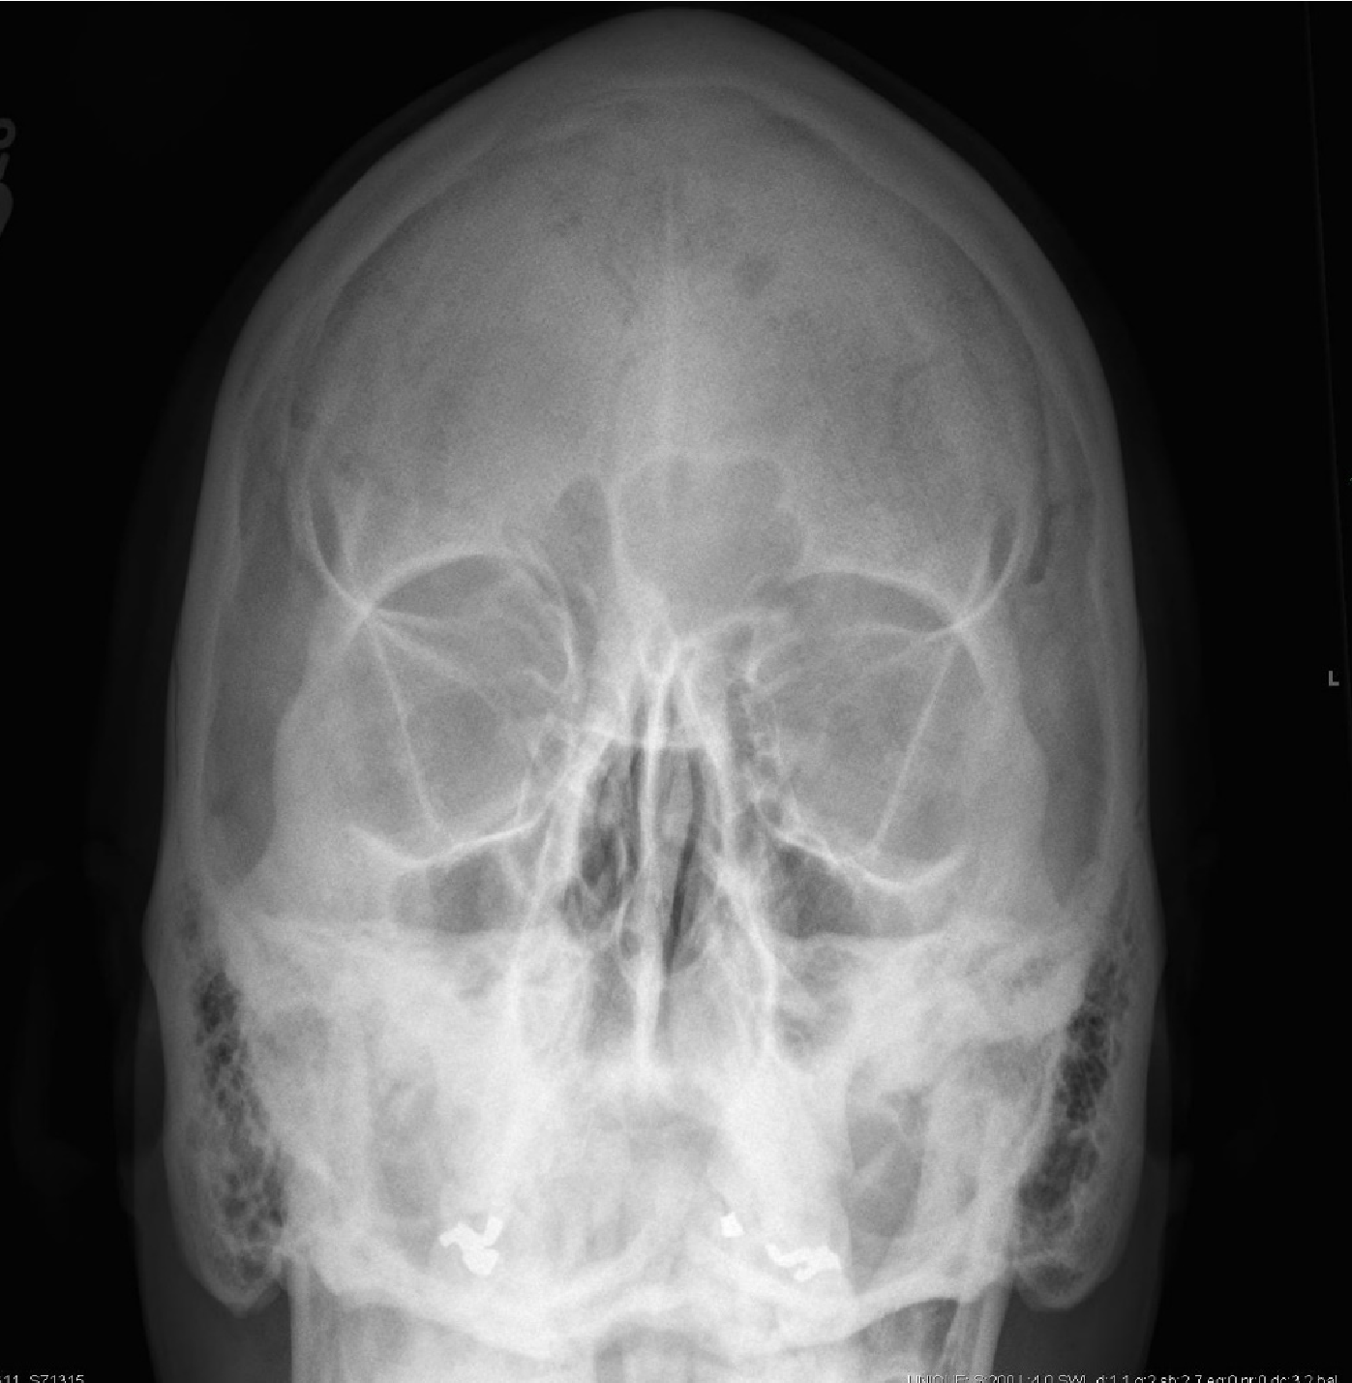
Collimation:
Required anatomy:
Caldwell for skull Acceptable?:
Case courtesy of Dr Matt A. Morgan, Radiopaedia.org, rID: 35611
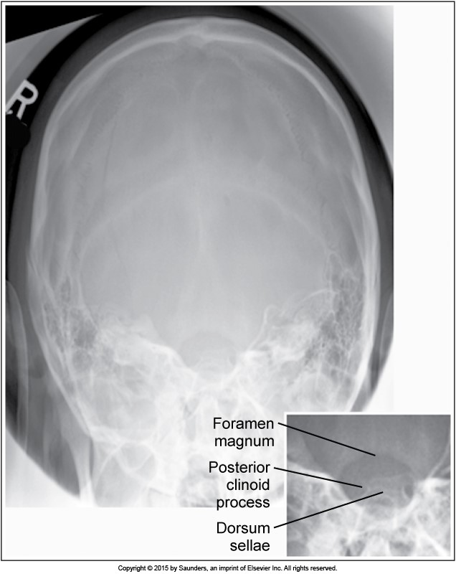
Positioning:
Central ray angulation:
Collimation:
Required anatomy:
Acceptable?:
Townes for skull
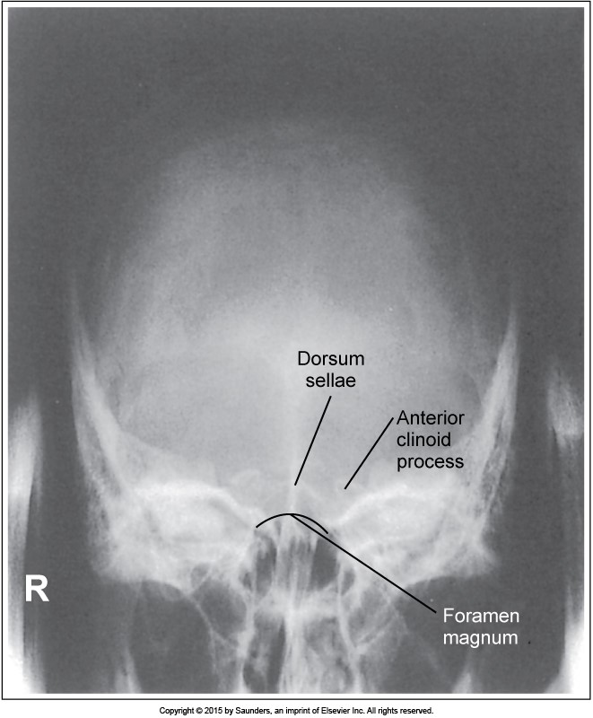
Positioning:
Central ray angulation:
Collimation:
Required anatomy:
Acceptable?:
Townes for skull
Positioning:

Central ray angulation:

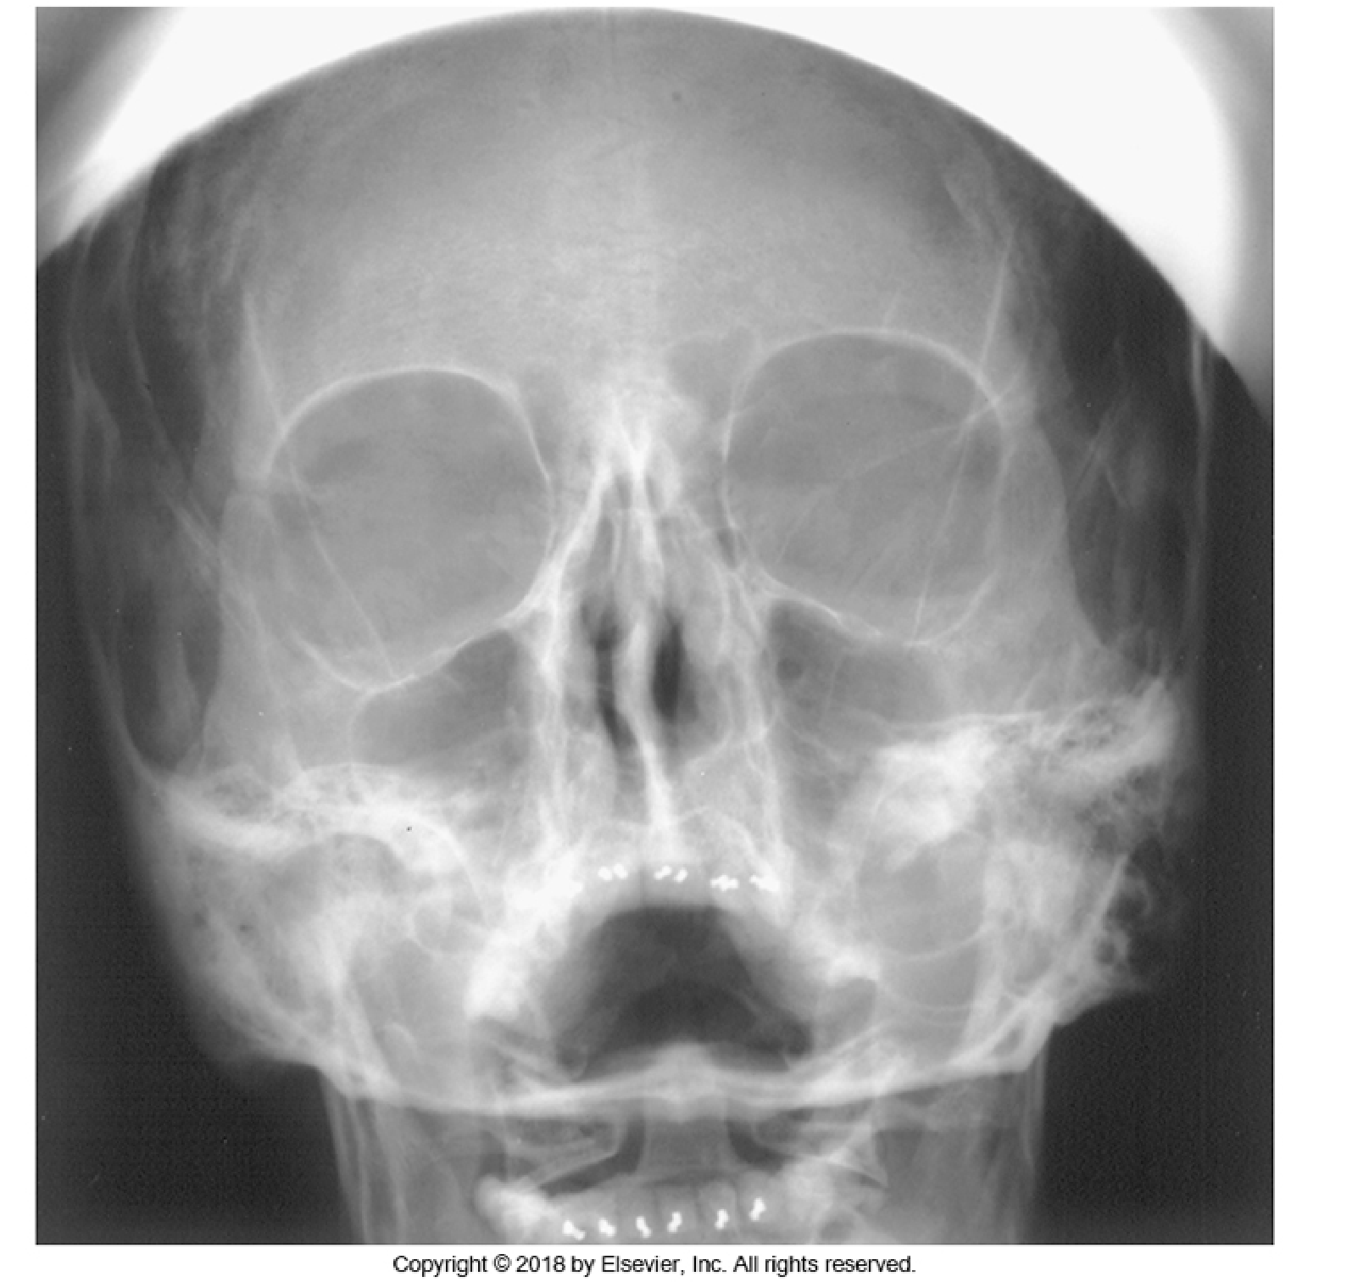
Collimation:
Required anatomy:
Acceptable?: Waters for sinuses

Positioning:
Central ray angulation:
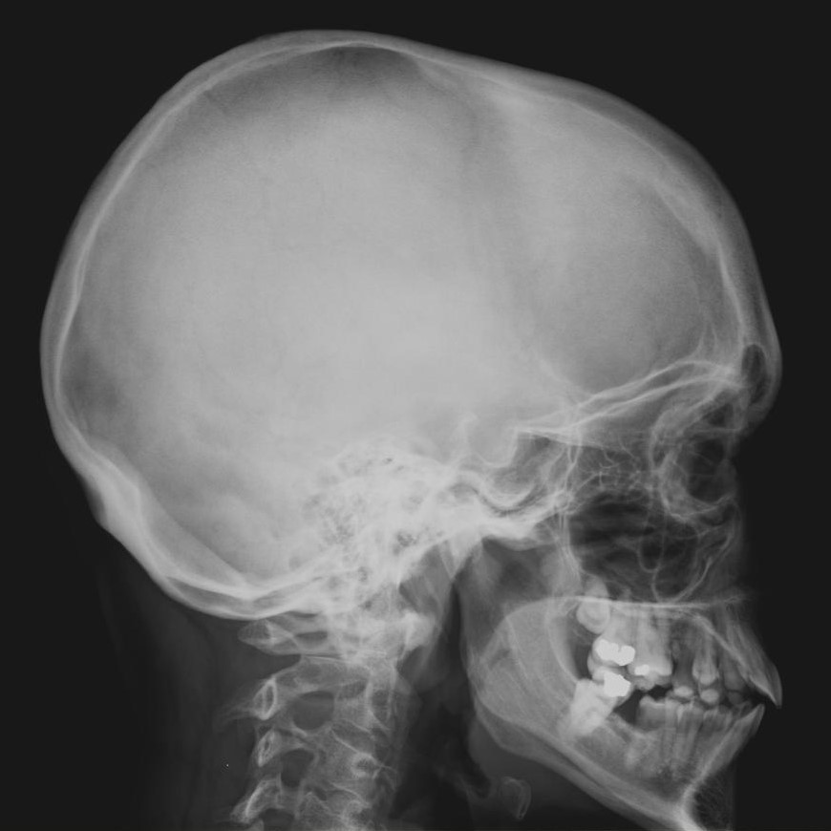
Collimation:
Required anatomy:
Acceptable?

Lateral skull
Case courtesy of Dr Matt A. Morgan, Radiopaedia.org, rID: 37222
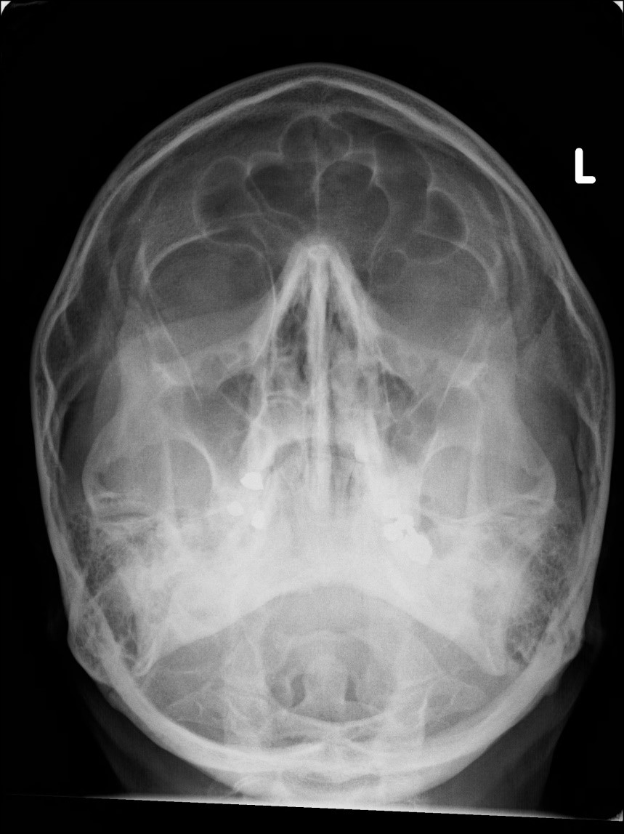
Positioning:
Central ray angulation:
Collimation:
Required anatomy:
Acceptable?:
Waters for facial bones
Case courtesy of Dr Jeremy Jones, Radiopaedia.org, rID: 46272
Positioning:
Central ray angulation:
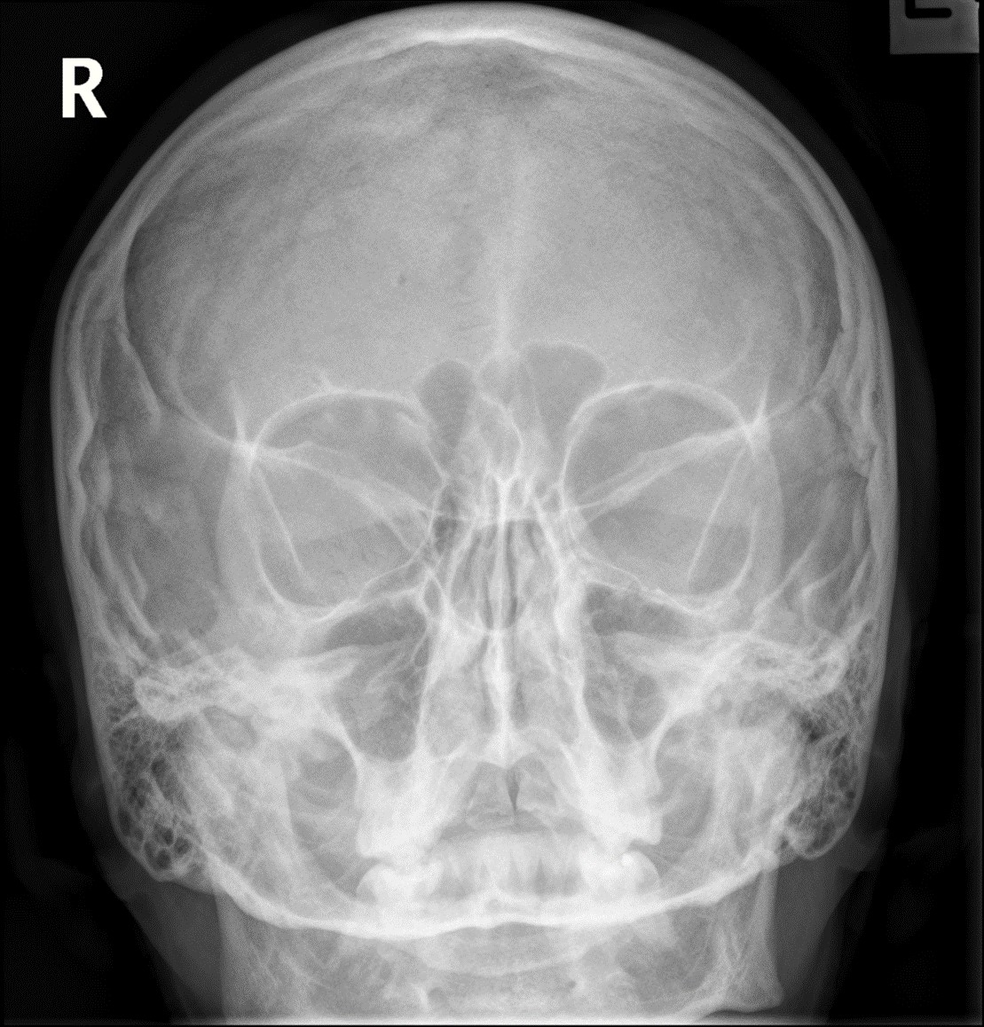
Collimation:
Required anatomy:
Acceptable?:

Caldwell for facial bonesCase courtesy of Dr Bruno Di Muzio, Radiopaedia.org, rID: 48270

Positioning:
Central ray angulation:
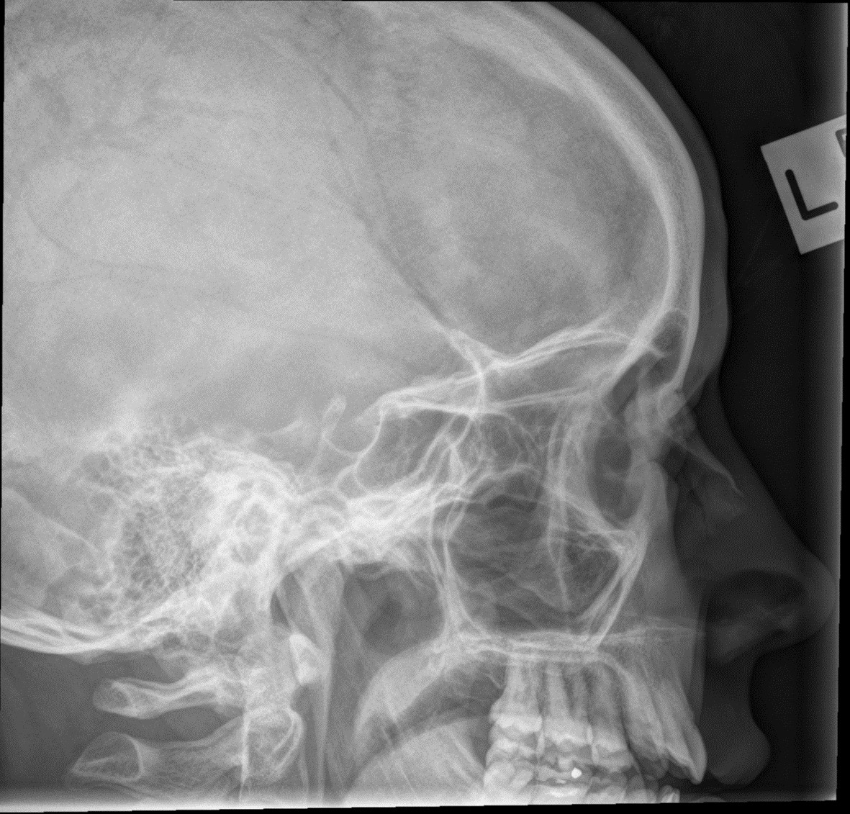
Collimation:
Required anatomy:
Acceptable?:
Lateral for facial bonesCase courtesy of Dr Bruno Di Muzio, Radiopaedia.org, rID: 48270

Positioning:

Central ray angulation:
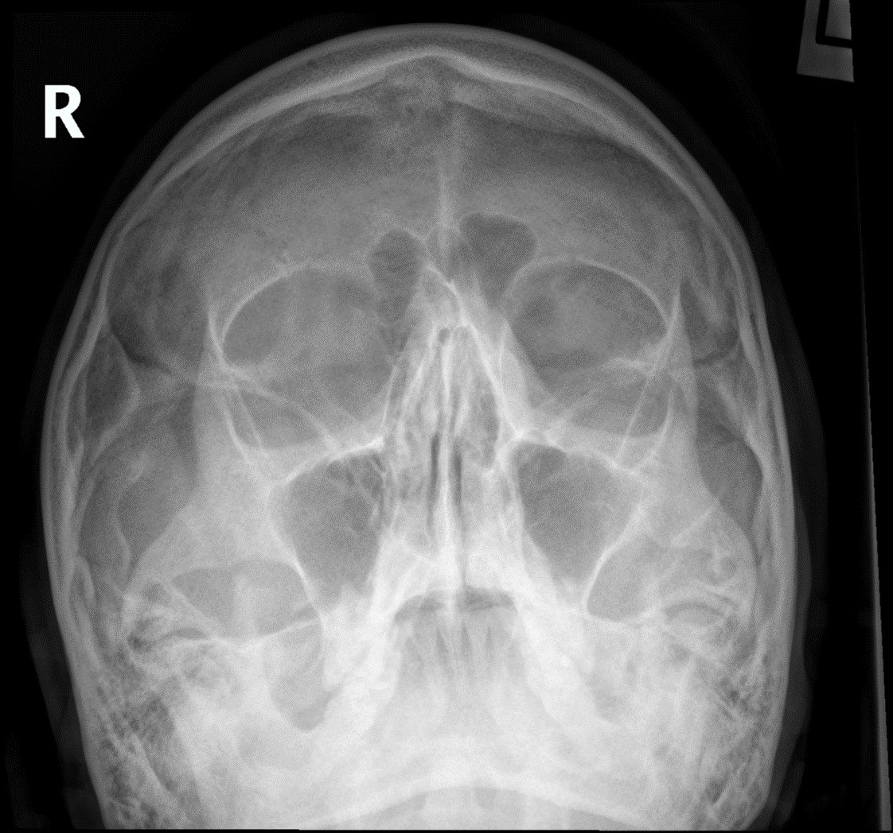
Collimation:
Required anatomy:
Acceptable?:

Waters for facial bones
Case courtesy of Dr Bruno Di Muzio, Radiopaedia.org, rID:
48270

Positioning:
Central ray angulation:
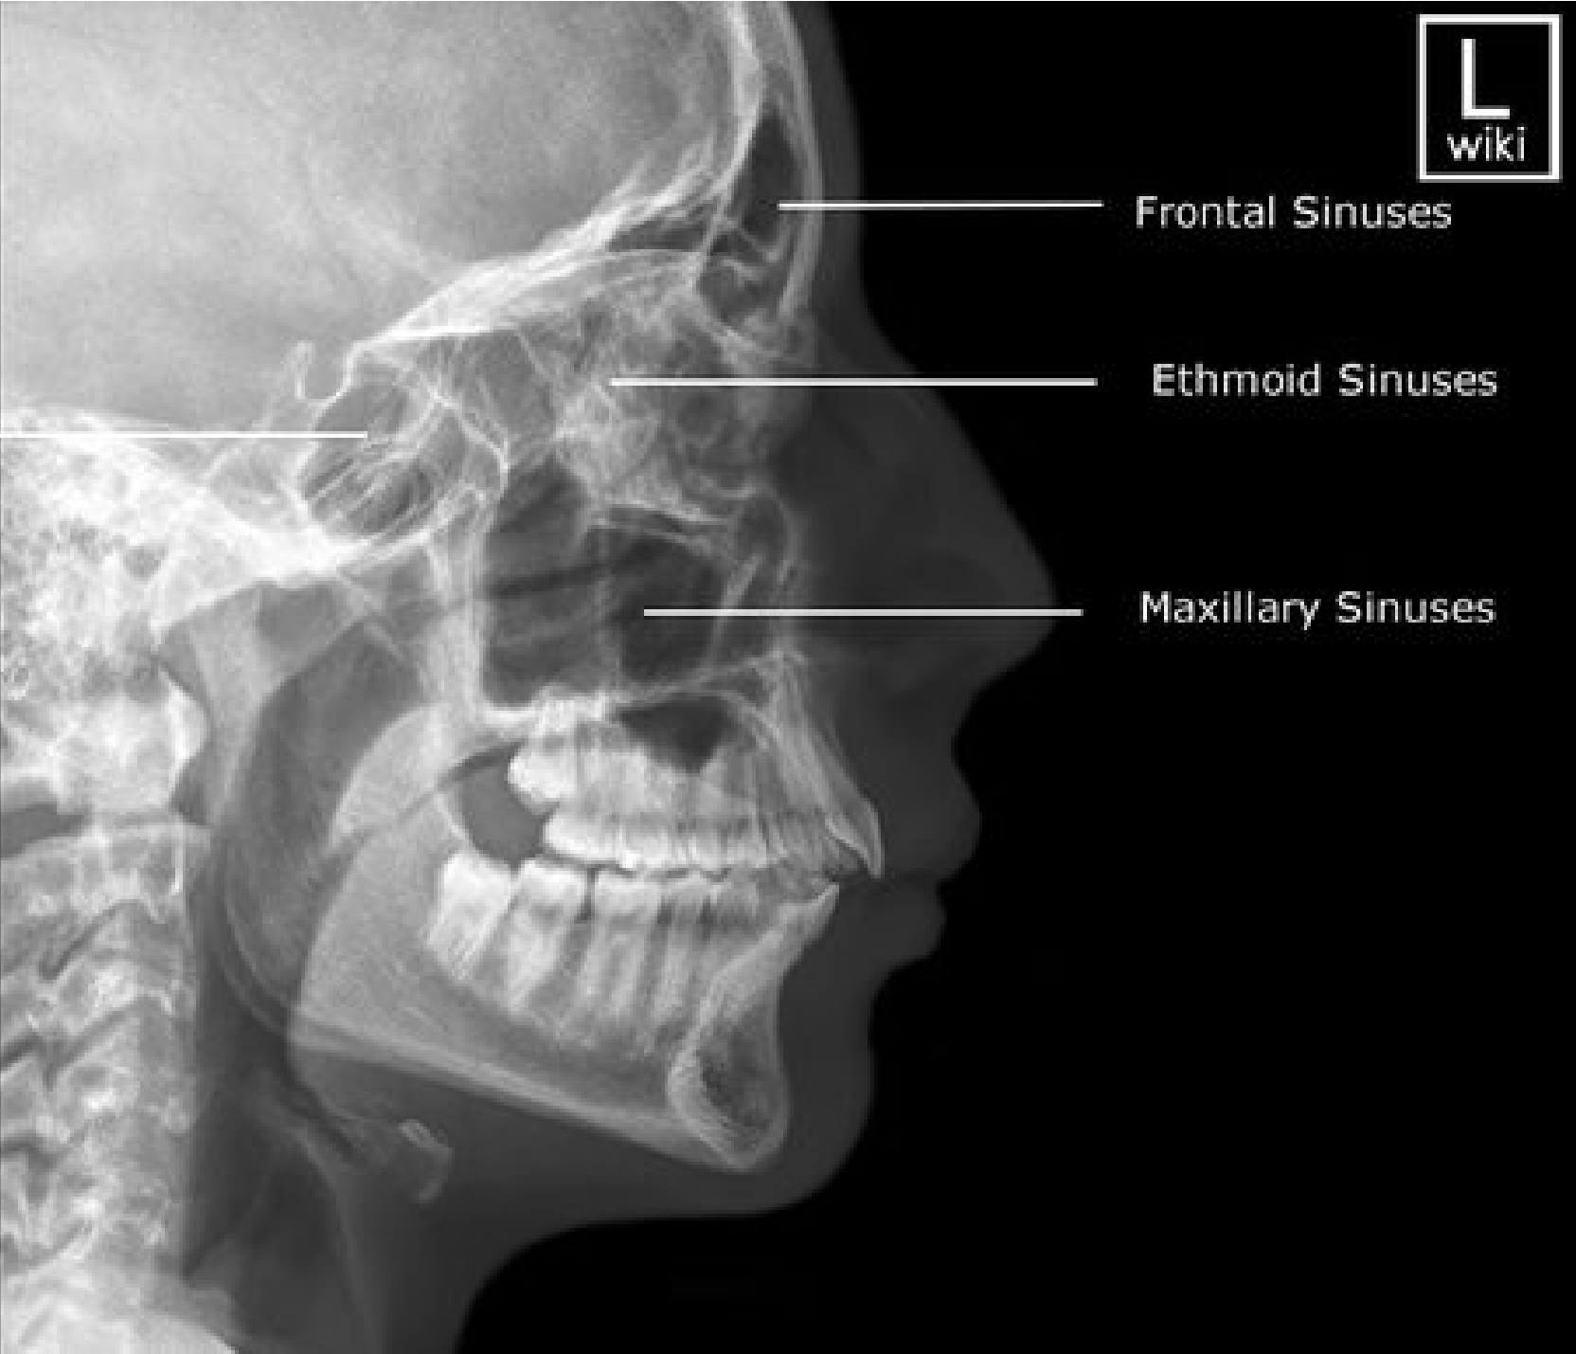
Collimation:
Required anatomy:
Acceptable?:

Lateral sinuses

Positioning:
Central ray angulation:
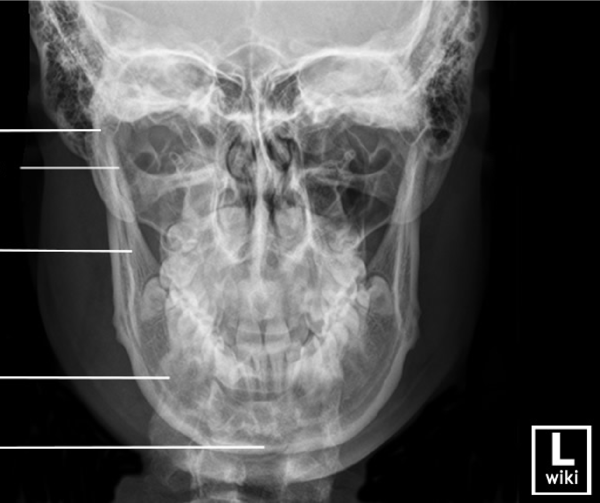
Collimation:
Required anatomy:

Acceptable?:

PA mandible

Positioning:
Central ray angulation:
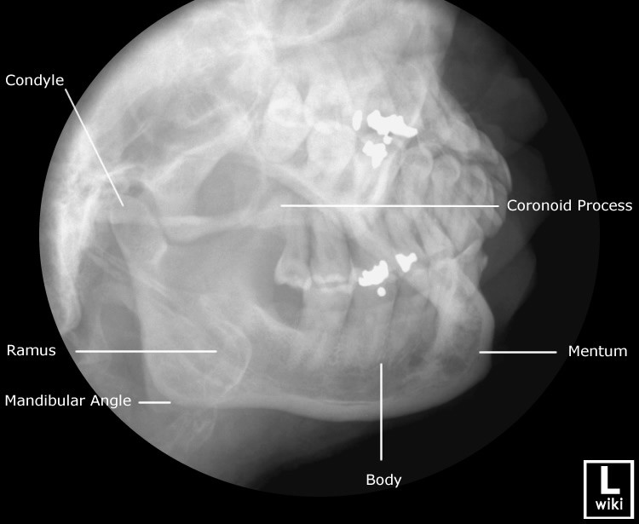
Collimation:
Required anatomy:
Axiolateral oblique mandible ^{Acceptable?:}

