Activity: Test 10 Visual Inspection Procedure

Purpose
This activity will help you complete a procedure checklist for a visual inspection.

Instructions
- Complete the verification checklist for a general X-ray room in your department. Ensure all lines are filled in to the best of your ability.
  - Consult a senior or QC technologist if there are items you encounter difficulty locating.
- Compare the textbook checklist for similarities and differences.
  - What differences do you see from the textbook compared to the Edenbrook MRT checklist?

Equipment
- General X-ray room

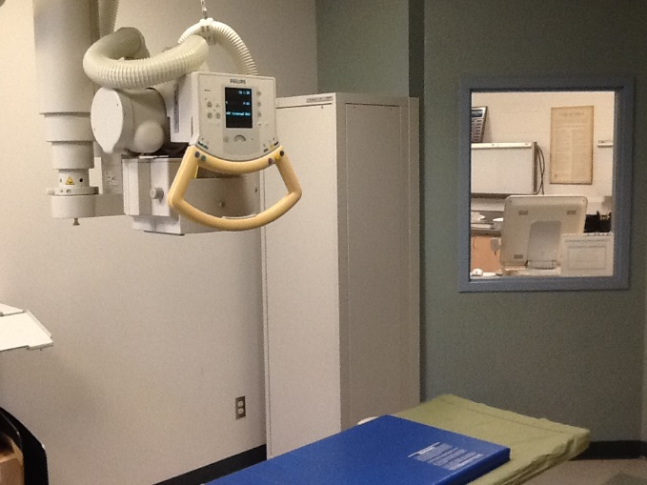 | 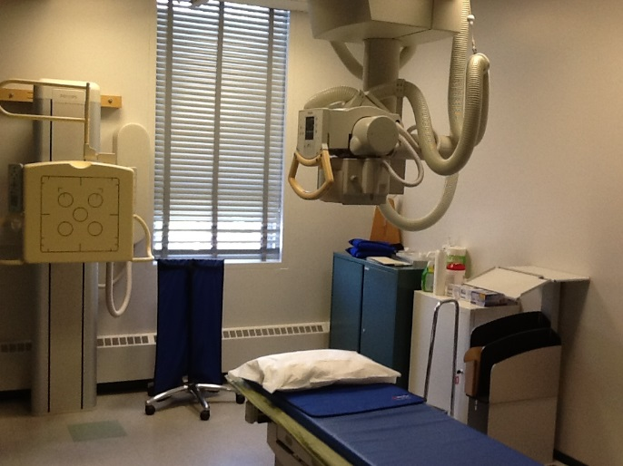

Edenbrook MRT Visual Inspection Checklist
Compliance Verification Checklist for DI Equipment
This report is for : |  | Acceptance Testing |  | Compliance Testing
Site/Facility:
Room:
Gen. Model:
Manufacturer:
Country:
Serial Number:
Equip. Type:
Tube Information
Description:
Serial Number:
Model:
Date Manufactured:
Country Manufactured:
Focal Spot: | Large: ___________ mm |  | Small: _________ mm
Inherent
filtration: _________ mm Al

General Information & Facility Requirements

Yes | No | N/A
 |  |  | - There is a certificate for the room.
- If “yes,” it must be posted in or nearby the room.
  - For mobile: if “yes,” where is it: _____________________.
 |  |  | - Radiation shielding is adequate for the room & meets standard.
 |  |  | - X-ray warning signs are posted on all entrance doors to the room.
 |  |  | - Protective apparel is available to patients & individuals in the radiation area.
 |  |  | - Does a QA program exist for the equipment?
 |  |  | - Does a quality maintenance program exist for the equipment?

General Requirements for Labeling

Generator
Yes | No | N/A
 |  |  | - Name of the Manufacturer
 |  |  | - Model Designation
 |  |  | - Serial Number
 |  |  | - Date of Manufacture
 |  |  | - Country of Manufacture

X-ray Tube
Yes | No | N/A
 |  |  | - Name of the Manufacturer
 |  |  | - Model Designation
 |  |  | - Serial Number
 |  |  | - Date of Manufacture
 |  |  | - Country of Manufacture
 |  |  | - Minimum permanent inherent filtration
 |  |  | - Are the anode & cathode clearly marked?

X-ray Room
Warning Signs

X-ray panel must have a permanent, visible & legible sign warning that hazardous X-rays are emitted when equipment is in operation and prohibiting unauthorized use.
Marking

All controls, lights and other indictors related to the operation of the equipment must be readily visible & clearly marked as to their function.
Mechanical
Stability
- X-ray tube must be securely fixed and correctly aligned within the tube housing.

- X-ray assembly and patient support must maintain their required positions without unwarranted drift or vibration during operation.

X-ray Room (cont’d)
Indicators & Lights
- There must be distinct & separate indicators on the control panel that indicate:

Yes | No | N/A
 |  |  | - When the control panel is energized & the machine is ready to produce X-rays.
 |  |  | - When X-rays are being produced.
 |  |  | - An audible signal to indicate the end of an exposure.
 |  |  | - If an AEC is provided, when that mode of operation is selected.
 |  |  | - If the AEC mode is not selected or does not exist, the selected loading factors must be available to the operator before exposure.
 |  |  | - If the equipment is battery operated, indication that the battery is adequately charged.
- If more than one X-ray tube is controlled by one control panel:

 |  |  | A visual display on or near each X-ray tube & control panel that shows that the tube is powered.
Indication of Loading Factors

 |  |  | - Equipment having variable loading must have meters or other indicators on the control panel that will determine the tube voltage, current & time, or combinations of all these.
 |  |  | - Loading factors must be displayed before, during & after the exposure is complete.
Irradiation Control

 |  |  | - There must be an exposure switch, controlling timer or other mechanism to initiate & terminate the X-rays.

Irradiation & Emergency Switches
Yes | No | N/A
 |  |  | - When the equipment is equipped with an exposure switch it must require continuous pressure from the operator to produce X-rays.
 |  |  | - In the case of a foot switch it must prevent the production of any unintended radiation when overturned.
 |  |  | - In the case of mobile equipment, it must allow the operator to stand at least 3 m from the X-ray source when the tube is energized.
 |  |  | - If the equipment moves around the patient by remote control there must be an emergency stop switch that will stop both movement & exposure.
Controlling Timer

- When the equipment is equipped with a controlling timer it must be constructed so that:

 |  |  | - It can automatically terminate an exposure on completion of a preset exposure time or number of X-ray pulses.
 |  |  | - It permits the operator to stop the exposure at any time.
 |  |  | - It will automatically reset itself to its original setting or to zero at the end of the exposures.
 |  |  | - When it is at zero, off position or at an unmarked setting an exposure cannot occur.
Focal Spot Marking

 |  |  | - The focal spot must be clearly & precisely marked on the X-ray tube housing.
 |  |  | - Measurement from the mark to the table was taken & when compared to digital display it is accurate.

