ANPH 202 – Anatomy and Pathology 1
Worksheet – Cardiovascular Anatomy – ANSWER KEY
Please note that by the time you have finished studying for this unit you should know the location of all the labelled anatomy in figures 14-1, 14-2, 14-7, and 14-9 of Patton and Thibodeau.

Cardiovascular Worksheet
- The human heart is about the size of one’s fist and sits directly behind the sternum with one third projecting to the right and two thirds projecting to the left.

- The apex of the heart lies on the diaphragm.

- The most anterior surface of the heart is formed mainly by the right ventricle

- The diaphragmatic surface of the heart is formed mainly by the right ventricle.

- The heart is located in the mediastinum. It is covered by its own double layered serous membrane known as the pericardium. The parietal layer of the pericardium is a loose fitting sac, while the visceral layer is in direct contact with the surface of the heart and as such it is sometimes called the epicardium. Between the parietal and visceral layers of the pericardium, is a narrow space that contains pericardial fluid.

- Explain the function of pericardial fluid:
It prevents friction as the heart beats

- The middle muscular wall of the heart is known as the myocardium, while the smooth innermost layer of tissue that lines the cavities of the heart is called the endocardium.

8 Number off the tissue layers of the heart and pericardium in order, from the most superficial to the most deep.

4 | Myocardium
1 | Parietal pericardium
2 | Pericardial cavity
3 | Visceral pericardium or epicardium
5 | Endocardium

- Internally, the heart is divided into right and left halves by the interatrial septum and the interventricular septum

- The heart is a double sided pump that has two upper chambers called the right and left atria (singular “atrium), and two lower chambers called right and left ventricles. “Auricles”, are outpouchings that expand the volume of the atria. The right side of the heart maintains pulmonary circulation while the left side of the heart maintains systemic circulation.

- The most muscular of the four heart chambers is the left ventricle, because it is primarily responsible for pumping blood to the far reaches of the body i.e. systemic circulation.

- The heart muscles receives its oxygen supply through the coronary arteries.

- Coronary circulation originates with the right and left coronary arteries which branch off the aorta near the aortic valve.

- The left coronary artery branches into the circumflex artery and the anterior interventricular artery which is sometimes called the left anterior descending artery or LAD)

- After blood has circulated through the myocardium it is collected by a series of cardiac veins that dump into the coronary sinus, and finally into the right atrium of the heart.

- There are four valves in the heart. Two atrioventricular valves which include the tricuspid valve and the mitral valve, and two semilunar valves which include the aortic valve and the pulmonary valve.

- Heart valves have “leaflets or “cusps” that are designed to ensure that blood can only move in one direction through the heart. If valve function is compromised, the blood may flow in a backwards or retrograde fashion.

- “Heart strings”, known medically as chordae tendineae control the movements of the atrioventricular valve leaflets.

- Heart chambers “contract” during systole and “relax”during diastole.
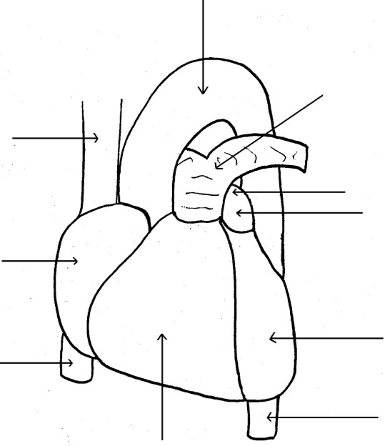









- Label the following on the diagram to the right:
1

2

3

4

5

6

7

8

9

    - Aortic arch
    - Inferior Vena Cava
    - Superior Vena Cava
    - Pulmonary arteries
    - Right atrium
    - Left atrium
    - Right ventricle
    - Left ventricle
    - Descending thoracic aorta

- Label the structures on the diagram below:

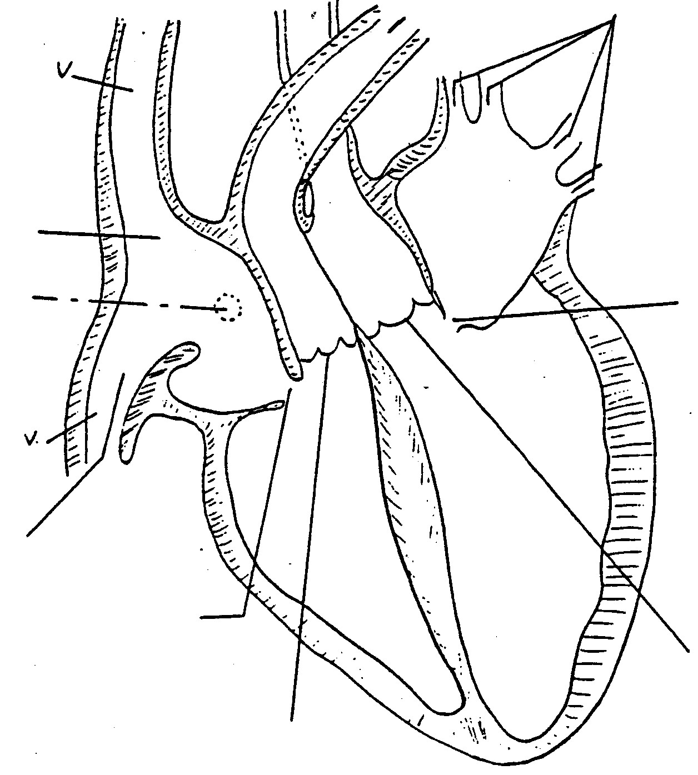

Vessel?

Superior vena cava

Chamber?

Right atrium

Structure?

Sino atrial node

Vessel?

Inferior vena cava

Valve?

Tricuspid valve

Valve?

Pulmonary valve

Valve?

Aortic valve

V
alve?

Mitral valve

Vessels?

Pulmonary veins

Vess
el?

Left Pulmonary artery

Vessel?

Aorta

Chamber?

Left atrium

Chamber?

Left atrium

Chamber?

Right atrium

Artery? A
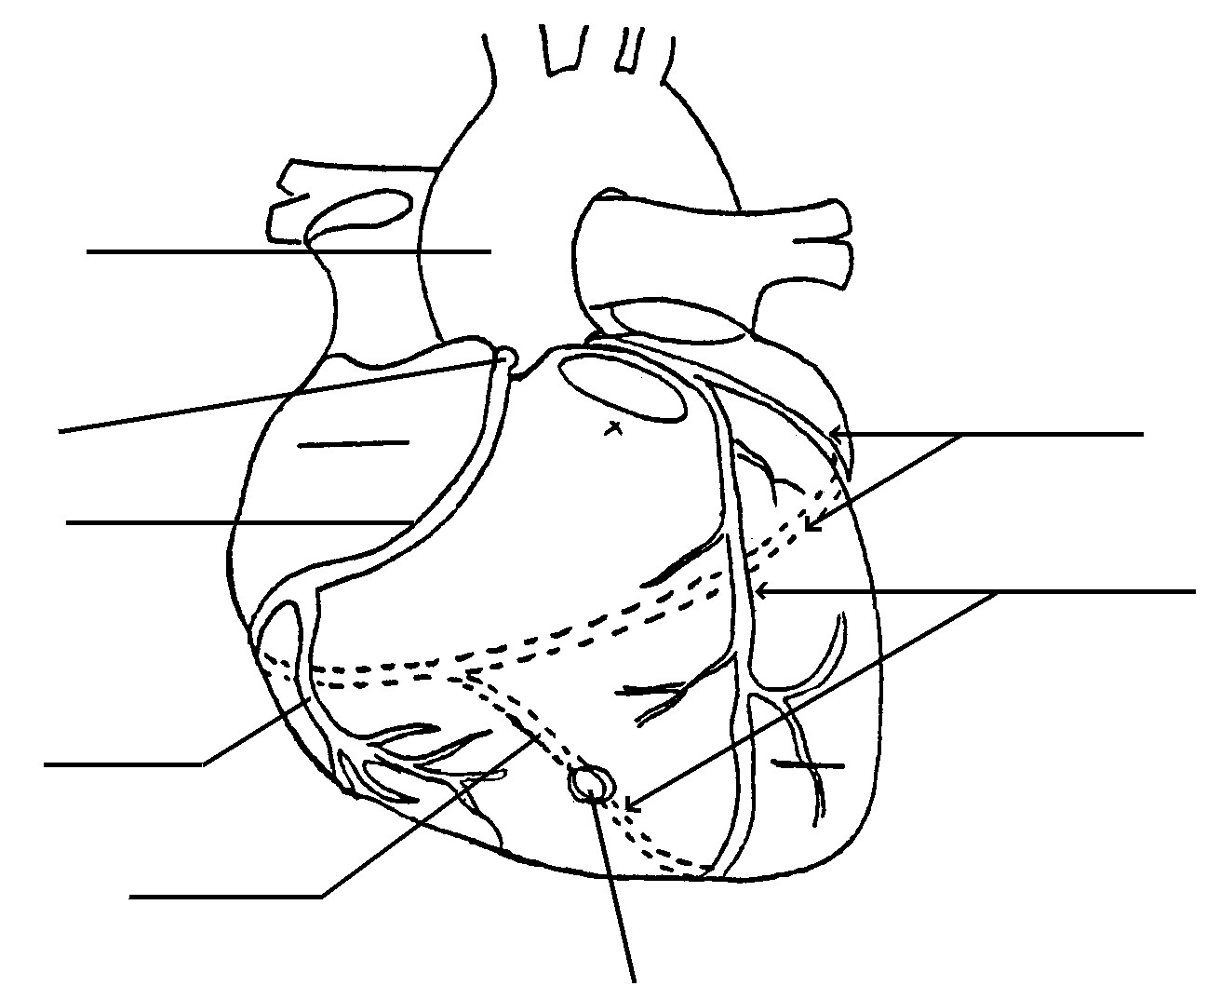
- Label the following arteries on the diagram to the right:
Artery?

B

Artery?

E
, G

Arter
y
?

C

Artery?

F

  - Right Coronary
  - Left Coronary
  - Right Marginal
  - Posterior Interventricular
  - Left anterior descending F) Circumflex artery
G) Anterior interventricular

Artery? D

- Describe the path an erythrocyte would take through the heart, from the time it enters the IVC to the time it leaves the aorta

IVC into right atrium, through tricuspid valve into right ventricle, through aortic valve to pulmonary artery to lung, returning from lungs via pulmonary veins into left atrium, through mitral valve into left ventricle, out aortic valve into ascending aorta

- Based on what you know about the anatomy and physiology of the heart, which heart valve takes the most wear and tear? Mitral valve

- Based on the what you know about the anatomy and physiology of the heart, explain why high blood pressure is often referred to as the “silent killer” See page 407-408 in Patton and Thibodeau.

