MRAD 240 – Specialized Imaging 1
Activity – Identify OR Images

View the images and go to the links for answering the question(s). You will have an OR rotation at your clinical site and opportunity to attend cases with an MRT.

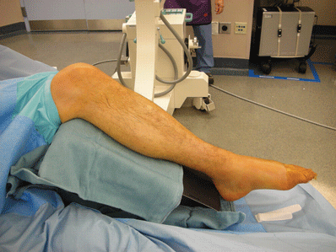
Image #1- Would this OR procedure require the C-arm or the mobile? https://musculoskeletalkey.com/foot-external-fixation/

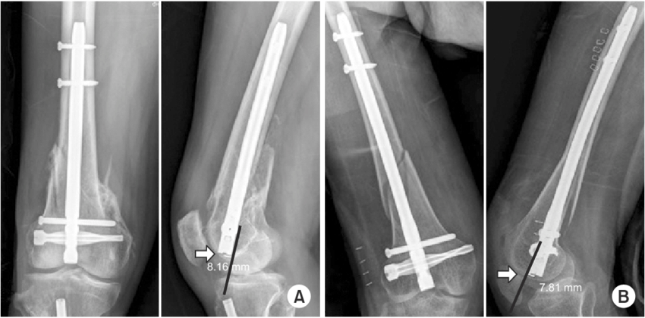
Image #2- Which direction does the distal part of the femur appear to be originally displaced towards? https://www.researchgate.net/figure/Entry-point-of-the-retrograde-intramedullary-nail-which-could-affect-the-posterior_fig2_324749970
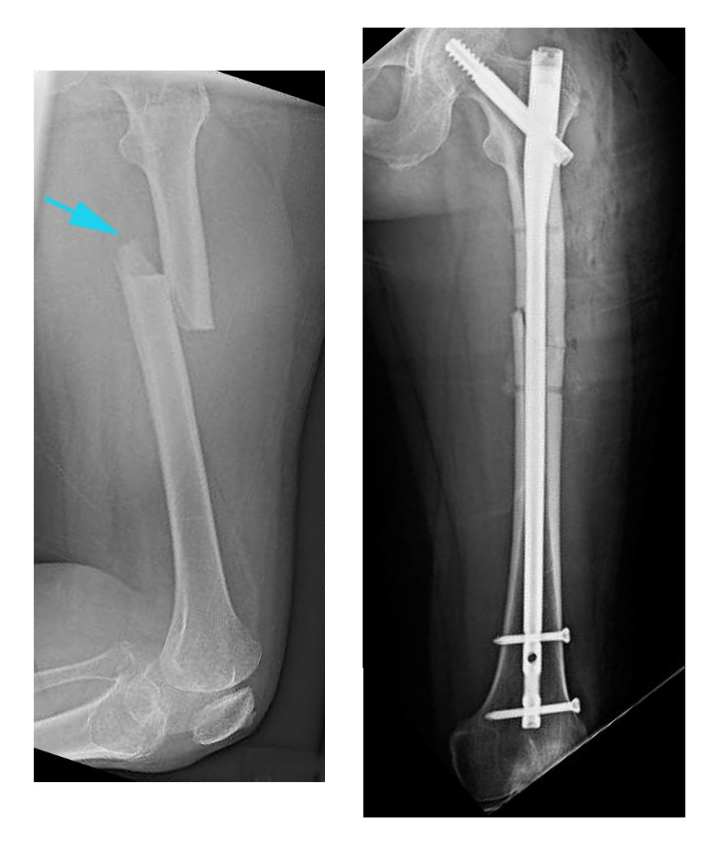
Image #3- Once the surgery is complete, estimate how many screws will be inserted into the IM rod. https://clinicasandalf.com/special-medical-treatment/trauma-surgery/
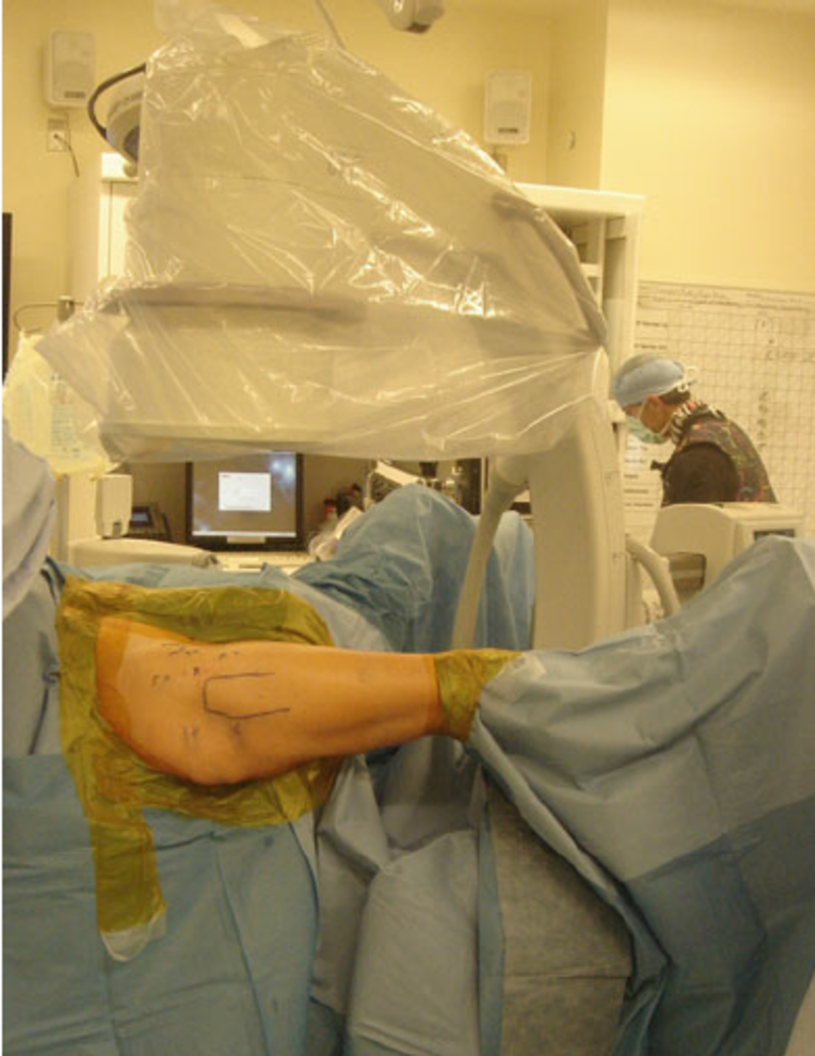
Image #4- Where is the C-arm located in relation to the patients’ legs?-https://www.researchgate.net/figure/ntraoperative-photo-demonstrating-patient-setup-following-prepping-and-draping-for-a_fig8_305725365
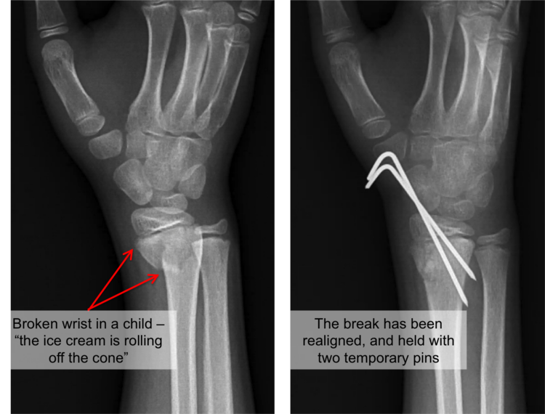
Image #5- Make a guess as to why temporary pins were used.
https://www.raleighortho.com/blog/3391/
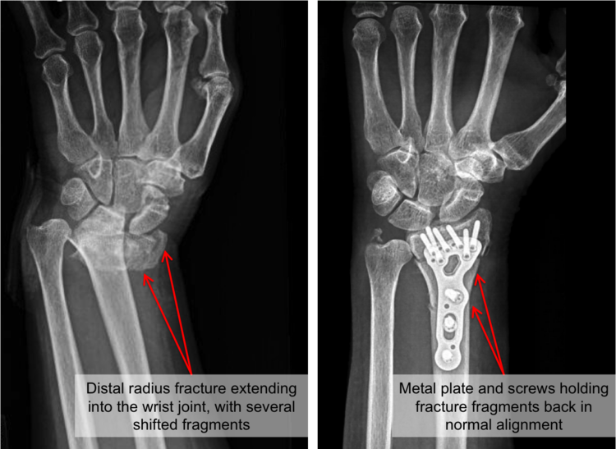
Image #6- By evaluating the bone integrity on the x-ray, do you think the patients’ age may have influenced this surgery? Explain your answer.
https://www.raleighortho.com/blog/3391/

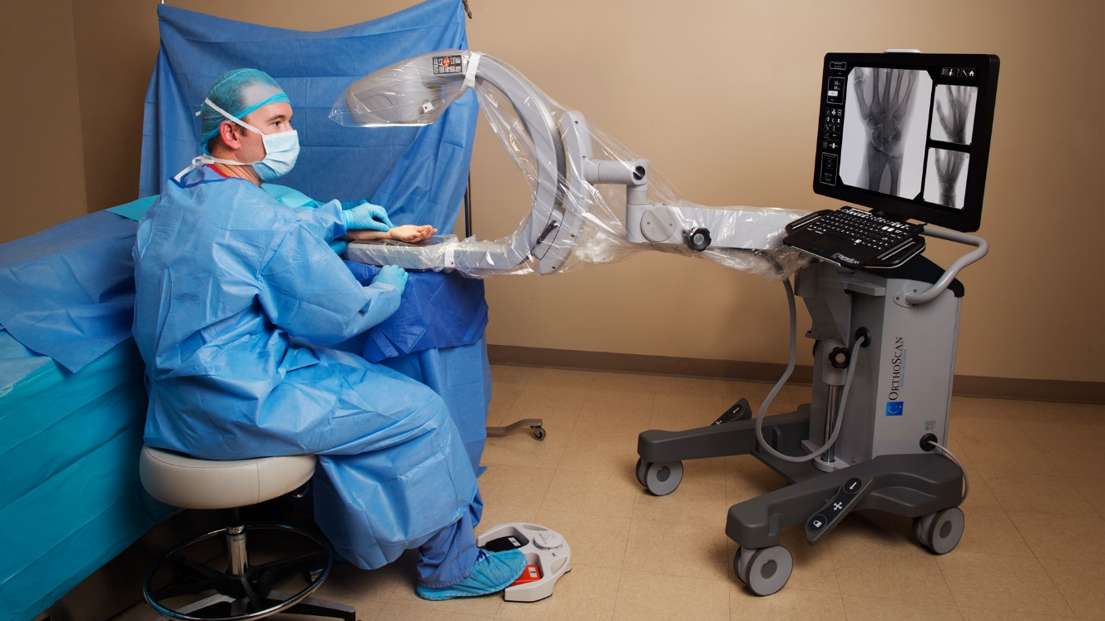
Image #7- Which parts of the body/structures, do you think this “mini” C-arm could be used for? Do you think this mini-C-arm has a modified ALARA practice? https://global.orthoscan.com/
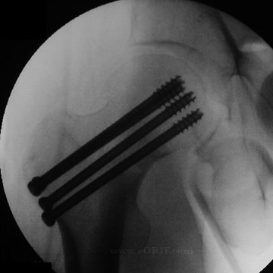
Image #8- Does the image demonstrate a hip replacement or a hip pinning?
https://eorif.com/femoral-neck-fracture-cannulated-screws-27235

