Image Critique Questions

Module 9
- Use the 5 evaluation criteria categories when critiquing the following image to determine if it
is diagnostic: Is this image diagnostic? Yes No*clipped anatomy

SAIT Imaging library
- Is all the required anatomy included in the radiograph? Yes No
*If no, explain what is required *greater trochanters must be included
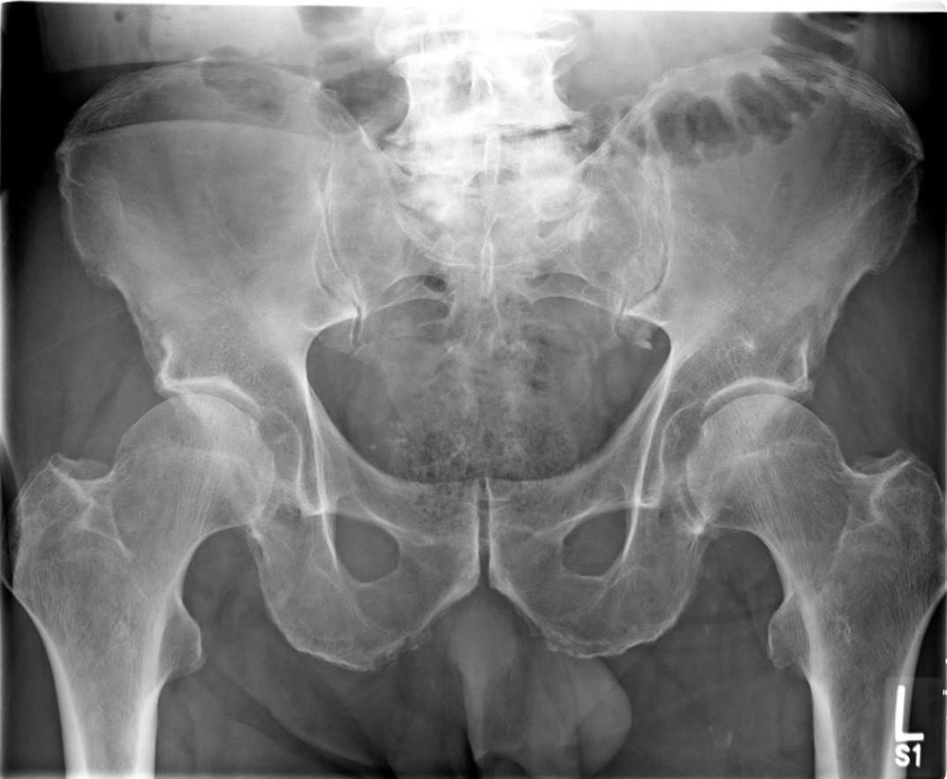
- Does the anatomical appearance in the radiograph correlate to what is expected from an AP projection? Yes No
AP Pelvis @ 95 kVp
*If no, explain how the appearance of this radiograph is different compared to the ideal radiograph Legs appear to be externally rotated (should be rotated medially 15-20º); visible foreshortening of the femoral necks with lesser trochanters in profile internally/medially
- Identify if the appropriate amount of radiation was used to form the image. Acceptable, Overexposed, Underexposed
• | Is motion present in the image? Yes | No
4. | Identify if the collimated light field was: | Acceptable, | Too Small *side to side, | Too Large
  - Was the CR close to the middle of the required anatomy? Yes No
- Does the marker placement follow Edenbrook Marker Rules? Yes No *should be closer to the ASIS
  - Are there artifacts in the image? Yes No
*If yes, could they have been removed? *Yes, the marker is superimposing anatomy of interest. Patients

should be provided with accurate gowning instructions prior to imaging (can see elastics from underwear)

- Use the 5 evaluation criteria categories when critiquing the following image to determine if it is diagnostic:
- Is all the required anatomy included in the radiograph? Yes No
*If no, explain what is required

  - Symphysis pubis

- Does the anatomical appearance in the radiograph correlate to what is expected from a routine AP projection?
Yes No
*If no, explain how the appearance of this radiograph is different compared to the ideal radiograph
  - Femoral neck is foreshortened
  - Lesser trochanter is in profile internally
  - Femur is not parallel to length of IR
- Identify if the appropriate amount of radiation was used to form the image.
Acceptable, Overexposed,
Underexposed
  - Is motion present in the image?
Yes No

- Identify if the collimated light field was:
Acceptable, Too Small, Too Large
*If CR centering was 1-inch more medially located, symphysis pubis would have been included
  - Was the CR close to the middle of the required anatomy?
Yes No
AP Hip @ 90 kVp

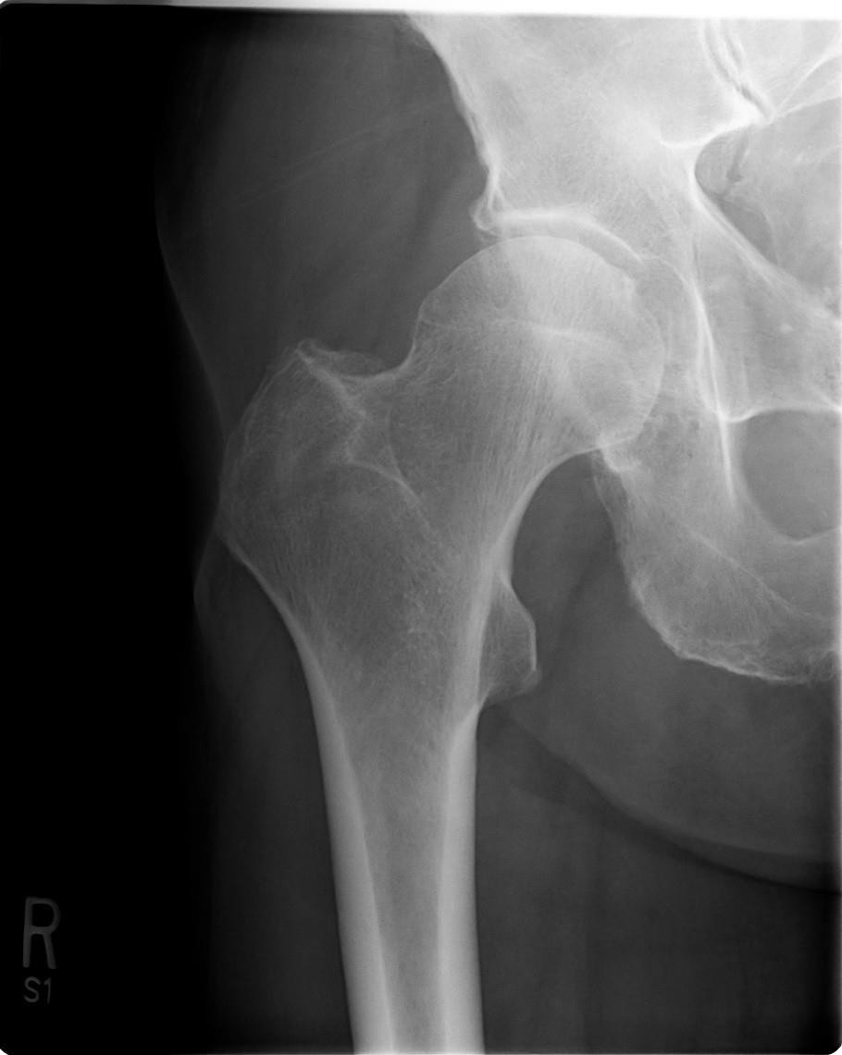
SAIT Imaging library

Is this image diagnostic? Yes No

- Does the marker placement follow Edenbrook Marker Rules?
Yes No
  - Are there artifacts in the image?
Yes No
*If yes, could they have been removed?

- Use the image below to answer the next five questions:
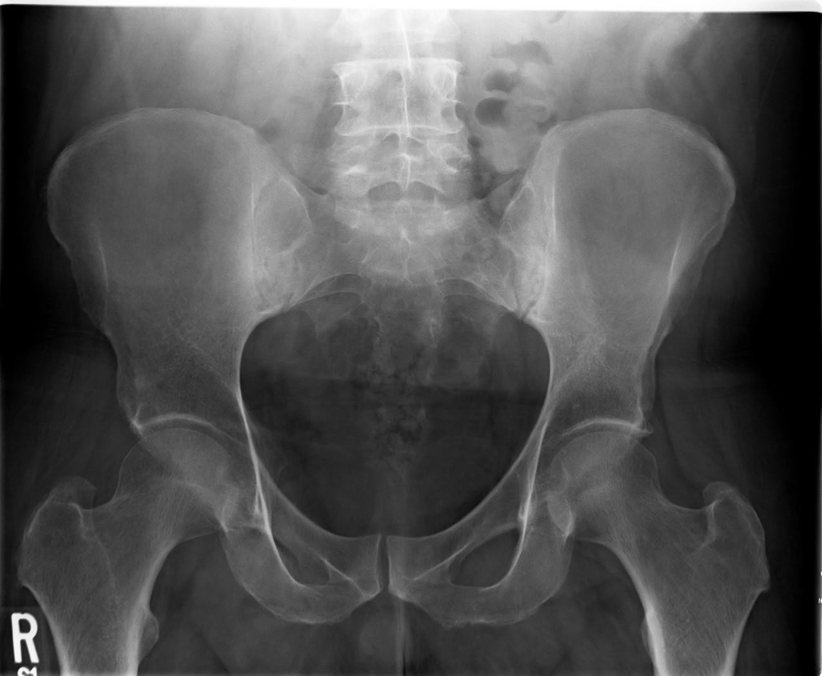
90 kVp
SAIT Imaging library
- Which routine projection of the pelvis is displayed? AP projection
- What positioning error(s) occurred?
  - Rotation
  - Insufficient internal rotation of the right femur
- If the image was repeated, how would you correct the positioning error(s)?
  - Palpate ASIS’s bilaterally until they are parallel to IR; rotate patient slightly towards their left side (patient is in a slight RPO position)
  - Internally rotate the right femur 15-20º to match the internal rotation of the left leg
- How did you identify the positioning error(s)?
  - Obturator foramen are not symmetrical (Left foramen appears larger than the right)
  - Ala are not symmetrical (Right wing appears “wider” than the left)
  - Right lesser trochanter is visualized medial to the body of the femur
- If the image had to be repeated, would you make any other adjustment(s)? Explain your rationale.
  - Move the anatomical marker closer to the ASIS
  - Center a bit more inferiorly (CR should be below ASIS) and increase collimation slightly in the superior-inferior direction

- Use the image below to answer the next five questions:

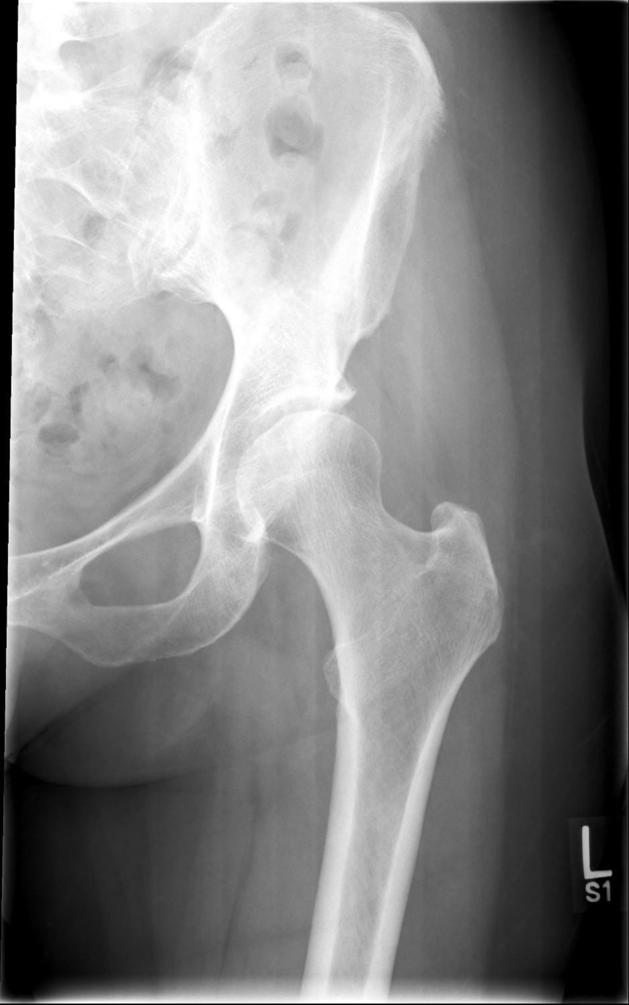
72 kVp

- Which routine projection of the hip is displayed?
AP projection
- What positioning error(s) occurred?
  - Left femur not abducted sufficiently

- If the image was repeated, how would you correct the positioning error(s)?

  - Move the femur laterally
- How did you identify the positioning error(s)?
  - Femoral body not parallel to length of IR

Note: recall on some patients even after a 15-20º internal rotation of the femur the medial edge of the lesser trochanter may still be visualized – as is seen in this radiograph

SAIT Imaging library
- If the image had to be repeated, would you make any other adjustment(s)? Explain your rationale.
  - Increase technique, image is underexposed
  - Slightly decrease collimation side-side (aka. increase field size) as symphysis pubis must be included in the radiograph
  - Center CR more inferiorly and increase collimation superiorly-inferiorly (top of light field should only extend to ASIS)

- Use the 5 evaluation criteria categories when critiquing the following image to determine if it is diagnostic:

Lateral Hip @ 80 kVp
Is this image diagnostic? Yes No

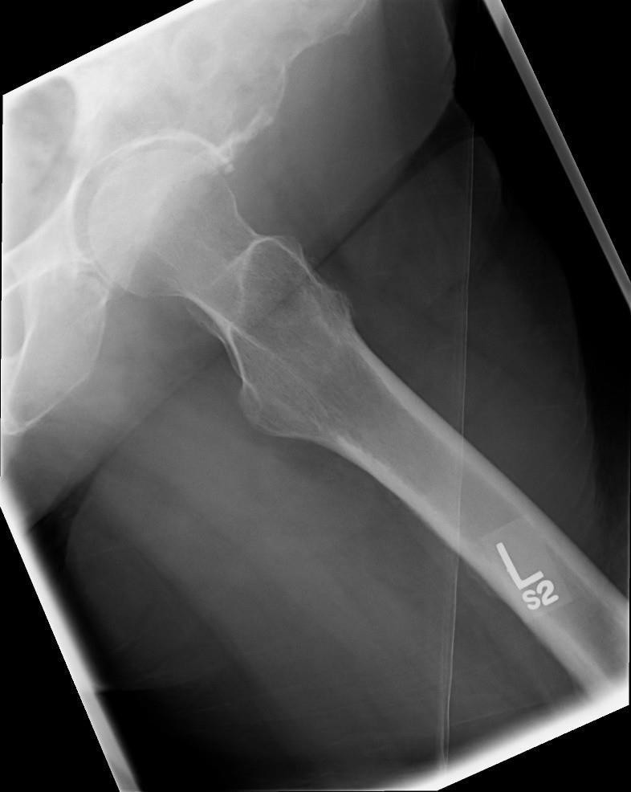
SAIT Imaging library
- Is all the required anatomy included in the radiograph? Yes No
*If no, explain what is required
- Does the anatomical appearance in the radiograph correlate to what is expected from a lateral projection?
Yes No
*If no, explain how the appearance of this radiograph is different compared to the ideal radiograph
- Identify if the appropriate amount of radiation was used to form the image.
Acceptable, Overexposed, Underexposed
  - Is motion present in the image? Yes No
- Identify if the collimated light field was: Acceptable, Too Small, Too Large *side to side entire soft tissues of the thigh are not required
- Was the CR close to the middle of the required anatomy? | Yes | No *CR should be more superior,
over the femoral neck
- Does the marker placement follow Edenbrook Marker Rules?  - Are there artifacts in the image? Yes No | Yes | No *marker is over anatomy
*If yes, could they have been removed? Yes the anatomical marker is a removable artifact

