MRAD 358 – Clinical Integration 1
Fluoroscopy Review – ANSWER KEY

- What structures must be demonstrated on an AP/ PA projection for a single contrast barium enema?

The entire colon including the left and right flexures and rectum.

- Describe the Valsalva maneuver.

Patient is asked to take a deep breath and to hold the breath in while bearing down as if trying to move the bowels.

- What is the patient prep for an upper GI?

NPO from midnight or 8-9 hours prior to exam, no smoking or chewing gum.

- How much, in what direction, and at what level do we angle our tube for a routine image of the sigmoid colon on a prone patient?

30-40º caudad @ the level of the ASIS.

- What are some reasons (indications) for the ordering of an esophogram?

Esophageal varices, achalasia, dysphagia, or hiatal hernia.

- What instructions should be given to a patient following a barium exam?

Drink lots of fluid (more than normal) to flush out the barium which can harden and cause obstructions.

- Why is it important for the patient to follow the preparation instructions prior to a barium enema?

Any retained fecal material may resemble pathology or obscure the viewing of any pathology that may be present.

- The purpose of double contrast exams of the stomach or colon is to better visualize __________.

The mucosal lining of the organ (which enables the viewing of any intraluminal lesions such as polyps or masses).

- What is the patient prep for an esophogram/barium swallow?

There is no prep if they are just having an esophogram/barium swallow.
- What position was the patient in for the image to the right?  The patient was in a right lateral decubitus position. This demonstrates the lateral aspect of the descending colon and the medial aspect of the ascending colon. | 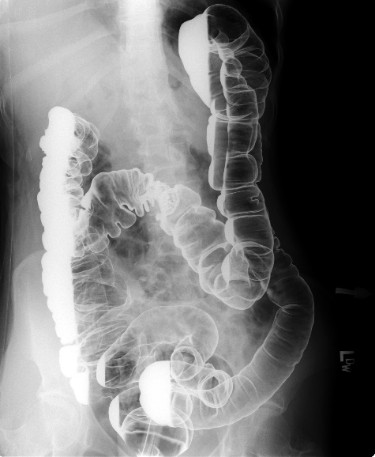

- Identify the anatomy on the image to the right:  - Liver  - Transverse colon  - Hepatic flexure  - Small intestine  - Ascending colon  - Sigmoid colon  - Rectum  - Descending colon  - Splenic flexure | 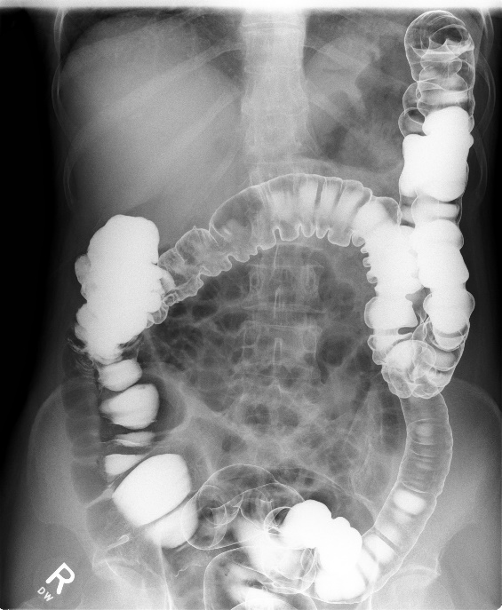  A  B  C  D  E  F  G  H  I

- What are the advantages to laparoscopic cholecystectomy?
Less pain, faster recovery, shorter hospitalization, smaller aesthetic incisions and cost savings.

- What position is the patient placed for a T-tube cholangiography?
15-20 degree RPO – this will allow visualization of the biliary tree without superimposition of the vertebral column.

- Identify the anatomy on the image to the right:  - Right hepatic duct  - Left hepatic duct  - Common hepatic duct  - Cystic duct  - Common bile duct | 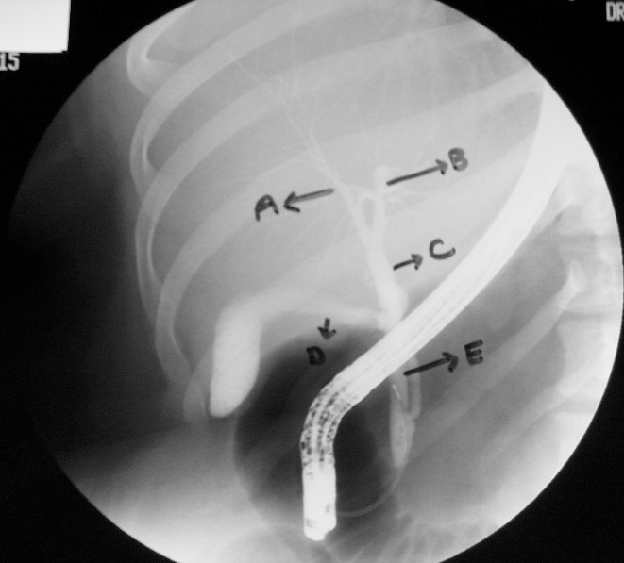

- List the reasons for performing a KUB ?

- To ensure patient preparation for further exams.
- To check position, size, shape and motility of kidneys.
- To demonstrate abnormal calcifications, or extra-renal lesions.
- To assess exposure factors.
- A preliminary view of an IVU

- List the major contraindications to injecting contrast?

Inability to filter contrast from blood (renal failure); patient’s history of allergies; diabetes; renal hypertension; congestive heart failure; prior contrast reaction.

- During an IVU, what are some things a technologist can do to move the contrast out of the kidneys and into the ureters?

- Have patient cough.
- Take the images with the patient in prone position.
- Take the images with the patient upright as kidneys have the greatest motility in this position.
- Apply compression at level of the ASIS

- Identify the exams demonstrated by the following images:

- Endocscopic retrograde cholangiopancreatography (ERCP)
- Operative cholangiogram
- Laparoscopic cholecystectomy
- Post-operative (T-tube) cholangiography
- Percutaneous transhepatic cholangiography (PTC)

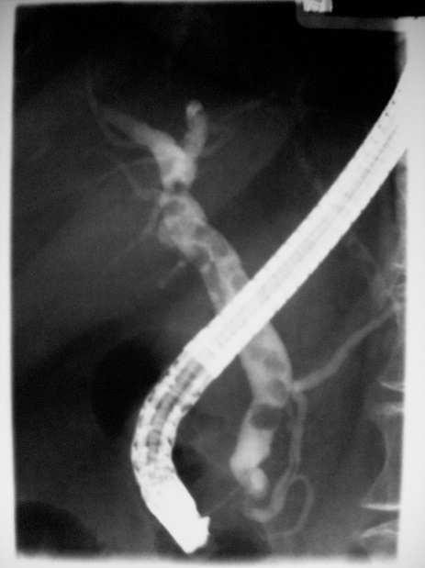  Image A |  | Image B  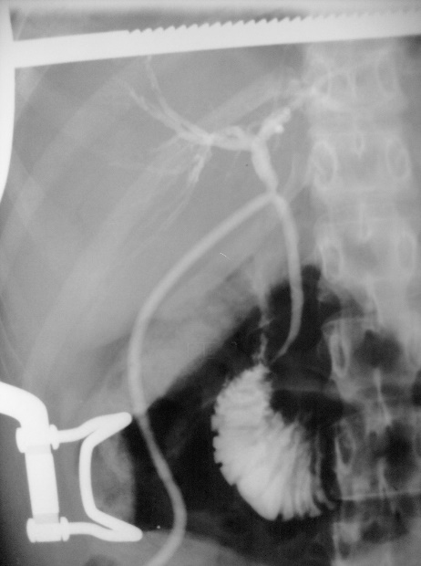 | Image D  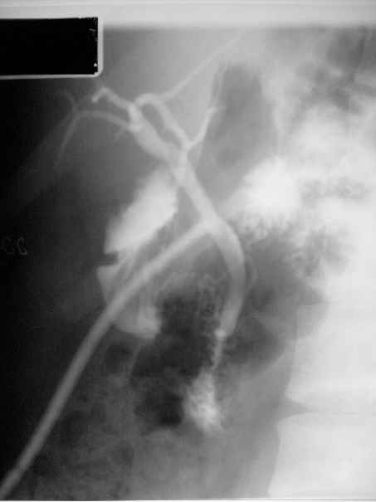

Image C  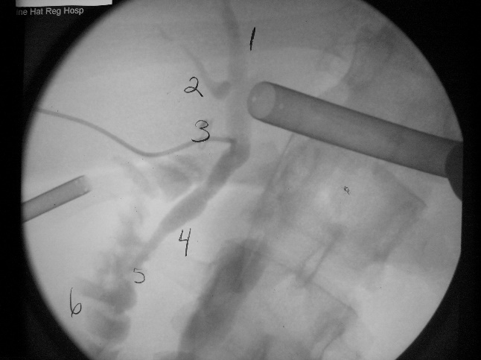 |  | Image E  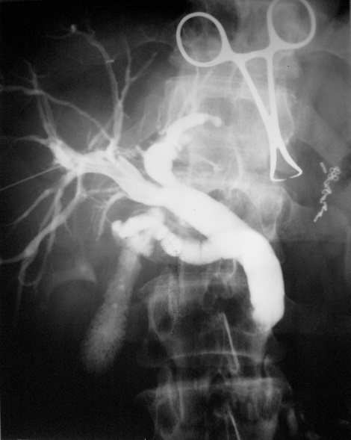

- What are some methods of stone removal?

Extracorporeal Shock Wave Lithotripsy (EWSL) and Percutaneous Nephrolithotomy.

- How is the CR directed for an AP projection of the bladder?

15-20 degrees caudal and entering 2’’ superior to symphysis pubis.

- Radiographically, what are we looking for during a hysterosalpingography?

We are looking for “spill,” i.e. contrast flowing out of the uterine tubes and spilling into the peritoneal cavity. This shows that the fallopian tubes are patent.

- Identify the anatomy on the picture below:

  - Right uterine tube
  - Normal “spill” into peritoneal cavity
  - Speculum
  - Left uterine tube
  - Body of uterus

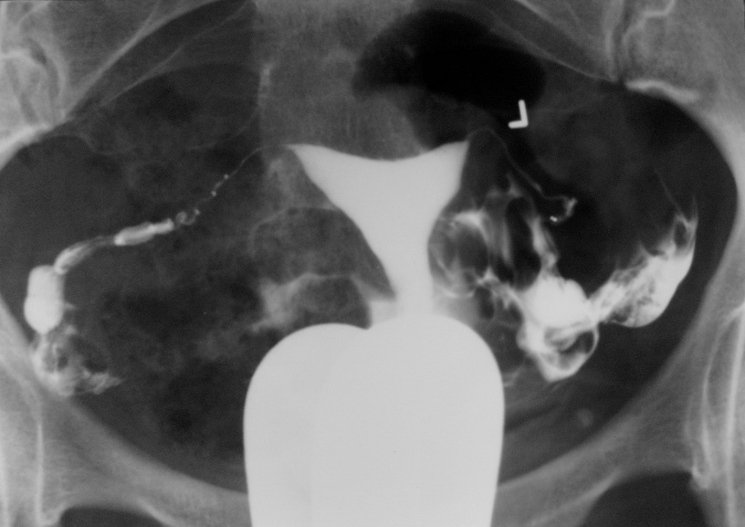
A
B
C
D
E

- Identify the anatomy:
- Renal calyces
- Renal pelvis
- Ureteropelvic junction (UP junction)
- Ureter
- Ureterovesical junction (UV junction)
- Urinary bladder

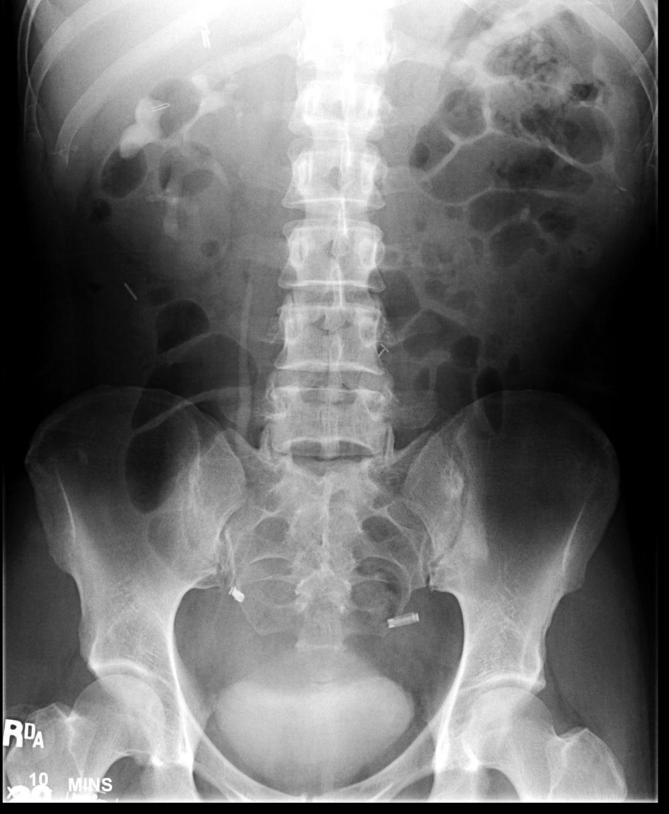
F A
A A
D A
C A
B A
E A

- What are the advantages of digital fluoroscopy over conventional fluoroscopy?

Digital fluoroscopy has a larger dynamic range, and uninteresting structures can be removed from the images through the process of digital subtraction.

- Why does the dose to the patient increase when operating the image intensifier on magnification mode?

During magnification mode, the electrons from the photocathode get focused closer to the input phosphor, and therefore the light photons from the peripheral edges of the input phosphor are not being projected onto the output phosphor, so the brightness of the image would decrease. We must increase exposure factors to maintain the brightness of the image.

- What is the minification gain of a 10/5 dual field I.I. in regular and magnification mode?

Minification gain = input screen diameter²
output screen diameter²

Regular fluoro = 100 magnification mode = 25

Output phosphors are either 2.5 or 5cm. (Bushong: Minification gain section)
Assuming the smaller of the two (2.5) because the output phosphor must be smaller than the smallest input field size. 2.5 squared = 6.25

100/6.25 = 16 (regular) 25/6.25 = 4 (mag mode)

- How would quantum mottle be corrected in a fluoro system that uses a set kVp and a variable mA ABC?

With the kVp set in this ABC unit, the brightness may be adequate but the number of photons or signal is not (the kVp is penetrating but the quantity is not there). If you decrease the set kVp, this will in turn automatically increase the mAs, which is what needs to be done to decrease the quantum noise.

- If we were to decrease the size of the input screen on the I.I. from 23 cm to 15 cm what would result?

A magnified image.

- If you increased the magnification, would the resolution be increased?

Yes; when on magnification, the peripheral edges of input screen are not being utilized and the center of the input screen has increased resolution.

