The timer (30 minutes) starts when the student either selects their patient or when they begin writing notes on the paper provided.

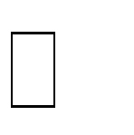



MRT Program

