MRAD 358 – Clinical Integration 1
Computed Tomography (CT) Review – ANSWER KEY

- What should you communicate to all patients prior to an enhanced scan?
The normal reactions to IV contrast administration (voiding sensation, flushed feeling, metallic taste, nausea and/or vomiting). This helps reduce patient anxiety and improves compliance (which reduces likelihood of patient motion during the scan acquisition).
Romans pg. 125-126

- How long should you monitor a high-risk patient post-scan? Identify the type of reaction that warrants this type of monitoring.
1 Hour due to the possibility of a delayed reaction. Idiosyncratic reactions warrant this type of monitoring.
Romans pg. 128

- Why is patient hydration an important consideration?
Level of hydration can affect a patient’s safe dose limits, and increase their risk of developing CIN (if not properly hydrated).
Romans pg. 123

- How would your image be affected if you had to use Optiray 350 instead of Optiray 300?
Higher concentrations are more likely to cause streak artifacts, unless you maintain the level of enhancement by using a slower injection rate & volume.
Romans pg. 156

- Can you utilize a PICC line to administer IV contrast media? Why or why not?
Only specially designed PICCs can be used with a mechanical injection device. They can only be accessed after the caps have been disinfected and dried. The patency must also be checked for blood aspiration, and no resistance. If it is not compatible, a separate standard peripheral IV must be established for contrast administration. If this is not possible, you could decrease the injection rate and perform the injection by hand.
Romans pg. 145-146

- The warming device brings the contrast media to body temperature. True or False?
The warming device only maintains temperature

- Which substance should be loaded into the syringe that has a green display on the control panel and which goes into the syringe with the blue display?
Contrast in green; blue is for the saline

- What can the technologist do to prevent causing an air embolus in the patient?
Clearing air bubbles from the syringes & tubing prior to connecting to the patient (correct preparation & connection of injector syringe & tubing)
Romans pg. 154 & 156
- A vertical plane that passes through the body, dividing it into anterior and posterior portions, is the _____ plane.
  - sagittal
  - coronal
  - axial
  - oblique

- The plane that passes diagonally between the axes of two other planes is the _____ plane.
  - Sagittal
  - Coronal
  - Axial
  - Oblique

- The dorsal cavity can be further subdivided into which of the following cavities?
- Cranial and spinal
- Thoracic and abdominopelvic
- Two lateral pleural
- Abdominal and pelvic

- Which of the following is a parameter that allows for the adjustment of the gray scale?
- CT number
- Hounsfield unit
- Window width
- Window level

- Water is used as a reference tissue and is given the CT number of:
- –1000
- –500
- 0
- +1000

- Slice Thickness in CT is determined by:
  - Technologist setting
  - Focal spot size
  - Collimator width
  - Radiologist preference

- How does noise appear on a CT image?
  - Decreased contrast
  - Increased brightness
  - Graininess
  - Streak artifact

- Increasing the pitch will result in a scan covering more anatomy lengthwise for a given total acquisition time. True or false?
- Patients with asthma must be identified prior to injection of contrast media because:
  - Their renal function may be impaired
  - The contrast media may cause hypertension in an asthmatic patient
  - The risk of allergic reaction is higher
  - The radiologist will cancel the exam

- What is the Scan Field of View?
  - The area within the gantry from which raw data is acquired
  - The size of the computer matrix
  - The collimation applied to the images
  - The region of interest selected by the operator

- Which of the following statements is true?
  - The DFOV cannot be larger than the SFOV
  - The DFOV is a subset of all the scan data available
  - Changing the DFOV changes the pixel size
  - Changing the DFOV does not affect image quality

- What is another name for a bone algorithm?
  - Standard
  - Soft-tissue
  - High resolution
  - High contrast

- The image below is an example of which of the following?
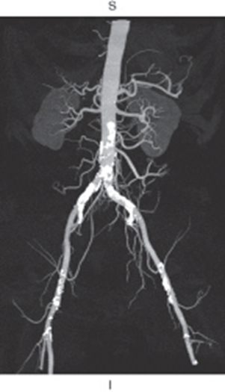
- Multiplanar reformation
- Shaded surface display
- Maximum intensity projection
- Volume rendering

- When would it be beneficial to apply the edge enhancement feature?
To demonstrate small structures of different density or for vascular imaging. The edge enhancement feature produces an edge sharpening effect. Edge enhancement increases image contrast.

- When would it be beneficial to apply the image smoothing feature?
This feature is useful in removing noise from an image. This post processing task will reduce image contrast.

