2.4 Discuss the hazard pictograms.
Hazard pictograms are used to represent the hazard classes. A pictogram is a graphical composition that may include a symbol plus other graphic elements, such as a border, background pattern or colour that is intended to convey specific information.¹ Most hazard pictograms have a square on point solid red border. Inside this border is a symbol that represents the potential hazard.
The exception to this is the biohazardous infectious materials symbol, which remains the same as the prior WHMIS program with the black circle border.
The pictogram immediately shows the worker the type of hazard that is present.

Table 4: Workplace Hazardous Materials Information System (WHMIS) 2015 Hazard Pictograms

Pictogram | Names and Descriptions
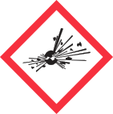 | Exploding bomb  (for explosive, unstable hazards)  Classes:  - Explosives *  - Self-reactive substances and mixtures (Type A, B)  - Organic peroxides (Category A, B)
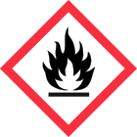 | Flame  (for flammable hazards)  Classes:  - Flammable liquids  - Flammable solids  - Flammable aerosols  - Flammable gases  - Pyrophoric liquids  - Pyrophoric solids  - Pyrophoric gases  - Self-heating substances and mixtures  - Substances and mixtures which, in contact with water, emit flammable gases  - Self-reactive substances and mixtures (Types B-F)  - Organic peroxides (Types B-F)

¹ Globally Harmonized System of Classification and Labelling of Chemicals (GHS), 5th edition, 2013, United Nations, New Yok and Geneva, page 14.

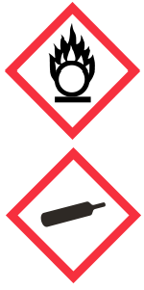
Flame over circle
(for oxidizing hazards)

Classes:
- Oxidizing gases
- Oxidizing liquids
- Oxidizing solids
Gas cylinder
(for gases under pressure)
Classes:
- Gases under pressure
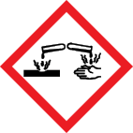 | Corrosion  (for corrosive damage to materials as well as skin, eyes)  Classes:  - Corrosive to metal  - Skin corrosion/irritation – Skin corrosion (Cat. 1, 1A, 1B and 1C)  - Serious eye damage/eye irritation – Serious eye damage  (Cat. 1)
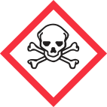 | Skull and Crossbones  (very toxic material that can cause illness/death with small amounts and short exposure)  Classes:  - Acute toxicity – Oral, Dermal, or Inhalation (Cat 1, 2, and 3)
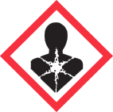 | Health hazard  (for materials that can cause serious health effects)  Classes:  - Respiratory or skin sensitization – Respiratory sensitizer (Cat 1, 1A, and 1B)  - Germ cell mutagenicity  - Carcinogenicity  - Reproductive toxicity  - Specific target organ toxicity - single exposure (Cat 1 and 2)  - Specific target organ toxicity – repeated exposure  - Aspiration hazard

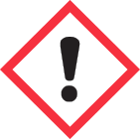 | Exclamation mark  (for materials that can cause health effects less serious than those using the health hazard pictogram)  Classes:  - Acute toxicity – Oral, Dermal, Inhalation (Cat 4)  - Skin corrosion/irritation – skin irritation (Cat 2)  - Serious eye damage/eye irritation – Eye irritation (Cat 2 and 2A)  - Respiratory or skin sensitization – Skin sensitizer (Cat 1, 1A, and 1B)  - Specific target organ toxicity – single exposure (Cat 3)  - Hazardous to the ozone layer*
 | Biohazardous Infectious Material  (for organism or toxins that can cause diseases in people or animals)  Classes:  - Biohazardous infectious materials
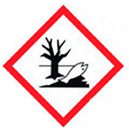 | Environment*  (for materials that can cause damage to the aquatic environment or the ozone layer)  Classes:  - Hazardous to the aquatic environment*

*Note: the Explosive hazard class and Environmental hazard group have not been adopted by Canada’s WHMIS 2015 but they are included as they may be seen on labels or safety data sheets on products in the workplace.

