
Final Exam
Quality Assurance and Control
QUAL 370
Date:
Weight: 30% Marks: ANSWERS

Time Allotted for This Exam:

Do not open this exam booklet until you are instructed to do so.
Student Name:
Student ID:

QUAL 370: Quality Assurance and Control Final Exam Answers

Multiple Choice Questions (X total marks)
- One purpose for obtaining the radiation output (mR/mAs) of X-ray generators is to ensure that the:
- Radiation output of three-phase and single-phase generators is similar
- Reproducibility values are consistent from X-ray room to X-ray room
- Percent linearity between like generators is within 5%
- Radiation output of like X-ray generators is consistent from room to room* Papp p. 98
- What is determined from an mA linearity test?
- A variance in mA selection will have a directly proportional effect on the exposure measured at a given kVp and time.* Papp p. 103
- Same measured exposure is obtained at a given mA selection, irrespective of mAs and kVp selected.
- A variance in mA selection will have an inversely proportional effect on the exposure measured at a given kVp and time.
- There is no known relationship between mA and measured exposure.

- A radiographic room with a positive beam limiting system should not pass if the sum of the absolute values of the differences in the dimensions of the radiation field and the image receptor area exceeds ______% of the focal spot to image receptor distance.
- 2
- 3
- 4* SC 35 pp. 75–12
- None of the above

*Please use the following table to answer questions 5–10

Table 1: Reproducibility Test Results
Exposure Number | Dosimeter Reading | Exposure Number | Dosimeter Reading
1 | 145 mR | 6 | 148 mR
2 | 144 mR | 7 | 148 mR
3 | 144 mR | 8 | 145 mR
4 | 149 mR | 9 | 147 mR
5 | 146 mR | 10 | 150 mR

- Each of the 10 radiation exposures must be within _____% of the ______ value of the 10 measurements.
  - 10%
  - 15%
  - Mean
  - Maximum

- 1, 3
- 1, 4
- 2, 3 * SC 35 p. 24
- 2, 4

*Please use the following table to answer questions 5–10

Table 1: Reproducibility Test Results
Exposure Number | Dosimeter Reading | Exposure Number | Dosimeter Reading
1 | 145 mR | 6 | 148 mR
2 | 144 mR | 7 | 148 mR
3 | 144 mR | 8 | 145 mR
4 | 149 mR | 9 | 147 mR
5 | 146 mR | 10 | 150 mR

- Each of the 10 radiation exposures must be within _____% of the ______ value of the 10 measurements.
  - 10%
  - 15%
  - Mean
  - Maximum

- 1, 3
- 1, 4
- 2, 3
- 2, 4

- Part A:
The Table 1 results are within the acceptable limits for all evaluations.
- True*
- False

Part B: Show your work below for a value of 5 marks.

Mean = 146.6 mR

Mean – max x 100 = 146.6 – 150 x 100 = -2.32%
Mean 146.6

Mean – min x 100 = 146.6 – 144 x 100 = 1.77%
Mean 146.6

Both values are below 15%, which is the acceptable limit.

- The purpose of calculating the coefficient of variation?
- Standard deviation
- To prove the results were not obtained by chance* SC 35 p. 24 ratio of the standard deviation to the mean value of a series of measurements
- To prove there is statistical evidence
- To prove results are within acceptable dose limits

- If the coefficient of variation (C) was 0.0019, this value would be within the acceptance limit.
- True* SC 35 p. 24
- False

- Results of the reproducibility test are compared to:
- Other rooms in the department
- Technique charts
- Acceptance results* Papp p. 97
- All of the above

- If the coefficient of variation is greater than the acceptable limit, the outcome will be:
- Predictable radiographic exposures resulting in consistent radiographic images
- The same results attained every time the same technical factors are used
- Inconsistent radiographic exposures attained by the same technical factors*
- Different technical factors result in predictable radiographic exposures

- In the clinical setting, if the central ray is NOT aligned with the centre of the detector/Bucky, a consequence could be:
- Magnification
- Clipped anatomy* Papp p. 107
- Density variation along anode-cathode axis less than 10%
- Significant anode heel effect on image

- The minimum filtration required for general purpose radiographic systems at a kVp of 110 is:
- 3.2 mm Al
- 3.6 mm Al
- 3.9 mm Al* SC 35 p. 24
- 4.3 mm Al

*Please use Table 2 to answer questions 13–17

Table 2: Leakage Radiation Test Results
Source | mR
Leakage | 0.22
Primary | 275

- What is the percentage of leakage radiation from the data in Table 2?
- 0.08%* activity calculation
- 1.25%
- 8.0%
- 12.5%

- What is the general requirement stated in SC 35 regarding leakage radiation from X-ray tube shielding?
- Not to exceed an air kerma rate of 1.0 Gy/h
- Not to exceed an exposure rate of 115 mR/h* SC 35 p. 80 29.1
- a and b
- None of the above

- When testing for leakage radiation using a paddle, measurements must be taken at a distance of 1 m away from the tabletop.
- True
- False* From the source

- The entire tube housing is commonly lined with lead.
- True
- False*

- Leakage radiation consists of:
- All photons escaping from the tube housing
- All photons escaping from the tube housing excluding those at the port*
- All photons escaping from the tube housing excluding those at the tabletop
- All photons escaping from the tube housing excluding those at the cathode

- Which of the following tests should be performed first?
- HVL
- kVp accuracy*
- mA linearity
- Timer accuracy

- An 8-penny test may also be used to evaluate:
- Collimation* Papp p. 106–107
- Perpendicularity
- Focal spot size
- Grid alignment

*Please use Table 3 to answer questions 19–22
Table 3: mA Linearity Test Results (80 kVp and 100 ms)
mA | mR
50 | 5
100 | 15
200 | 21
300 | 45
500 | 69
600 | 103

- Calculate the percent linearity of the entire mA range of this generator.
- 1.14%
- 2.65%
- 11.3%
- 26.5%* Papp p. 103

- The main purpose of this test is:
- To determine the radiation output* Papp p. 103
- To determine the amount of filtration in the tube
- To determine the accuracy of the mAs settings
- To determine the consistency of exposures

- Why is this test important?
- Allows us to use linearity law
- Allows us to use repeatability law
- Allows us to use 15% rule
- Allows us to use reciprocity law* Papp p. 103

- Ideally, how many exposures are required at each mA setting to obtain accurate data?
- 3
- 5
- 10*
- 15

*Please use Graph 1 to answer questions 23–27
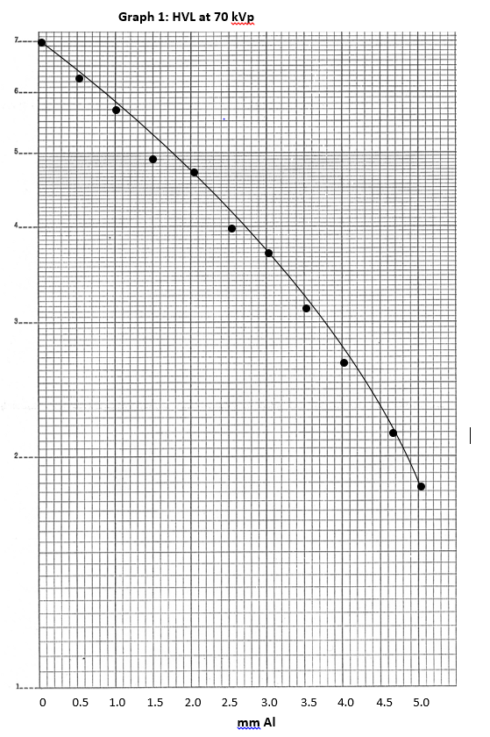

- What is the HVL for the tube tested in Graph 1?
- 2.2 mm Al
- 2.5 mm Al
- 3.2 mm Al*
- 3.5 mm Al

- In accordance with the SC 35, has the minimum requirement for HVL been met for this tube?
- Yes*
- No

- What is the quantity of inherent filtration in the tube?
- 2.5 mm Al equivalent
- 3.2 mm Al equivalent
- 3.5 mm Al equivalent
- There is insufficient information to determine this*

- HVL is dependent on:
  - kVp
  - Total shielding
  - Type of generator
  - mAs
  - Total beam filtration

- 1,3,5* Papp pp. 98–99
- 1,2,3
- 1,4,5
- All of the above

- What values are plotted on the y-axis of the graph?
- mm Al thickness
- Exposure* Papp pp. 98–99
- mGy/mA
- Amount of filtration

- Three benefits of a quality assurance program include reduced equipment down-time, decreased patient dose and decreased department morale.
- True
- False* SC 35 pp. 38–41

- Who is ultimately responsible for the radiation safety of a diagnostic X-ray facility?
- The manufacturer
- The government
- The radiographer
- The owner* SC 35 p. 7

- Quality assurance focuses on:
- Technical factors that can lead to variation in quality care.
- Medical factors that can lead to variations in quality care.
- Managerial factors that can lead to variations in quality care.
- Human factors that can lead to variations in quality care.* Papp p. 7

- What is quality control?
- An aspect of quality assurance to optimize the performance of the operator.
- An aspect of quality assurance that monitors the technical components of the imaging systems.* Papp p. 7
- All activities that provide confidence in radiology services.
- A method of controlling the radiographic experience from start to finish.

- A technologist using dosimeters in quality control testing falls into the category of:
- Level I: noninvasive and simple
- Level II: noninvasive and complex* Papp p. 7
- Level III: invasive and complex
- All of the above

- Which of the following tools evaluates the relationship between the central ray and the field of exposure?
- Densitometer
- Collimator test tool
- Synchrometer
- Beam alignment test tool* Papp p. 107

- According to the SC 35, cassettes must be inspected and cleaned daily.
- True
- False* SC 35 p. 45

- Identify the following test pattern:
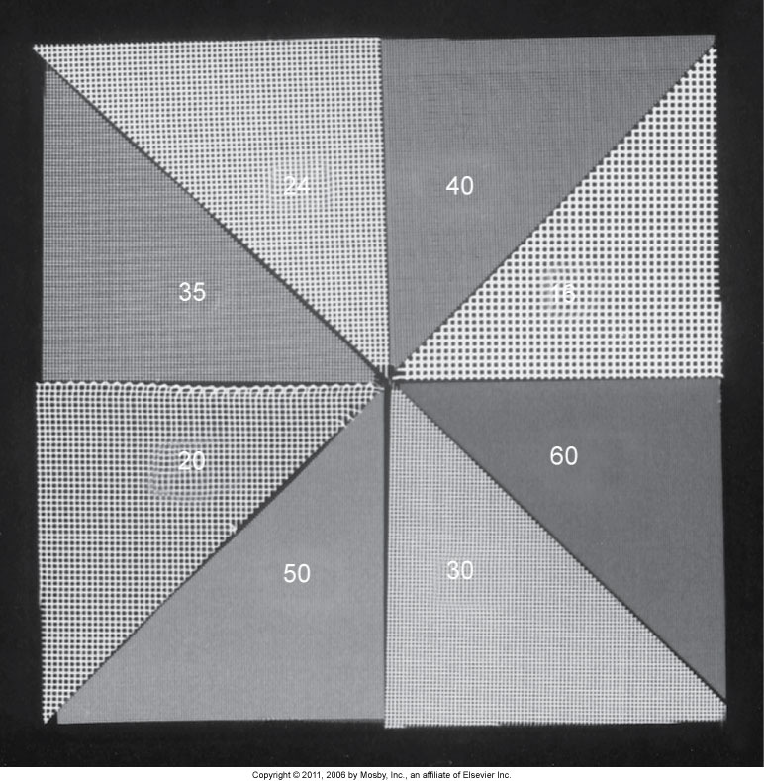
- High-contrast resolution* Papp p. 131
- Low-contrast resolution
- Line pair/mm
- Image lag

- Which of the following statements regarding half value layer is true?
- HVL represents the amount of aluminum filtration in the primary beam
- HVL represents the amount of aluminum required to decrease the intensity of the primary beam by half* Papp p. 98
- A high HVL indicates that the primary beam has insufficient penetrability
- HVL must be equivalent to at least 2.5 mm of aluminum at any given kVp

- The test which demonstrates that the dose remains constant between exposures when the same mA, time and kVp are selected is:
- Linearity
- Reproducibility* Papp p. 97
- Wave form accuracy
- Generator congruency

- Light field–radiation field congruency can be tested:
  - Using a collimator template test tool
  - Using a nine-penny test
  - To ensure that the central ray is perpendicular to the IR
  - To ensure structures that are in the light field are included in the radiation field
- 1
- 1,2
- 1,2,4* Papp p. 105
- All of the above

- Lead aprons, gloves and shields should be inspected periodically. When using fluoroscopy to test lead apparel, the cracks would appear _______ on the monitor.
- As dark areas
- As bright areas*
- Large
- As fuzzy areas

- According to the SC 35, the minimum lead equivalent for protective gloves is _______ and for gonadal shielding is _________.
- 0.25 mm; 0.25 mm* SC 35 p. 35
- 0.35 mm; 0.5 mm
- 0.5 mm; 0.35 mm
- 0.25 mm; 0.5 mm

- What does the linearity test determine?
- A generator must be repeatable with reasonable limits every time you change technique and then come back to the same kVp, mA and exposure time
- Measurements made under the phantom are more sensitive to changes in the kVp than those made in the air
- The output of the X-ray tube using mR/mAs for various mA and timer station combinations* Papp p. 103
- Radiographs are made with extremely low energy radiation

- What is the outcome if the reproducibility results between consecutive measurements are above 20%?
- Change in radiographic density
- Change in radiographic contrast
- No change, this is within the acceptable limit
- a and b* Papp p. 97

- HVL is checked routinely because:
- Softer X-rays can damage the equipment
- A decreased HVL can increase patient dose* Papp p. 98
- An increased half value layer means an increased patient dose
- The dose to the patient drops dramatically as the half value layer is decreased

- What may be a consequence in the clinical setting if kVp accuracy deviates by 15%?
- There will be a change in the field congruency
- There may be a change in the image contrast* Papp p. 99
- There will be no change in patient dose
- No change, this result is within the acceptable limit

- Performance testing of fluoroscopic systems must include all the following except:
- X-ray tube housing
- Automatic film processor* Papp p. 128
- Total filtration
- Automatic brightness control

- Which type of test tool may be used to demonstrate pincushion distortion?
- Dosimeter
- Wire mesh tool* Papp p. 123
- Ion chamber
- Homogenous phantom

- Quality control tests of fluoroscopic systems must be performed:
- Daily
- Weekly
- Semiannually
- Annually* SC 35 p. 52

- At any combination of tube potential and current, fluoroscopic equipment with an automatic brightness control should not produce an air kerma rate exceeding ________ mGy/min
- 20
- 50
- 100* SC 35 p. 54 Y20
- 150

- Automatic Brightness Control works by:
- Variable kVp, constant tube current
- Constant kVp, variable tube current
- Constant kVp, constant tube current
- Variable kVp, variable tube current* Papp p. 123

- Automatic Gain Control works by:
- Constant kVp, variable tube current
- Constant kVp, constant tube current
- Variable kVp, variable tube current
- None of the above* Papp p. 122

- Technologist responsibilities in bone mineral density include quality control through:
- Daily phantom scans*
- Generator testing
- Daily dose calibrations
- All of the above

- The recommended testing frequency of kVp variance for mammographic X-ray generators is:
- Weekly
- Monthly
- Semi-annually
- Annually* SC 36 3.6 A1

- The recommended testing frequency of variation for accuracy of exposure time on mammographic X-ray generators is:
- Weekly
- Monthly
- Semi-annually
- Annually* SC 36 3.6 A8

- In mammography, retake analysis is performed:
- Daily
- Weekly
- Monthly*
- Semi-annually

- Quality control testing on mammography equipment is performed by:
- Technologists
- QC technologist
- Medical physicist*
- All of the above

- Which of the following is found inside the image receptor used for a CR system?
- Intensifying screen
- Duplitized film
- Imaging plate* Papp pp. 140–141
- All of the above

- Which of the following is an advantage of CR versus film/screen radiography?
- Lower patient dose
- Higher-contrast resolution
- Edge enhancement
- All of the above*

- Which of the following are components of a CR system?
  - Image receptors
  - Reader unit
  - Workstation
- 1 and 3
- 2 and 3
- 1 and 2
- 1, 2 and 3

- Which of the following artifacts occurs as a result of patient motion during an exposure?
- A processing artifact
- An exposure artifact*
- A handling artifact
- No artifact

- In departments with a quality management program in place, the greatest number of repeats is due to which of the following?
- Equipment problems
- Image fog
- Patient motion
- Positioning error* Papp p. 178

- Which of the following artifacts can occur in both CR and film/screen radiography?
- Static electricity
- Wet-pressure sensitization
- Moire pattern* Papp p. 184
- Water spots

- If a department performs 1,853 views during a 1-month period and 137 are repeated, the department repeat rate is which of the following?
- 9.37%
- 14.8%
- 7.4%* Papp p. 180
- 4.8%

- Which of the following factors does NOT affect the brightness of fluoroscopic images?
- mA
- kVp
- Patient thickness and tissue density
- Time (ms)* Papp p. 123

- A pattern from the Society of Motion Picture and Television Engineers can be utilized to evaluate electronic display devices.
- True* Papp p. 159
- False

- Which of the following terms describes a person, department or organization that needs or wants a desired outcome?
- Supplier
- Input
- Avenger
- Customer* Papp p. 9

- Examples of things covered under an operating budget for a diagnostic imaging clinic include all except:
- Technologists
- Administrative staff
- Hand sanitizer
- CR to DR conversion*

- Smudge static can occur on a CR plate in very low humidity environments.
- True
- False* Papp p. 185

- General radiographic X-ray tubes and mammographic X-ray tubes both use a thin glass or beryllium window which is less likely to absorb the lower energy X-rays.
- True
- False* Papp p. 195

- This is an image of an AAPM TG-18 QC test pattern:
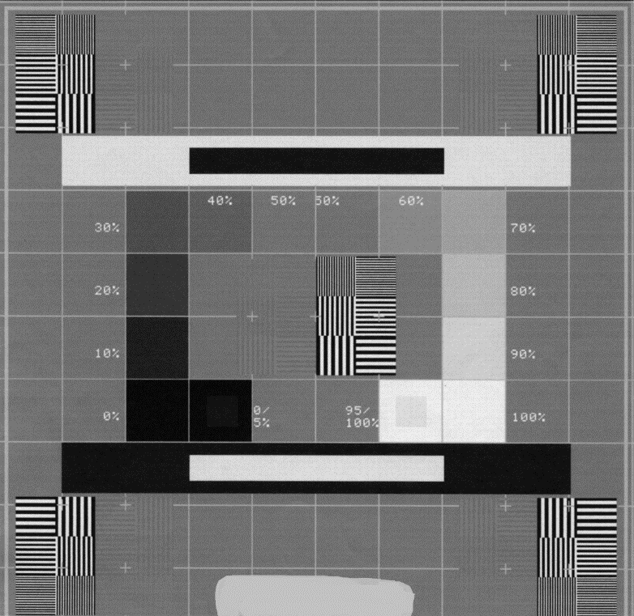
- True
- False* Papp p. 159

- What could cause collimation to be out of alignment?
- Routine handling of tube housing
- Power surge through tube head
- O-ring degradation due to heat within tube housing
- Mirror shifting over time* Papp p. 105

