CT Imaging of the Abdomen & Pelvis CT Imaging of the Spine

Part 1 – Anatomy
- Describe the major artery supplying blood to the abdominal organs and list its identifiable braches.
The abdominal aorta is the major artery of the abdomen (once the descending aorta passes
through the diaphragm it is called the abdominal aorta). It’s major branches:
  - Inferior Phrenic
  - Celiac Trunk / Artery – gastric, splenic, hepatic
  - Superior Mesenteric
  - Renal arteries
  - Inferior Mesenteric

- Describe the major vein draining blood of the abdominal organs and list its identifiable branches.
The inferior vena cava is the major vein of the abdomen. It’s major branches:
  - Renal Veins
  - Portal Veins
  - Hepatic Veins

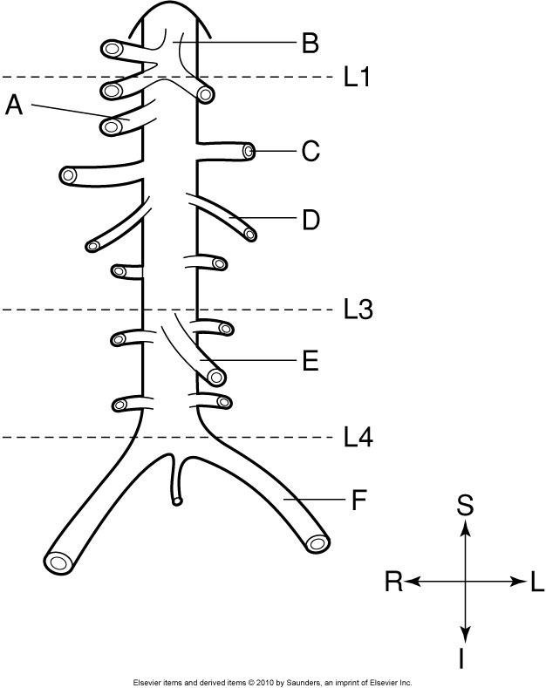
- Label the branches of the abdominal aorta:

- SMA
- Celiac trunk
- Left renal artery
- Left gonadal artery
- IMA
- Left common iliac artery

- At L4, the abdominal aorta bifurcates into which two vessels? Right and Left Common Iliac Arteries
- At what vertebral level does the IVC pass from the abdomen into the mediastinum? What is this opening called?
Caval Hiatus of the diaphragm at level of T8.
- What two vessels join to form the IVC? Right and left common iliac veins
- At the level of the origin of the SMA, what is the SMA’s relationship to the splenic vein? To
the left renal vein?
Splenic vein is anterior to the SMA
Left Renal vein is posterior to the SMA (sits between the SMA and the aorta)

- What term is used to describe the location of organs in the abdominal cavity that have peritoneum only on the anterior surface?
Retroperitoneal
- What anatomical structure marks the division between the right and left lobes of the liver? Falciform Ligament

- What separates the posterior caudate lobe from the more anterior quadrate lobe? Porta Hepatis

- What vessel supplies the liver with oxygenated blood? Hepatic Artery
- Describe the relationship of the gall bladder to the liver. Sits between the quadrate lobe and ligamentum teres.
- Describe the regions of the stomach and their relationships (ie – which is most superior, anterior, etc.)
Two curvatures – lesser directed to the right, and greater directed to the left.
Cardiac Portion – most superior, the portion where the esophagus enters the stomach. Fundus – rounded upper, posterior portion of the stomach.
Body – Mid portion, between the fundus and pylorus.
Pylorus – most inferior, anterior portion, empties into the small bowel.
- List and describe the segments of the small intestine.
Duodenum is proximal portion, c-shaped wrapping around the head of the pancreas. about 25 cm long.
Jejunum is middle portion. Tightly coiled and located in the umbilical region, it is indistinguishable from the ileum.

Ileum is distal portion and continuous with the jejunum. Terminates in the RLQ at the ileocecal valve.

- List and describe the segments of the colon.
Cecum – located in the right iliac region of the abdomen, about 5-7 cm past the ileocecal valve. Attached to the appendix.
Ascending Colon – extends superiorly along the right side of the abdomen to the liver, along the posterior abdominal wall. It then turns sharply to the left, the hepatic or right colic flexure.

Transverse Colon – Extends across the abdomen from the right colic flexure to the left colic flexure (splenic flexure). It is the longest part of the colon. Runs along the anterior aspect of the abdominal wall.
Descending colon – Extends from the splenic flexure downwards until the level of the iliac crests, runs along the posterior wall of the abdomen.
Sigmoid Colon – continuous with the descending colon after the level of the iliac crests, curves into the midline at the level of the pelvic brim.
Rectum – Extends in the midline from the sigmoid colon to just below the tip of the coccyx (on average, 12 cm in length). The rectum turns dorsally to become the anus.

- Where is the spleen located?
In the left upper quadrant, posterior to the stomach. It is protected by the 9th, 10th and 11th ribs.
- The splenic vein is usually easy to see on an axial CT image. Where does it sit?
The splenic vein is large in size and passes along the posterior border of the pancreas as it travels from the spleen to the IVC.
- The pancreas extends between which two organs? Duodenum and spleen

- Which portion of the pancreas is the most superior and posterior? Tail / Distal segment
- Describe the relationship of the IVC to the abdominal aorta. The IVC is anterior and to the right of the abdominal aorta.

- Label
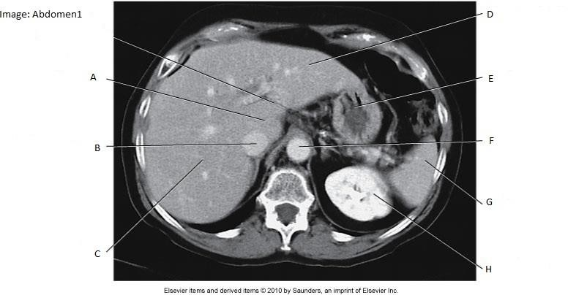
  - Caudate Lobe of Liver
  - IVC
  - Right lobe of liver
  - Left lobe of liver
  - Stomach
  - Aorta
  - Spleen
  - Left kidney

- Label
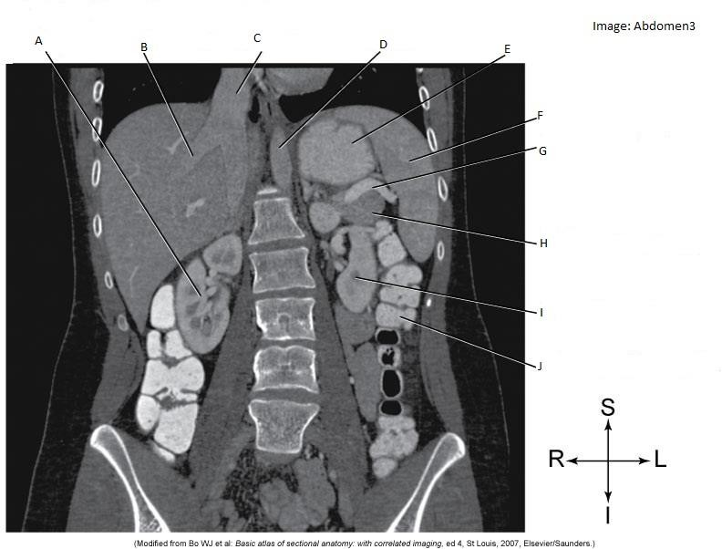

  - Right Kidney
  - Hepatic Vein
  - IVC
  - Abdominal Aorta
  - Stomach
  - Spleen
  - Splenic vein
  - Tail of pancreas
  - Left Kidney
  - Descending Colon

- Label:
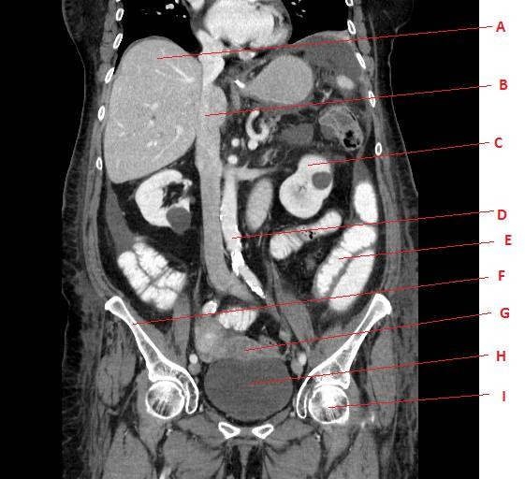

  - Liver
  - Inferior Vena Cava
  - Left Kidney

  - Abdominal Aorta
  - Small Intestine
  - Right Ilium
  - Uterus
  - Urinary Bladder
  - Left femoral head

- Label
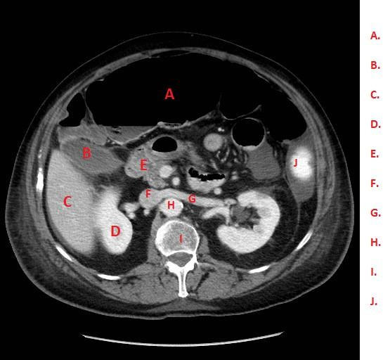
- Transverse Colon
- Gall Bladder
- Liver

- Right Kidney
- Duodenum
- IVC
- Left Renal Vein
- Abdominal Aorta
- Thoracic Vertebrae
- Spleen

- Label the image:

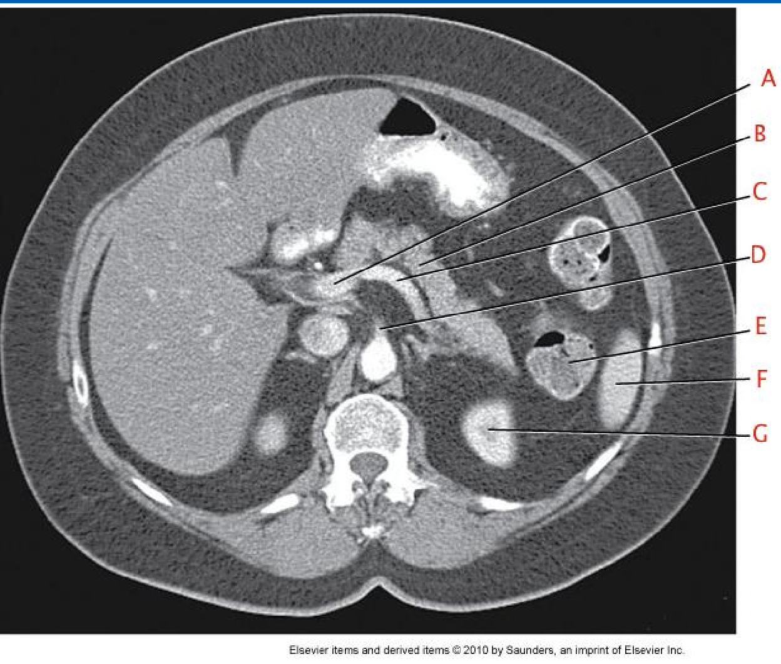
A – Portal Vein
B – Pancreas
C – Splenic Vein
D – Superior mesenteric Artery
E – Descending colon
F – Spleen
G – Left kidney

- Label the image:
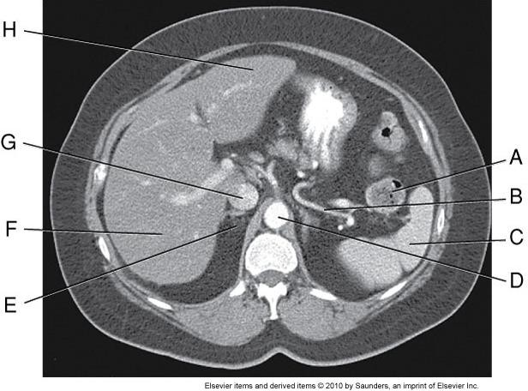

A – Splenic flexure / left colic flexure / descending colon
B – Splenic Artery
C – Spleen
D – Abdominal Aorta
E – Rt adrenal gland
F – Rt lobe of liver
G – IVC
H – Left lobe of liver

- What are the unique features that distinguish each type of vertebra?

All vertebrae are composed of a body, vertebral arch, transverse process, spinous process, pedicle, lamina and inferior and superior articular processes.
Cervical vertebrae – transverse foramina within the transverse process, bifid spinous processes (except C7).
Thoracic vertebrae – costal facets for rib articulator and long, pointed spinous processes Lumbar vertebrae – large bodies, short and blunt spinous processes

- What special names are given to C1 and C2? C1 – atlas, C2 – axis
- What are the two parts of an intervertebral disc? Which is the inner portion and which is the outer portion?
Soft central core – nucleus pulposis Firm outer ring – annulus fibrosis
- What is the purpose of curvatures in the vertebral column?
Increase the strength and resiliency and flexibility of the spine. Cervical and lumbar posterior curves develop when an infant starts to hold their head up and when they start to walk/stand.

- At what level does the spinal cord terminate infereiorly? What structure(s) are present in the vertebral canal inferior to the spinal cord?
Terminates at the level of L1. Inferior to L1 is a triangular conus medullaris, which extends down and forms a collection of spinal nerves called the cauda equina.
- What is in the subarachnoid space around the spinal cord? CSF
- What type of tissue makes up the spinal cord?

A core of grey matter (shaped similar to a butterfly) surrounded by white matter. The white matter contains bundles of myelinated nerve fibers called nerve tracts.

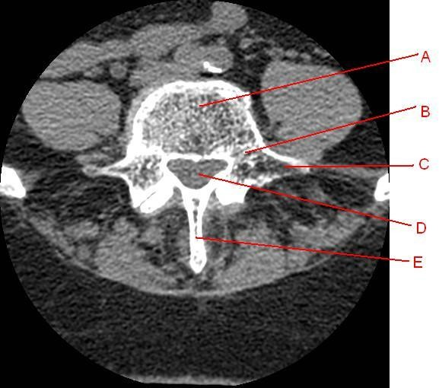
- A) Label the image:
  - Vertebral body
  - Pedicle
  - Transverse process
  - Vertebral canal
  - Spinous Process

B) In what plane is this image? What section of the spine is this? (C, T, L)?
Axial plane. Lumbar spine (L2)- short blunt spinous process, surrounded by the psoas muscle. Inferior to the termination of the spinal cord (not seen within the vertebral canal)

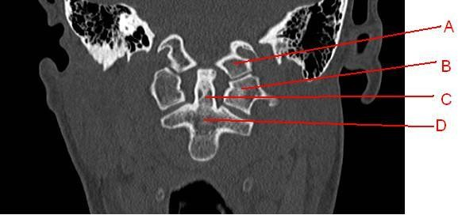
- Label the image:
  - C1
  - Lateral Mass of C1
  - Odontoid Process
  - C2

- Label the image:

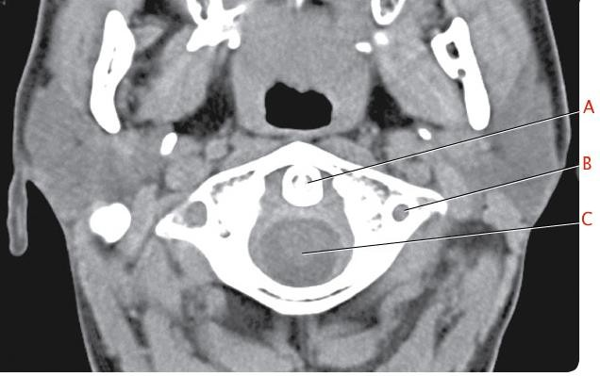

  - Odontoid Process
  - Transverse Foramen
  - Spinal Cord

- Label the image:

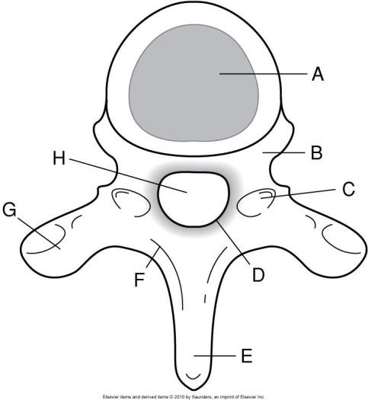
- Vertebral Body
- Pedicle
- Vertebral foramina
- Posterior arch
- Spinous Process
- Lamina
- Transverse process
- Vertebral foramen

- Label the images:
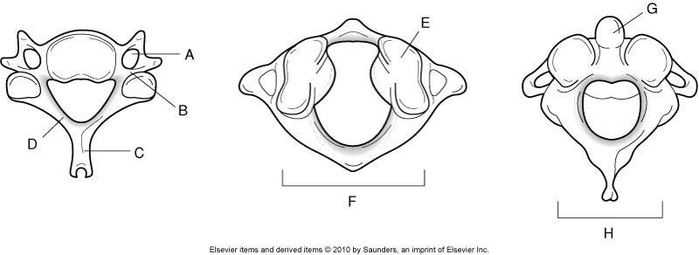
  - Transverse foramen
  - Pedicle
  - Spinous Process
  - Lamina
  - Superior Articular Process
  - Posterior Arch
  - Dens
  - Spinous Process

Part 2 – Procedures

- List at least 3 benefits of using oral contrast for a CT Abdomen & Pelvis. Demonstrates interstitial lumen, distend GI tract, differentiate between a fluid-filled bowel loop and a mass or abnormal fluid collection.

- How much oral contrast should be given for a CT Abdomen & Pelvis?
Minimum 600 ml, 900 is typical for best bowel opacification. Patient compliance is often the limiting factor.
- What low-attenuation contrast agents are commonly used for CT Abdomen & Pelvis? Describe their use.
Air – insufflate the colon for CT colonography, provide high negative contrast.

Water – (or low HU barium) will not obscure mucosal surfaces or superimpose abdominal vessels on post-processed images. Also will not mask a radiopaque stone.
- List at least 3 benefits of using IV contrast for a CT Abdomen & Pelvis. Opacify blood vessels
Increase CT density of vascular abdominal organs Improve contrast between lesions and normal structures

- What is a routine, soft tissue window setting for a CT Abdomen & Pelvis? WW 350 - 450 WL 50
- What is a liver window setting, and what will the setting demonstrate?
WW 150 WL 70. Narrower window better demonstrates subtle liver lesions.
- What setting does the technologist control, that improves comparison to previous CT Abdomen & pelvis studies?
DFOV – set the same DFOV as the previous study.

- What is the patient position for a CT Abdomen & Pelvis?
Supine, feet first, scan superior – inferior. Arms over head, pillow under knees.

- List 4 common causes of involuntary motion artifact on CT Abdomen & Pelvis scans, and what can be done to minimize motion?
Cardiac motion, respiratory motion, vessel pulsation and bowel peristalsis. Management – fast acquisition time, helical scanning, suspend respiration.
- What is the approximate CT number of a normal liver?
38 – 70 HU. A healthy liver is at least 10HU greater than the spleen.

- Fatty infiltration of the liver attenuation of the liver. Reduces

- In what phase is fatty infiltration of the liver best demonstrated? NECT

- Describe a hemangioma, and how it appears on CT.
Benign tumor of the liver, usually solitary but can have multiple lesions. On NECT, it appears as a well-defined, hypodense mass. On CECT, the lesion shows pooling of contrast around the lesion’s periphery. After a longer delay, the lesion fills from the periphery eventually becoming uniformly enhanced.

- What is the contrast protocol for a RAP?
125 ml at 3 ml/sec with 50 ml saline flush. Scan delay 65 seconds. Oral contrast: 900 ml barium sulfate (or water-soluable), 1-2 hrs prior to scanning. Final 225ml given just prior to scanning.
- What phase is a RAP scanned in, as described above? Venous Phase
- What is the IV contrast protocol for a multi-phase liver, and what phases are scanned? 125ml at 4ml/sec, with 50 ml saline flush.
Phase 1 – NECT
Phase 2 – 35 sec for hepatic arterial phase Phase 3 – 65 sec for portal venous phase
- What is the IV contrast protocol for a multi-phase pancreas, and what phases are scanned?
125 ml at 4 ml/sec, with 50 ml saline flush. Phase 1 – NECT
Phase 2 – 40 sec for Late Arterial phase Phase 3 – 65 sec for portal venous phase

- List 3 indications for a RAP.
Abdominal mass, tumor staging, abscess
- List 3 indications for a CAP. Infection, mass, trauma
- What is the main difference between a Routine CECT Abdomen & Pelvis, and a CECT Abdomen & Pelvis for appendicitis?
Thin slices

- List one indication (and an example of the clinical history) for an NECT Abdomen & Pelvis (or CT KUB).
? kidney stone/calculi. History = flank pain or renal colic

- List 3 positive indications for an appendicitis on CT images. Dilated, non-opacified appendix
Soft-tissue inflammation in the fat around the appendix (also called stranding)

Presence of appendicolith (calculi) within the appendix.
- List the two most common indications for NECT spine examinations. Fracture, Dislocation

- Describe CT myelography
Administer intrathecal contrast into the subarachnoid space, patient waits 1-3 hours to allow contrast to sufficiently dilute. Patient is scanned 1-3 hours following intrathecal contrast injection.

- List 2 indications for CT myelography.
Intradural/extradural abnormalities, spinal stenosis, DDD, extradural neoplasm.
- What anatomy should be included for a NECT cervical spine? Skull base – mid T1 (unless level indicated)

- What anatomy should be included for a NECT thoracic spine? Above T1 – Below T12 (unless level indicated)
- What anatomy should be included for a NECT Lumbar spine? Above L1 – Below S1 (unless level indicated)

- What SFOV should be used for CT spine? Large body
- What is the advantage of performed helical scans of the spine? Short acquisition time, 3D post processing capability
- What are the bone window settings for CT spine? WW 2000 WL 500
- What mA setting is used for the cervical spine? Why?
mA averages between 125 – 325. Use Auto mA, large tissue difference between upper C-spine, mid cpsine and within the shoulders so the mA required will vary.

- What is a contraindication for CT spine?
Pregnancy (weigh risk vs. benefit), and potentially extensive hardware in the spine.

