Activity: Test 16 Fluoroscopic kVp Accuracy Procedure

Purpose
This activity will help you identify the procedure steps for this test.

Instructions
- Review the images below of the equipment and materials used at Edenbrook for this test.
- Review the procedure steps from the Edenbrook MRT lab.
- Compare this procedure, the textbook reading and your practicum site QA manual for similarities and differences between a C-arm and dedicated fluoro unit.

Equipment
- Dosimeter
- Digital kVp meter (if dosimeter does not have kVp function)
- Lead apron

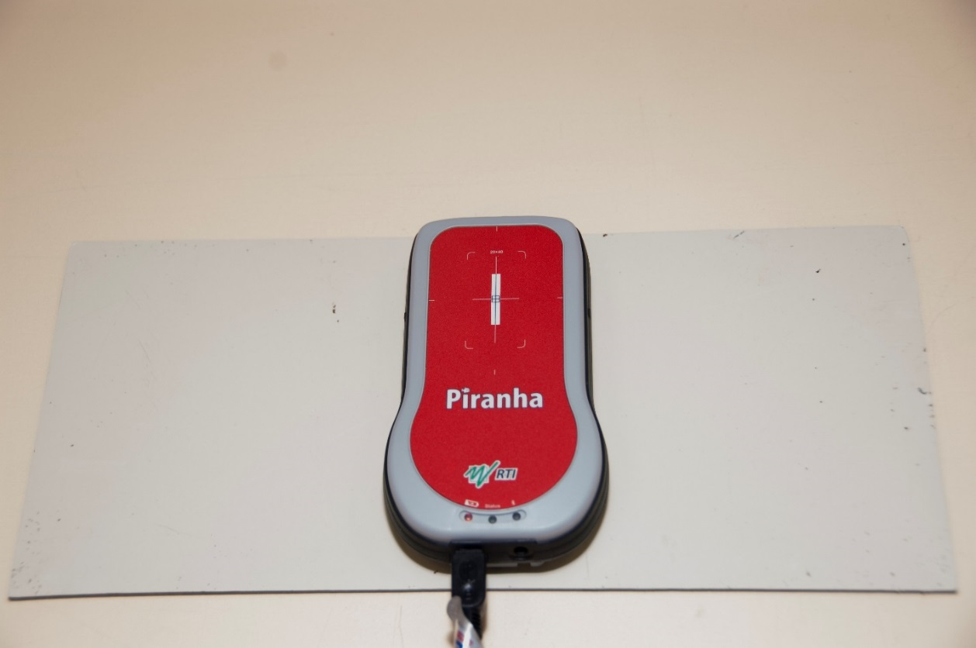

Edenbrook MRT Procedure Steps (Note: using C-arm at Edenbrook is limited by equipment)
- Position the C-arm with the image intensifier under the table.

- Place a lead apron or lead sheet on the table to absorb any back scatter. Position the dosimeter on top of the lead and centre it to the X-ray tube. Collimate to include the entire chamber.

- Set the kVp to 60.

- Expose for 2 seconds and record the reading. Repeat the exposure once more and record the reading.

- Repeat step 4 for the following kVp settings: 70, 80, 100.

