Activity: Biological Aspects of Exposure – ANSWER KEY

- Define LET
- Linear energy transfer is a measure of energy deposited along the path (track) of ionizing radiation as it travels through matter. LET is the average energy deposited per unit length of track. It is described in units of kEv/µm (kiloelectron volts per micron)
- As LET increases, the likelihood of a biologic response increases. As the probability of biologic response increases, the chance of interaction with DNA also increases.

- Explain the significance of Low-LET and High LET
Low LET
- X-rays and gamma rays are both low LET
- Low LET radiation primarily causes damage indirectly by producing free radicals

High LET
- Alpha particles, ions of heavy nuclei, charged particles released from interactions btw neutrons and atoms
- They exhaust their energy quickly and so are not able to travel very far in tissue.
- High LET is more destructive to biological matter than low LET
- Risk of damage to DNA is increased

- Define RBE
- Relative Biologic Effectiveness is the comparison of radiation with differing LET’s abilities to produce the same biologic reaction.
- RBE = Dose of standard radiation necessary to produce a given effect
Dose of test radiation necessary to produce the same effect

- Define OER
- Oxygen Enhancement Ratio is the ratio of radiation dose required to cause a particular biologic response of cells or organisms in an oxygen-deprived environment to the radiation dose required to cause an identical response under normal oxygenated conditions
- OER = Radiation dose required to cause biologic response without O₂
Radiation dose required to cause biologic response with O₂

- Define Protraction and Fractionation
- If the dose is delivered continuously but slowly, it is protracted.
- If the dose is delivered at the same dose rate in equal fractions or parts it is fractionated.

- What is the difference between somatic and genetic cells?
- Somatic Cells
  - All cells in the body except male/female germ cells
  - If enough of these cells are affected, entire body processes can be disrupted
  - Early somatic effects
    - Epilation, skin erythema, hematologic depression
  - Late somatic effects
    - Radiation induced malignancies, cataracts
- Genetic Cells
  - Reproductive cells
  - If damaged by radiation the damage can be passed to future generations in the form of mutations in the genes. Can lead to defects in the offspring.

- What are the three major effects of irradiation of macromolecules?
- Main-Chain Scission
  - Reduces size of macromolecule, makes the solution thinner
- Cross-Linking
  - Spurs on the molecule attach to other molecules, makes solution thicker
- Point Lesions
  - Disruption in single chemical bond

- Describe the process of radiolysis of water.
- An x-ray photon interacts with a water molecule and creates an ion pair made up of a water molecule with a positive charge (HOH+) and an electron (e-)
- The free electron can recombine with the HOH+ returning to a stable state
- The free electron could join another water molecule creating a negative water ion (H₂O + e- = HOH-)
- Positive water molecule (HOH+) and negative water molecule (HOH-) are unstable. They can break apart in an attempt to become stable.

- What are the products of radiolysis of water?
- HOH+ becomes H+ (hydrogen ion) and OH* (hydroxyl free radical)
- HOH- becomes OH- (hydroxyl ion) and H* (hydrogen free radical)

- What is the difference between direct and indirect action?
Direct Action
- When ionizing particles interact directly with DNA, RNA or proteins and enzymes
Indirect Action
- Radiation interacts with water molecules to produce free radicals
- Free radicals act on a molecule such as DNA

- Explain the concept of Target Theory and describe what we believe the master molecule is.

- Theory is that, if the master molecule in a cell is damaged by radiation exposure, the cell will die
- Master molecule, also known as key molecule believed to be DNA

- According to the Law of Bergonié and Tribondeau what determines cells radiosensitivity?
- Radiosensitivity of cells is directly proportional to their reproductive activity
- Young cells are replicating at a higher rate than older cells, and so are more radiosensitive

- What is the purpose of radiation dose response curves?
- To predict the risk of malignancy in human populations exposed to low levels of ionizing radiation
- Helps us better understand risk and develop safety precautions

- What is the difference between threshold and nonthreshold?
Threshold
- A point at which a response to radiation first occurs
- No biological effects are observed below this point/dose.
Nonthreshold
- No “safe” dose levels
- Any dose can produce a response or biological effect

- Label the following dose response curves
Linear Non threshold Nonlinear Threshold

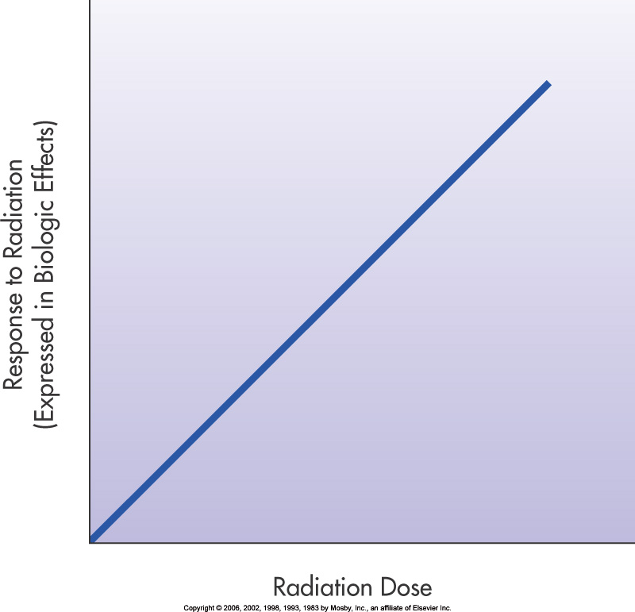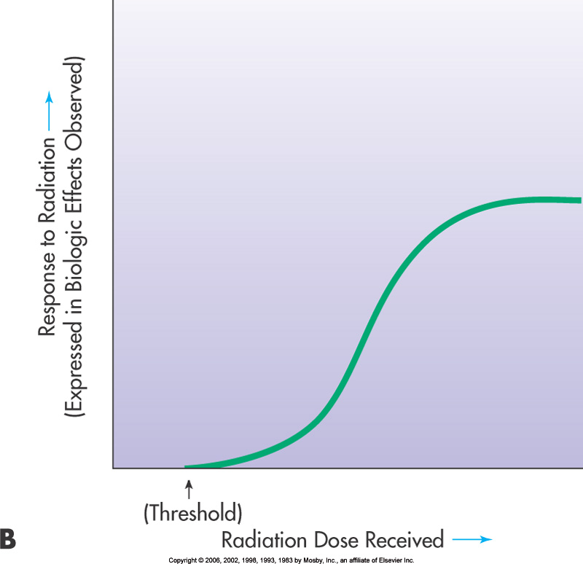

- Explain the concept of somatic effects. How are these effects classified?

- When a living organism is biologically damaged due to radiation exposure
- Effects are classified as early or late depending on the length of time from exposure to the first appearance of symptoms
- Early
  - When biologic effects of radiation occur relatively soon after receiving radiation dose
- Late
  - Responses that do not manifest for several months or years after the radiation exposure

- What is the difference between stochastic and deterministic reactions?
Stochastic
- Due to low doses of radiation delivered over a long period of time
- Randomly occurring biological changes
- Severity is Independent of dose
Deterministic (tissue reactions/non-stochastic)
- Due to substantial dose within short period of time
- Severity of effects increases with increase in dose

- Are stochastic effects threshold or nonthreshold? Explain why.
- Non threshold
  - There is no minimum dose to see the effect
- Randomly occurring
  - No telling who will experience an effect
  - As the dose increases, the probability of an effect increases

- List examples of stochastic effects
  - Cancer
  - Genetic Effects

- List examples of early deterministic effects
- Nausea
- Fatigue
- Erythema
- Epilation
- Blood disorders
- Intestinal disorders
- Fever
- Dry and moist desquamation
- Depressed sperm count
- Temporary sterility in male and female
- Injury to CNS
- ARS when body exposed to very high dose of radiation

- List examples of late deterministic effects
  - Cataract
  - Reduced fertility
  - Sterility
  - Organ atrophy

- Describe ARS, include the major stages.
- Acute radiation syndrome or sickness results in humans after a large, whole body dose of ionizing radiation.
- Four major response stages:
- Prodromal or initial stage
  - Occurs within hours of a whole body absorbed dose of 1 Gy (100 rad) or more
  - Nausea, vomiting, diarrhea, fatigue, leukopenia
  - Severity dependent on dose
  - May last from a few hours to a few days
- Latent period
  - About 1 week
  - No visible symptoms occur
  - Either recovery or lethal effects begin
- Manifest illness
  - Symptoms that affect the hematopoietic, gastrointestinal, and cerebrovascular systems becomes visible
  - Symptoms – apathy, confusion, decrease in number of red and white blood cells and platelets, fluid loss, dehydration, epilation, exhaustion, vomiting, severe diarrhea, fever, headaches, infection, hemorrhage, cardiovascular collapse
  - In very high doses, death can occur
- Recovery or death
  - Recovery may occur, may show signs of radiation damage in late effects
  - May occur within 3 or so months
  - 2 – 3 Gy likely to pass through first three stages with less severe symptoms

- Describe the three forms of ARS
- Hematopoietic Syndrome
  - 1 – 10 Gy
  - Affects bone marrow
  - Body becomes susceptible to infection and prone to hemorrhage
  - Death can occur 6 – 8 weeks from exposure exceeding 2 Gy, sooner if higher dose
- Gastrointestinal Syndrome
  - Approx 6 – 10 Gy
  - May die 3 – 10 days from exposure
  - Severe N-V-D for 24 hours
  - Latent can last up to 5 days
  - Severe N-V-D returns as well as fatigue, loss of appetite, lethargy, anemia, leukopenia, hemorrhage, infection
  - Death results from damage to epithelial cells lining the GI tract
- Cerebrovascular Syndrome
  - CNS and Cardiovascular system receive 50 Gy or more
  - Death can result within a few hours or 2 – 3 days
  - Excessive nervousness, confusion, severe N-V-D, loss of vision, burning sensation on the skin, loss of consciousness
  - Latent can last up to 12 hours
  - Symptoms reappear with increased severity plus disorientation, shock, agitation, ataxia, …coma.

- Define Lethal Dose
- LD 50/30 means a whole body dose of radiation that can be lethal to 50% of the population in 30 days
- Estimated to be 3-4 Gy without medical support

- What is the purpose of risk estimates?
- It is nearly impossible to relate a late effect to a specific exposure, making it is hard to develop precise dose-response relationships
- We use information from early high dose exposure to develop risk estimates to help us understand the relationship between exposure and effects

- List and describe the three types of risk estimates.
- Relative
  - Compares the number of people in an exposed population demonstrating a specific late effect with the number of people in an unexposed group with the same effect.
  - Relative risk = Observed cases/expected cases
- Excess
  - The difference between the observed cases and the expected number of cases
  - Excess cases are assumed to be radiation induced
  - Excess Risk = Observed cases – Expected cases

- Absolute
  - When at least two different dose levels are known.
  - Consists of units of cases/population/dose

- What is radiation hormesis?
- Theory that very low radiation doses are beneficial
- Suggests that there is some protective benefit – stimulates molecular repair and immunologic response

- What is the difference between quality factor and radiation weighting factor?
- The 2 terms are interchangeable.
- Radiation weighting factor is the current term.
- A factor that accounts for differences in biological effectiveness between different radiation types.
- See table 4.1 and 4.2 (pg68/69) in Sherer et.al

