Image Critique Questions

Module 5
- Use the 5 evaluation criteria categories when critiquing the following images to determine if they are diagnostic:
Lateral Humerus @ 70 kVp
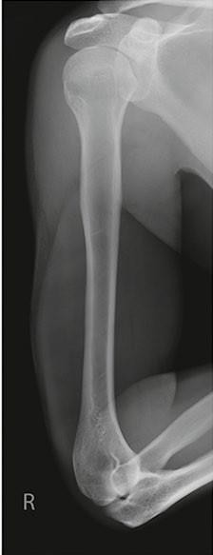
- Is all the required anatomy included in the radiograph?
Yes No
*If no, explain what is required
- Does the anatomical appearance in the radiograph correlate to what is expected from a lateral projection?
Yes No
*If no, explain how the appearance of this radiograph is different compared to the ideal radiograph
  - Humeral epicondyles are not directly superimposed
  - Elbow is not flexed 90⁰

- Identify if the appropriate amount of radiation was used to form the image.
Acceptable, Overexposed, Underexposed
  - Is motion present in the image?
Yes No

- Identify if the collimated light field was:
Acceptable, Too Small, Too Large
  - Was the CR close to the middle of the required anatomy?
Yes No

- Does the marker placement follow Edenbrook Marker Rules?

Yes No
*Never invade a patient’s personal space when placing a marker (even though this is a lateral projection, placing the marker on the anterior side would invade the patients personal space)
  - Are there artifacts in the image?
Yes No

McQuillen Martensen 5th Ed. pg. 251 Fig. 4.210

*If yes, could they have been removed? Is this image diagnostic? Yes No

*appears more similar to an AP projection

- Use the 5 evaluation criteria categories when critiquing the following images to determine if they are diagnostic:
- Is all the required anatomy included in the radiograph?
Yes No

*If no, explain what is required
- Does the anatomical appearance in the radiograph correlate to what is expected from an AP projection?
Yes No
*If no, explain how the appearance of this radiograph is different compared to the ideal radiograph
  - Epicondyles are not in profile (aka. parallel to IR)
  - Greater tuberosity is not in profile laterally
  - Excessive humeral head superimposition over the glenoid cavity
- Identify if the appropriate amount of radiation was used to form the image. Acceptable, Overexposed, Underexposed
  - Is motion present in the image?
Yes No
- Identify if the collimated light field was: Acceptable, Too Small, Too Large
* Collimator was not tilted to match angle of humeral body, causing excessive amounts of thorax (aka. chest/torso) to be included in the light-field; too much anatomy included inferiorly/distally
AP Humerus @ 80 kVp
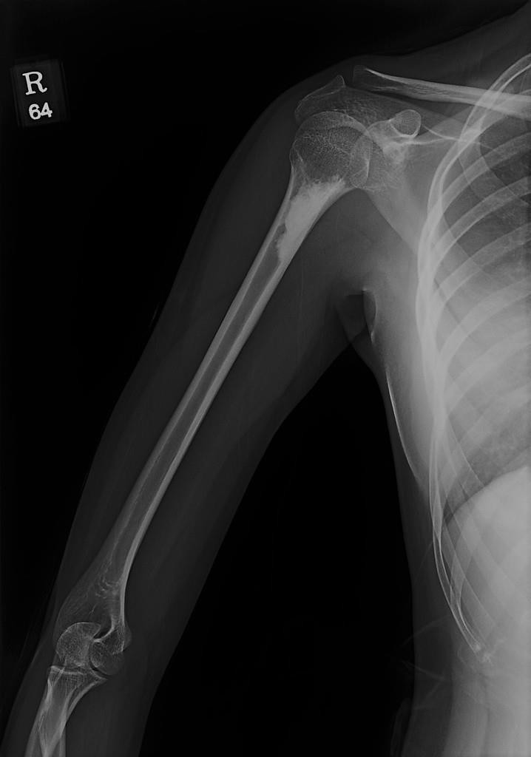
https://radiopaedia.org/cases/giant-humeral-enostosis

  - Was the CR close to the middle of the required anatomy? Yes No
*Superiorly to inferiorly = yes; Laterally to medially = no

- Does the marker placement follow Edenbrook Marker Rules?
Is this image diagnostic? Yes No

Yes No
  - Are there artifacts in the image?
Yes No
*If yes, could they have been removed?
*No, this is patient pathology (dense bony sclerotic lesion)

- Use the image below to answer the next five questions:

- Which projection of the elbow is displayed?
Lateral projection

- What positioning error(s) occurred?
  - Acute-flexion
  - Shoulder and elbow not on same plane (aka. shoulder is elevated above the elbow)
  - Wrist and elbow not level (aka. wrist is depressed below the elbow)

- If the image was repeated, how would you correct the positioning error(s)?
  - Decrease the flexion (aka. extend the patients elbow slightly) until the humerus and forearm create a 90⁰ angle
  - Lower the shoulder until it is at the same height as the elbow
  - Raise the wrist until it is at the same height as the elbow (*a sponge may be used to help the patient hold this position)
- How did you identify the positioning error(s)?

  - Humerus and forearm are flexed greater than 90⁰
  - Capitulum is projected inferior (aka. below) the trochlea
  - Capitulum is projected anterior (aka. in front of) the trochlea

60 kVp

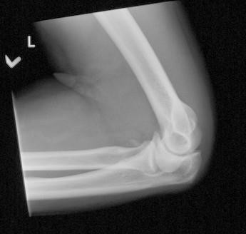
SAIT imaging library

- If the image had to be repeated, would you make any other adjustment(s)? Explain your rationale.

  - Increase technique, as the image was underexposed

- Use the image below to answer the next five questions:

- Which projection of the elbow is displayed?
AP Oblique projection
(with medial/internal rotation)

- What positioning error(s) occurred?
  - Over-rotation
  - Slight flexion

- If the image was repeated, how would you correct the positioning error(s)?

  - Rotate the humeral epicondyles towards the lateral side (aka. externally) until they are 45⁰ to the IR
  - Fully extend the patients arm

- How did you identify the positioning error(s)?
  - Radial head and neck superimposition is too anterior (aka. radial head and neck not centered over the proximal ulna) *note: radial head is almost superimposing the coronoid process
  - Elbow joint space almost closed; Humerus is not aligned to edge of IR, but forearm is aligned (i.e. entire limb should be parallel to long edge of IR for full extension)
65 kVp
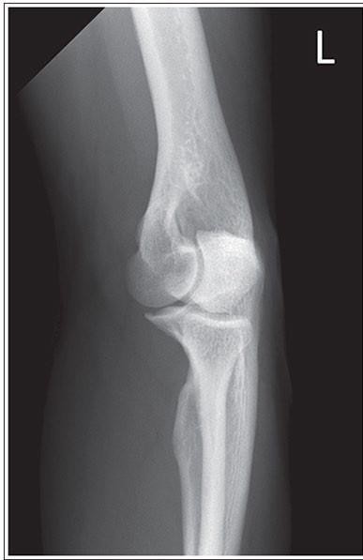
McQuillen Martensen 5th Ed. pg. 231 Fig. 4.162

- If the image had to be repeated, would you make any other adjustment(s)? Explain your rationale.

  - Increase collimation (up and down/proximally-distally), only 1/3rd of the proximal forearm is required
  - Move CR centering slightly more distally, placing the crosshairs over the elbow joint

- Use the 5 evaluation criteria categories when critiquing the following images to determine if they are diagnostic:

- Is all the required anatomy included in the radiograph?
Yes No
*If no, explain what is required

- Does the anatomical appearance in the radiograph correlate to what is expected from an AP projection?
Yes No
*If no, explain how the appearance of this radiograph is different compared to the ideal radiograph
  - Almost no superimposition of radial head, neck and tuberosity with the proximal ulna
  - Humeral epicondyles not in profile bilaterally

AP Elbow @ 77kVp

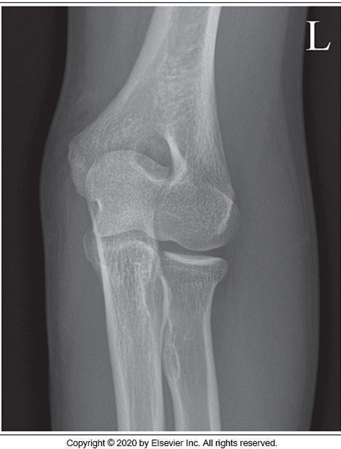
- Identify if the appropriate amount of radiation was used to form the image.
Acceptable, Overexposed, Underexposed
*kVp too high
  - Is motion present in the image?
Yes No

- Identify if the collimated light field was:
Acceptable, Too Small, Too Large

McQuillen Martensen 5th Ed. pg. 225 Fig. 4.147
Is this image diagnostic? Yes No
*appearance is more similar to an AP oblique projection with external/lateral rotation

  - Was the CR close to the middle of the required anatomy?
Yes No

- Does the marker placement follow Edenbrook Marker Rules?
Yes No
  - Are there artifacts in the image?
Yes No
*If yes, could they have been removed?

- Use the 5 evaluation criteria categories when critiquing the following images to determine if they are diagnostic:

AP Elbow @ 63kVp
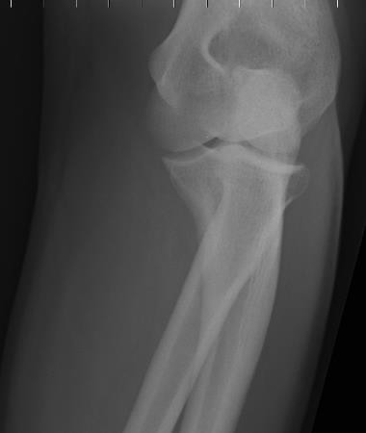
- Is all the required anatomy included in the radiograph?
Yes No
*If no, explain what is required
Should include @ least ¼ of the distal humerus
- Does the anatomical appearance in the radiograph correlate to what is expected from an AP projection?
Yes No
*If no, explain how the appearance of this radiograph is different compared to the ideal radiograph
  - Excessive superimposition of the proximal radius and ulna
  - Elbow joint space not fully open
  - Humeral epicondyles not in profile bilaterally
  - Olecranon process not “seated” within the olecranon fossa

- Identify if the appropriate amount of radiation was used to form the image. Acceptable, Overexposed, Underexposed
*kVp too low
  - Is motion present in the image?
Yes No
SAIT imaging library

Is this image diagnostic? Yes No
*Underexposed, & clipped anatomy

- Identify if the collimated light field was:
Acceptable, Too Small, Too Large
*even if CR was correct, we would not be able to include 1/3rd of distal forearm
  - Was the CR close to the middle of the required anatomy?
Yes No *should be over the elbow joint (i.e. must be moved proximally)

- Does the marker placement follow Edenbrook Marker Rules?Yes No *none present (i.e. should be on lateral side)
  - Are there artifacts in the image?
Yes No
*If yes, could they have been removed?

- Use the image below to answer the next five questions:

- Which projection of the elbow is displayed?

AP Oblique projection
(with lateral/external rotation)

- What positioning error(s) occurred?
  - Over-rotation
  - Elbow flexion
  - Anatomy not aligned parallel to IR

- If the image was repeated, how would you correct the positioning error(s)?

  - Decrease patient obliquity (i.e. slightly rotate the humeral epicondyles medially/internally until they form a 45⁰ angle with the IR)
  - Fully extend the patients elbow, until entire limb is “flat” on the IR
  - Ensure the shoulder, elbow and wrist are parallel to long edge of IR and light field

- How did you identify the positioning error(s)?

  - Lateral epicondyle and capitulum not in profile (i.e. lateral epicondyle superimposed over the capitulum)
  - Elbow joint space is closed
  - Humerus is not aligned to edge of IR, but forearm is aligned (i.e. entire limb should be parallel to long edge of IR)

70 kVp

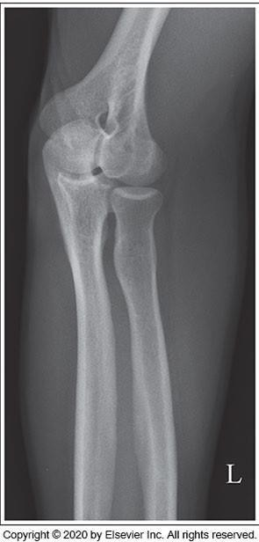
McQuillen Martensen 5th Ed. pg. 233 Fig. 4.169

- If the image had to be repeated, would you make any other adjustment(s)? Explain your rationale.

  - Incorrect centering of the CR can also contribute to the appearance of closed joint spaces; center CR more proximally (over the elbow joint)
  - Increase collimation, excessive amounts of anatomy are included in the radiograph (only require 1/3rd of the proximal forearm – radiograph includes half)

