4.4 Describe the emergency procedures related to a hazardous product.

The safety data sheet (SDS) is an important resource for the worker for emergency information regarding the supplier contact information, first aid, firefighting and accidental release measures.
Prior to using the hazardous product, the worker should review the SDS, in its entirety, for important emergency information. Workers should also receive training on specific worksite emergency procedures and equipment.
The following are some examples of where to find some of the information needed for emergency procedures of a hazardous product (e.g. liquid nitrogen).
Section 1 – Identification (Figure 10) is where the emergency phone number of the supplier is found. If there are any restrictions on the use of the phone number, it must be written here. In the case of emergency and more information is needed about the hazardous product, the supplier should be contacted.
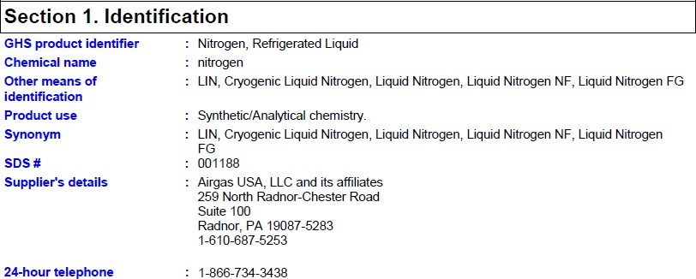

Acme Chemical 123 ABC Street
Somewhere, AB, Canada 1A1 2B2

1-800-555-1234

Figure 10: Safety Data Sheet (SDS) - Section 1 – Identification

Section 4 – First Aid Measures has a description of first aid measures for all the possible ways of exposure: eye contact, inhalation, skin contact, ingestion etc. Figure 11 states that if there is skin contact with liquid nitrogen the first aid treatment is to warm the frozen tissues slowly with lukewarm water, get medical attention and do not rub the affected area. Also in this section is a list of the most important symptoms and effects from exposure.

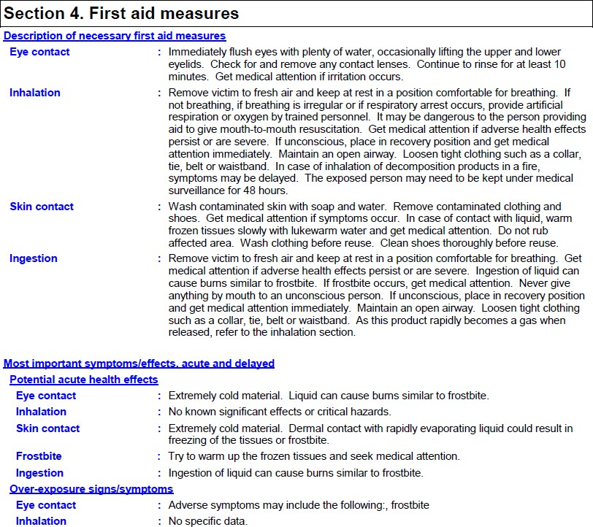
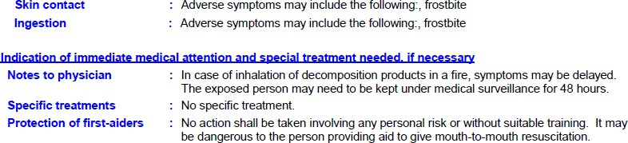

Figure 11: Safety Data Sheet (SDS) – Section 4 – First Aid Measures

Section 5 – Fire-Fighting Meaures provides information on what materials to use to extinguish fires and what not to use. It also provides information for fire-fighters on specific hazards, special protective actions and personal equipment. As per Figure 12, there is a hazard of explosion if a fire or heated. The area should be promptly isolated and on action should be taken involving personal risk without suitable training.

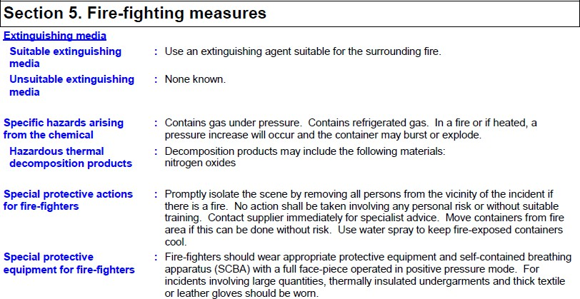

Figure 12: Safety Data Sheet (SDS) – Section 5 – Fire-Fighting Measures
Section 6 – Accidental Release Measures contains information for the methods and materials needed for containment and cleanup of an accidental release of the hazardous product. For an accidental release of liquid nitrogen, as per Figure 13: do not touch or walk through spill; avoid breathing gas (use respirator if needed); and immediately contact emergency personnel.

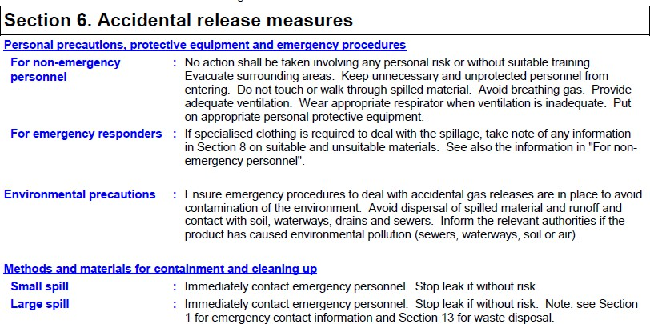
Figure 13: Safety Data Sheet (SDS) – Section 6 – Accidental Release Measures

