MRAD 281 – Computed Tomography Theory 2
Activity - Introduction to CT Scanning – Planes and Directional Terms

The following activity will help you review planes and directional terminology. Using your current knowledge and course textbook, Kelley, L, & Petersen, C. (2013). Sectional anatomy for imaging professionals (3rd ed.). Philadelphia, PA: Elsevier., complete the questions below.

- Identify the planes in the diagram below.

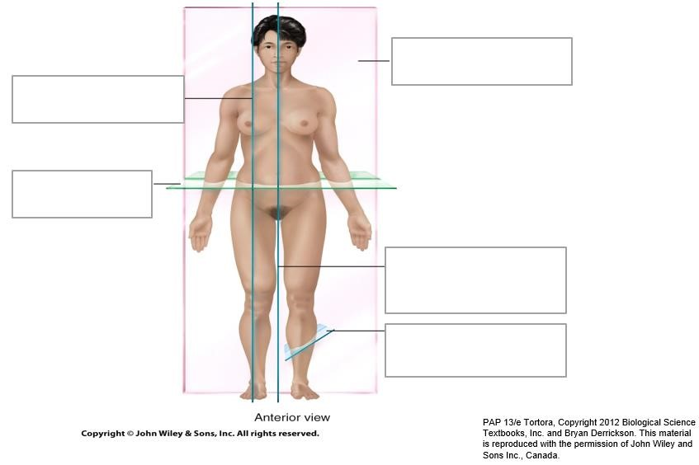

- Fill in the chart below.

Plane | Divides body into…
Axial (Transverse)
Sagittal (Mid and Para)
Coronal
- Fill in the chart below.

Directional Term | Definition
Superior
Inferior
Anterior (Ventral)
Posterior (Dorsal)
Medial
Lateral
Proximal
Distal
Superficial
Deep (Visceral)
Intermediate
Ipsilateral
Contralateral
Cranial (Cephalic)
Caudal
Rostral
Thenar
Volar
Palmar
Plantar

- Fill in the regional terminology below.

Regional Term | Definition
Antebrachial
Antecubital
Axillary
Brachial
Cephalic
Cervical
Costal
Flank
Gluteal
Inguinal
Occipital
Ophthalmic
Popliteal

- Fill in the table on body cavities.

Main Body Cavity | Smaller Cavity/Organs
Dorsal
Ventral

- Label the 9 quadrants in the image below.



