Activity: Test 3 mA Linearity Procedure

Purpose
This activity will help you identify the procedure steps for this test.

Instructions
- Review the images below of the equipment and materials used at Edenbrook for this test.
- Review the procedure steps from the Edenbrook MRT lab.
- Compare the textbook readings, Edenbrook lab and your practicum site QA manual for similarities and differences.

Equipment
- Dosimeter
- Lead sheet or lead ½ apron
- Calculator

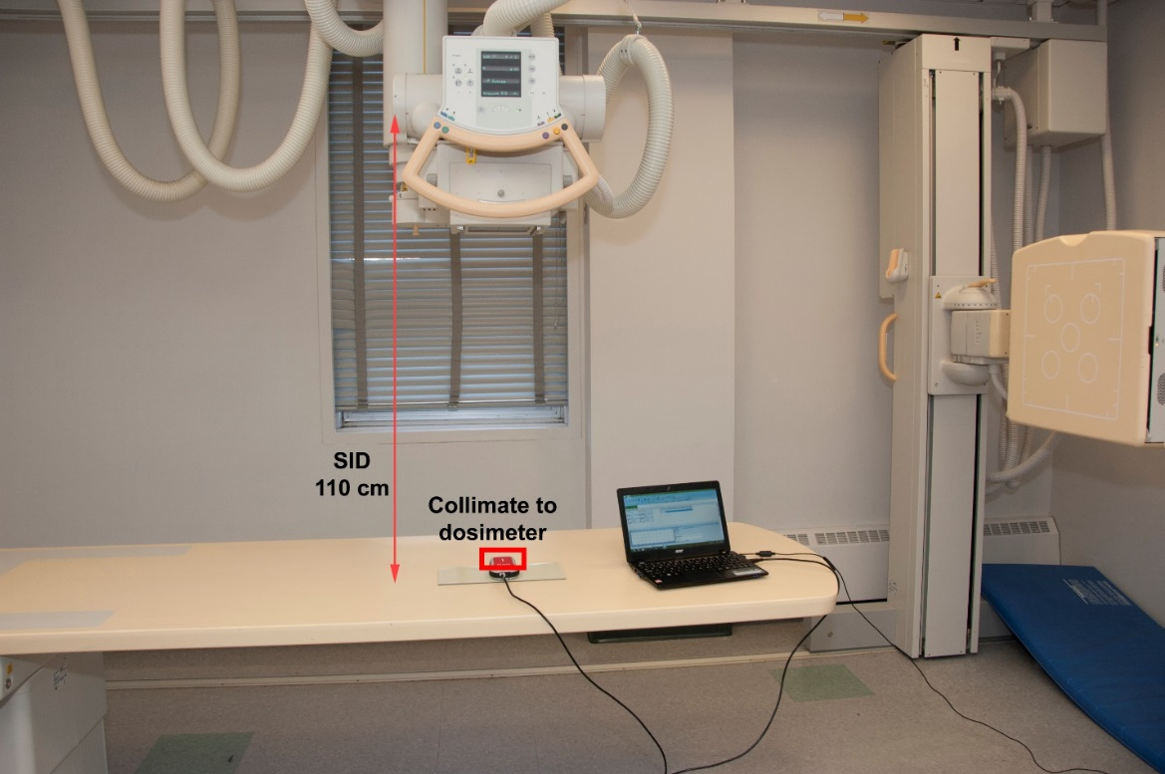

MRT Procedure Steps
- Place a lead sheet or ½ apron on the X-ray table top to reduce the effects of back scatter.

- Using a 110 cm SID, centre the dosimeter and collimate to include the entire chamber.

- Set exposure factors to 80 kVp and 100 ms.

- Start at 50 mA. Expose on the small focal spot and record the result in mR. Expose on the large focal spot and record the result in mR.

- Repeat step 4 with 50, 100, 125 and 160 mA and record the results.

- Please note that in a clinical setting, ideally we would take 10 exposures at each mA station and focal spot size.

Questions
- What differences do you see from the textbook compared to the Edenbrook MRT procedure steps or equipment?
- Access your department’s quality control manual and compare the equipment and procedure to the Edenbrook MRT steps and equipment.
- View the City College of San Francisco (CCSF) Diagnostic Radiology Quality Control video. https://www.youtube.com/watch?v=lAKc-Tj88_k
  - Find the mA Linearity Test.
  - Compare the procedure with the Edenbrook MRT procedure steps and equipment.

