Gowning, Log Roll, Immobilization and Restraints

Gowning
Assisting a patient with gowning. These patients include those who have upper limb injury, and IV or who are paralyzed or have limited mobility. There should always be two people assisting with dressing or undressing a patient.

Putting on a gown
  - Place injured side in the arm hole of the gown first, then continue to put the gown on the uninjured side.

Removing a gown
  - Take the gown off the uninjured side first, then remove the gown from the injured side.

Log Roll Technique Using a Slider Board
Example of a “spinal precaution policy”. Technologists are required to know their site’s spinal precaution policy. As of 2017, AHS has a new “Spinal Motion Restriction Management in DI manual”
- Placing a slider board using the log roll technique under non-spinal precaution patient. This log roll requires two to three technologists.
- Placing a slider board using the log roll technique under a “known or possible” spinal
precaution patient. This log roll requires five technologists.
Patient transfers using a slider board and spinal precaution techniques are used most often with patients who have an injury to the cervical and/or lumbar spine. A five-person log roll is required if the patient has a known spinal injury or a suspected spinal injury (Dutton, Linn-Watson & Torres, 2013, p. 87).
Bolsters

Provides the pt. with support & padding

↑ comfort = ↑ compliance = ↓ movement
Don’t use if it compromises pt. positioning
  - Pillow causes artifact but…
    - Relieves neck strain and
    - Easier for a pt. to breathe
- Bolsters under the knees ↓ lumbosacral stress (aka. Straightening lordosis)

Boosters help prevent formation of decubitus ulcers/bed sores by:
- Repositioning the patient, which helps with adjusting distribution of body weight
- Ensuring the patient is clean and dry

The best way to immobilize or restrain a patient is by using Therapeutic Communication – additional information will be provided. Ehrlich 9th edition pg.100- 102, Table 6-1 and Table 6-2

Immobilization
  - The purpose is to limit movement during an exam. Less patient movement = reduction of repeat exposures = less radiation.

Does not require a doctor’s order.
    - Individuals may assist in immobilizing patients along with various types of equipment such as sandbags, tape, lead shields and sponges.
    - Nurses, doctors, parents/guardians and technologists may assist in immobilizing patients. Health care professionals other than the x-ray technologist should be the first to assist, then the parent/guardian. The last person to assist, if needed, should be another x-ray technologist.
    - Immobilization by another person should occur in the strongest areas, such as the shoulders, elbows, and knees.
    - Items used for immobilization include: sponges, tape, sandbags, lead sheets/shields and specialty devices. Pillows (preferably the patient’s own) can be used but ONLY if it is not in the area of interest or light field.

Restraints – Purpose
  - Ensure patient safety from themselves or hurting others.
  - Prevent disengaging therapeutic devices (e.g., urinary catheter).
  - Prevent undesired motion during an imaging procedure.
Note: A physician’s order is required to restrain a patient.

- Only used if therapeutic communication and/or other less restrictive measures will not work.
- Restraint is to be attached to an immovable part such as the frame of a stretch but not the side rails.
- Must be applied so quick release can occur. No knots
- They should not tighten when the patient moves or could cause injury.
- Are padded to assist with comfort and minimizing skin damage
- Can be either 2 or 4 point restraints. Example- 2 point are arms/wrists only but 4 point includes the arms and ankles.

Seven Rules of Immobilizers and Restraints

- Patients must be allowed as much mobility as safely possible.

- Immobilizers/restraints must be padded to prevent injury to skin beneath device.
- Normal anatomic position must be maintained.
- Knots that will not become tighter with movement must be used.

- Neither circulation nor respiration must be impaired by immobilizer/restraint.
  - Sometimes circulation may be compromised briefly, but this is in rare cases.
- Immobilizer/restraint must be easy to remove quickly.
- If leg immobilizers/restraints are used, then wrist immobilizers/restraints must be applied is well (4-point restraint)

NOTE
  - Only undue restraints if necessary in order to obtain a projection or view. Once projection or view completed, reapply restraints.

  - Never leave restrained patient alone unsupervised under any conditions. If an emergency situation occurs the patient is at risk of injury or harm. Example- vomit while lying on their back.

Illustration of how to safely apply restraints.

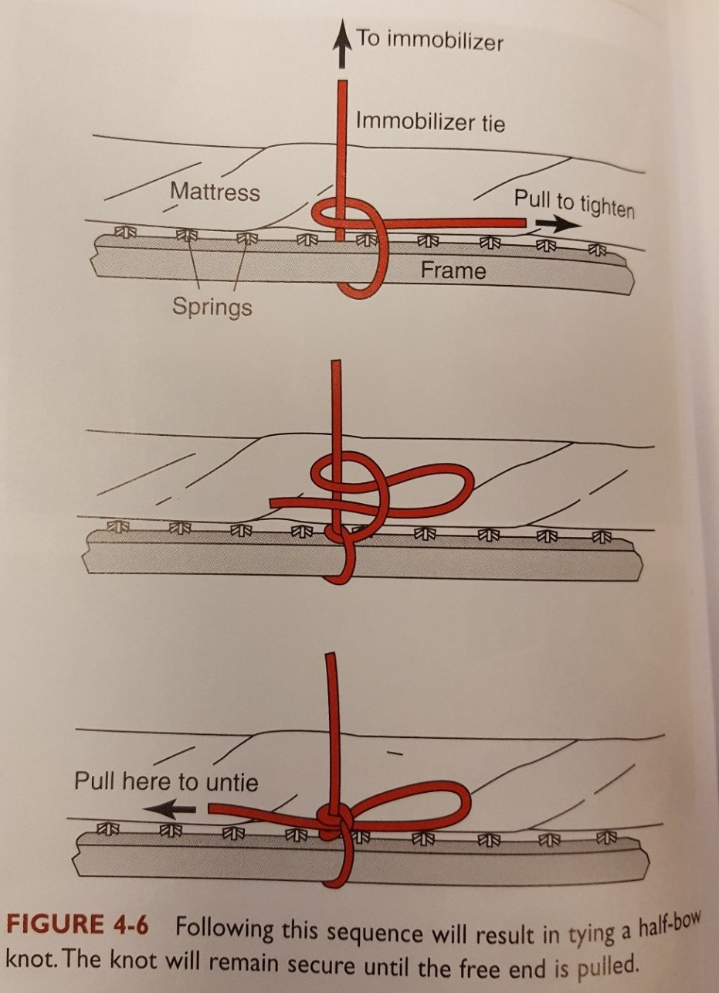

Reference
Dutton, A. G., Linn-Watson, T. A., & Torres, L. S. (2013). Torres’ patient care in imaging technology (8th ed.). Baltimore, MD: Lippincott Williams & Wilkins.

