Image Critique Questions

Module 11
- Use the 5 evaluation criteria categories when critiquing the following image to determine if it is diagnostic:

AP Ankle @ 80 kVp
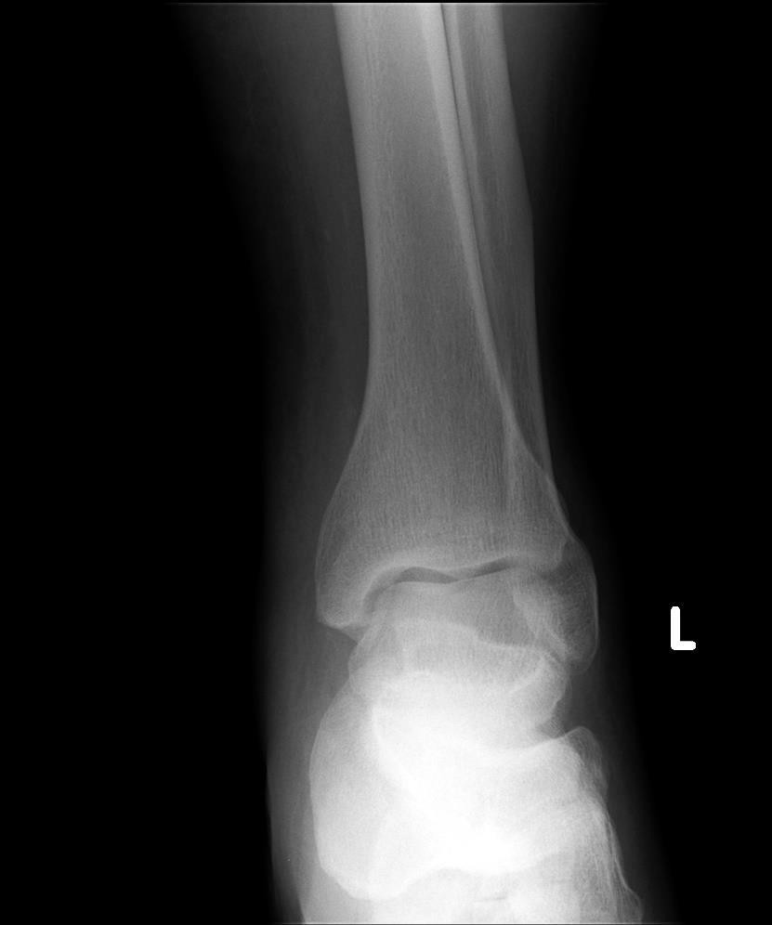
EDENBROOK Imaging library

- Is all the required anatomy included in the radiograph? Yes No
*If no, explain what is required

- Does the anatomical appearance in the radiograph correlate to what is expected from a Routine AP projection?
Yes No
*If no, explain how the appearance of this radiograph is different compared to the ideal radiograph
Rotation (in the lateral direction) evidenced by closed medial mortise joint and excessive superimposition of the distal tibia, fibula, and talus

- Identify if the appropriate amount of radiation was used to form the image. Acceptable, Overexposed, Underexposed
  - Is motion present in the image? Yes No

Is this image diagnostic? Yes No

- Identify if the collimated light field was: Acceptable, Too Small, Too Large *side-side
  - Was the CR close to the middle of the required anatomy? Yes No

- Does the marker placement follow Edenbrook's Marker Rules? Yes No
  - Are there artifacts in the image? Yes No
*If yes, could they have been removed?

- Use the image below to answer the next five questions:

- Which routine projection of the ankle is displayed?
Lateral projection

- What positioning error(s) occurred?
  - Malposition of the foot
  - Rotation

- If the image was repeated, how would you correct the positioning error(s)?

  - Dorsiflex the foot (aka. pull the toes up to the nose)
  - Ensure entire lateral surface of foot is parallel to IR – rotate patients heel back towards IR (i.e. ensure the heel is not elevated)
- How did you identify the positioning error(s)?
  - The long axis of the foot forms a greater than 90º angle to the anterior tibia (aka. toes are pointing downward)
  - The talar domes are not superimposed anteriorly- posteriorly & the distal fibula is projected more posteriorly than ideal
75 kVp
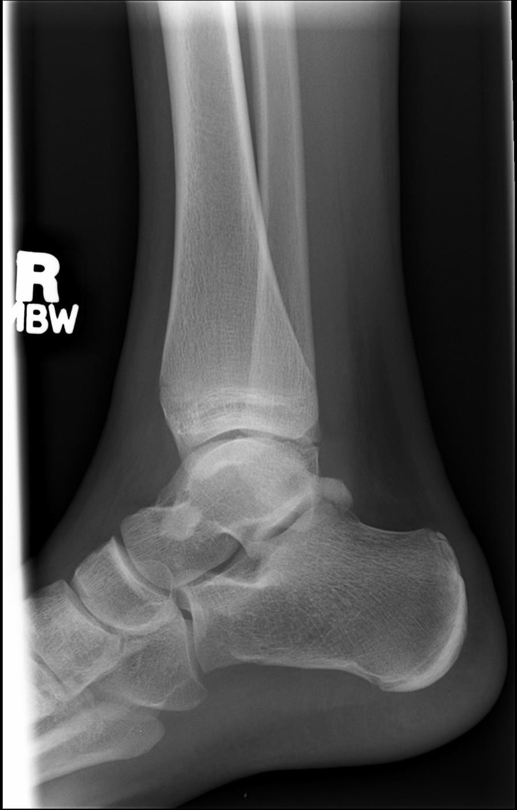
EDENBROOK Imaging library

- If the image had to be repeated, would you make any other adjustment(s)? Explain your rationale.
  - No – the marker placement is appropriate, and the technique is adequate

- Use the 5 evaluation criteria categories when critiquing the following image to determine if it is diagnostic:
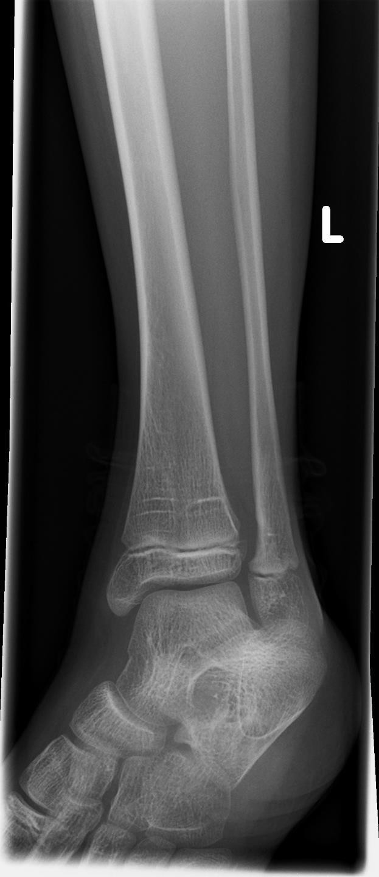
AP Mortise @ 70 kVp
  - Is all the required anatomy included in the radiograph?
Yes No
*If no, explain what is required

  - Does the anatomical appearance in the radiograph correlate to what is expected from an AP Mortise projection?
Yes No
*If no, explain how the appearance of this radiograph is different compared to the ideal radiograph
    - Over-rotation in the medial direction evidenced by closed medial mortise joint and no superimposition of the distal tibiofibular joint
    - No evidence of dorsiflexion (toes are pointing downward)

  - Identify if the appropriate amount of radiation was used to form the image.
Acceptable, Overexposed, Underexposed
    - Is motion present in the image? Yes No

EDENBROOK Imaging library
- Identify if the collimated light field was: Acceptable, Too Small, Too Large *up and down; only require
1/3rd of distal tib/fib
- Was the CR close to the middle of the required anatomy? Yes No *should center more distally, over the ankle joint

Is this image diagnostic? Yes No *appears more like a 45o oblique projection

- Does the marker placement follow Edenbrook's Marker Rules? Yes No
- Are there artifacts in the image? Yes No
*If yes, could they have been removed?

- Use the 5 evaluation criteria categories when critiquing the following image to determine if it is diagnostic:
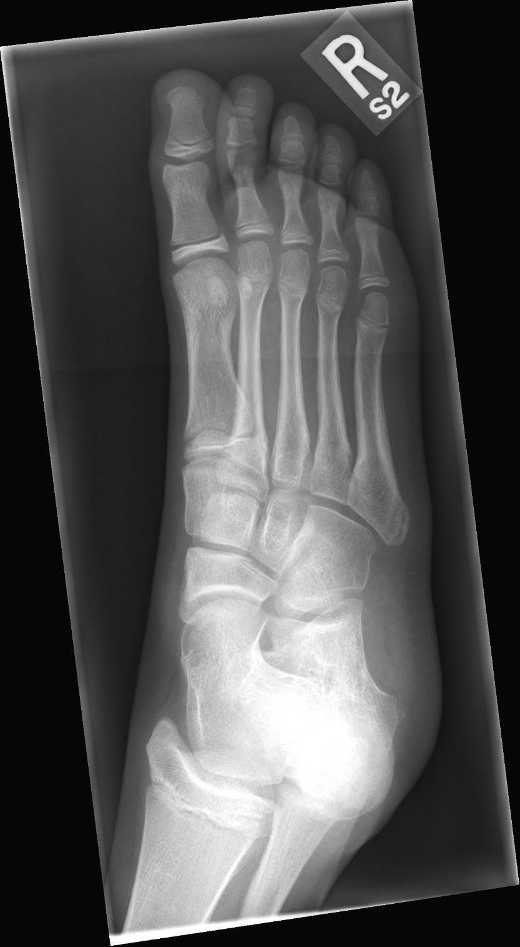
AP Oblique Foot @ 60 kVp
  - Is all the required anatomy included in the radiograph? Yes No
*If no, explain what is required

  - Does the anatomical appearance in the radiograph correlate to what is expected from a Routine AP oblique projection?
Yes No
*If no, explain how the appearance of this radiograph is different compared to the ideal radiograph
    - Over-rotation (in the medial direction) evidenced by closed medial cuboid joint space (between cuboid and 3rd cuneiform)
    - Excessive superimposition of the 1st and 2nd metatarsals (note: only minimal interosseous space is demonstrated)

  - Identify if the appropriate amount of radiation was used to form the image. Acceptable, Overexposed, Underexposed
    - Is motion present in the image? Yes No

  - Identify if the collimated light field was:
Acceptable, Too Small, Too Large
*Note: ideally, collimator should not be tilted
    - Was the CR close to the middle of the required anatomy? Yes No

EDENBROOK Imaging library

Is this image diagnostic? Yes No
- Does the marker placement follow Edenbrook's Marker Rules Yes No
- Are there artifacts in the image? Yes No
*If yes, could they have been removed?

- Use the 5 evaluation criteria categories when critiquing the following image to determine if it is diagnostic:
- Is all the required anatomy included in the radiograph? Yes *excessive amounts No
*If no, explain what is required
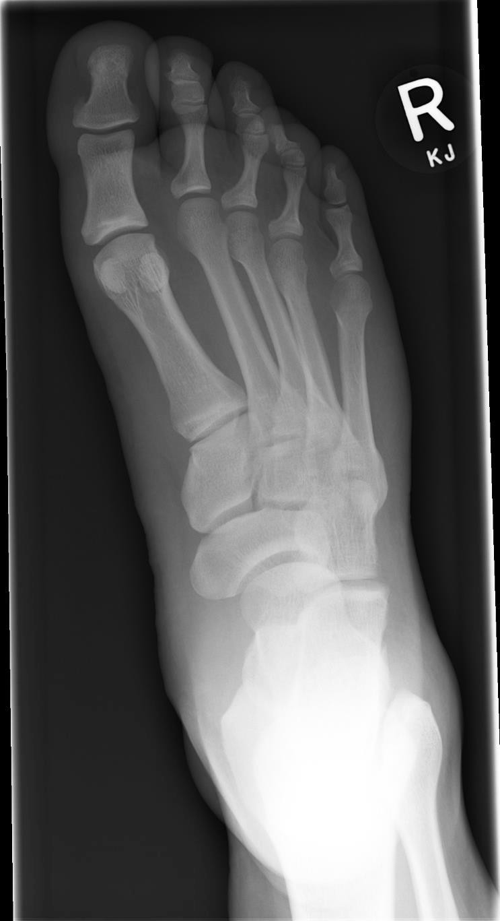
AP Foot @ 70 kVp
- Does the anatomical appearance in the radiograph correlate to what is expected from a Routine AP (axial) projection?
Yes No
*If no, explain how the appearance of this radiograph is different compared to the ideal radiograph
  - Rotation (in the lateral direction) evidenced by excessive superimposition of the 2nd-5th metatarsals (note less interosseous space visualized than ideal) & closed intertarsal joint space between 1st and 2nd cuneiforms
  - Foot not parallel to long edge of IR

- Identify if the appropriate amount of radiation was used to form the image.
Acceptable, Overexposed, Underexposed
  - Is motion present in the image?
Yes No
- Identify if the collimated light field was: Acceptable, Too Small, Too Large *”top-
bottom”/distal-proximal – ½ of calcaneus should have been excluded from the radiograph
  - Was the CR close to the middle of the required anatomy?
Yes No

- Does the marker placement follow Edenbrook’s Marker Rules?
Yes No
  - Are there artifacts in the image?
Yes No
*If yes, could they have been removed?

EDENBROOK Imaging library

Is this image diagnostic? Yes No * appears more like an AP lateral oblique projection which is not routine imaging

- Use the image below to answer the next five questions:
75 kVp
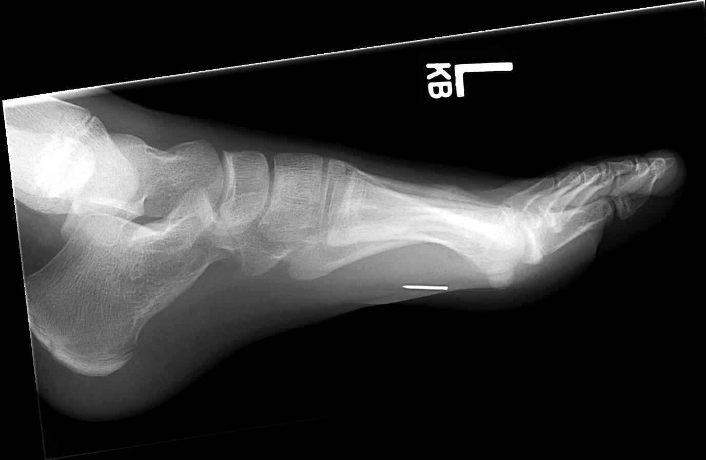
EDENBROOK Imaging library

- Which routine projection of the foot is displayed? Lateral projection
- What positioning error(s) occurred?
  - Malposition of the foot
  - Knee and ankle not on same plane

- If the image was repeated, how would you correct the positioning error(s)?
  - Dorsiflex the foot 90º (aka. pull the toes up to the nose)
  - Ensure the knee and ankle are level – lower the knee towards the IR surface

- How did you identify the positioning error(s)?
  - The long axis of the foot forms a greater than 90o angle to the anterior tibia (patient appears to be in plantar flexion)
  - The talar domes are not superimposed superiorly-inferiorly and the lateral malleolus is projected proximal to the medial malleolus

- If the image had to be repeated, would you make any other adjustment(s)? Explain your rationale.
  - Decrease technique – radiograph was over-exposed
  - Flip the marker so that it appears to be “walking” on the anterior surface of the foot
  - Center the CR more posteriorly, remove the collimator tilt, and decrease collimation anteriorly-posteriorly to include all the soft-tissue surrounding the calcaneus

- Use the 5 evaluation criteria categories when critiquing the following image to determine if it is diagnostic:

Lateral calcaneus @ 75 kVp
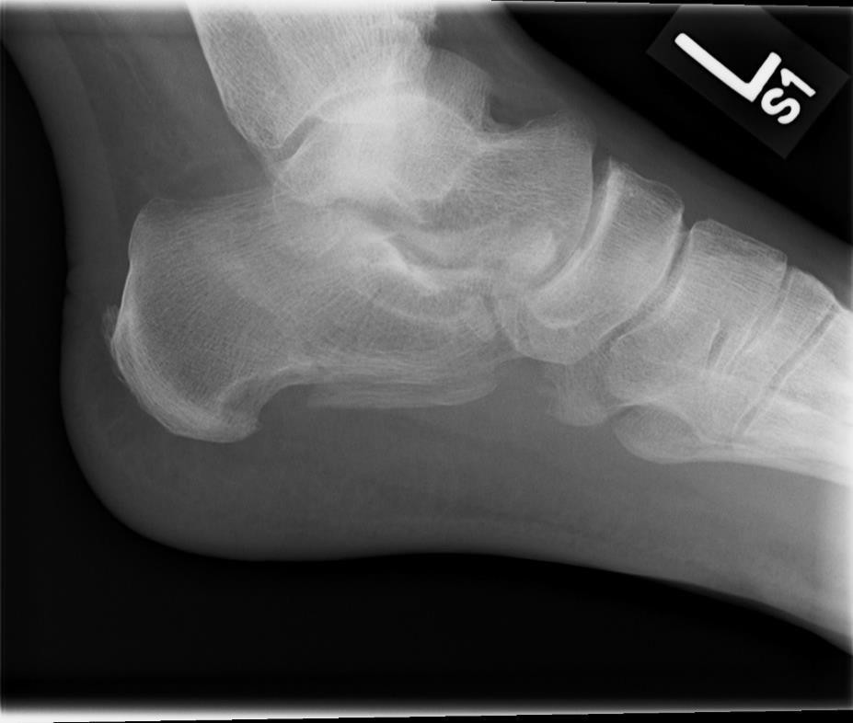
EDENBROOK Imaging library
Is this image diagnostic? Yes No

- Is all the required anatomy included in the radiograph? Yes*excessive amounts No
*If no, explain what is required
- Does the anatomical appearance in the radiograph correlate to what is expected from a routine lateral projection?
Yes No
*If no, explain how the appearance of this radiograph is different compared to the ideal radiograph
  - Foot is not dorsiflexed 90º
  - Talar domes are not superimposed superiorly- inferiorly, lateral malleolus is more anterior than ideal, and excessive superimposition of the cuboid (indicating the knee and ankle were not level)

- Identify if the appropriate amount of radiation was used to form the image.
Acceptable, Overexposed, Underexposed
  - Is motion present in the image? Yes No

- Identify if the collimated light field was: Acceptable, Too Small, Too Large
  - Was the CR close to the middle of the required anatomy? Yes No * should be centered over the calcaneus approximately 1-inch inferior to medial malleolus – CR centering needs to be moved more posterior and superiorly

- Does the marker placement follow Edenbrook’s Marker Rules? Yes *however marker should not be tiltedAreNtohere artifacts in the image? Yes No
*If yes, could they have been removed?

- Use the images below to answer the next five questions:

75 kVp

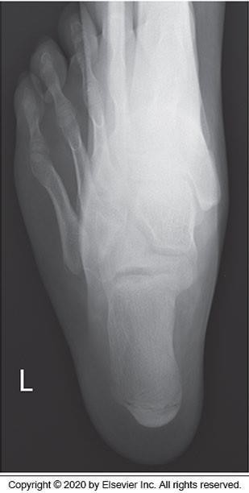
McQuillen Martensen 5th Ed. Fig.6-78

- Which routine projection of the calcaneus is displayed? Plantodorsal (axial) projection
- What positioning error(s) occurred?
  - Rotation or eversion

- If the image was repeated, how would you correct the positioning error(s)?
  - Ensure the entire plantar surface of the foot is perpendicular to the IR (aka. flat against an imaginary surface)
- How did you identify the positioning error(s)?
  - 4th and 5th metatarsals are demonstrated lateral to the calcaneus (indicates lateral rotation of leg or ankle eversion)
- If the image had to be repeated, would you make any other adjustment(s)? Explain your rationale.
  - Center the CR more inferiorly (closer to the calcaneus) and increase collimation in all directions (phalanges should not be included in the radiograph)

