ANPH 252 – Anatomy and Pathology 2
Worksheet – GI Anatomy
- Technically speaking, the GI tract is shorter than the alimentary canal. T F
- Starting with the most inferior, list the four layers that make up the walls of the GI tract and describe their basic functions:
1)
2)
3)
4)
- Mechanical digestion is completed by the _________ and the __________
- Food that has been mechanically digested can be directly absorbed into adjacent tissues
  - True
  - False
- Food that has been chemically digested can be directly absorbed into adjacent tissues
  - True
  - False
- List the accessory organs that aid in digestion.
- In the human body the three pairs of salivary glands include:
- The largest salivary gland is the _____________ The medical term “otic” is used with reference to the _______________
- The portion of the throat posterior to the soft palate is known as the _______________

- The portion of the throat posterior to the buccal cavity is known as the ______________
- The portion of the throat posterior to the laryngeal prominence (and larynx) is known as the ____________________
- The structure that prevents food from slipping into the trachea (windpipe) during swallowing is the _________________. It is attached to a “free floating bone” inferior to the tongue, known as the _____________
- Which of the following structures is most immediately anterior to the spine?
    - Nasopharynx
    - Trachea
    - Esophagus
    - Palatine tonsil
- Which of the following is most superior?
    - Hepatic flexure
    - Tail of the pancreas
    - Splenic flexure
    - Spleen
- The stomach lies more transversely in patients with a ________________ body habitus.
- A specific pathology of the digestive system that causes projectile vomiting inyoung neonates is known as hypertrophic pyloric stenosis. Describe what each of these medical terms means, and based on the definitions, make an educated guess regarding the location and physiology associated with this pathology:

- The gastric folds that allow the stomach to expand with food are called ___________
- From the most superior to the most inferior, the three sections of the small bowelinclude:
1.
2. 3.
- If a patient developed a tumor on the head of the pancreas what part of thedigestive system would be “displaced”?
- The pancreatic duct opens into the duodenum at the ____________________ which is located in the ________________portion of the duodenum.
- The _______________occupies most of the right upper quadrant of the abdomen.
- What is the English translation of “porta hepatis”, and what structures pass through it?
- Bile produced in the liver is stored in a concentrated form in the
______________
- What is the main purpose of bile?
- Fats in _____________ stimulate the release of cholecystokinin (CCK) into the duodenum. CCK is a hormone that triggers the gallbladder to _____________ which releases bile into the ______________

- The right and left hepatic ducts join to form the _____________________
- The common bile duct is formed by the ______________ and the
___________________
- The only “two directional” duct in the biliary tree is the ________________
- Match the following:
A) Lower esophageal sphincter |  | Controls chyme leaving the stomach
B) Sphincter of Oddi |  | Allows a food bolus to enter the stomach
C) Pyloric sphincter |  | Controls flow of pancreatic digestive enzymes and bile
D) Ileocecal valve |  | Controls food entering the large bowel

- Which part of the stomach is most posterior? ________________
- The blind pouch at the proximal end of the large intestine is known as the __________
- Another name for the right colic flexure is the ________________
- Another name for the left colic flexure is the ________________
- The most distal section of the colon is the ______________
- The descending colon is on the right side of the body T F

- Wavelike muscular contractions of the digestive system are known as ___________.
- Which part of the GI tract is the main site of nutrient absorption?
Label the anatomy on the radiograph below:
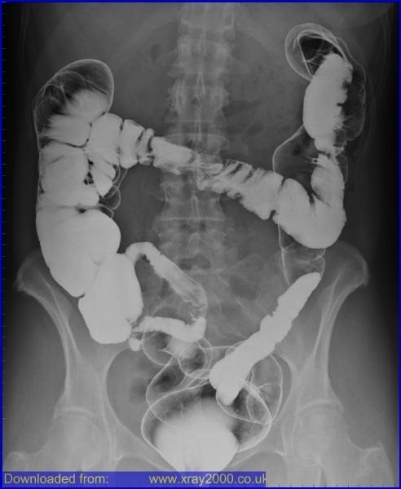
A

B

C

D

E

F

G

A.
B.
C.
D.
E.
F.
G.

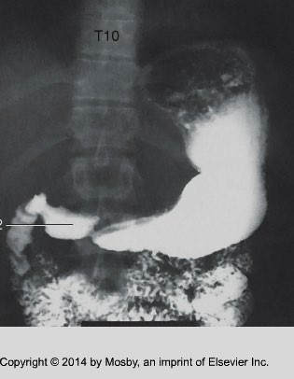
Label the anatomy on the radiograph below:
\
1
.

of
(
the
stomach)

2
.

(
of the stomach
)

5
.
Location of which

o
rgan?
3.

of the stomach
(
)

4.

1.
2.
3.
4.
5.
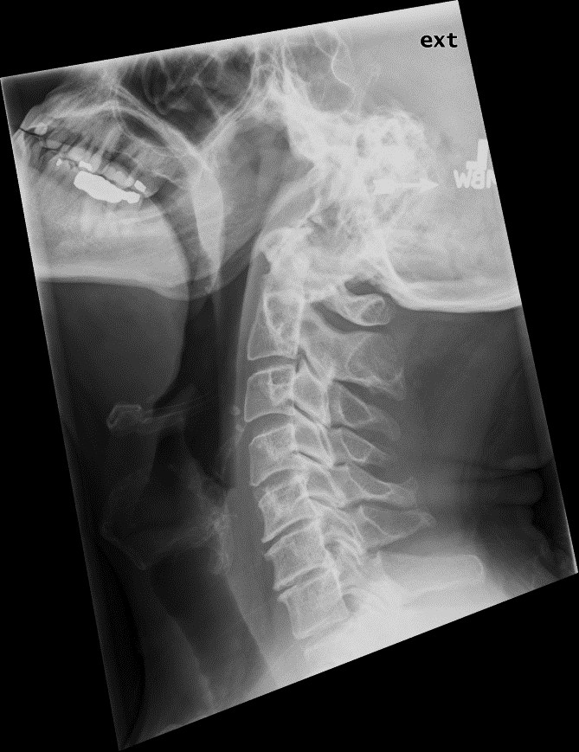
Label the structures in the radiograph below:
A)Cavity?
B)Cavity?
C)

D
)

F)

E)

G)

A.
B.
C.
D.
E.
F.
G.

