Anatomy and Pathology 1 Final Exam Comprehensive Review

- Where does a subdural hematoma occur? Between the dura mater and the arachnoid mater
- What causes an epidural hematoma? Acute arterial bleeding
- Which of the following is a cause of a Transient Ischemic Attack (TIA)? an embolism
- Which type of leukemia is primarily a disease of children? Acute Lymphocytic Leukemia
- How does the lymphatic system maintain blood volume? By collecting plasma that has been left in the interstitial spaces by circulatory processes
- What is the term given to a stationary blood clot? Thrombus
- When an embolus is travelling through the IVC, which vessel could it potentially occlude prior to reaching the left side of the heart? Pulmonary artery
- After a knee replacement surgery, the staff help the patient to be up and moving as soon as possible to prevent which complication? Deep vein thrombosis
- Which of the following is an example of an elastic artery? Aorta
- Where does the blood that goes to the liver for filtration come from? The intestines
- How many pulmonary veins are there? 4
- Identify the superior mesenteric artery, left renal artery, left internal iliac artery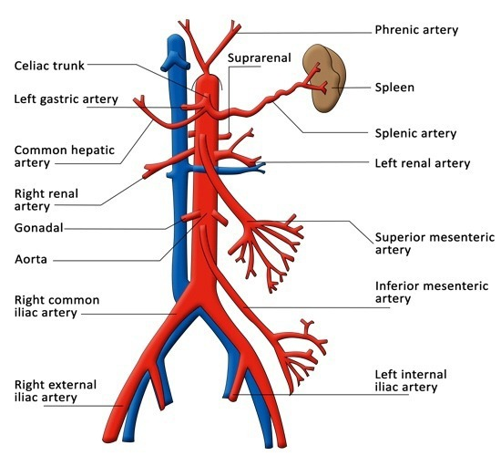
- Identify the Left common carotid artery and right vertebral artery

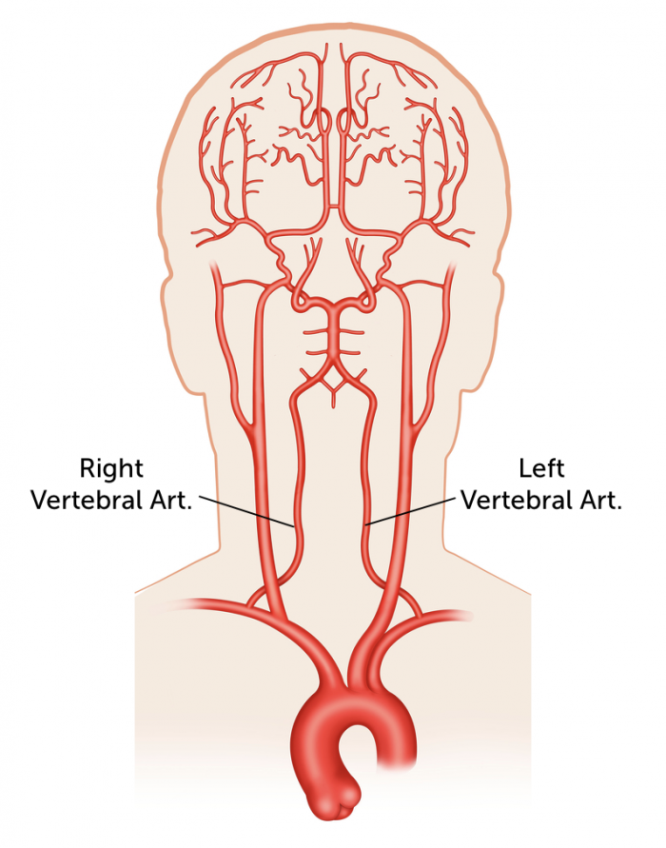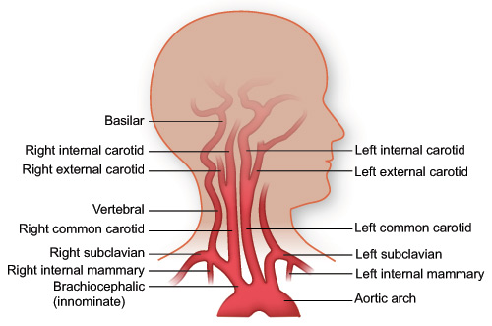
- What is the term for an injury to brain tissue caused by movement of the brain within the skull after blunt head trauma? Contusion
- What is the name for a viral inflammation of the brain? Encephalitis
- What is caused by a temporary oxygen insufficiency to the heart muscle, causing pain? Angina pectoris
- What is the most common cause of congestive heart failure and strokes? Hypertension
- Which portion of the heart is damaged by rheumatic fever? Valves
- Which chamber of the heart forces blood into the pulmonary arteries? Right ventricle
- What is the term for air entering the pleural space? Pneumothorax
- What term refers to a decrease in the amount of hemoglobin in the blood? Anemia
- Which space is the needle inserted into for a lumbar puncture? Subarachnoid space
- Which of the following patients has the greatest chance of surviving without brain damage? Patient has had 3 TIA's in the past month (Transient Ischemic Attack) or mini stroke
- Which term is correct for acute inflammation of the pia mater and arachnoid layers? Meningitis
- What is the name for the networks of capillaries in the ventricles that form CSF? Choroid plexus
- What is Cushing's Disease? Abnormally high levels of cortisol in blood stream
- Multiple myeloma can be characterized by which of the following? Destruction and fracture of bones
- What is a function of the lymphatic system? It maintains blood volume
- Which homeostatic mechanism regulates the hormone levels in the blood? Negative feedback
- The islets of Langerhans are found in which organ? Pancreas
- Which of the following is NOT a function of the cardiovascular system? Producing red blood cells
- Which of the following arrhythmias are immediately life threatening? Ventricular fibrillation
- Which of the following conditions is a slow heart rhythm, less than 60 BPM? Bradycardia
- What structure in fetal circulation shunts blood directly from the right atrium to the left atrium? Foramen ovale
- Which layer of blood vessels is made up of a single layer of squamous epithelium? Tunica interna
- Which blood vessel returns blood to the left atrium? Pulmonary vein
- Which blood vessel returns blood to the right atrium? Vena cava
- Identify the Brachiocephalic artery, brachial artery, ulnar artery (see diagrams)
- Which of the following is NOT a congenital heart disease? Congestive heart failure
- What is the term for the deposition of fatty material on the walls of arteries? Atherosclerosis
- Which of the following is true regarding the posterior pituitary gland? It stores hormones produced by the hypothalamus
- What is the function of parathyroid hormone (PTH). To increase blood calcium levels
- Where are the adrenal glands located? On the superior end of the kidneys
- What is our first line of defense in protecting ourselves from infection? Maintaining intact skin and mucous membranes
- The vertebral arteries unite to form which artery? Basilar artery
- Where is the Circle of Willis located? Surrounding the sella turcica
- Identify the right common iliac artery, right renal artery, abdominal aorta (see diagrams)



