posterior arch of C1

left pedicle of C4

intervertebral foramina C5-6

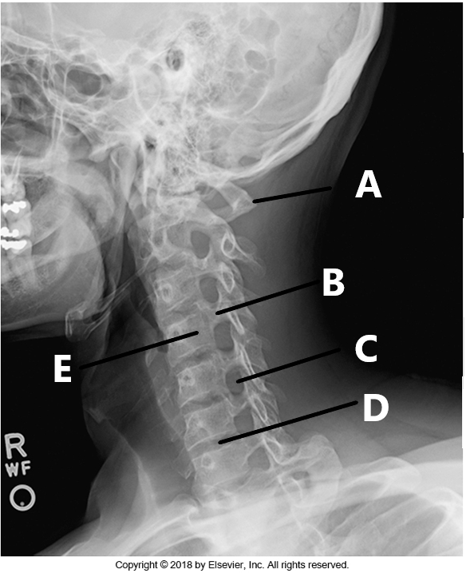
Body of C4

Intervertebral joint of C6-7

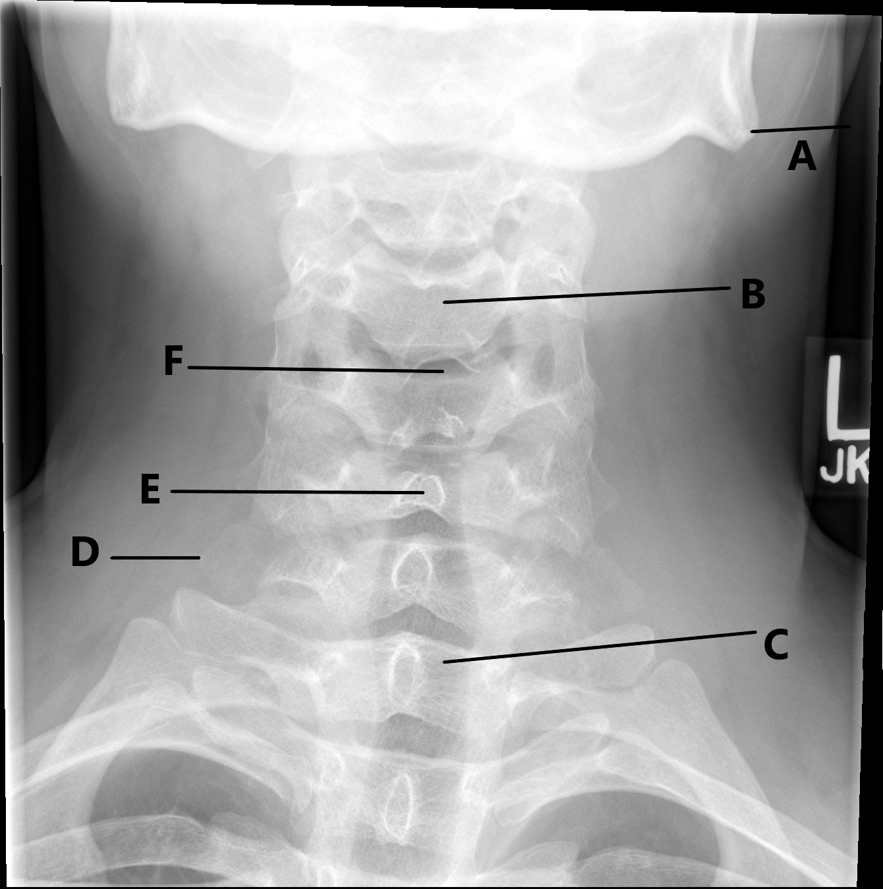

Angle of mandible/ gonion

Body of C4

Intervertebral joint space of C4-5

Spinous process of C6

Transverse process of C7

Body of T1

Sella turcica

Anterior tubercle of C1

Zygapophyseal joints of C3-4

Mandibular ramus

Intervertebral joint space of C4-5

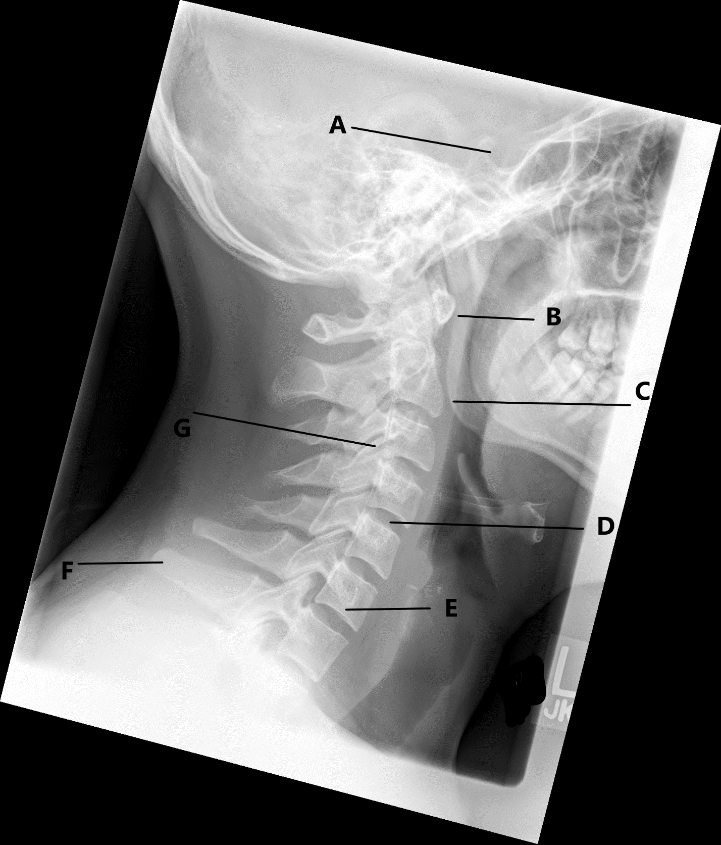
Vertebra prominens

Body of C6

