INFC 215 – Infection Prevention and Control

Module Two: Interaction between Microbe and Host

Topic 2.3: Signs and Symptoms of Infection
Most diseases are recognized by their signs and symptoms. A sign is a characteristic of a disease that can be observed by examining the patient. A symptom is a characteristic of the disease that can be observed or felt only by the patient. Signs of disease include fever, redness and swelling. Symptoms include things such as pain, nausea and malaise.
The human body has a very effective defense mechanism against bacterial invasion. When infectious micro-organisms manage to get past the superficial defenses such as intact skin, mucous membranes and the acids of the digestive systems, a number of indications of infection may be manifested including fever, lymph node swelling and inflammation.

Fever
An increase of 1°C above the normal body temperature is called fever, or pyrexia. (Normal body temperature range is 36.1°C to 37.8°C.)
Certain chemical substances released from micro-organisms cause the body's “thermostat” to be reset at a higher temperature. Heat is generated through:
- Constriction of the blood vessels (less blood goes to the skin surface where heat would be lost due to evaporation)
- An increased metabolic rate
- Shivering (mechanical generation of heat)
These activities cause the core body temperature to increase, but the skin remains cold. The person has the “chills” until the new higher body temperature is reached.
When the chemicals that trigger the temperature increase are no longer present, the thermostat setting returns to normal, and the body experiences heat loss. Blood vessels dilate (widen) allowing more blood to circulate close to the skin surface to lose heat. This is accompanied by sweating, another heat loss activity and an indication the fever has broken.
Fever speeds up the metabolic rate in body cells and may facilitate phagocytosis and tissue healing. Fever is one of the few measurable signs of disease that can be used to monitor a patient’s condition.

Lymph Node Swelling
The lymphatic system is a series of vessels that drain fluid from tissues and return it to the blood stream. As the fluid moves along the lymphatic vessels, it passes through lymph nodes.
Lymph node swelling may occur during infections as a result of:
- Microbes from tissue fluid being trapped in a lymph node, multiplying there and causing infection of the node
- Multiplication of lymphocytes responsible for immunity which are located in the lymph nodes
A single swollen node may indicate an infected node but multiple swollen nodes usually indicate the immune system is responding to the micro-organism.
Many of the lymph nodes are in deep tissue and cannot be felt through the skin. There are three locations where the lymph nodes are close to the skin and can easily be palpitated¹:
- Cervical nodes in the neck
- Axillary nodes under the arms
- Inguinal nodes in the groin
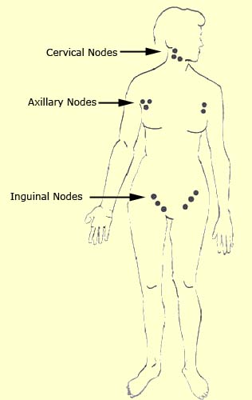
Figure 2.3.1

Inflammation
When host cells are invaded by micro-organisms, they respond by releasing histamine. Histamine initiates the inflammatory response. Other insults to host tissues such as trauma and chemical agents will also initiate the inflammatory response. There are four cardinal signs and symptoms of inflammation: heat, redness, pain and swelling. Tip: To remember the signs and symptoms of inflammation, think “HRPS.” (heat, redness, pain and swelling).
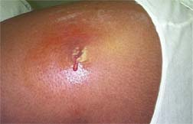 | Description: This 2005 photograph depicted a cutaneous abscess located on the hip of a prison inmate, which had begun to spontaneously drain, releasing its purulent contents. The abscess was caused by methicillin-resistant Staphylococcus aureus bacteria, referred to by the acronym MRSA.
Image 2.3.1: Cutaneous Abscess that Began to Spontaneously Drain
Used with Permission: (© Courtesy CDC Public Health Collection) PHIL ID# 7826
Histamine results in:
- Vasodilation (widening of the blood vessels) which increases blood flow to the injury site causing heat and redness.
- Increased permeability of the blood vessels, which causes fluid to leak from the vessels into the surrounding tissues creating swelling and pain.
Figure 2.3.2 illustrates the enhanced movement of phagocytic white blood cells to the area of an injury due to increased blood vessel permeability.
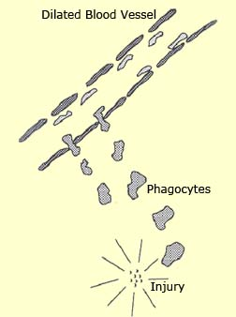
Figure 2.3.2
How these events help the host clear the tissue of infecting micro-organisms:
- An increased number of phagocytic white blood cells are attracted to the area to engulf and destroy bacteria. They also present antigens (parts of the micro-organisms) to lymphocytes to activate antibody production.
- Antibodies that may already be present in the blood are brought to the injury site. These antibodies coat the bacteria in preparation for phagocytosis or neutralize toxins.
- Clotting elements from the blood move to the injury site to surround and isolate the microbes.
Other signs of infection that result from the inflammatory response include:
- Purulent exudates: Otherwise known as pus. This represents phagocytic white blood cells that have been killed in action.
- Leukocytosis: This term means an increase in the number of white blood cells and it is the body’s response to the increased need for these cells.
¹Adapted from Figure 17-2, The Lymphatic System, p.366, Tortora, Introduction to the Human Body, 3rd Edition, Harper Collins College Publishers, 1994.

