INFC 215 – Infection Prevention and Control
Module One: Characteristics of Microorganisms

Topic 1.1: Microorganisms

Microorganisms
A Microorganism is:
- An organism too small to be seen without the aid of a microscope.
- Relatively simple in structure and often unicellular (single-celled).
- Also called a “microbe”, “germ” or “bug”.
- Some people in the medical community may use the slang term “bug” when referring to a microorganism. For example “What kind of bug does the patient have?” They are not referring to an insect in this case, but rather an infection causing microorganism.
box 1
Note: You will not be tested on the content in blue tabbed boxes in this course.
Microorganisms are named according to international rules. The first name describes the genus to which the organism belongs, while the second is the species. Within each species there are a number of subspecies with individual characteristics. The genus is always written first, followed by the species.
- For example: There are many subspecies of Escherichia coli such as O157:H7; O65:B3; 069:B32 etc. The 0157 type is associated with “hamburger disease”, while some of the others may be associated with urinary tract infections or may be part of the normal microorganisms in the intestine.
- Staphyloccus aureus and Staphylococcus epidermidis (Coagualse negative Staphylococcus) belong to the same genus. Staphylococcus aureus organisms cause a number of serious infections, requiring different antibiotics for treatment, while Coagulase negative Staphylococcus (Staphylococcus epidermidis) is found normally on the skin.
- Streptococcus pyogenes subspecies cause a wide variety of infections ranging from Strept throat, tonsillitis, erysipelas skin infection, scarlet fever (the leading cause of death in the 1800’s), damaged heart valves and kidneys to the dreaded flesh eating disease.

Groups of Microorganisms
The four groups of microorganisms are:
- Protozoa
- Fungi
- Bacteria
- Viruses
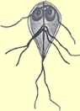
Figure 1.1.1
- Protozoa
Protozoa are unicellular creatures that are able to move either by flagella or amoeboid motion. Each cell has a nucleus and is enclosed by a plasma membrane. Protozoa live in water and soil and feed on bacteria and small particles.
Some protozoa live in our bodies without causing any harm but a few are responsible for disease. Most people are familiar with Giardia infections, commonly called “beaver fever.” Giardia attach to the intestinal wall by two sucking discs resulting in diarrhea because the food cannot be broken down and absorbed properly. Giardia move by flagella.
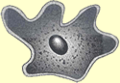
Figure 1.1.2
Some kinds of amoeba will also invade the intestinal wall and cause diarrhea. Occasionally they move into deeper tissue. These protozoa are usually picked up in warm countries with poor sanitation. The amoeba move by extension of pseudopods and do not have flagella, as shown in Figure 1.1.2.
- Fungi
Fungi can be thought of as non-photosynthetic plants. Each cell has a nucleus and is enclosed by a rigid cell wall. The fungi are a very diverse group of microorganisms that can be simply divided into
- yeasts and
- molds
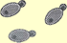
Figure 1.1.3
Yeasts are unicellular oval structures that reproduce by budding. Many types of yeast are used in the food and beverage industry for making breads and wines. They all look the same under the microscope. Some yeasts are capable of causing disease in humans with Candida being the most commonly involved. Candida may cause oral thrush, vaginal discharge, skin infections, pneumonia and even death. Examples of the microscopic appearance of Candida are shown in Figure 1.1.2 and Image 1.1.3.
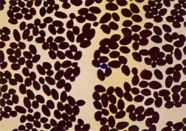
Image 1.1.2: Used with Permission: (© Courtesy SAIT, 2004)

Yeast Infections:
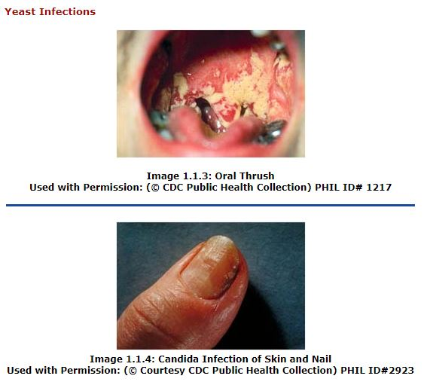
Molds are multicellular structures that form visible clumps of growth. Bread and cheese molds are typical examples. The mold starts out with long tubular structures that eventually produce spores which are visible as grey, blue – green or black growth.
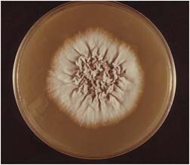 | Description: Human infections caused by the mold-type of fungi usually involve the skin. Athlete's foot and ring worm are infections caused by this type of fungus.
Image 1.1.5: Fungi growing in a laboratory culture
Used with Permission: (© Courtesy CDC Public Health Collection) PHIL ID# 10540
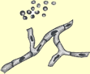
Figure 1.1.4
Figure 1.1.4 is a diagram of the microscopic appearance of a fungi causing skin infections.
Infection caused by Molds:
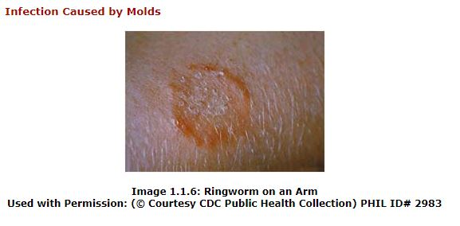

- Bacteria
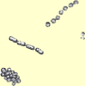
Figure 1.1.5
Bacteria are tiny unicellular organisms typically surrounded by a rigid cell wall. They do not have an organized nucleus but carry out all of the activities necessary for growth and reproduction.
Bacteria are ubiquitous which means that they are found just about everywhere there is moisture and nutrients. Many bacteria grow in or on humans and are an essential part of our body flora. However, many other bacteria cause infections.
Sore throat or “Strept throat” is caused by a type of bacteria called Streptococcus. Certain types of Staphylococcus cause skin abscesses called boils. Almost everyone has heard of food poisoning caused by the Salmonella from poultry. Figure 1.1.5 shows what bacteria look like under the microscope.

Infections caused by the Bacteria Streptococcus pyogenes:
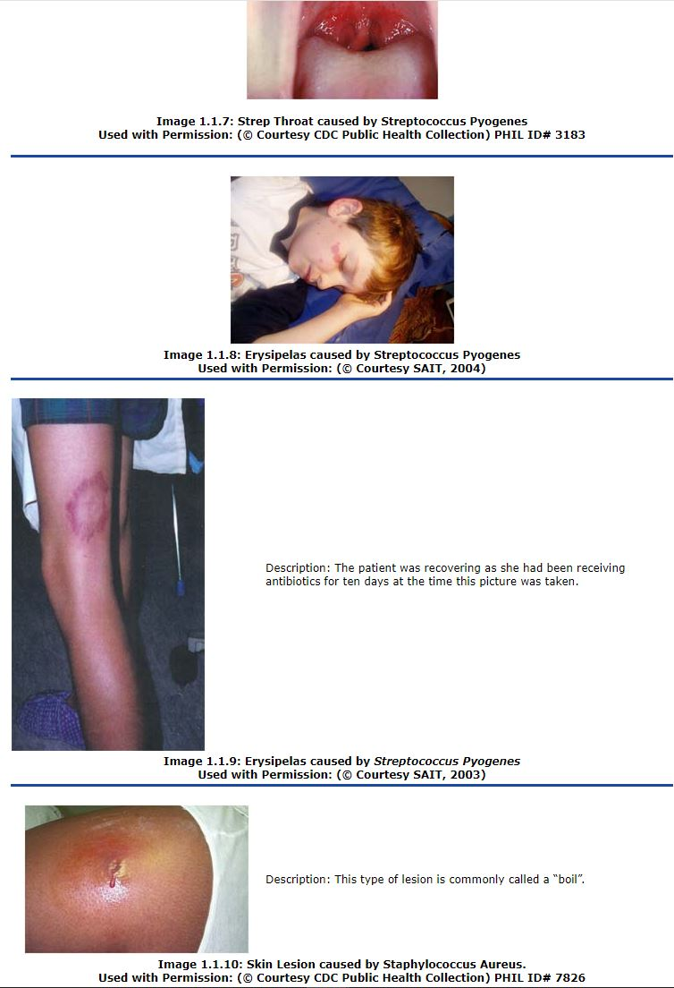

- Viruses
Viruses are even smaller than bacteria and have very simple structure. Viruses are unable to grow and reproduce on their own so must rely on a living host cell to replicate the viral parts. Animal, plant and bacterial cells all serve as host cells for viruses.
A number of human diseases are caused by viruses. Influenza and colds are viral infections that inflict discomfort on everyone at some point during their life. More serious viral infections include hepatitis, rabies and HIV.
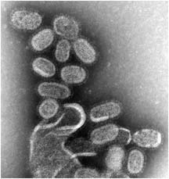
Image 1.1.11: 1918 Influenza Virus as viewed by an electron microscope
Used with Permission: (© Courtesy CDC Public Health Collection) PHIL ID# 8160
Viral Infections:

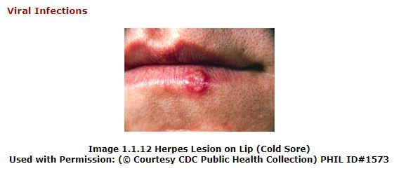

Treatment
Each group of microorganism, when causing an infection, requires a different drug for treatment. Protozoal infections are treated with antiprotozoal drugs, fungal infections are treated with antifungal drugs; bacterial infections are treated with antibiotics and viral infections are treated with antiviral drugs.

Size of Mircorooganisms
Most microorganisms are measured in metric units called micrometers.
One micrometer equals 1/1,000 of a millimetre. A portion of a metric ruler is shown in Figure 1.1.6, with the larger units being centimetres and the smaller units being millimetres.
Figure 1.1.6
The Staphylococci bacteria found on the skin are about 1 micrometer in diameter. 1000 of them would fit in a row on 1 millimeter on the ruler above.
Your skin is totally covered with these bacteria, so you can imagine how many there are on you. Fortunately, they are beneficial as are the sixteen trillion found in your mouth.
All microorganisms are smaller than 0.1 mm which equals 100 micrometers, but there is considerable size variation as illustrated in Figure 1.1.7.
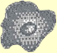  Protozoa | 15 - 20  micrometers
Fungi | 5 - 10  micrometers
Bacteria | 0.3 - 5  micrometers
Viruses | 0.02 - 0.2  micrometers
Figure 1.1.7

