Image Critique Questions
Module 9

- Use the 5 evaluation criteria categories when critiquing the following image to determine if it is diagnostic:
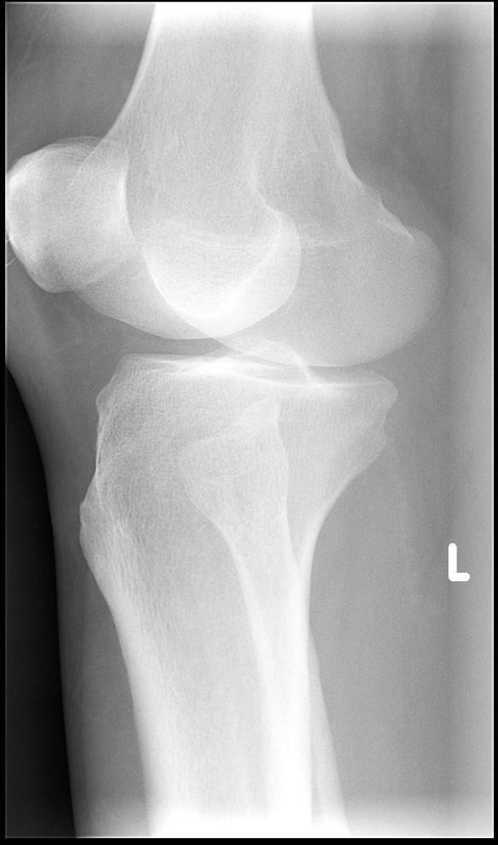
AP Oblique Knee @ 60 kVp

  - Is all the required anatomy included in the radiograph? Yes No
*If no, explain what is required
Entire patella must be included
Lateral soft-tissue margins should be included

  - Does the anatomical appearance in the radiograph correlate to what is expected from a routine AP oblique projection?
Yes No
*If no, explain how the appearance of this radiograph is different compared to the ideal radiograph
Over-rotation in the lateral direction demonstrated: Fibular head should be aligned with anterior edge of tibia (appears too posterior)

  - Identify if the appropriate amount of radiation was used to form the image.
Acceptable, Overexposed, Underexposed
    - Is motion present in the image? Yes No

EDENBROOK Imaging library

Is this image diagnostic? Yes No

  - Identify if the collimated light field was: Acceptable, Too Small, Too Large
    - Was the CR close to the middle of the required anatomy? Yes No

  - Does the marker placement follow Edenbrook’s Marker Rules? Yes No
    - Are there artifacts in the image? Yes No
*If yes, could they have been removed? The anatomical marker should not obscure soft-tissues

- Use the 5 evaluation criteria categories when critiquing the following image to determine if it is diagnostic:
- Is all the required anatomy included in the radiograph? Yes No
*If no, explain what is required

- Does the anatomical appearance in the radiograph correlate to what is expected from a routine AP projection?
Yes No
*If no, explain how the appearance of this radiograph is different compared to the ideal radiograph
Slight lateral rotation evidenced by:
More than ½ of fibular head is superimposed by the tibia Asymmetric appearance of femoral condyles

- Identify if the appropriate amount of radiation was used to form the image.
Acceptable, Overexposed, Underexposed
  - Is motion present in the image?
Yes No
AP Knee @ 75 kVp

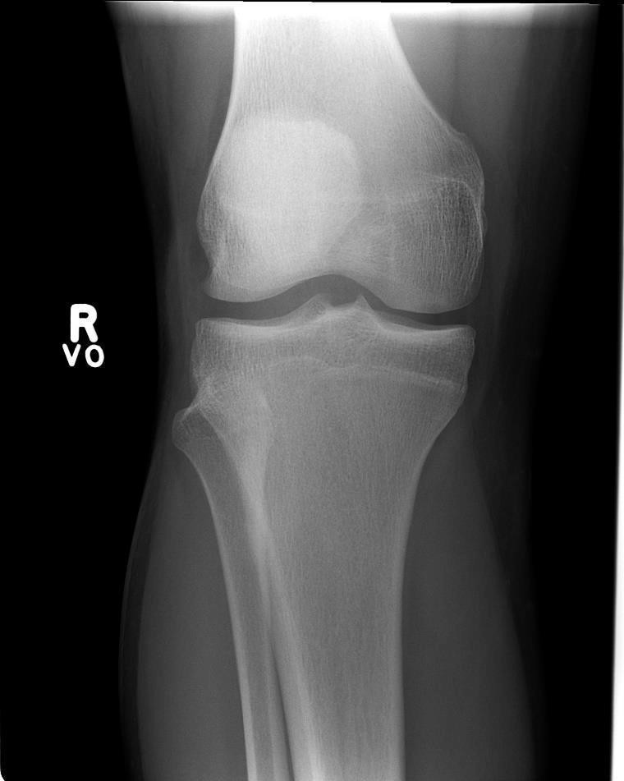
- Identify if the collimated light field was:
Acceptable, Too Small, Too Large
  - Was the CR close to the middle of the required anatomy?
Yes No * slightly too distal
- Does the marker placement follow Edenbrook’s Marker Rules?

EDENBROOK Imaging library

Is this image diagnostic? Yes No

Yes No
  - Are there artifacts in the image?
Yes No
*If yes, could they have been removed?

- Use the image below to answer the next five questions:

- Which routine projection of the knee is displayed?

Lateral projection
- What positioning error(s) occurred?

  - Rotation

- If the image was repeated, how would you correct the positioning error(s)?

  - Rotate the leg anteriorly (aka. roll knee down towards IR)

- How did you identify the positioning error(s)?

  - The medial femoral condyle is posterior to the lateral femoral condyle (identified via the abductor tubercle) – aka. femoral condyles are not superimposed
80 kVp
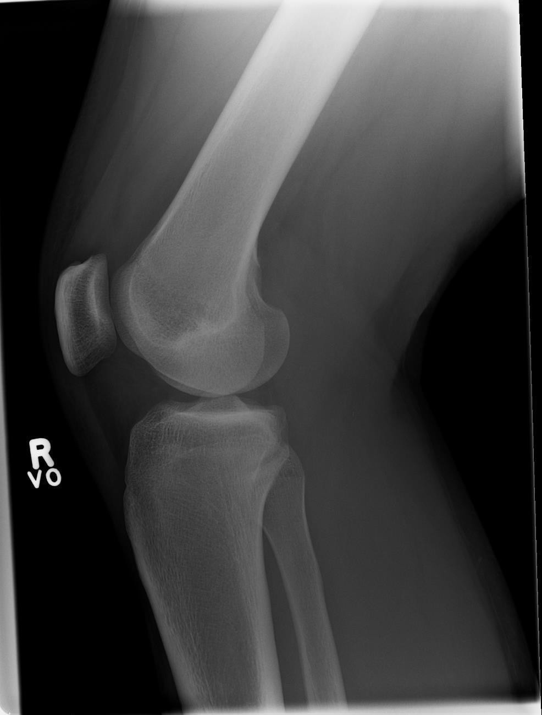
EDENBROOK Imaging library

- If the image had to be repeated, would you make any other adjustment(s)? Explain your rationale.
  - Ensure the distal femur is parallel to the IR/light field to enable increased side-to-side collimation
  - Increase collimation superiorly-inferiorly slightly (excessive amounts of distal femur and proximal tibia/fibula are included radiographically)
  - Center CR over the femorotibial joint (CR was centered too superiorly and posteriorly)

- Use the 5 evaluation criteria categories when critiquing the following image to determine if it is diagnostic:

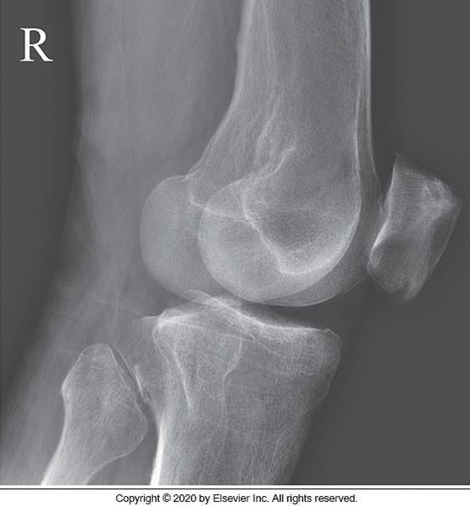
Medial Oblique Knee @ 85 kVp

McQuillen Martensen 5th Ed. pg. 375 Fig. 6.163

Is this image diagnostic? Yes No
- Is all the required anatomy included in the radiograph? Yes No
*If no, explain what is required
Must include at least ¼ of proximal tibia/fibula
- Does the anatomical appearance in the radiograph correlate to what is expected from a PA axial projection?
Yes No
*If no, explain how the appearance of this radiograph is different compared to the ideal radiograph
Excessive medial rotation evidenced by:
Excessive superimposition of femoral
condyles (i.e. distal femur is “too narrow”) Patella appears to be in a more lateral orientation
Tibial tuberosity is well demonstrated (i.e. the anterior surface of the tibia is “too flat”)

- Identify if the appropriate amount of radiation was used to form the image. Acceptable, Overexposed, Underexposed
  - Is motion present in the image? Yes No

- Identify if the collimated light field was: Acceptable, Too Small, Too Large
  - Was the CR close to the middle of the required anatomy? Yes No *too superior

- Does the marker placement follow Edenbrook’s Marker Rules? Yes No *lead anatomical marker is preferred over digital annotations
  - Are there artifacts in the image? Yes No
*If yes, could they have been removed? Patients should be given proper changing & gowning instructions to remove clothing that would appear over anatomy of interest

- Use the images below to answer the next five questions:

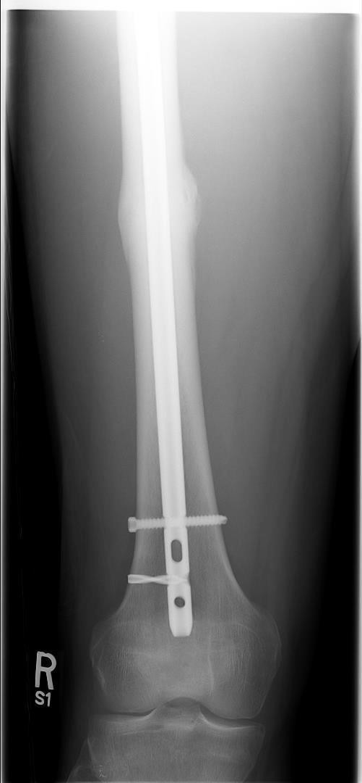
70 kVp
70 kVp
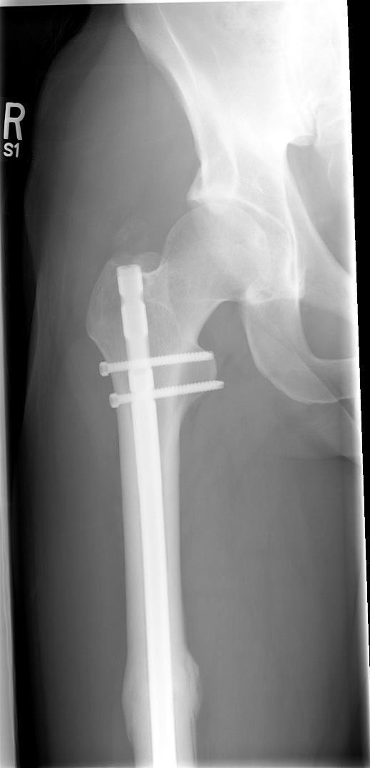
EDENBROOK Imaging library
- Which routine projection of the femur is displayed? AP projection
- What positioning error(s) occurred?
  - Anatomy not in required AP position for proximal femur image (i.e. femur was not internally rotated 15-20⁰ for the proximal image)
- If the image was repeated, how would you correct the positioning error(s)?
  - Rotate the right leg (aka. affected limb) medially 15-20º
- How did you identify the positioning error(s)?
  - Femoral neck not in profile (superimposition of greater trochanter over femoral neck)
  - Lesser tubercle clearly visible medially (should not be visible or only barely visible)
- If the image had to be repeated, would you make any other adjustment(s)? Explain your rationale.
  - Increase technique – images are underexposed
  - Use the anatomical marker to prove overlap between images (Marker should have been in the inferior lateral corner in the proximal image & superior lateral corner in the distal image)

- Use the images below to answer the next five questions:

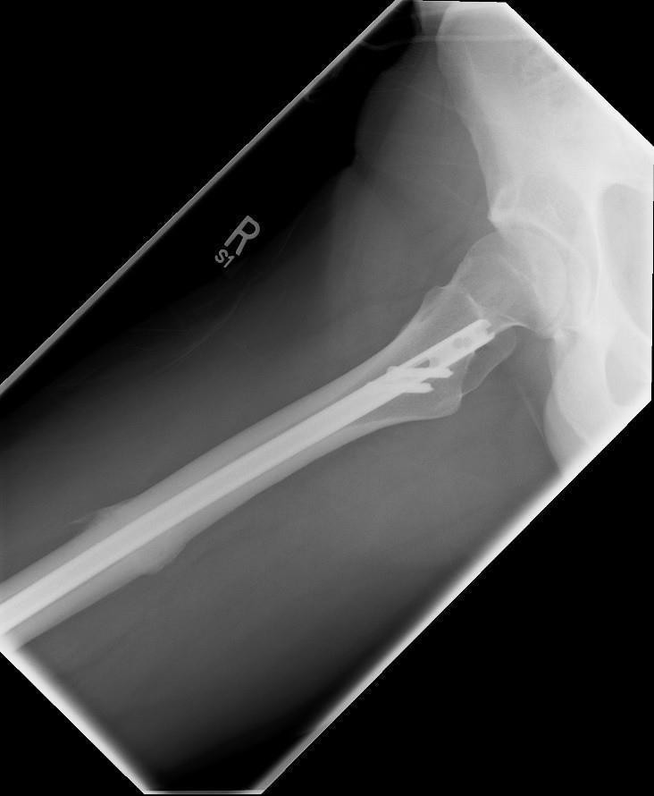
75 kVp 75 kVp
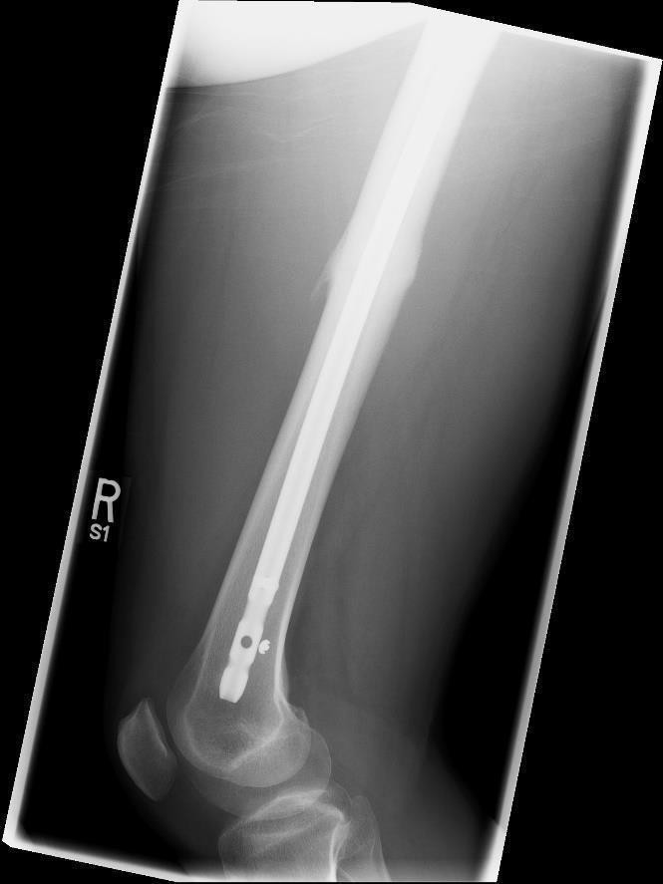
EDENBROOK Imaging library

- Which routine projection of the femur is displayed? Lateral projection
- What positioning error(s) occurred?
  - Unaffected leg was not removed completely from distal image
  - Femur not parallel to anterior edge of IR
- If the image was repeated, how would you correct the positioning error(s)?
  - Ensure unaffected leg is abducted away from the affected leg
  - Move the affected leg until it is running parallel to long edge of table (and/or move the mattress to position the femur parallel to the anterior edge of the IR)
- How did you identify the positioning error(s)?
  - Soft-tissue of unaffected leg is visible in superior anterior corner of distal image (i.e. the bright white density)
  - Collimator had to be tilted to match angle of anatomy (collimator should not be tilted)
- If the image had to be repeated, would you make any other adjustment(s)? Explain your rationale.
  - Use the anatomical marker to prove overlap between images (Marker should have been in the inferior anterior corner for the proximal image & superior anterior corner for the distal image)
  - Increase collimation side-to-side (aka. anterior-posteriorly); some soft-tissue should be clipped

