Handout - Working with Pediatric Patients
Principles of Pediatric Imaging

Understanding that children are not just small adults and appreciating that they need to be approached on their level is an essential ingredient for successful encounters with children. Radiographers often lack confidence in two main areas of pediatric positioning: pediatric communication skills and immobilization techniques.
Although pediatric and adult imaging have many similarities, including basic positioning and image quality assessment, some significant differences remain. The way to approach the child tops the list of differences. It may help novice pediatric radiographers to think about children whom they know and to imagine how they would explain a particular radiographic examination to those children.
Working successfully with children requires an open mind, patience, creativity, the willingness to learn and the ability to look at the world through a child’s eyes.

Waiting Room
Parents of pediatric patients often arrive in the X-ray department feeling quite anxious, and these feelings can be transferred from parent to child.
- They can feel nervous about the test, worried about their child, or maybe are feeling unsure of what is happening.
A well-equipped waiting room can reduce tension.
- Toys, age appropriate books, coloring activities can occupy the child and allow the parent an opportunity to check in at the front desk.

Imaging Room
Experience has shown that children are less likely to become upset if brought into a prepared room.
- Make sure to include placement of image receptor, approximate centering of tube and placement of all immobilization tools likely to be used at the end of the table.
- Children can be afraid of the dark but are more comfortable with low levels of illumination.
- Dim the lights prior to the patient entering not while they are in the room.
- Once the exam is complete, take the time to over emphasize how helpful the child was and to explain where to go or what to expect next.

Approaching the Parent (s)
When children arrive, they are generally accompanied by a parent.
  - Knowing whether to address the child or the parent can be confusing.
    - If the child is capable of understanding, direct the explanation to the child but use age appropriate language. This establishes a rapport with your young patient.
    - The parent will listen and consequently understand what is expected.
    - Communicating this way puts parents more at ease and increases their confidence in the skill of the radiographer.
    - They appreciate that their child has been made the focus of attention.
If the child is too young to comprehend, direct the explanation to the parent, keeping it as simple as possible as to what is going to happen and what is expected of the parent.
    - Remember that the parent is under stress and may need you to clarify instructions.

Dealing with Agitated Parents
When approaching the agitated parent, the radiographer should observe the following guidelines:
- Remain calm and speak in an even tone, remembering that fear or frustration may be the cause of the agitation.
- Use phrases such as “My name is…, I can identify with how you must be feeling and can appreciate your concern,” followed by “Let me explain to you what is happening.”
- If possible, escort the parent to a nearby room to continue the explanation and listen to their concerns without interruption. This can avoid an unwanted scene in the waiting room.

Parent Participation
The degree of parent participation depends on several factors:
- The general philosophy of the department
- The wishes of the parent/guardian
- The laws of the province regarding radiation protection
Explain the procedure to both parents but it is advisable that only one of the parents be present in the room for the exam to minimize distraction and not overcrowd the room. Many provincial laws permit only one additional person in the room.

There are several reasons that having a parent or guardian in the room with the patient can work in your favour:
- The parent can ensure patient safety if the radiographer’s attention is directed towards equipment.
- The radiographer may need to leave the room
- The parent can assist with immobilization.
- The parent who witnesses an entire procedure has little room for doubt regarding professional conduct.
In some situations, parental presence is not advised. For example, some children are further agitated by their parent’s presence, or some parents find certain procedures disturbing. In cases such as these, reassure parents that this is common and that their child is safe with you. Solicit the help of another technologist for the duration of the case.

When parents are in the room during a radiographic exposure they should be protected from scatter radiation with appropriate lead shielding. If the parent or guardian is a female of childbearing age, you must confirm the DLMP to rule out a chance of pregnancy and document. If there is a possibility, ask the female parent to step out of the room and solicit help from another technologist or another parent or guardian (if possible).

Approaching the Child
Good communication is key to obtaining maximum cooperation, so try to speak to the child at a level that they can understand.

A few strategies to keep in mind:
  - Greet the patient and parent in the waiting area with a smile.

  - Bend down to talk to the child at the child’s eye level.

  - Take a moment to introduce yourself and ensure you are meeting the correct person and confirm the exam. Depending on the age of the child, you may need to get this information from the parent rather than the child.

  - Suggest rather than ask the child to help you with some pictures. This firm, yet gentle approach avoids creating the idea that the child has a choice. After all, the patient may be emphatic and say no.

  - Use sincere praise immediately. This is a powerful motivator. Children have short attention spans and often expect immediate rewards. Say things like “You sat very nice and still for me, thank you,” or “You took a nice big breath for that picture. I am going to ask you to do that again for the next one.”

  - When the outcome will be the same, give the child the option “Would you like Mom to lift you onto the table, or may I help you?” or “We have two pictures to do. Which would you like first, the one laying down or the one sitting?”

  - Employ distraction techniques. As they develop confidence in adapting basic radiography skills with children, radiographers are able to engage themselves in chatter and distractive techniques, thus making the experience as pleasant as possible. Ask the child about brothers, sisters, pets, school, favourite TV shows/characters or friends.

  - Answer all questions honestly, regardless of their nature. If it is going to be uncomfortable, you should acknowledge that. Confidence and credibility built by previous strategies can be lost if the truth is withheld. The secret is not to volunteer information too early or dwell on unpleasantness.

The child’s age will greatly influence your approach.

Infants
  - Up to 6 months of age, their basic needs are warmth, security and nourishment.
  - Often calmed by pacifier. As they grow older, they become attached to familiar objects, which they should be allowed to keep with them.
  - Easily startled so keep loud stimuli to a minimum.

Children 6 months to 2 years old
  - Particularly fearful of pain, separation from their parents, and limitation of their freedom of movement.
  - Very disturbed by immobilization techniques – this age group usually requires the most assertive immobilization techniques.
  - Experience has shown that immobilization used well is less disturbing than a bunch of adults dressed in lead trying to hold the child down in correct positions.
  - One of the most valuable forms of immobilization is natural sleep.
    - The challenge is making it through the whole exam without the child waking up but this can be accomplished by carefully transferring the child to the table and taking care to maintain warmth, comfort and safety.
  - Parent participation in this age group is as valuable as it is with the 2-4-year age group.
    - Radiographers can pick up tips for communicating with children by taking cues from parents.
    - Parents can “babysit” the child during the procedure.
*Note chest radiography should always be performed with the child awake to ensure an adequate inspiration.

Children 2 to 4 years old
Preschoolers are extremely curious – their favourite question is “Why”? They also enjoy fantasy.
They may readily cooperate if the situation is treated like a game or distraction techniques are used.
The following strategies may be helpful:
  - Give explanations at the child’s eye level by bending down or by sitting the child on the table.
  - Take a moment to show the child how the collimator light works. Allow them to push the button to turn on the “flashlight”.
  - Use the camera analogy to describe the X-ray tube, taking care to explain that the tube may move sideways but will not come down and touch the child.
  - Avoid unnecessary equipment manipulation.
  - Encourage the child gently as the child attempts to cooperate and then praise the cooperation.
Children in this age group can be verbally and physically aggressive. A child having a tantrum will not respond to games and distraction techniques. Making the procedure as short as possible through the use of kind, yet effective immobilization techniques is the best approach. Young patients generally calm down quickly once back with their parents or resuming an activity they were engaged in prior to the exam.

The 5-year-old
  - Has typically reached a time that is rich in new experiences.
  - Reactions can vary greatly, depending on how at ease the child feels with a given environment.
  - Generally, children in this age group want to perform tasks correctly and enjoy mimicking adults.
  - A 5-year-old can appear confident and act older; however, when worried or afraid may cling to parents and become uncooperative.
    - Constant reassurance and simple explanations help in such moments.

School Age Children (6 years to 10 years old)
This is perhaps the best age group to start with when unaccustomed to working with children because they are generally accommodating and eager to please.
  - They are modest and embarrass easily, so their privacy should be protected.
  - Easiest age group to communicate with, so talk them through exams so they know what’s happening.
    - Anatomical landmarks are easier to find as body habitus evens out (toddler belly disappears).

Adolescents
Image is important to teens and although they are better able to comprehend the need for hospitalization, they can be upset by interferences with socialization and school activities. They can be quite concerned that they will not be able to return to their pre-injury state. They often require clear, exact explanations and radiographers should not be surprised by the frankness of their questions.

Adolescents often want to be treated as adults and it’s up to you to judge their level of maturity.

  - Sensitive issues such as possibility of pregnancy in the post pubescent girl must be approached discreetly. Most often they will be more honest if a parent is not in the room.
    - Start the questioning by stating information of a sensitive nature needs to be obtained for radiation safety.
    - Ask the adolescent girl if she has starting menstruating. If affirmative, continue by stating that a slightly more sensitive question needs to be asked and ask if there is any possibility of pregnancy. Judging from the patient’s response and expression, decide how to continue.
    - Differing levels of maturity call for different explanations. If necessary apologize for the need to ask such sensitive questions and assure the patient that the same questions get asked of all girls of this age.
    - Follow the questioning with an explanation that it is unsafe for unborn babies to receive radiation.
    - If possible have the questioning completed by a female.

Approaching Patients with Special Needs
You should consider age when approaching children with physical and mental disabilities.
Older patients with disabilities strive to achieve as much autonomy and independence as possible. They can be sensitive to the fact that they are less independent than their peers.
The radiographer should follow the following guidelines:
  - Direct communication to child first. All children appreciate the opportunity to listen and respond and appreciate being talked to versus being talked about.
  - If this proves ineffective, turn to the parents. Parents often know the best way to lift their child and transfer the child from the wheelchair or stretcher to the table. Parents also know the abilities and level of co-operation their children are able to give. These children may have a fear of falling and trust only their parent’s assistance.
  - If the child is capable of advanced communication, ask them directly how to best transfer them. They will know with what they need help with. Allow them to choose the pace of movement.
  - Children with spastic contractions are often frustrated by muscle movements that are counterproductive to the intended action. Immobilization devise may be helpful to maintain the required positions.
Communicating with a patient who has a mental disability can be very challenging depending on its severity. Some patients respond to verbal stimuli but loud or abrupt phrases can startle and consequently agitate them. The guardian, parent, or caregiver will often know the best way to communicate, so use their expertise.

Premature Infant
One of greatest dangers facing a premature and sometimes full-term neonate is hypothermia.
  - Should be examined within the infant warmer or isolette whenever possible, using a portable or mobile unit.
  - The radiographer should take great care to not let the baby’s skin contact the IR. Some isolettes have a drawer incorporated into the design that you can put the IR in. Use a cloth or pillow case to cover the IR. Be cautious of material creases as this can cause an artifact on the image.

When in the NICU, encourage the help of the nurse. The nurse can follow your directions to position the child as necessary. Too much movement can tax the neonate’s heart.

Protection from Unnecessary Radiation
Radiographers should be mindful that bone marrow, active in the formation of blood cells, is distributed throughout the pediatric skeleton and that tissue damage is associated with ionizing radiation.

Radiographers should observe the following steps:
  - Proper centering, selection of exposure factors, exposure times, precise collimation, and appropriate use of filters (when necessary) all contribute to reduced dose.
  - Keep repeats to a minimum.
  - Exposure factors must follow ALARA principle, and the lowest exposure factors must be utilized.
  - Short exposure times will reduce the incidence of motion unsharpness and the need for repeat imaging.
  - Grids should be used when the part being examined is greater than 10 centimetres. The exception is the pediatric CXR.
  - Use strategic placement of gonadal shielding and of long bones and breast tissue.
  - Use effective immobilization techniques to reduce the need for repeat examinations in combination with short exposure times.
  - Instead of AP projection, use PA projection of thorax and skull (when possible) to reduce amount of radiation to breast tissue and lens of the eye, respectively.
  - The fact that digitally acquired images can be “post processed” thereby correcting some exposure errors, does not negate an important truth – images of proper density are achieved by proper positioning and collimation. The anatomy must be in proper alignment with the photocell or ionization chamber to achieve the appropriate exposure index.

Other Modalities

CT
  - Useful in diagnosis and assessment of:
    - Congenital anomalies
    - Metastases
    - Bone sarcomas
    - Sinus disease
    - Limb length discrepancies
    - Fast scanners reduce the need for sedation

Nuclear Medicine
  - Direct radionuclide cystogram may be used in place of VCUG if bladder function is a concern.
    - Reduced radiation dose.
    - Does not demonstrate anatomy.

MRI
  - Much longer exam times, so the child must usually be heavily sedated.
  - Modality of choice to evaluate spinal cord abnormalities.
  - Useful for cardiac imaging.
  - Brain disorder studies ie. ADHD, autism, etc.
  - Aids in the diagnosis of epiphyseal fractures.
  - Provides multiplanar images for surgical assessments.

Ultrasound
  - Non-ionizing radiation.
  - Modality of choice to diagnose congenital hips dislocation in utero or shortly after birth.
  - Ultrasound can detect other genetic abnormalities of soft tissue.

Bone Development and Ossification
The bones of infants and small children go through various growth changes from birth through adolescence. In the pelvis image below, the divisions of the hip bone between the ileum, ischium, and the pubis is evident
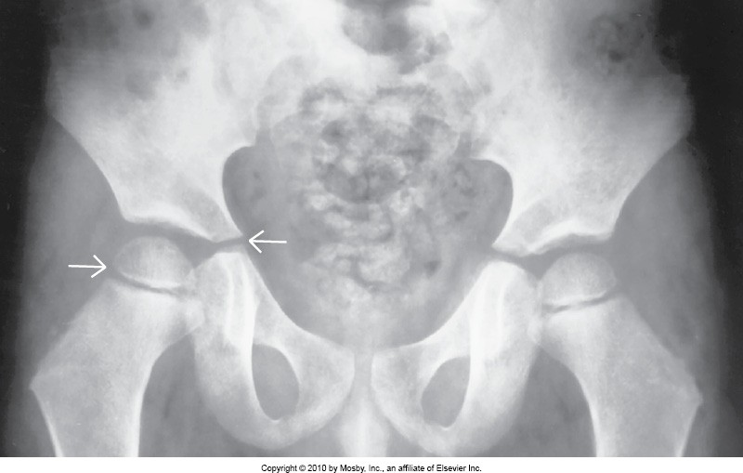
They appear as individual bones separated by a joint space but this is the cartilaginous growth region. You also see it in the heads of the femora.

  - Most primary centers for bone growth appear before birth (the mid shaft of long bones) and become the diaphysis of long bones.
  - Secondary centers of ossification involve the ends of long bones and are called the epiphysis.
  - The space between the two is called the epiphyseal plate until skeletal growth is complete, around age 25 years.
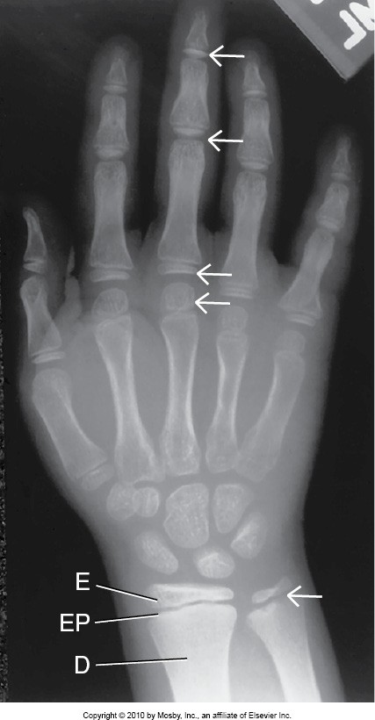
This 9-year-old PA hand projection shows the epiphysis (E), epiphyseal plate (EP) and diaphysis (D) in the distal radius and ulna as well as the metacarpals and phalanges (see arrows).

The epiphysis is the part of the bone that increase in size and appearance as the child grows, as you will see in the following knee images:

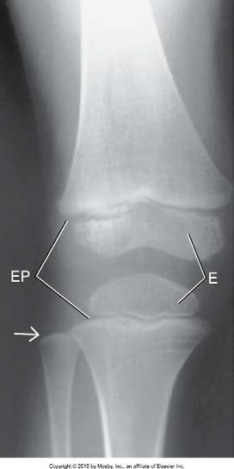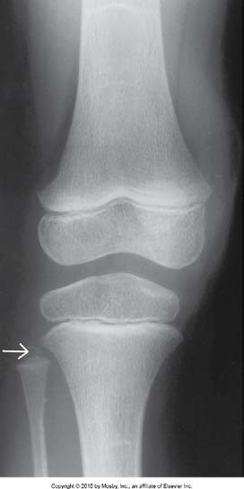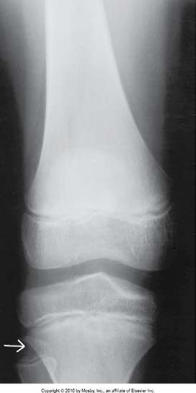

Note the change in the size and shape of the epiphysis of this knee from age 3 – 12 (from left to right).
  - At age 3, the epiphysis of the fibula is not yet seen but by age 12 becomes obvious (see arrows).
  - Growth charts are available that list and demonstrate normal growth pattern.

