Label the blood supply to the brain

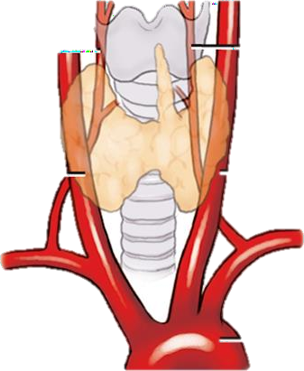

Label the arteries of the head and neck indicated

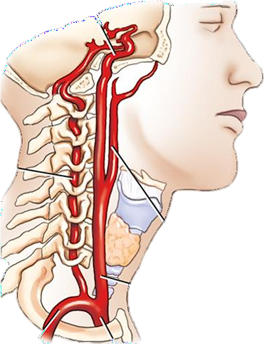

What is this an illustration of? Label the various arteries.

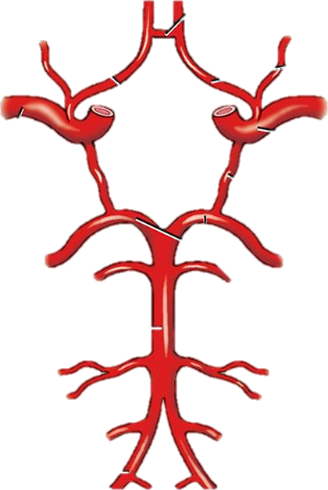

What type of angiogram is this? Label the anatomy correctly.

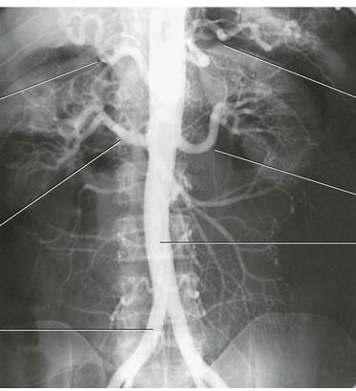

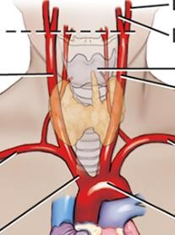
Label the arteries indicated by solid lines and identify the landmark at the level of the dotted line.

Identify the veins of the neck.

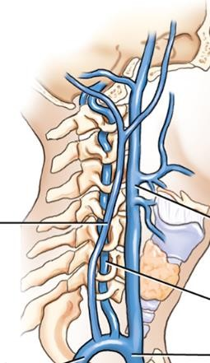

Label these parts of the thoracic aorta

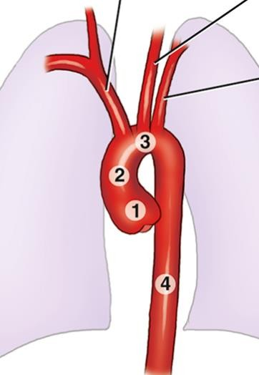

1
2
3
4

Label the following indicating correct side:
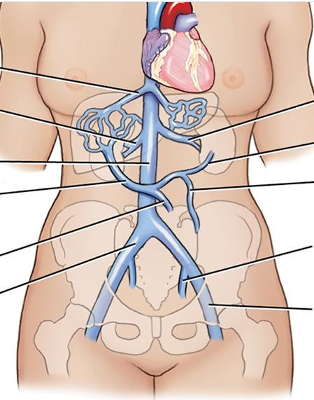

- What are the three main branches of the aorta?

- Which two vessels deliver blood to the heart muscle?

- The right common carotid artery bifurcates into internal and external arteries at what level?

- Which vessel is formed when the vertebral arteries join at the base of the skull?

- Eventually the eternal jugular connects with the to form the brachiocephalic vein?

- Where do the openings for the coronary arteries originate?

- What vein drains and receives blood form the intercostal, bronchial, esophageal and phrenic veins?

- Which of the branches of the abdominal aorta is considered the most superior?

- Which two vessels unite to form the hepatic portal vein?

- On the right side of the body, the subclavian artery is a branch of which artery?

- On the left side of the body the subclavian is a branch of which anatomical structure ?

- Venous blood below the diaphragm is returned to the heart by the :

- The distal portion of the abdominal aorta will bifurcate into the:

- How long should food be withheld prior to angiography?

- What vessels are typical puncture site for catheterization during angiography?

- Which is the preferred site for arterial puncture for most angiography?

- What are three contraindications for angiography?

- When imaging the aortic arch and thoracic aortography what is the most useful position to prevent superimposition?

- Where does the inguinal ligament site in reference to the femoral artery?

- If an interventionalist is performing a left common carotid angiogram and using the femoral artery as the access point, identify the arterial path that the catheter would travel to reach its destination?

- Match each description with the correct interventional term.
Terms:
Kyphoplasty
Embolization
Stent placement
Thrombolysis
Inferior Vena Cava filter
TIPS
Percutaneous transluminal angioplasty

Dilation of stenosed vessel
Placement of cage-like metal device in the lumen of the
vessel
A procedure wherein a clot is disintegrated
A procedure to treat variceal bleeding cause by portal
hypertension
A procedure to restore and stabilize a compression
fracture within a vertebral fracture
Cease blood flow to a site of pathology
A procedure for patients at high risk of developing
pulmonary embolism

- Select the most likely angiographic procedure performed for each pathologic condition.

Coronary artery disease | Pulmonary angiography
Evaluation of aorta pseudocoarctation | Cerebral angiography
Arteriovenous malformations | Peripheral angiography
Atherosclerosis disease lower limbs | Abdominal angiography
Pulmonary emboli | Angiocardiography
Stenosis/occlusion celiac or mesenteric arteries | Thoracic angiography

- Label the following anatomy?



