Activity: Test 20 Fluoroscopic Low Contrast Resolution Procedure

Purpose
This activity will help you identify the procedure steps for this test.

Instructions
- Review the images below of the equipment and materials used at Edenbrook for this test.
- Review the procedure steps from the Edenbrook MRT lab.
- Compare this procedure, the textbook reading and your practicum site QA manual for similarities and differences between a C-arm and dedicated fluoro unit.

Equipment
- Low resolution tool

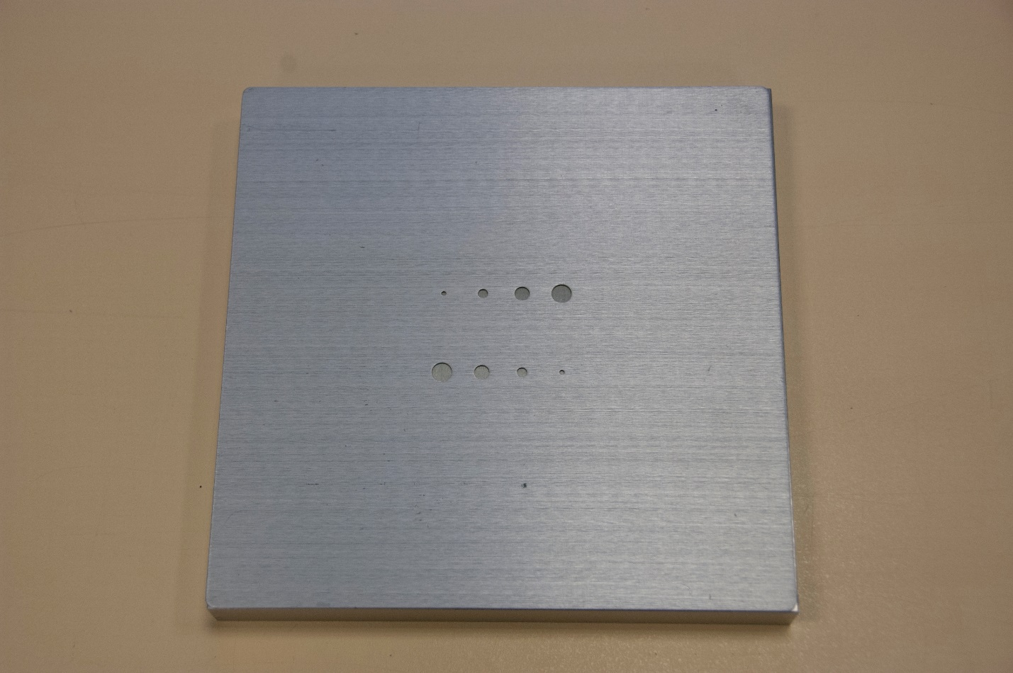

Edenbrook MRT Procedure Steps (Note: using C-arm at Edenbrook is limited by equipment)
- Position the C-arm with the image intensifier on the bottom.

- Centre the low contrast test tool on the image intensifier and collimate appropriately to include the entire test tool.

- Using 100 kVp on the continuous fluoro setting, expose for 2 seconds and determine the number of holes that can be clearly visualized. Record the results.

The resultant image could look like this, with circles of varying density: (Note: this image is taken using a different low contrast test tool than the one used at EDENBROOK).
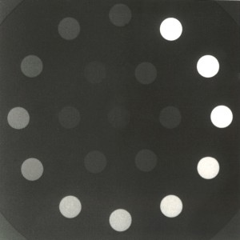
Source: Gammasonics. Reproduced and used in accordance with EDENBROOK’s Fair Dealing Policy (Schedule A, Copyright of External Materials Procedure AC.2.12.1); further distribution may infringe copyright. Retrieved from http://gammasonics.com/UI/Images/LCD4-300x300.jpg

- Add one aluminum block onto the tool and repeat the exposure. Record the results.

- Add the second aluminum block onto the first block and expose. Record the results.

- Repeat steps 3–5 on both magnification settings as well. Record the results.

