Activity: Test 8 AEC Sensitivity Procedure

Purpose
This activity will help you identify the procedure steps for this test.

Instructions
- Review the images below of the equipment and materials used at Edenbrook for this test.
- Review the procedure steps from the Edenbrook MRT lab.
- Compare the textbook readings and your practicum site QA manual for similarities and differences.

Equipment
- Dosimeter
- Two Plexiglas blocks
- Calculator

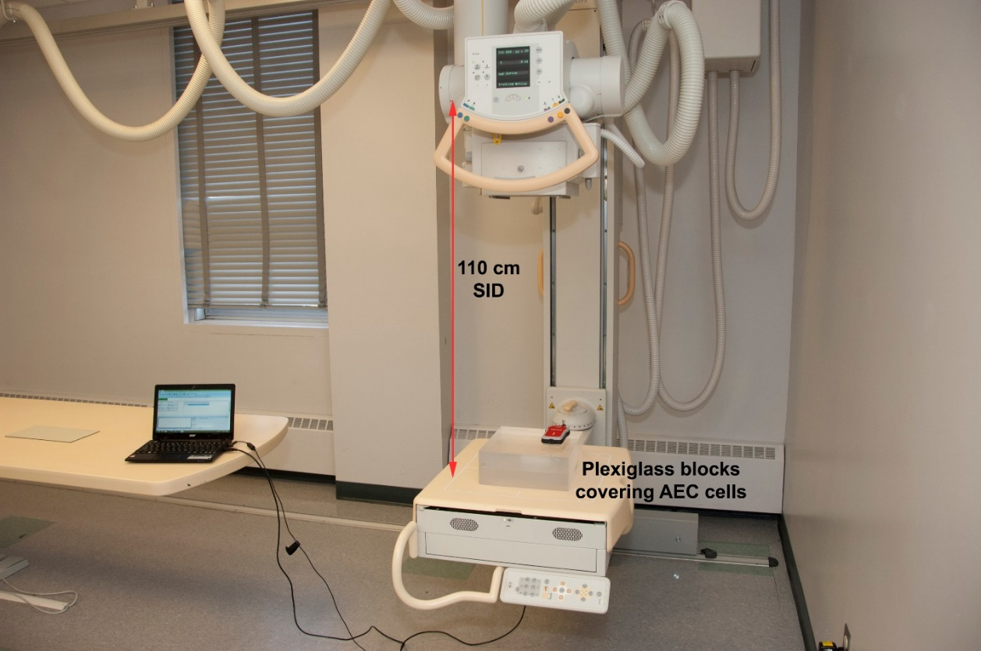

Edenbrook MRT Procedure Steps
- Place the Plexiglass blocks (stacked) over the AEC cells of the detector ensuring the AEC cells are completely covered.

- Using a 110 cm SID, centre the dosimeter and collimate to include the Plexiglass blocks entirely.

- Place the dosimeter probe on top of the blocks to one side of the centre cell, ensuring it is not obstructing any of the AEC cells.

- Select the centre AEC cell and set 70 kVp.

- Take an exposure at the speed/sensitivity settings of S200, S400 and S800.

- Record the mAs and mR at each setting.

